CHEMICAL AND ANTICANCER ACTIVITY STUDIES FOR SOME 3-CHLORO-3-CHLOROSULFENYL-4'-METHYLSPIRO[CHROMAN-2,1'-CYCLOHEXANE]-4-ONES
Tamer El Malah,¹ Ahmed H. Shamroukh,¹ Eman R. Kotb,¹ Hanan A. Soliman,¹ Khaled Mahmoud,² Mohamed I. Hegab^{1*}
¹Photochemistry Department, National Research Centre, Dokki, 12622 Giza, Egypt.
² Drug Bioassay Cell Culture Laboratory, National Research Centre, Dokki, 12622 Giza, Egypt.
*Email: pmihegab_2010@yahoo.com
Supplemental Materials

Figure S 1: IR spectrum for compound 3

Figure S 2: ¹H NMR spectrum for compound 3

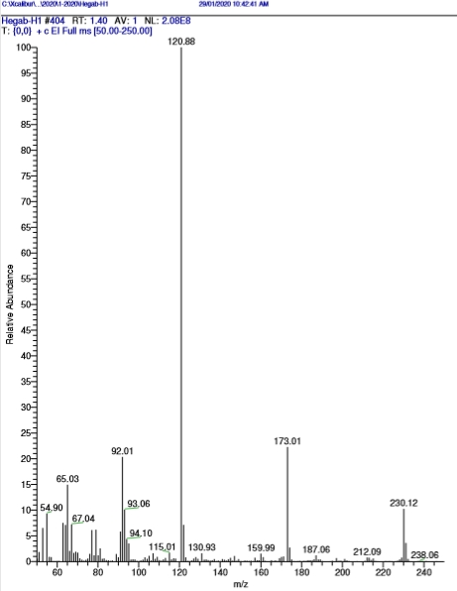
Figure S 3: Mass spectrum for compound 3

Figure S 4: IR spectrum for compound 4

Figure S 5: ¹H NMR spectrum for compound 4

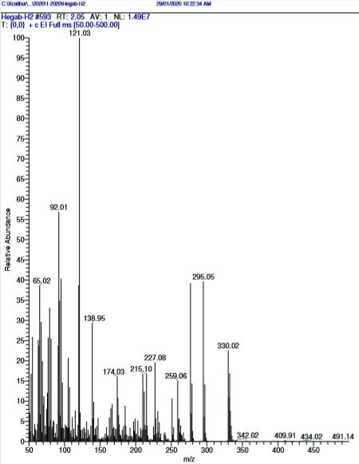

Figure S 6: Mass spectrum for compound 4

Figure S 7: IR spectrum for compound 5

Figure S 8: ¹H NMR spectrum for compound 5

Figure S 9: ¹³C NMR spectrum for compound 5

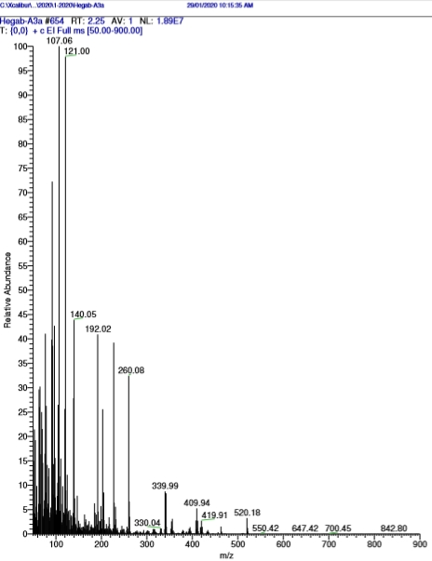
Figure S 10: Mass spectrum for compound 5

Figure S 11: IR spectrum for compound 6

Figure S 12: ¹H NMR spectrum for compound 6

Figure S 13: ¹³C NMR spectrum for compound 6

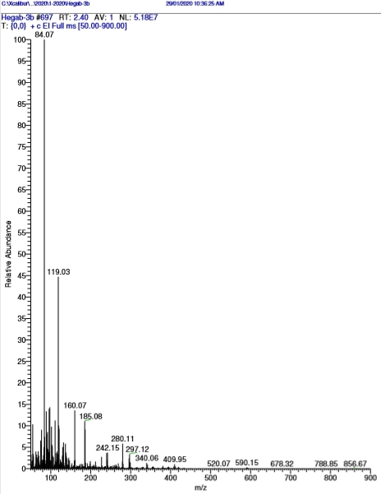
Figure S 14: Mass spectrum for compound 6

Figure S 15: IR spectrum of compound 7

Figure S 16: ¹H NMR spectrum for compound 7

Figure S 17: ¹³C NMR spectrum for compound 7

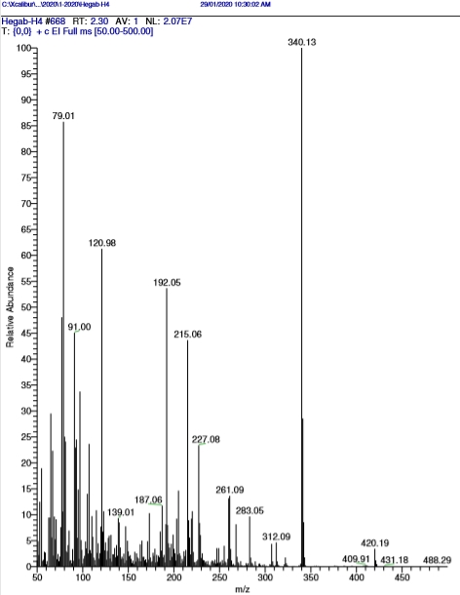
Figure S 18: Mass spectrum of compound 7

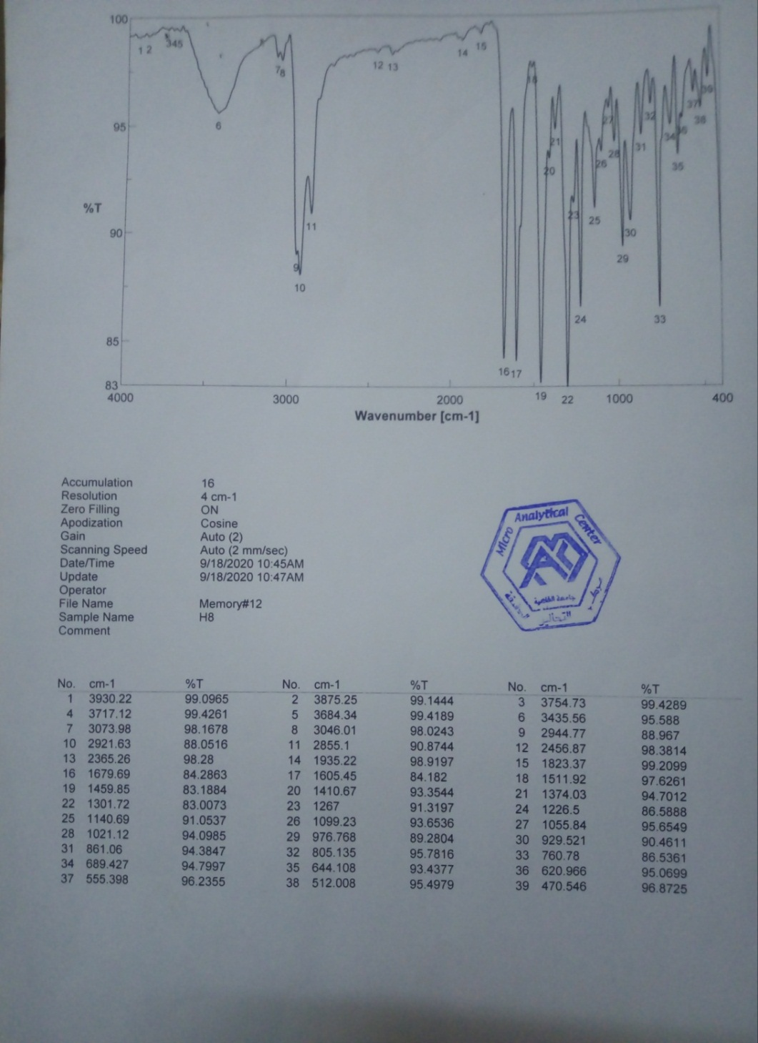
Figure S 19: IR spectrum of compound 8

Figure S 20: ¹H NMR spectrum for compound 8

Figure S 21: ¹³C NMR spectrum for compound 8

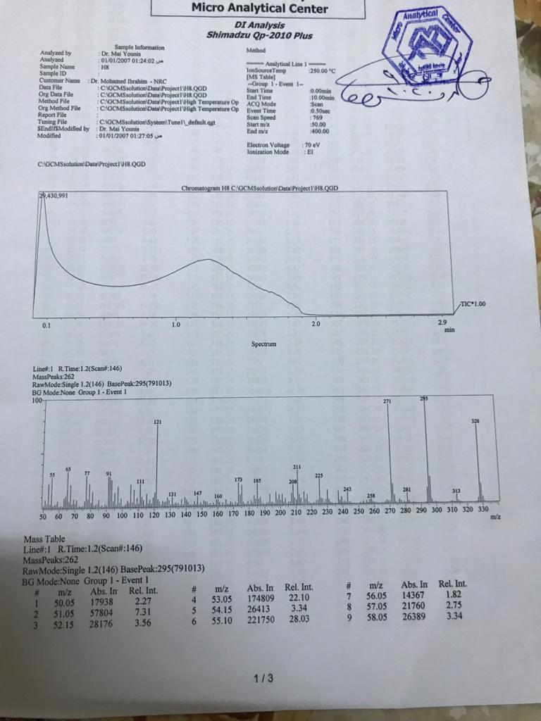
Figure S 22: Mass spectrum of compound 8

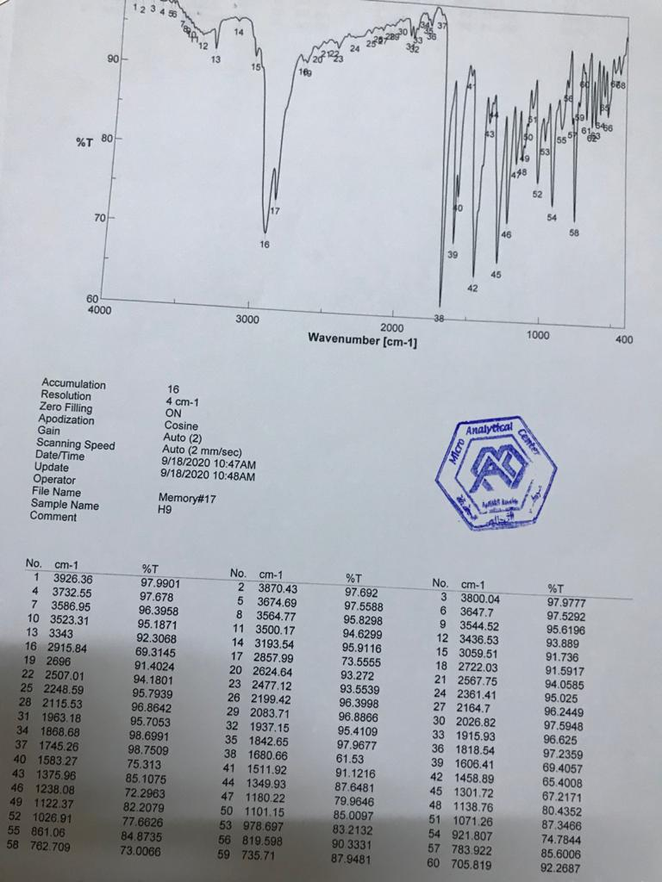
Figure S 23: IR spectrum of compound 9

Figure S 24: ¹H NMR spectrum for compound 9

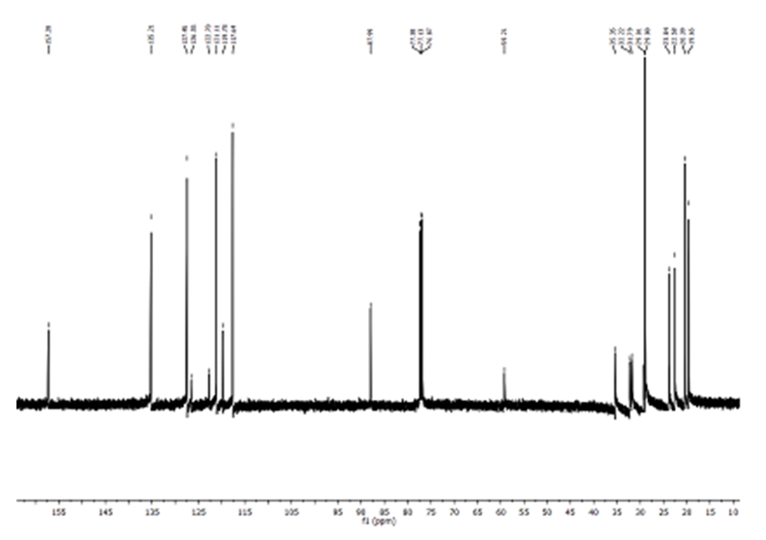

Figure S 25: ¹³C NMR spectrum for compound 9

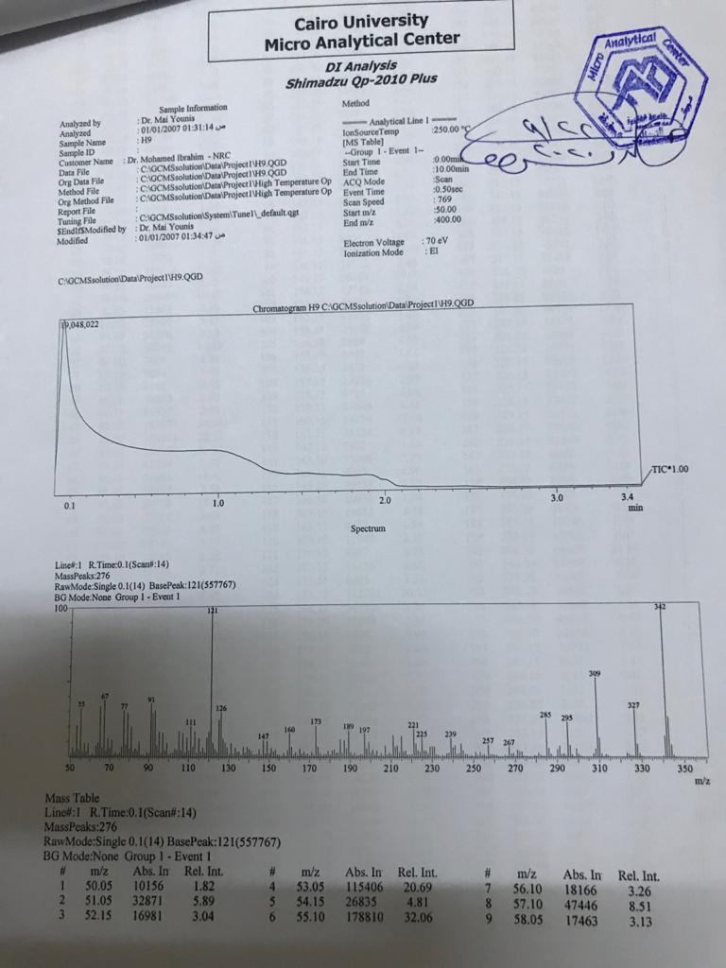
Figure S 26: Mass spectrum of compound 9

Table S 1: Cytotoxic activity of the newly synthesized chromone derivatives
Compound No. | A549  (Lung carcinoma) |  | PC3  (Prostate cancer) |  | PACA2  (Pancreatic cancer) |  | MDA  (Breast Cancer)
 | IC50 (µM) | IC90 (µM) | IC50 (µM) | IC90 (µM) | IC50 (µM) | IC90 (µM) | IC50 (µM) | IC90 (µM)
3 | 14.8 | 20.7 | 12.4 | 19.2 | 16.1 | 25.5 | --- | ---
4 | 57.3 | 80.5 | 52.8 | 79.2 | 58.7 | 88.7 | --- | ---
5 | --- | --- | --- | --- | --- | --- | --- | ---
6 | --- | --- | --- | --- | --- | --- | --- | ---
7 | 59.0 | 106.6 | 37.7 | 73.6 | 67.0 | 102.3 | 25.3 | 47.7
8 | --- | --- | 50.8 | 99 | 90.7 | 139.3 | 31.3 | 55
9 | --- | --- | 63.0 | 110.0 | 74.7 | 120.6 | 38.8 | 71.9
(Doxorubicin) | 49.3 | --- | 41.1 | --- | 48.8 | --- | 45.3 | ---

