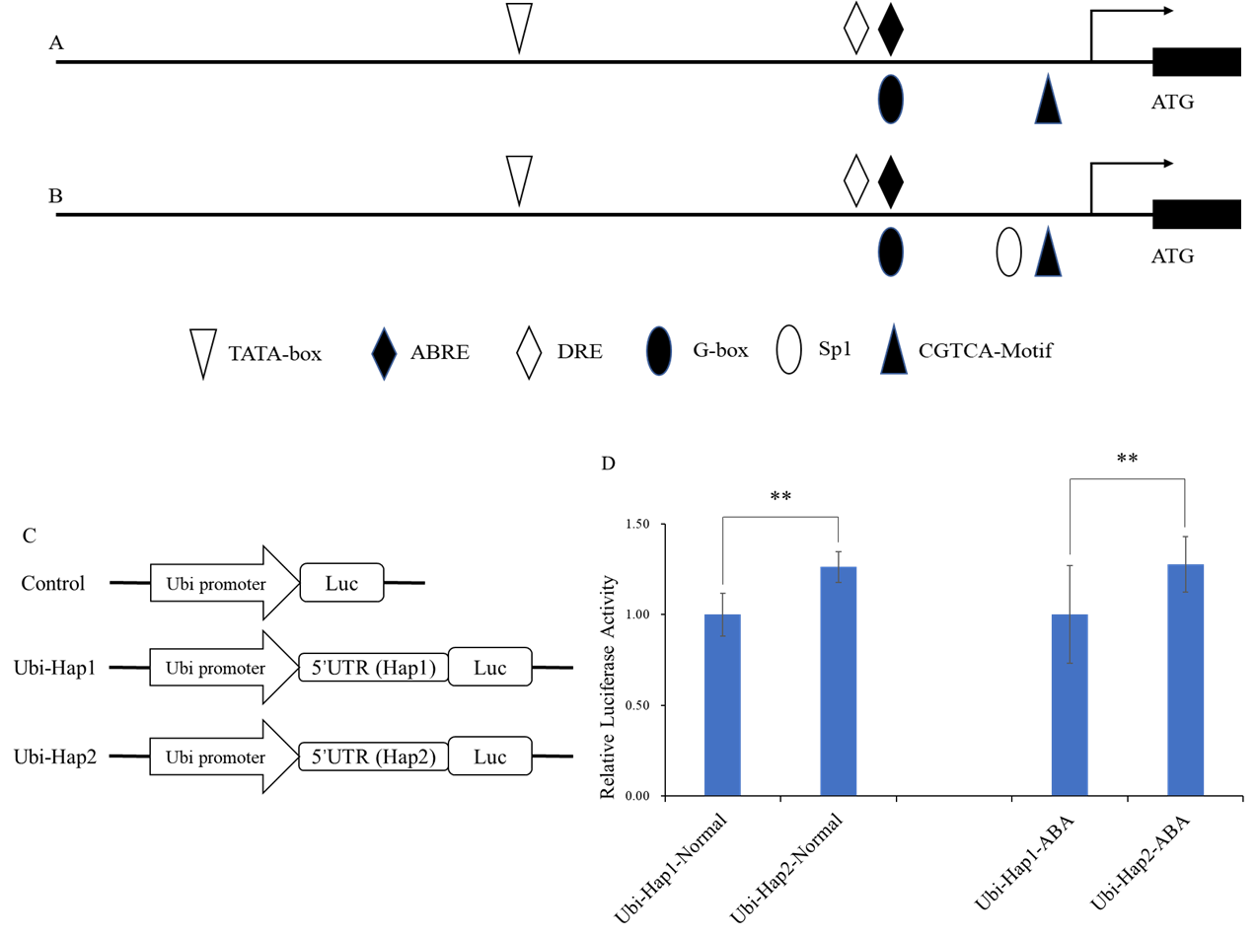
Supplemental Figure S1 Distribution of cis-acting regulatory elements and transcriptional activation of 5’-UTR of ZmNAC080308. (A) Distribution of several cis-elements in Hap1 genotypes and (B) Hap2 genotypes; (C) Vector construction for the Dual-Luciferase Reporter Assay system; (D) The LUC to REN ratio controlled by the Ubiquitin (Ubi) promoter or the 5’-UTR of the two ZmNAC080308 haplotypes. Each data point is the mean (± SD) of 12 replicates (Student’s t-test).

Supplemental Table 1 Primers used for amplification of ZmNAC080308 genomic sequence
Primers | Sequence | Amplified region
Q1-F | GTCGGGAAAAGCTCAGTT | Promoter
Q1-R | ATAGAATCGCGTTGTCCG
5U-F | GCACGAGCTGGGCTACGC | 5’ UTR
5U-R | GATGATGGGCACGGGCAG
SNAC8308-F | GGACAACGCGATTCTATTTATT | ATG-TGA
SNAC8308-R | CCTTACAAGACTACCAGCAACA
3U-F | CGACGAAGATGTGGCAGAC | 3’ UTR
3U-R | GACCAATCTCGGTTCAGG

