Fig S1A. Gel electrophoresis of mRNA extracted from tissue of a patient with laryngeal squamous cell carcinoma.
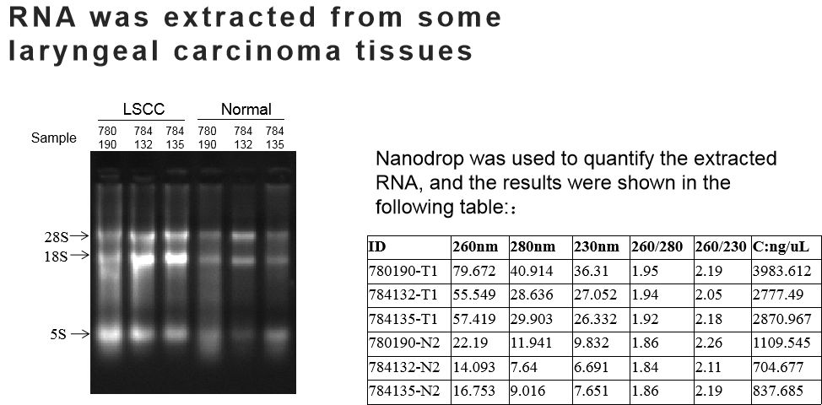

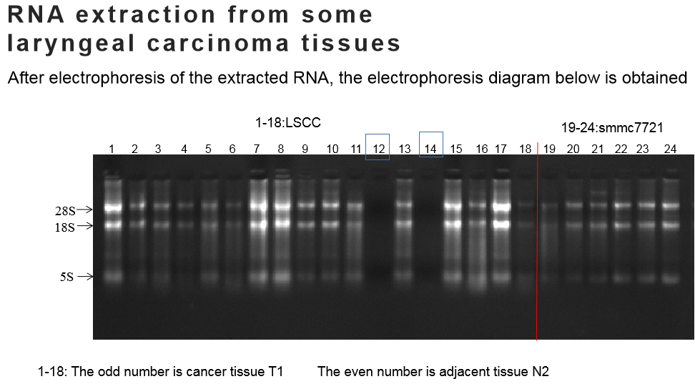

Fig S1B. The relative expression levels of lncRNA genes were detected by qPCR.
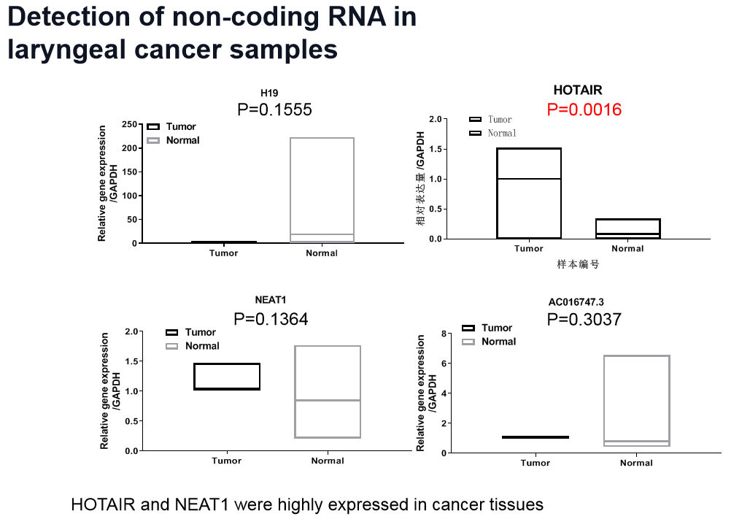
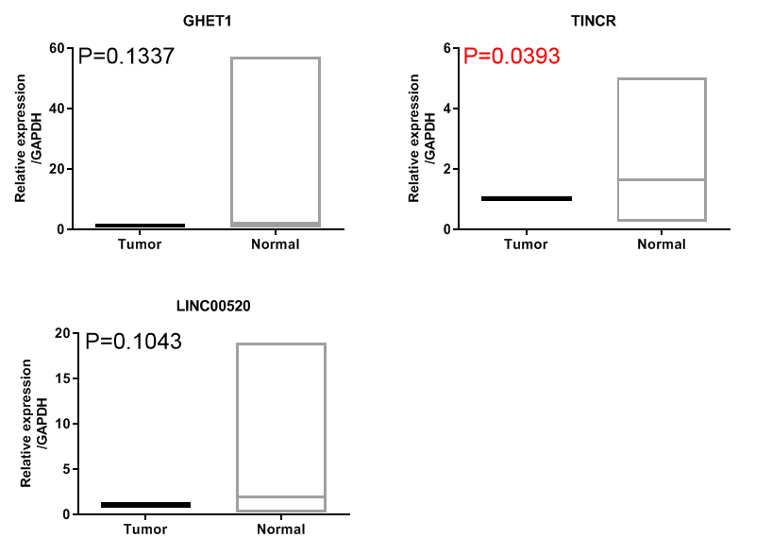

Fig S1C. Transwell detects the invasion ability of different laryngeal squamous cell carcinoma cell lines.

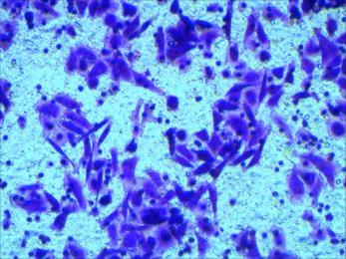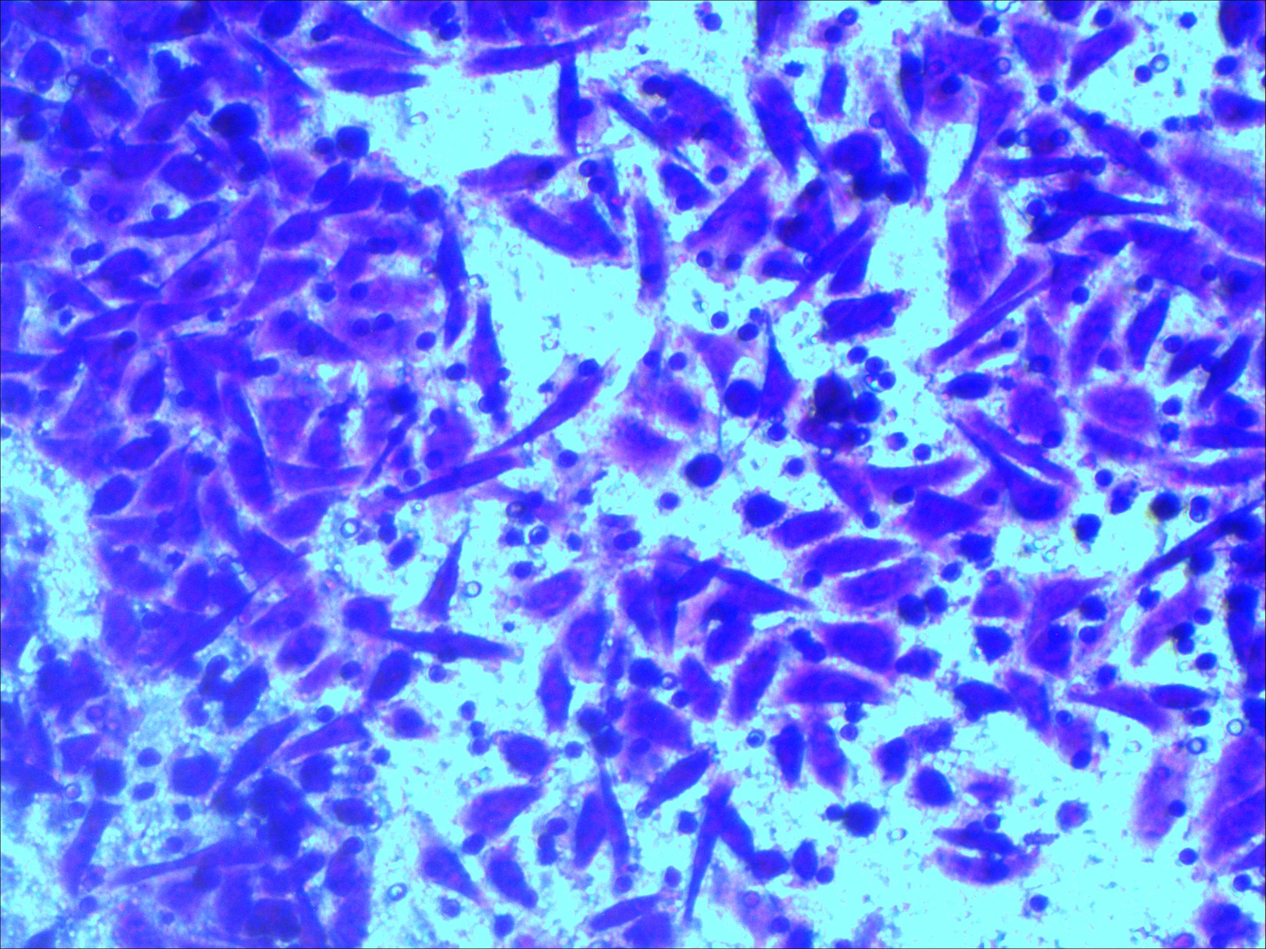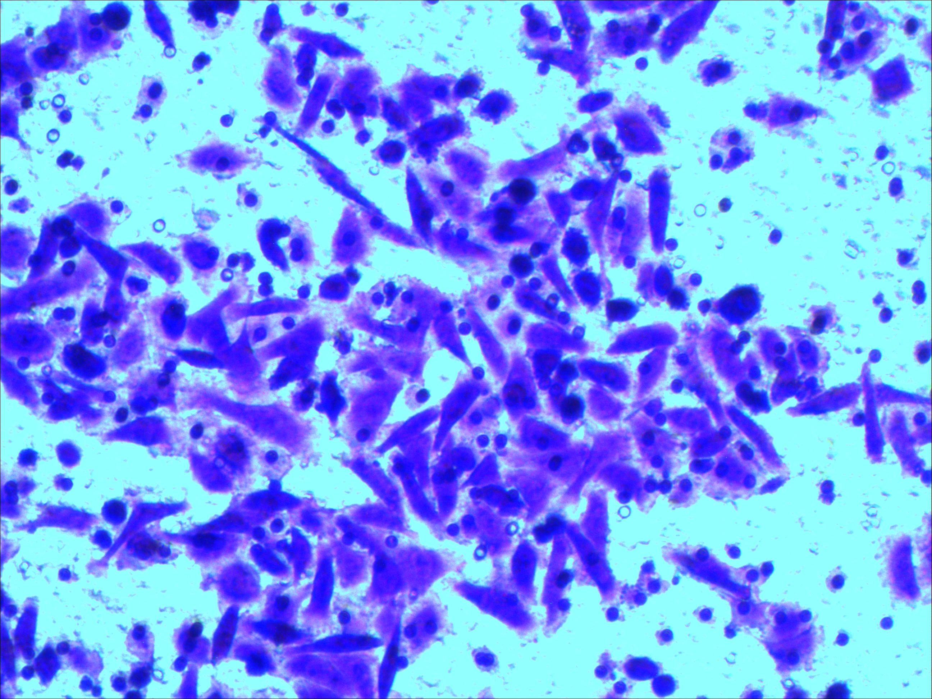
TU686
TU212
Hep-2

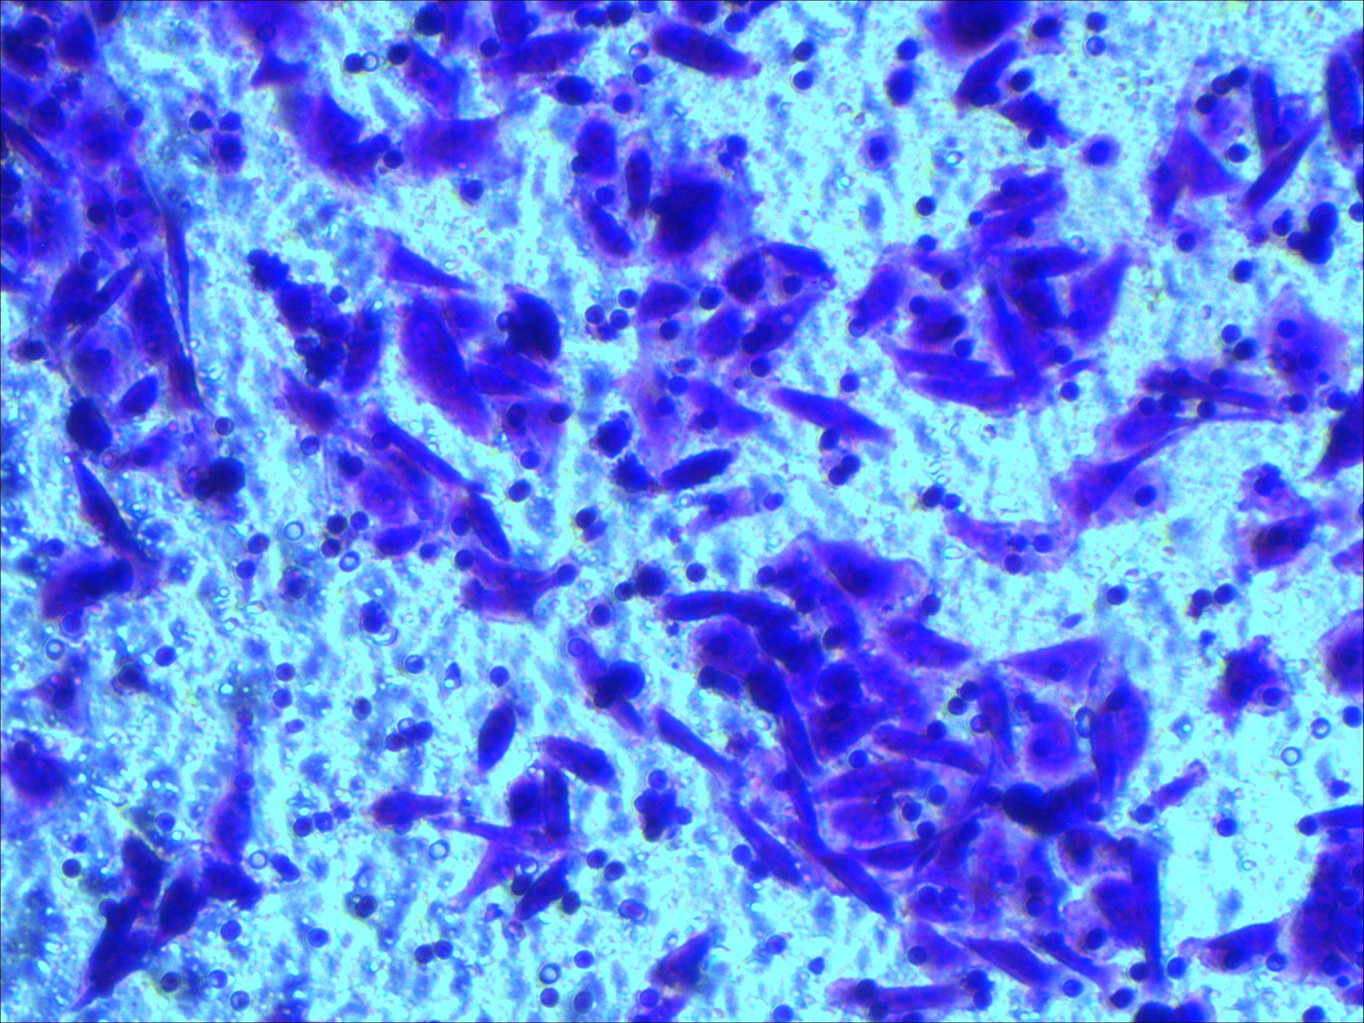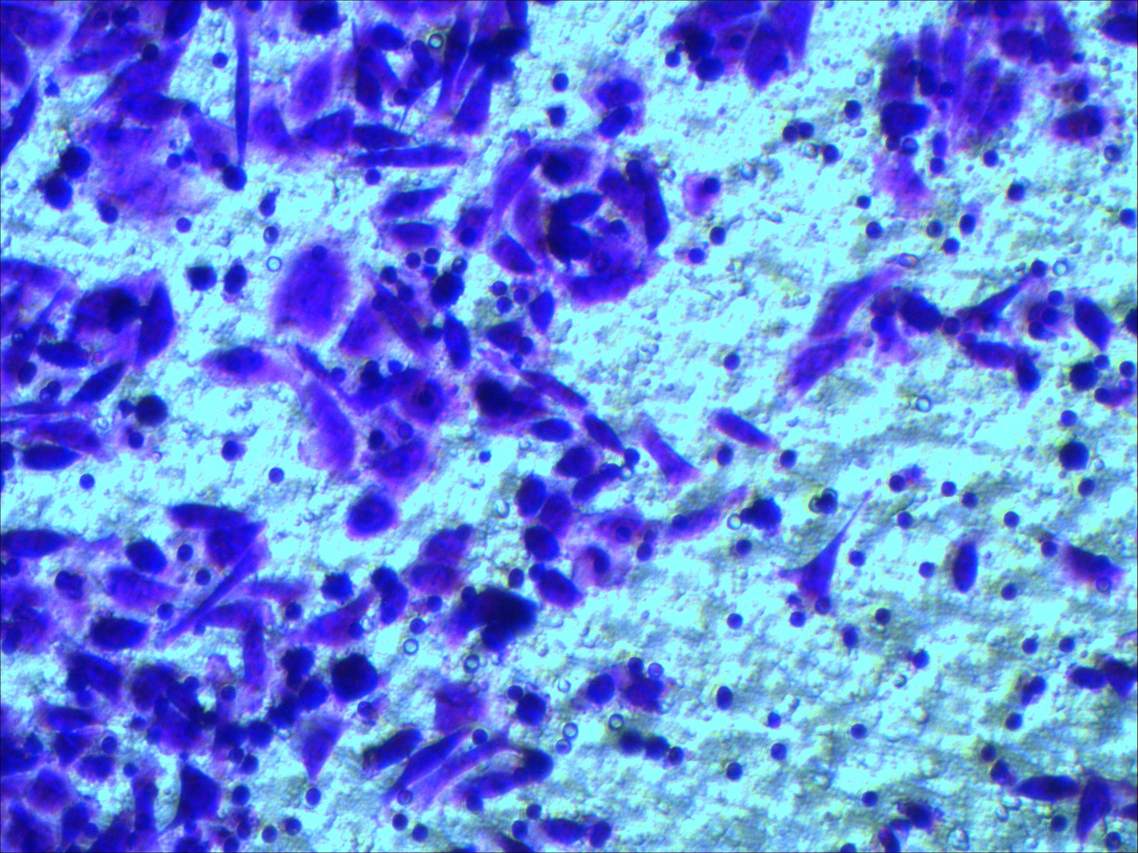
M4e
M2e

Fig S1D. CCK-8 detects the proliferation ability of different laryngeal squamous cell carcinoma cell lines.

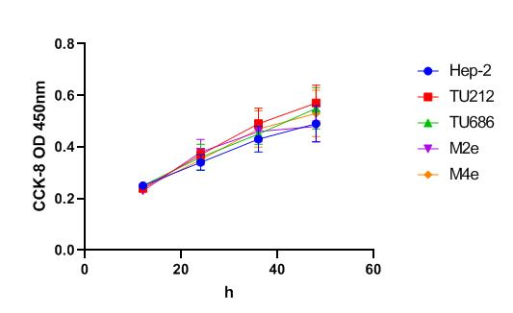

Fig S1E. Bioinformatics Web sites predict the targeted binding of TINCR to miRNA.
The miRDB online website predicted the sequences of binding sites between hsa-miR-210-5p and Tincr sequences. The sequence segments in the figure below are the nucleotide sequences of Tincr, and the blue sites are the binding nucleotide sites

Fig S1F. Bioinformatics Web sites predict the targeted binding of hsa-miR-210-5p to miRNA
TargetScan predicted that hsa-miR-210-5p had targeted binding sites with 7 consecutive binding nucleotide sites in the 3’UTR sequence of BTG2.

