Supplementary material
Content: 8 figures
Figure S1. Global distribution of (A) temperature and (B) salinity observation weights extracted from EN4.2.1 dataset for each season DJF, MAM, JJA and SON at 5 m and 56 m depth.
(A) Temperature
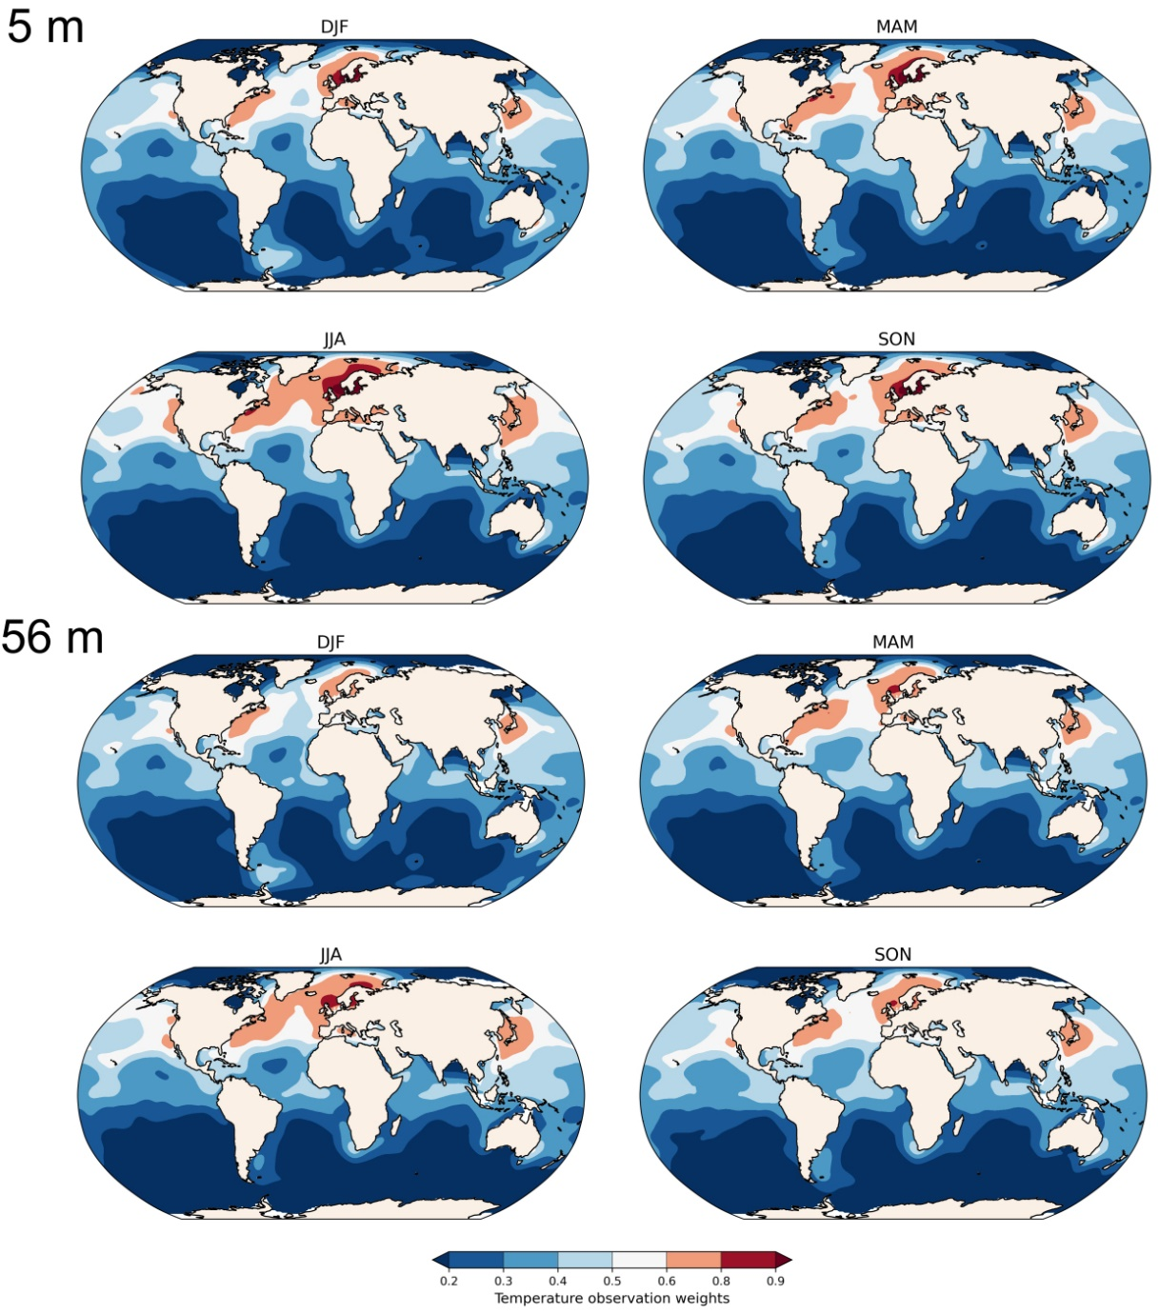

(B) Salinity
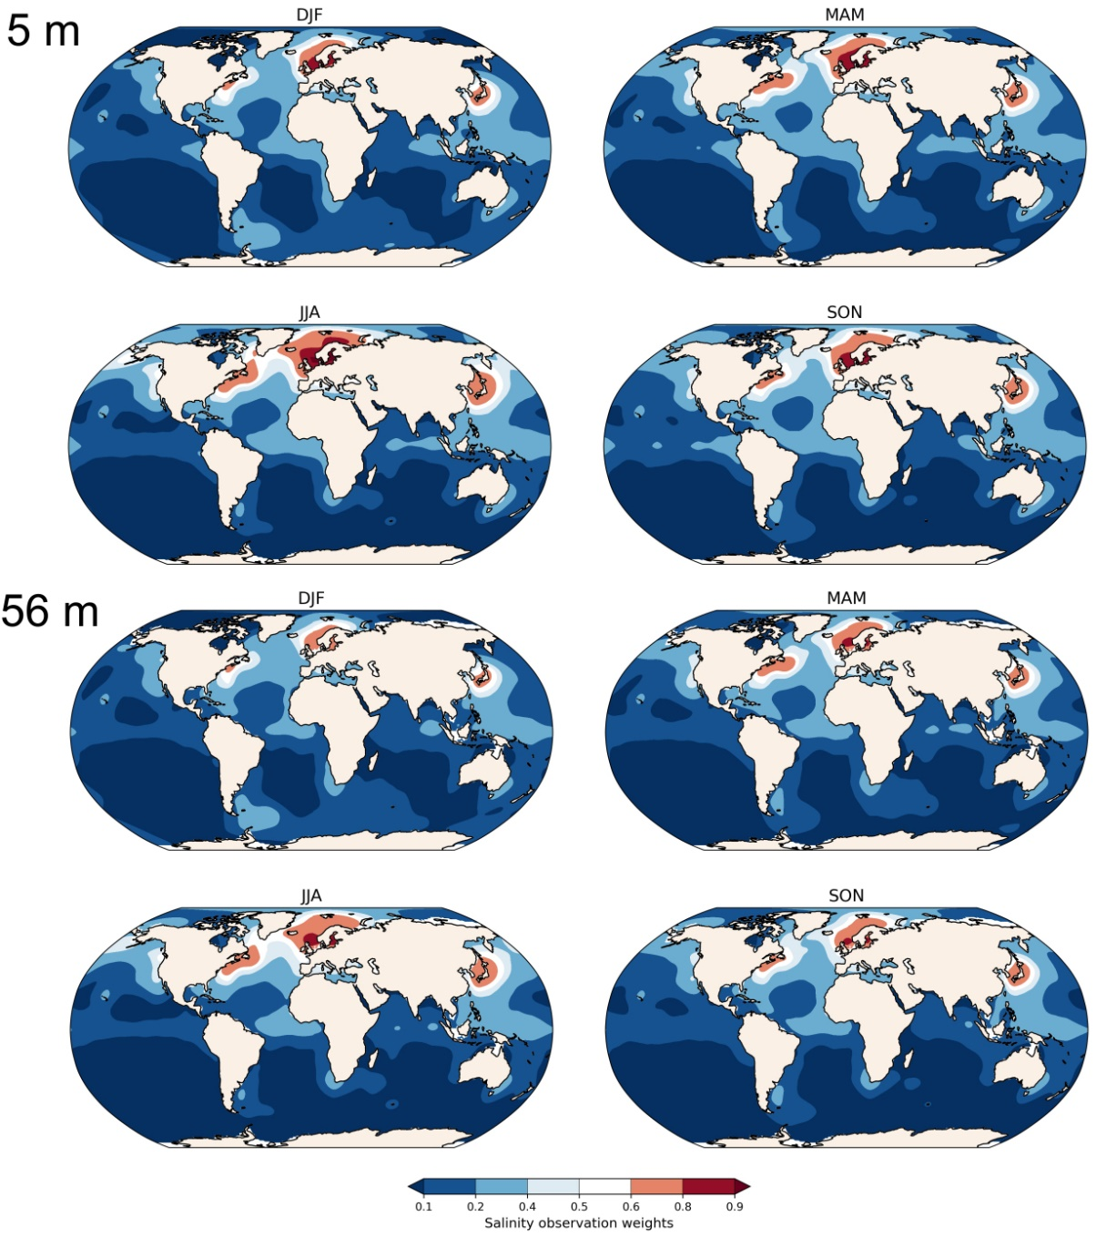

Figure S2. Global distribution of (A) temperature and (B) salinity uncertainties (standard deviation) extracted from EN4.2.1 dataset for each season DJF, MAM, JJA and SON at 5 m and 56 m depth.
(A) Temperature
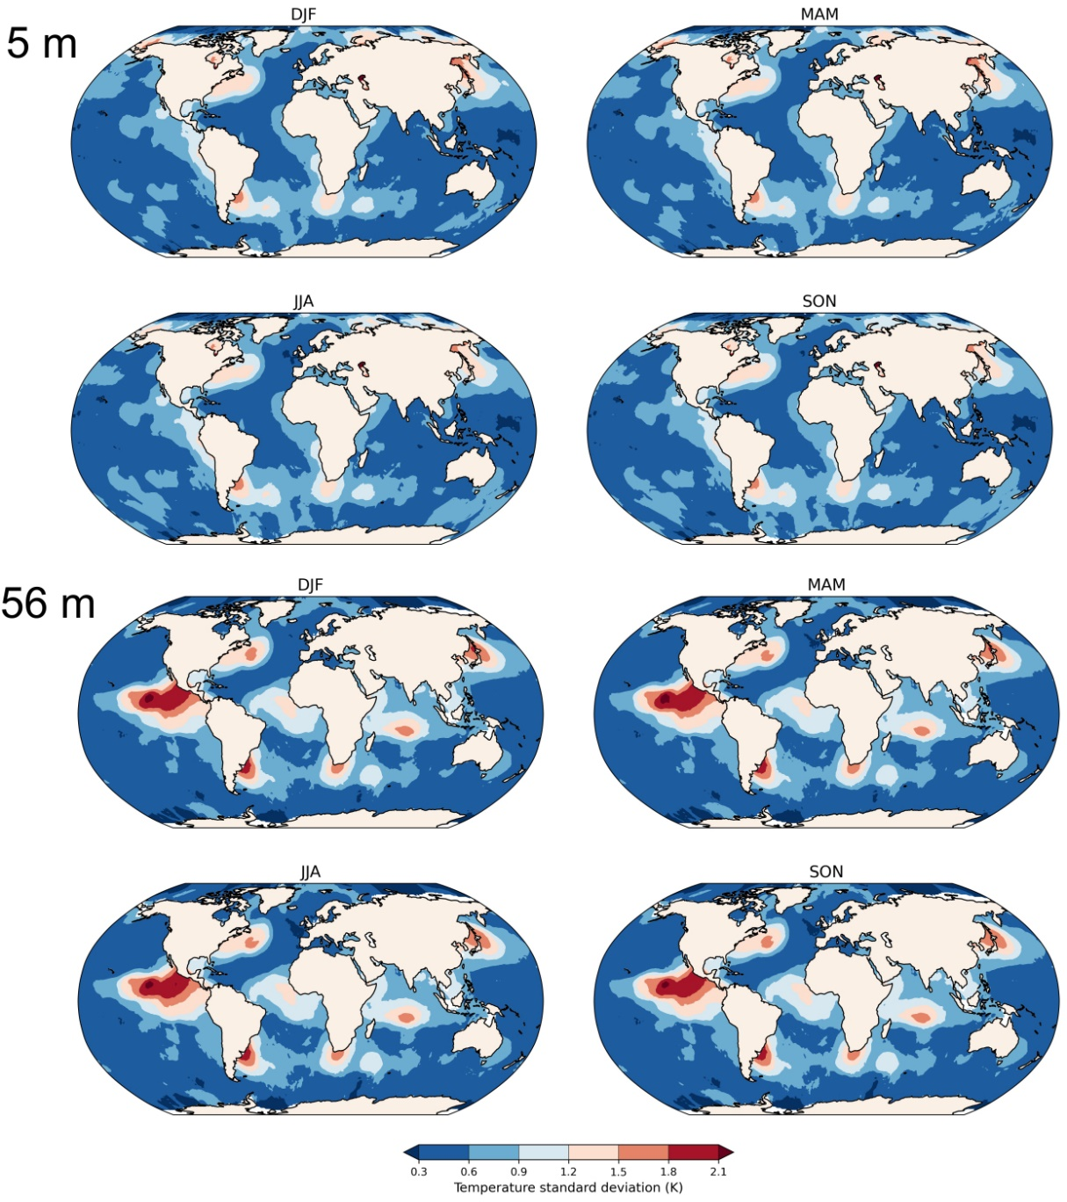

(B) Salinity
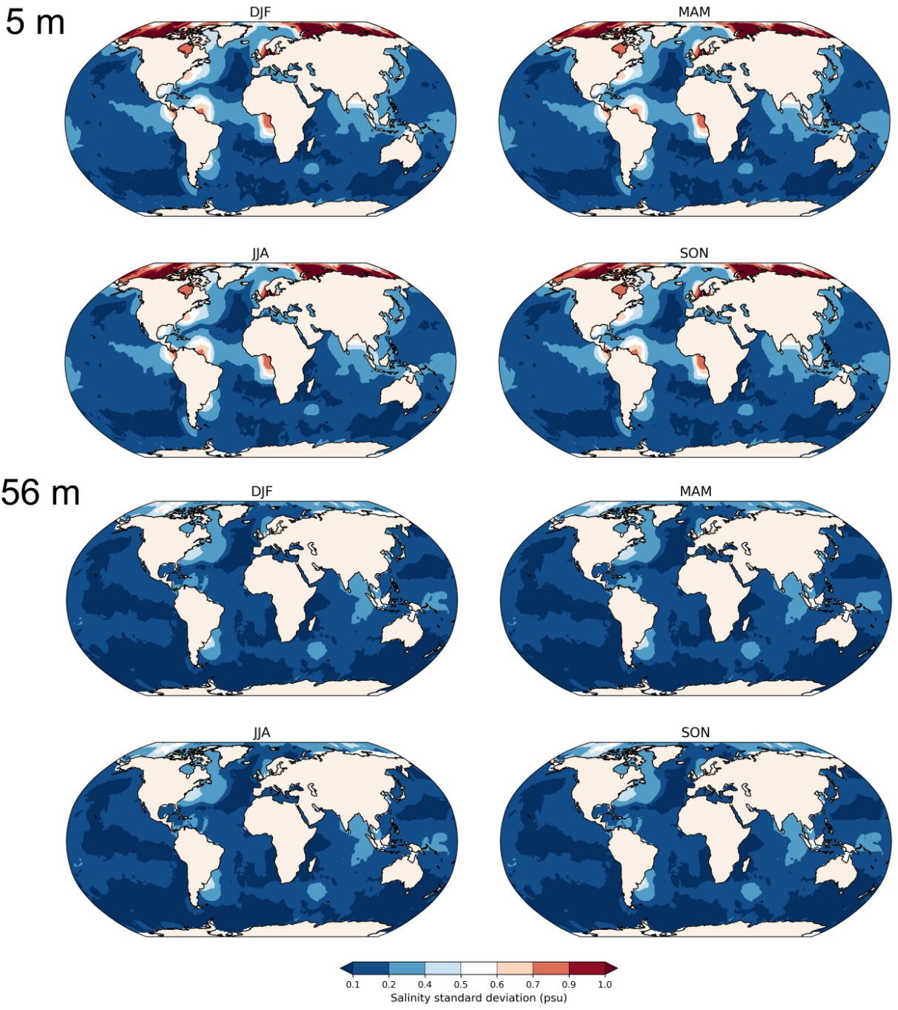

Figure S3. Multi-seasonal Pearson correlation analysis between the shell growth signal and subsurface water temperature at the approximate collection site (66° N, 18°W) for 1900-2005 at different significance levels: (A) 90%, (B) 95% and (C) 99%. The correlation coefficients above the significance threshold are not shown (grey grids). The numbers represent the lag (yr) at which the maximum correlation occurs.
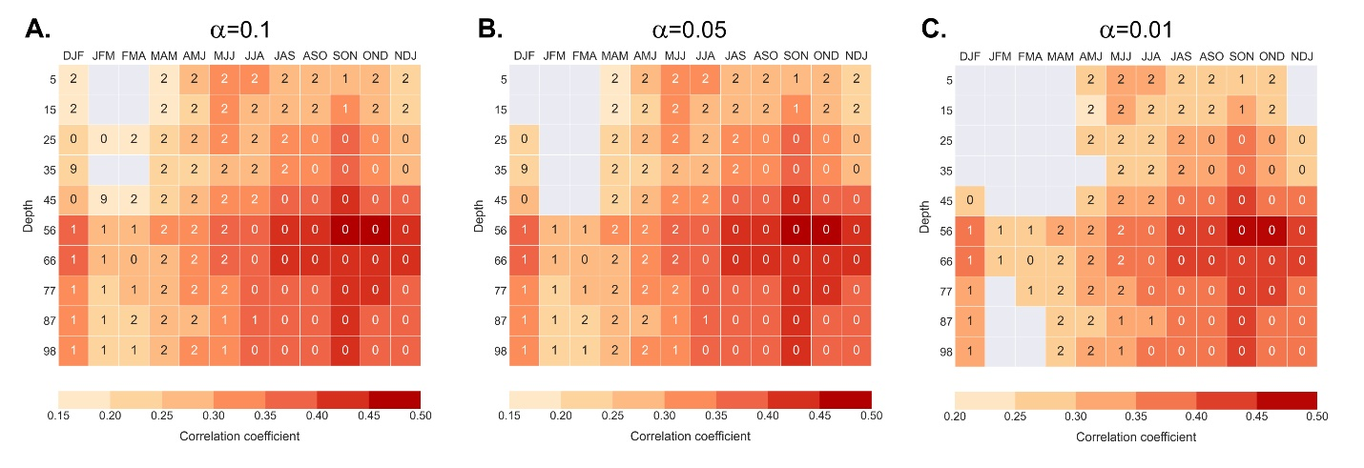

Figure S4. Multi-seasonal Pearson correlation analysis between the shell growth signal and subsurface salinity at the approximate collection site (66 °N, 18 °W) for 1900-2005. The correlation results are presented for different significance levels: (A) 90%, (B) 95% and (C) 99%. The correlation coefficients above the significance threshold are not shown (grey grids). The numbers represent the lag (yr) at which the maximum correlation occurs.
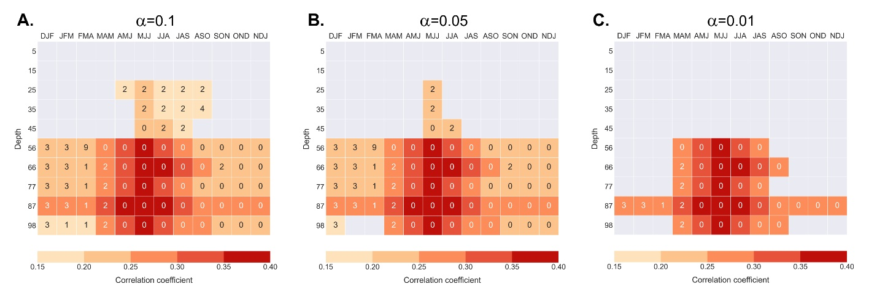

Figure S5. Seasonal salinity-depth profiles along a longitudinal transect (25 °W-15 °W; 66 °N). The transect is close to the shell collection site (black filled circle). The grey-shaded areas represent no available data.
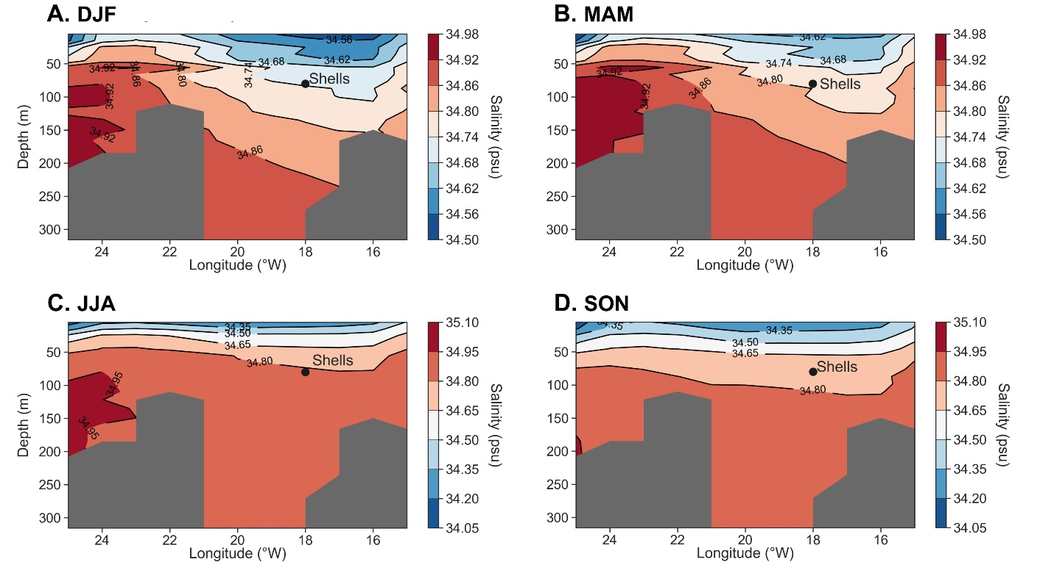

Figure S6. A 15-yr running correlation between the annually resolved master chronology and water temperature at 56 m depth during summer and autumn. Periods of decreased synchronization are shaded in grey.
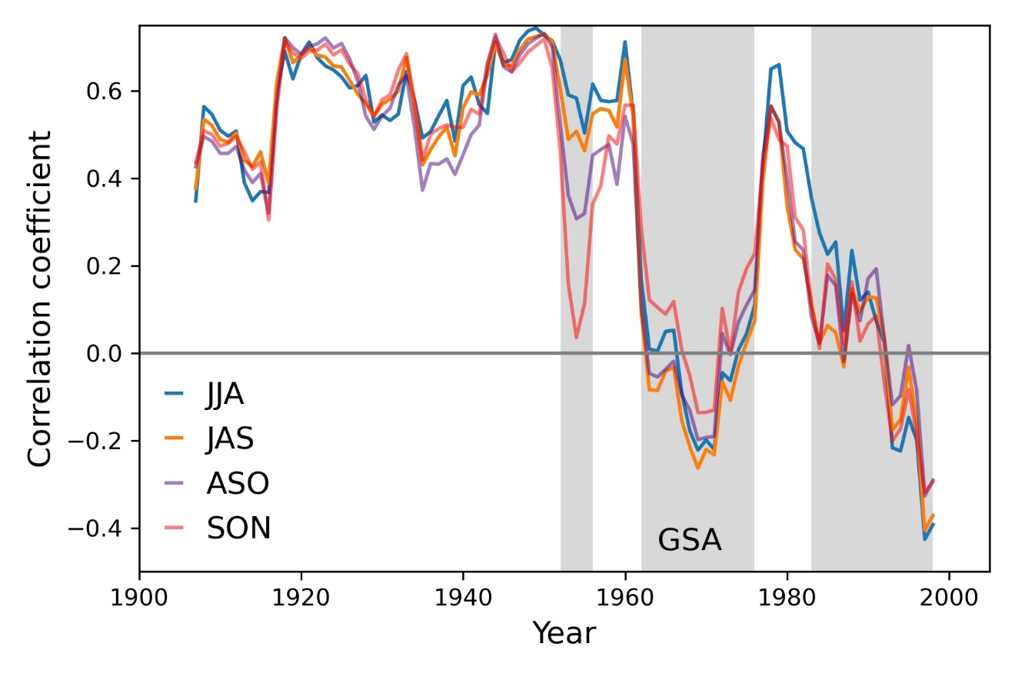

Figure S7. Salinity variability at 56 m depth during May-July (MJJ) for the 1900-2005 analysis period (grey line). Salinity values above 0 are characteristic for a more prominent influence of Atlantic waters, whereas values below 0 represent Arctic influences. The salinity time series was extracted from EN4.2.1 data at shell collection site (66° N, 18° W) and detrended and standardized. A 5-yr Savitsky-Golay (low-pass) filter was applied to the time series (blue line). The period of reduced synchrony with water temperature is shaded in grey.
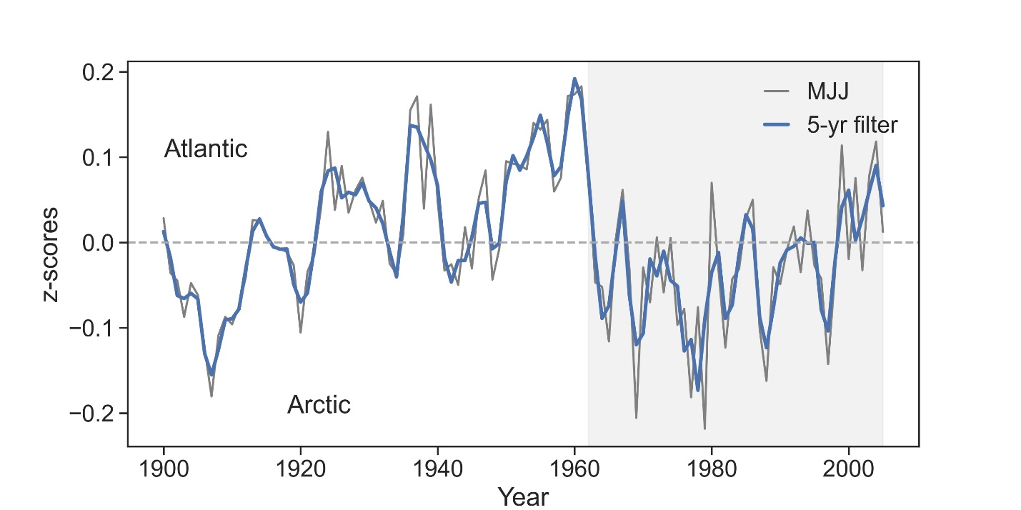

Figure S8. Depth-dependent seasonal variability of growth index time series at four different water depths (i.e., 5, 56, 66 and 77 m) for 1900-2005 analysis period. Color shading shows the Pearson correlation coefficient (p<0.05) between ARMC and seasonal salinity time series at each grid point.
