Instructions for part 2:

- We’d now like to show you a short video of a person explaining some simple guidelines when interacting with a cat. These are based around a ‘CAT’ acronym, which is explained on the other side of this sheet.

- If you would like a tea or coffee while you’re watching the video, please let us know!

- After watching the video, we’d then like you to follow these guidelines when you visit your final three cats.

- As before, please go into their pen and sit on the floor with your back against the door. Please remain in this position for the whole 5 minutes.

- Please refrain from touching the cat if they are hiding, and avoid picking them up.

- The researcher will leave you with the cat for 5 minutes, please stay with the cat in their pen until the researcher returns, even if the cat wanders off, is hiding, starts eating or using its litter tray.

- The researcher will be nearby in case you are feeling uncomfortable for any reason, or need assistance.

- There will be two small GoPro cameras recording the interaction, one pointing towards the back of the cat’s pen, the other pointing towards the front, so we can record both you and the cat.

P.T.O For interaction guidelines:

‘CAT’ INTERACTION GUIDELINES
C: Provide the cat with choice and control during the interaction.
- Gently offer your hand to the cat, allow the cat to approach you, and let them choose if they want to interact or not.
- If the cat wants to be touched, he or she will rub against you. If they don’t make contact, avoid stroking the cat
- Allow the cat to control how much you stroke them. If stroking the cat, briefly pause every 3-5 seconds to ‘check in’ with the cat – when you stop stroking them, do they rub against you to ask for more? If not, they may be ready for a break.
A: Pay attention to the cat’s behaviour and body language; the following are also signs that the cat may need a little break:
- The cat moves away from you
- Their ears become flattened or rotate backwards
- They shake their head
- The fur on their back appears to ripple
- They lick their nose
- They go a bit still, and stop purring or rubbing against you
- They sharply turn their head to face you or your hand
- They suddenly start grooming themselves, lasting only a few seconds
T: Think about where you’re touching the cat.
- Most friendly cats will prefer being touched under their chin, around their cheeks and at the base of their ears, so try to stick mainly to these areas.
- Avoid the base of the tail and tummy, and be cautious then touching the cat’s back, legs and tail – pay close attention to their body language to see if they appear comfortable.
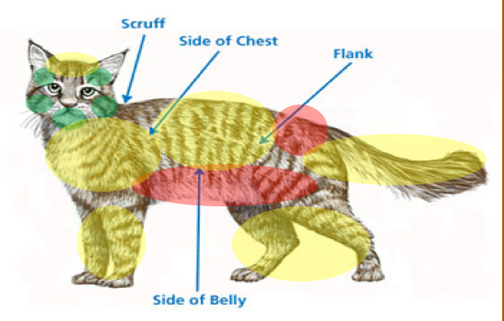
Green: Areas to focus on
Yellow: Some cats will like these areas being touched, some won’t. Pay close attention to the cat’s behaviour if touching these areas
Red: Most cats won’t like being touched here. Try to avoid touching these areas

