Supplementary Figure 1
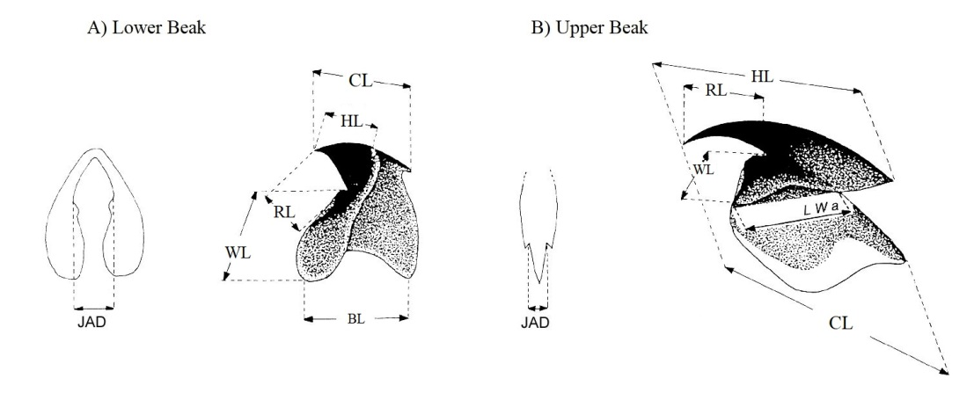

Supplementary Figure 1. Scheme of measurements taken from Lower Beak (A) and Upper Beak (B): Crest Length (CL), Hood Length (HL), Wing Length (WL), Rostrum Length (RL), Jaws Angle Distance (JAD), Baseline Length (BL), Lateral Wall amplitude (LWa), following Clarke, 1986.

Supplementary Figure 2

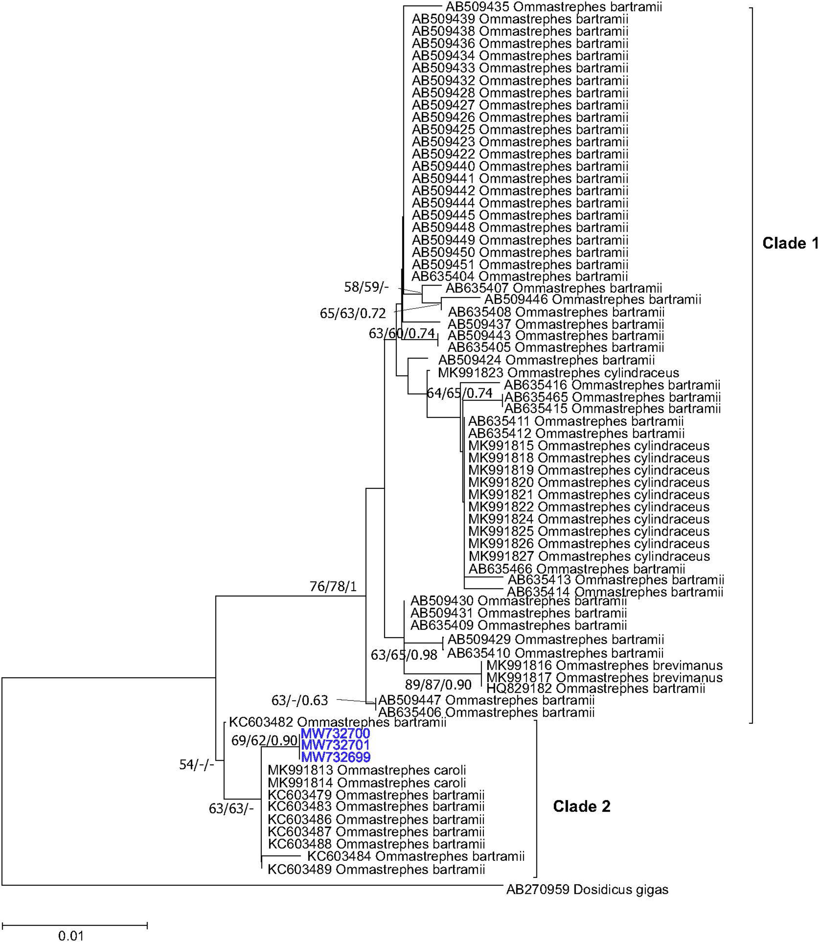
Supplementary Figure 2. Neighbour joining (NJ) phylogenetic tree of the 16s sequences. Near the nodes are the support values obtained for NJ, Maximum Likelihood (ML) and Bayesian (BA) trees, respectively. NJ and ML values refer to bootstrap while BA support are posterior probabilities. Codes in the tips of branches correspond to the GenBank Accession number of sequences (see main text for details). In blue, the sequences from individuals obtained in the present study.

Supplementary Figure 3
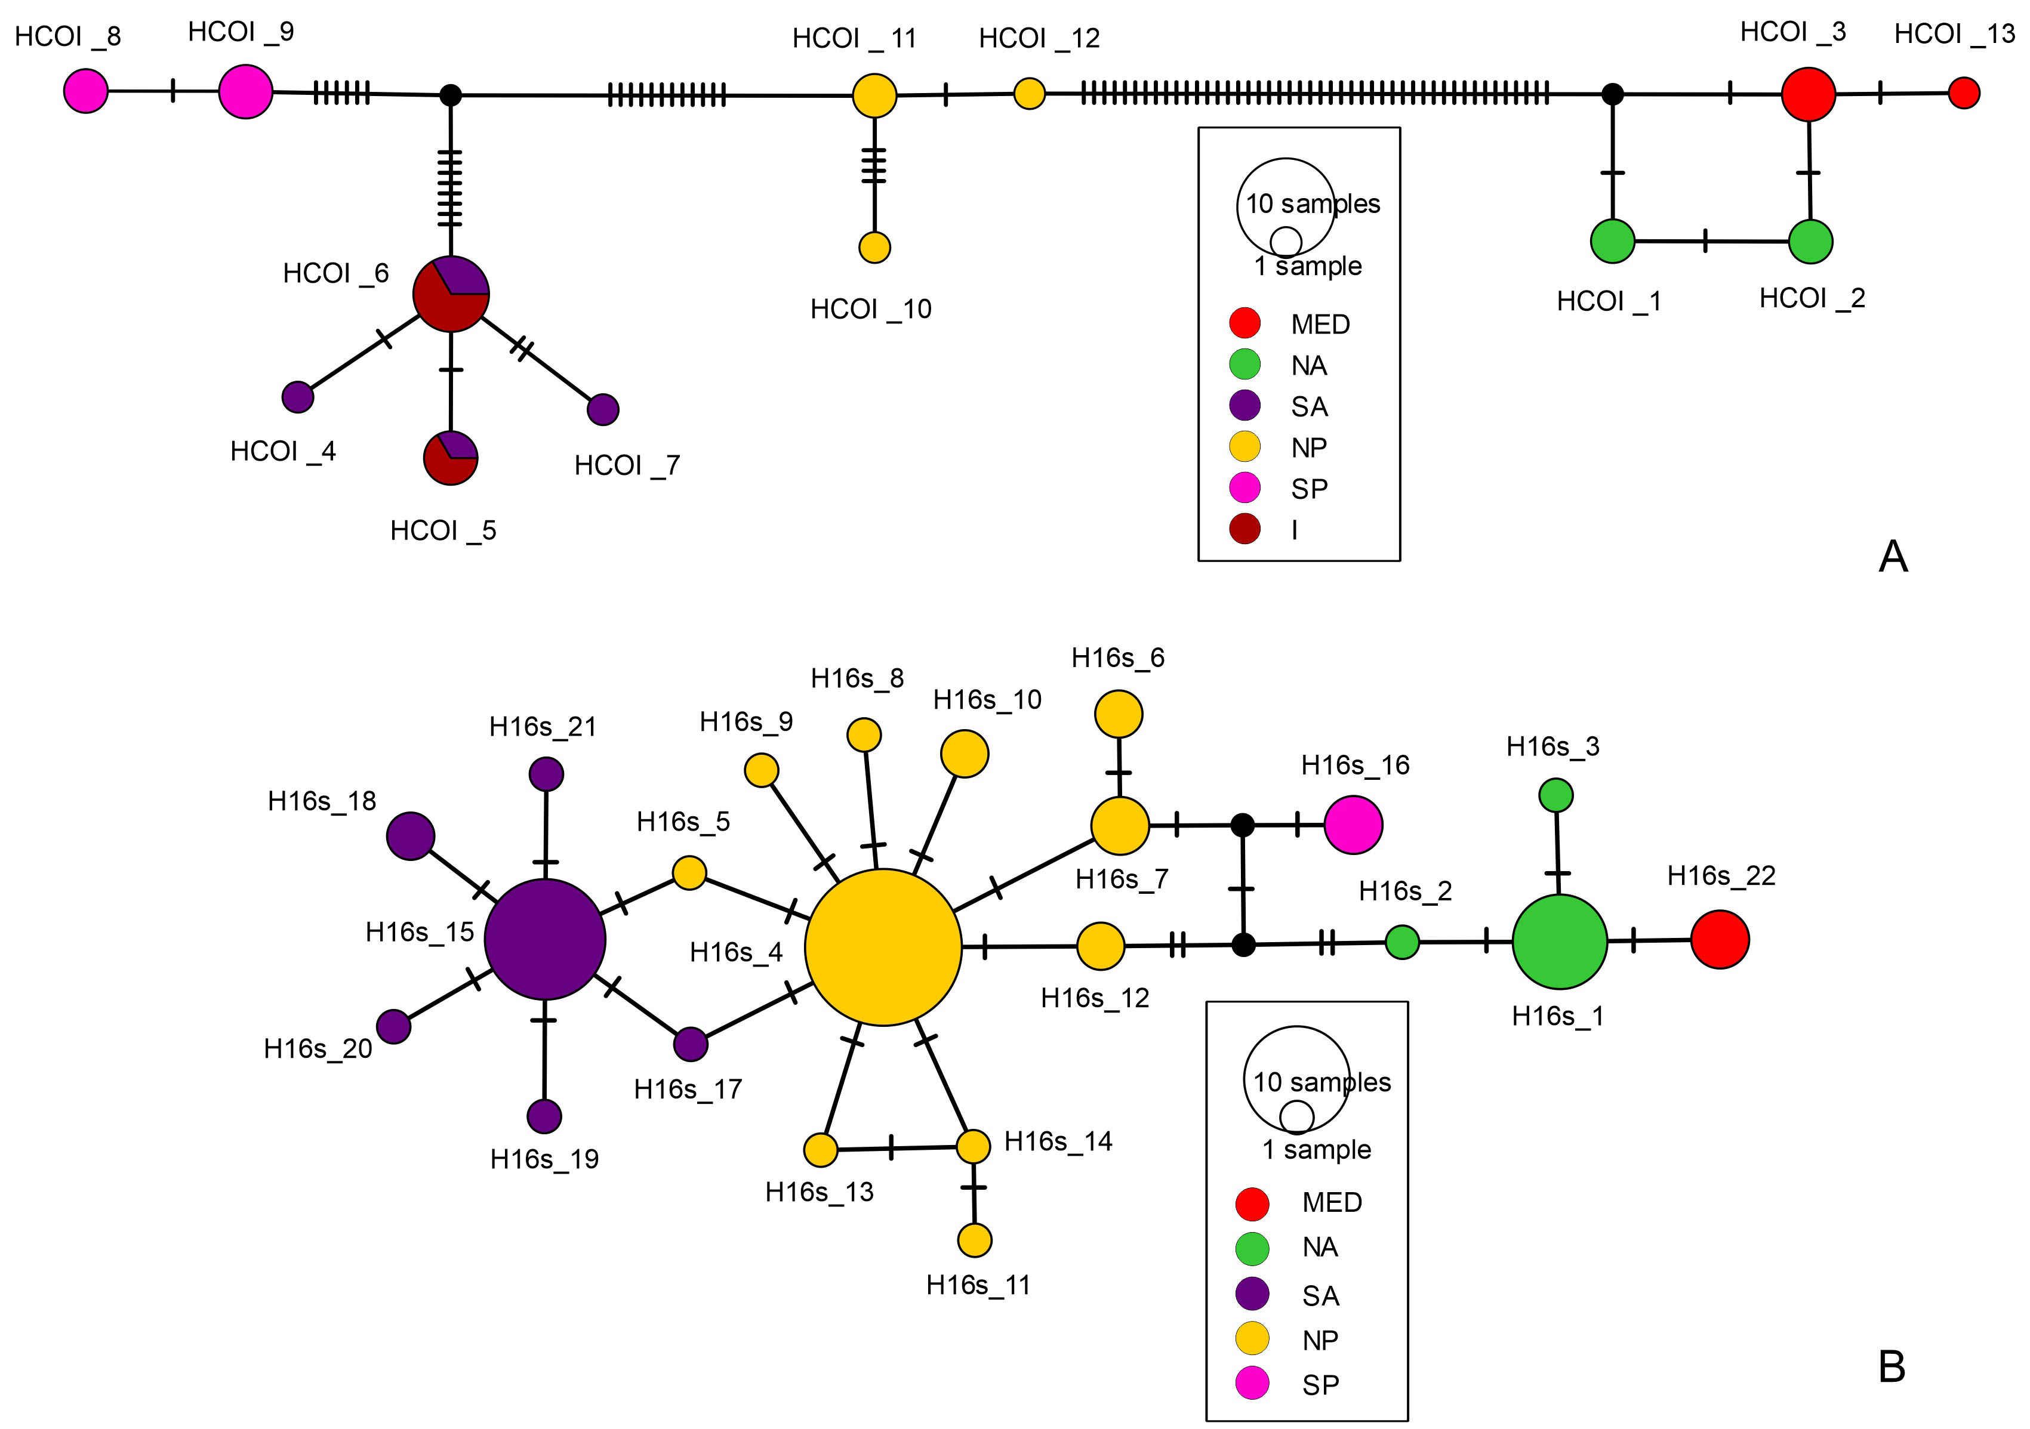

Supplementary Figure 3. Haplotype statistical parsimony networks constructed by the TCS function of PopART for each gene. The geographical origins of the samples are indicated on the legend. For GenBank records, the approximate geographical position was inferred when necessary. A) cytochrome c oxidase subunit I (COI). B) 16S rRNA (16S). Abbreviations: MED, Mediterranean Sea; NA, North Atlantic; SA, South Atlantic; NP, North Pacific; SP, South Pacific; I, Indian.

Supplementary Table 1
Details of the COI sequences analyzed in this study – haplotype, species as in GenBank, GenBank accession number, reference (when available), sampling location and consensus species.

Haplotype | Submitted GenBank | GenBank Accession | Reference | Sampling Location | Consensus species
HCOI_1 | Ommastrephes caroli | MK995129 | Fernández-Álvarez et al., 2020 | Atlantic Ocean:North | Ommastrephes caroli
HCOI_2 | Ommastrephes caroli | MK995128 | Fernández-Álvarez et al., 2020 | Atlantic Ocean:North | Ommastrephes caroli
HCOI_2 | Ommastrephes caroli | MK995127 | Fernández-Álvarez et al., 2020 | Atlantic Ocean:North | Ommastrephes caroli
HCOI_1 | Ommastrephes caroli | MK995126 | Fernández-Álvarez et al., 2020 | Atlantic Ocean:North | Ommastrephes caroli
HCOI_3 | Ommastrephes bartramii | KF212462 | Franjevic et al., 2015 | Mediterranean Sea - Croatia | Ommastrephes caroli
HCOI_4 | Ommastrephes sp. | MF980596 | Fernández-Álvarez et al., 2018 | Atlantic Ocean:South | Ommastrephes cylindraceus
HCOI_5 | Ommastrephes cylindraceus | MK995141 | Fernández-Álvarez et al., 2020 | Atlantic Ocean:South | Ommastrephes cylindraceus
HCOI_6 | Ommastrephes cylindraceus | MK995140 | Fernández-Álvarez et al., 2020 | Atlantic Ocean:South | Ommastrephes cylindraceus
HCOI_6 | Ommastrephes cylindraceus | MK995139 | Fernández-Álvarez et al., 2020 | Atlantic Ocean:South | Ommastrephes cylindraceus
HCOI_7 | Ommastrephes cylindraceus | MK995138 | Fernández-Álvarez et al., 2020 | Atlantic Ocean:South | Ommastrephes cylindraceus
HCOI_5 | Ommastrephes cylindraceus | MK995137 | Fernández-Álvarez et al., 2020 | Indian Ocean | Ommastrephes cylindraceus
HCOI_6 | Ommastrephes cylindraceus | MK995136 | Fernández-Álvarez et al., 2020 | Indian Ocean | Ommastrephes cylindraceus
HCOI_6 | Ommastrephes cylindraceus | MK995135 | Fernández-Álvarez et al., 2020 | Indian Ocean | Ommastrephes cylindraceus
HCOI_6 | Ommastrephes cylindraceus | MK995134 | Fernández-Álvarez et al., 2020 | Indian Ocean | Ommastrephes cylindraceus
HCOI_6 | Ommastrephes cylindraceus | MK995133 | Fernández-Álvarez et al., 2020 | Indian Ocean | Ommastrephes cylindraceus
HCOI_5 | Ommastrephes cylindraceus | MK995132 | Fernández-Álvarez et al., 2020 | Indian Ocean | Ommastrephes cylindraceus
HCOI_8 | Ommastrephes bartramii | HQ829183 | Unpublished | Pacific Ocean: South | Ommastrephes brevimanus
HCOI_8 | Ommastrephes bartramii | HQ829184 | Unpublished | Pacific Ocean: South | Ommastrephes brevimanus
HCOI_9 | Ommastrephes brevimanus | MK995130 | Fernández-Álvarez et al., 2020 | Pacific Ocean: South | Ommastrephes brevimanus
HCOI_9 | Ommastrephes brevimanus | MK995131 | Fernández-Álvarez et al., 2020 | Pacific Ocean: South | Ommastrephes brevimanus
HCOI_9 | Ommastrephes bartramii | MH347315 | Carrasco et al., 2019 | Pacific Ocean: South | Ommastrephes brevimanus
HCOI_10 | Ommastrephes bartramii | AF000057 | Carlini et al., 1999 | Pacific Ocean: North | Ommastrephes bartramii
HCOI_11 | Ommastrephes bartramii | AB199549 | Wakabayashi et al., 2006 | Pacific Ocean: North | Ommastrephes bartramii
HCOI_12 | Ommastrephes bartramii | AB199551 | Wakabayashi et al., 2006 | Pacific Ocean: North | Ommastrephes bartramii
HCOI_11 | Ommastrephes bartramii | AB270941 | Wakabayashi et al., 2012a | Pacific Ocean: North | Ommastrephes bartramii
HCOI_3 | Ommastrephes sp 2006 | MW752851 | present study | Mediterranean Sea - Sardinia | Ommastrephes caroli
HCOI_13 | Ommastrephes sp 2012 | MW752850 | present study | Mediterranean Sea - Sardinia | Ommastrephes caroli
HCOI_3 | Ommastrephes sp 2014 | MW752849 | present study | Mediterranean Sea - Sardinia | Ommastrephes caroli
outgroup | Dosidicus gigas | AB270944 | Wakabayashi et al., 2012a | Pacific Ocean | OUTGROUP

Supplementary Table 2
Details of the 16S sequences analyzed in this study – haplotype, species as in GenBank, GenBank accession number, reference (when available), sampling location and consensus species.

Haplotype | Submitted GenBank | GenBank Accession | Reference | Sampling Location | Consensus species
H16s_1 | Ommastrephes caroli | MK991813 | Fernández-Álvarez et al., 2020 | Atlantic Ocean: North | Ommastrephes caroli
H16s_1 | Ommastrephes caroli | MK991814 | Fernández-Álvarez et al., 2020 | Atlantic Ocean: North | Ommastrephes caroli
H16s_1 | Ommastrephes bartramii | KC603479 | Alonso et al., 2014 | Atlantic Ocean: North | Ommastrephes caroli
H16s_2 | Ommastrephes bartramii | KC603482 | Alonso et al., 2014 | Atlantic Ocean: North | Ommastrephes caroli
H16s_1 | Ommastrephes bartramii | KC603483 | Alonso et al., 2014 | Atlantic Ocean: North | Ommastrephes caroli
H16s_3 | Ommastrephes bartramii | KC603484 | Alonso et al., 2014 | Atlantic Ocean: North | Ommastrephes caroli
H16s_1 | Ommastrephes bartramii | KC603486 | Alonso et al., 2014 | Atlantic Ocean: North | Ommastrephes caroli
H16s_1 | Ommastrephes bartramii | KC603487 | Alonso et al., 2014 | Atlantic Ocean: North | Ommastrephes caroli
H16s_1 | Ommastrephes bartramii | KC603488 | Alonso et al., 2014 | Atlantic Ocean: North | Ommastrephes caroli
H16s_1 | Ommastrephes bartramii | KC603489 | Alonso et al., 2014 | Atlantic Ocean: North | Ommastrephes caroli
H16s_4 | Ommastrephes bartramii | AB509422 | Unpublished | Pacific Ocean: North | Ommastrephes bartramii
H16s_4 | Ommastrephes bartramii | AB509423 | Unpublished | Pacific Ocean: North | Ommastrephes bartramii
H16s_5 | Ommastrephes bartramii | AB509424 | Unpublished | Pacific Ocean: North | Ommastrephes bartramii
H16s_4 | Ommastrephes bartramii | AB509425 | Unpublished | Pacific Ocean: North | Ommastrephes bartramii
H16s_4 | Ommastrephes bartramii | AB509426 | Unpublished | Pacific Ocean: North | Ommastrephes bartramii
H16s_4 | Ommastrephes bartramii | AB509427 | Unpublished | Pacific Ocean: North | Ommastrephes bartramii
H16s_4 | Ommastrephes bartramii | AB509428 | Unpublished | Pacific Ocean: North | Ommastrephes bartramii
H16s_6 | Ommastrephes bartramii | AB509429 | Unpublished | Pacific Ocean: North | Ommastrephes bartramii
H16s_7 | Ommastrephes bartramii | AB509430 | Unpublished | Pacific Ocean: North | Ommastrephes bartramii
H16s_7 | Ommastrephes bartramii | AB509431 | Unpublished | Pacific Ocean: North | Ommastrephes bartramii
H16s_4 | Ommastrephes bartramii | AB509432 | Unpublished | Pacific Ocean: North | Ommastrephes bartramii
H16s_4 | Ommastrephes bartramii | AB509433 | Unpublished | Pacific Ocean: North | Ommastrephes bartramii
H16s_4 | Ommastrephes bartramii | AB509434 | Unpublished | Pacific Ocean: North | Ommastrephes bartramii
H16s_8 | Ommastrephes bartramii | AB509435 | Unpublished | Pacific Ocean: North | Ommastrephes bartramii
H16s_4 | Ommastrephes bartramii | AB509436 | Unpublished | Pacific Ocean: North | Ommastrephes bartramii
H16s_9 | Ommastrephes bartramii | AB509437 | Unpublished | Pacific Ocean: North | Ommastrephes bartramii
H16s_4 | Ommastrephes bartramii | AB509438 | Unpublished | Pacific Ocean: North | Ommastrephes bartramii
H16s_4 | Ommastrephes bartramii | AB509439 | Unpublished | Pacific Ocean: North | Ommastrephes bartramii
H16s_4 | Ommastrephes bartramii | AB509440 | Unpublished | Pacific Ocean: North | Ommastrephes bartramii
H16s_4 | Ommastrephes bartramii | AB509441 | Unpublished | Pacific Ocean: North | Ommastrephes bartramii
H16s_4 | Ommastrephes bartramii | AB509442 | Unpublished | Pacific Ocean: North | Ommastrephes bartramii
H16s_10 | Ommastrephes bartramii | AB509443 | Unpublished | Pacific Ocean: North | Ommastrephes bartramii
H16s_4 | Ommastrephes bartramii | AB509444 | Unpublished | Pacific Ocean: North | Ommastrephes bartramii
H16s_4 | Ommastrephes bartramii | AB509445 | Unpublished | Pacific Ocean: North | Ommastrephes bartramii
H16s_11 | Ommastrephes bartramii | AB509446 | Unpublished | Pacific Ocean: North | Ommastrephes bartramii
H16s_12 | Ommastrephes bartramii | AB509447 | Unpublished | Pacific Ocean: North | Ommastrephes bartramii
H16s_4 | Ommastrephes bartramii | AB509448 | Unpublished | Pacific Ocean: North | Ommastrephes bartramii
H16s_4 | Ommastrephes bartramii | AB509449 | Unpublished | Pacific Ocean: North | Ommastrephes bartramii
H16s_4 | Ommastrephes bartramii | AB509450 | Unpublished | Pacific Ocean: North | Ommastrephes bartramii
H16s_4 | Ommastrephes bartramii | AB509451 | Unpublished | Pacific Ocean: North | Ommastrephes bartramii
H16s_4 | Ommastrephes bartramii | AB635404 | Wakabayashi et al., 2012b | Pacific Ocean: North | Ommastrephes bartramii
H16s_10 | Ommastrephes bartramii | AB635405 | Wakabayashi et al., 2012b | Pacific Ocean: North | Ommastrephes bartramii
H16s_12 | Ommastrephes bartramii | AB635406 | Wakabayashi et al., 2012b | Pacific Ocean: North | Ommastrephes bartramii
H16s_13 | Ommastrephes bartramii | AB635407 | Wakabayashi et al., 2012b | Pacific Ocean: North | Ommastrephes bartramii
H16s_14 | Ommastrephes bartramii | AB635408 | Wakabayashi et al., 2012b | Pacific Ocean: North | Ommastrephes bartramii
H16s_7 | Ommastrephes bartramii | AB635409 | Wakabayashi et al., 2012b | Pacific Ocean: North | Ommastrephes bartramii
H16s_6 | Ommastrephes bartramii | AB635410 | Wakabayashi et al., 2012b | Pacific Ocean: North | Ommastrephes bartramii
H16s_15 | Ommastrephes bartramii | AB635411 | Wakabayashi et al., 2012b | Atlantic Ocean: South | Ommastrephes cylindraceus
H16s_15 | Ommastrephes bartramii | AB635412 | Wakabayashi et al., 2012b | Atlantic Ocean: South | Ommastrephes cylindraceus
H16s_15 | Ommastrephes cylindraceus | MK991815 | Fernández-Álvarez et al., 2020 | Atlantic Ocean: South | Ommastrephes cylindraceus
H16s_16 | Ommastrephes brevimanus | MK991816 | Fernández-Álvarez et al., 2020 | Pacific Ocean: South | Ommastrephes brevimanus
H16s_16 | Ommastrephes brevimanus | MK991817 | Fernández-Álvarez et al., 2020 | Pacific Ocean: South | Ommastrephes brevimanus
H16s_15 | Ommastrephes cylindraceus | MK991818 | Fernández-Álvarez et al., 2020 | Atlantic Ocean: South | Ommastrephes cylindraceus
H16s_15 | Ommastrephes cylindraceus | MK991819 | Fernández-Álvarez et al., 2020 | Atlantic Ocean: South | Ommastrephes cylindraceus
H16s_15 | Ommastrephes cylindraceus | MK991820 | Fernández-Álvarez et al., 2020 | Atlantic Ocean: South | Ommastrephes cylindraceus
H16s_15 | Ommastrephes cylindraceus | MK991821 | Fernández-Álvarez et al., 2020 | Atlantic Ocean: South | Ommastrephes cylindraceus
H16s_15 | Ommastrephes cylindraceus | MK991822 | Fernández-Álvarez et al., 2020 | Atlantic Ocean: South | Ommastrephes cylindraceus
H16s_17 | Ommastrephes cylindraceus | MK991823 | Fernández-Álvarez et al., 2020 | Atlantic Ocean: South | Ommastrephes cylindraceus
H16s_15 | Ommastrephes cylindraceus | MK991824 | Fernández-Álvarez et al., 2020 | Atlantic Ocean: South | Ommastrephes cylindraceus
H16s_15 | Ommastrephes cylindraceus | MK991825 | Fernández-Álvarez et al., 2020 | Atlantic Ocean: South | Ommastrephes cylindraceus
H16s_15 | Ommastrephes cylindraceus | MK991826 | Fernández-Álvarez et al., 2020 | Atlantic Ocean: South | Ommastrephes cylindraceus
H16s_15 | Ommastrephes cylindraceus | MK991827 | Fernández-Álvarez et al., 2020 | Atlantic Ocean: South | Ommastrephes cylindraceus
H16s_18 | Ommastrephes bartramii | AB635465 | Unpublished | Atlantic Ocean: South | Ommastrephes cylindraceus
H16s_15 | Ommastrephes bartramii | AB635466 | Unpublished | Atlantic Ocean: South | Ommastrephes cylindraceus
H16s_19 | Ommastrephes bartramii | AB635413 | Wakabayashi et al., 2012b | Atlantic Ocean: South | Ommastrephes cylindraceus
H16s_20 | Ommastrephes bartramii | AB635414 | Wakabayashi et al., 2012b | Atlantic Ocean: South | Ommastrephes cylindraceus
H16s_18 | Ommastrephes bartramii | AB635415 | Wakabayashi et al., 2012b | Atlantic Ocean: South | Ommastrephes cylindraceus
H16s_21 | Ommastrephes bartramii | AB635416 | Wakabayashi et al., 2012b | Atlantic Ocean: South | Ommastrephes cylindraceus
H16s_16 | Ommastrephes bartramii | HQ829182 | Unpublished | Pacific Ocean: South | Ommastrephes brevimanus
H16s_22 | Ommastrephes sp 2006 | MW732699 | present study | Mediterranean Sea - Sardinia | Ommastrephes caroli
H16s_22 | Ommastrephes sp 2012 | MW732700 | present study | Mediterranean Sea - Sardinia | Ommastrephes caroli
H16s_22 | Ommastrephes sp 2014 | MW732701 | present study | Mediterranean Sea - Sardinia | Ommastrephes caroli
outgroup | Dosidicus gigas | AB270959 | Wakabayashi et al., 2012° | Pacific Ocean | OUTGROUP

Supplementary Table 3
Relationships between the beak measurements and body sizes in Ommastrephes caroli
Power model relationship  DML/beak | R² | Power model relationship  TW/beak | R²
DML = 36.802LCL^{0.8241} | 0.69 | TW = 1.1106LCL^{0.6257} | 0.7265
DML = 84.159LHL^{0.7535} | 0.4985 | TW = 15.878LHL^{2.3902} | 0.5203
DML = 36.165LRL^{1.094} | 0.9185 | TW = 1.2652LRL^{3.4078} | 0.9244
DML=68.024LWL^{0.6915} | 0.6971 | TW= 6.47LWL^{2.271} | 0.7799
DML = 51.29LBL^{0.6752} | 0.6328 | TW = 3.4985LBL^{2.1245} | 0.6498
DML = 101.45LJAD^{0.6754} | 0.641 | TW = 32.041LJAD^{2.0957} | 0.6403
DML = 15.596UCL^{0.9037} | 0.8061 | TW = 0.0777UCL^{2.8596} | 0.8371
DML = 15.821UHL^{0.9526} | 0.8565 | TW = 0.0891UHL^{2.989} | 0.8746
DML = 69.843URL^{0.7591} | 0.6163 | TW = 11.587URL^{2.3009} | 0.5872
DML = 97.363UWL^{0.6818} | 0.6168 | TW = 25.185UWL^{2.1633} | 0.644
DML = 74.45ULWA^{0.6265} | 0.6986 | TW = 14.051LWA^{1.8992} | 0.6659
DML = 71.347UJAD^{0.8756} | 0.7383 | TW = 8.7755UJAD^{2.8088} | 0.788

References
Alonso, H., Granadeiro, J.P., Waap, S., Xavier, J., Symondson, W.O., Ramos, J.A. et al. (2014). An holistic ecological analysis of the diet of Cory's shearwaters using prey morphological characters and DNA barcoding. Mol. Ecol. 23(15), 3719-3733. doi: 10.1111/mec.12785.

Carlini, D.B., and Graves, J.E. (1999). Phylogenetic analysis of cytochrome c oxidase I sequences to determine higher-level relationships within the coleoid cephalopods. Bull. Mar. Sci. 64(1), 57-76.

Carrasco, S.A., Meerhoff, E., Yannicelly, B., and Ibáñez, C.M. (2019). First Records and Descriptions of Early Life Stages of Cephalopods from Rapa Nui (Easter Island) and the Nearby Apolo Seamount. Pac. Sci. 73(1), 163-175. doi: 10.2984/73.1.8
Clarke, M.R. (1986). A Handbook for the Identification of Cephalopod Beaks. Mar. Biol. Assoc. U.K. Plymouth: Clarendon Press: Oxford.
Fernández-Álvarez, F.Á., Braid, H.E., Nigmatullin, Ch.M., Bolstad, K.S.R., Haimovici, M., Sánchez P. et al. (2020). Global biodiversity of the genus Ommastrephes (Ommastrephidae: Cephalopoda): an allopatric cryptic species complex. Zool. J. Linn. Soc. 190(2), 460-482. doi: 10.1093/zoolinnean/zlaa014
Fernández-Álvarez, F.Á., Machordom, A., García-Jiménez, R., Salinas-Zavala, C.A., and Villanueva, R. (2018). Predatory flying squids are detritivores during their early planktonic life. Sci. Rep. 8(1): 3440. doi: 10.1038/s41598-018-21501-y
Franjević, D., Skaramuca, D., Katavić, V., Rajević, N., and Skaramuca, B. (2015). Genetic Identification of a Rare Record of Ommastrephes bartramii (Cephalopoda: Ommastrephidae) from the Eastern Adriatic Sea. Folia Biol. (Kraków). 63(1), 19-23. doi: 10.3409/fb63_1.19

Wakabayashi, T., Suzuki, N., Sakai, M., Ichii, T., and Chow, S. (2006). Identification of ommastrephid squid paralarvae collected in northern Hawaiian waters and phylogenetic implications for the family Ommastrephidae using mtDNA analysis. Fish. Sci. 72(3), 494-502. doi: 10.1111/j.1444-2906.2006.01177.x
Wakabayashi, T., Suzuki, N., Sakai, M., Ichii, T., and Chow, S. (2012a). Phylogenetic relationships among the family Ommastrephidae (Mollusca: Cephalopoda) inferred from two mitochondrial DNA gene sequences. Mar. Genom. 7, 11-16. doi: 10.1016/j.margen.2012.04.005
Wakabayashi, T., Wada, S., Ochi, Y., Ichii, T., and Sakai, M. (2012b). Genetic differentiation of the neon flying squid Ommastrephes bartramii between north Pacific and south Atlantic populations. Nippon Suisan Gakk. 78, 198-203.

