Supplementary Material

Supplementary Methods

Detailed Ship-board Sampling
Microplastics were collected using the non-contaminated seawater inlet at 7m below the sea surface in the hull of the CCGS Amundsen, during leg3b of Arctic Net 2018 (August-September). The seawater system continuously pumped water under pressure through a stainless-steel inlet at the bow of the ship and through a strainer with a mesh 20 (841µm) to keep out mesoplastics and other debris from entering the system. Temperature, salinity, and flow rate were measured with an inline thermosalinograph (TSG) and flowmeter prior to being pumped to separate lab outlets. In the laboratory, a splitter was used to divert the water through polycarbonate tubing and through a bespoke microplastics sampling system (Figure S1).
Rather than collecting microplastics through one stainless steel sieve, tubing was used to direct the flow of water down through a small opening in an otherwise sealed off cylindrical aluminium modular tower. This served to position three nylon filters of increasing pore size above one another (50, 100 and 300 µm), by clamping them between each module of the tower (Figure S1). Each filter was a square-cut 120 mm piece of nylon mesh, replaced for each transect and larger than the diameter of the modules (100 mm). The clamping of each filter between two modules was achieved by recessing the base of each module to slot inside, and screw fastening, ensuring the filters were held taut. The modules were sufficiently tall to allow some retention of water within each module should the flow rate be slow. The inline flowmeter registered the flowrate and was subsequently minute-integrated (S2, tsg data). The outlet tap was only slightly opened so that the flow rate in the laboratory was manually measured and found to be consistently 2.4 times slower than the inline flowmeter recording. This enabled the average flow rate (0.43 L/min) of water directed through the microplastic sampling system to be calculated (S1, Table 2).
At the start of each transect the polycarbonate tube was connected to the system to run continuously. Transects ended when either the water in the finest filter (50 µm) became saturated with particulate matter, evidenced by the discolouration of the filter, or by any fatiguing of the filter which may suggest retention of water in the module. This latter condition was evidenced by the overhang of the filter being reduced in size by at least 5 mm in any direction. The tubing was then disconnected, and the system left in place for any residual water to drain though. Each module was removed in sequence, from top to bottom, rinsing down the inside of each module with Mili-Q water, concentrating any residual particulate onto each respective filter. The filters were removed and handled carefully with nitrile gloves, only holding the corners, and folding together in half. These were then sealed individually in aluminum foil and each transect in sample bags and frozen at -20˚C; a quick process which limited exposure to airborne contamination.
Figure S1: Schematic sketch of the microplastics collection system. Seawater was collected from an inlet in the hull of the CCGS Amundsen, at 7m below the sea surface. The water passed through a strainer (A) and a series of instruments to measure the water’s properties, including a flowmeter (B). A pump (C) directed flow to different laboratory outlets. A splitter was used to direct flow from an outlet (D) into the microplastics sampling system via polycarbonate tubing affixed to a small opening on the otherwise, sealed system (F). The blue arrow indicates the direction of water flow, through the nylon mesh filters. The aluminium modules were inset to enable mesh filters to be clamped together and were secured with screw-holds (G). Plastic suckers (H) fastened the collection system to the basin.

Concentration Calculations using correction factors
Concentrations of plastics have been normalized per Litre. The total concentration of plastics for each transect comprises the particle and fibre component separately as per the process below:
Plastic Particles = $\frac{(Confirmed Plastic Particles + Estimated Plastic Particles) }{Volume Sampled \left(Litres\right)for fitler x}$ [Eqn 1]
Whereby:
            - T otal Particle Count = Number of particles on all mesh from transect x.
            - Measured Particle Count = Number of particles measured with FTIR
            - Confirmed Plastic Particle Count = Number of particles with positive plastic identification from the measured count
            - Plastic Particle Fraction = $\frac{Confirmed Plastic Particles}{Measured Particle Count}$
            - Estimated Plastic Particle Count = $Plastic Particle Fraction X \left(Total Count-Measured Count\right)$
Plastic Fibre concentrations include an element of correction, owing to the presences of fibres in the procedural blank (see supplementary data, table xx) and fibres on air contamination filters.
Air contamination filters were opened and closed at the start of each laboratory day. This means that each air contamination filter represents the potential air contamination shared amongst the filters analysed in any given day. A sub-sample of fibres from the air contamination filter were measured using FTIR and were found to be a mix of plastic and cellulose derived (Table 3b). The following is assumed however:
The composition of the fibres are unknown, as with the initial total count of all fibres on each transect. Taking a precautionary approach, one assumes that all of the fibres from the contamination filter are potentially plastic and therefore must be subtracted as per equation 2 and 3:
Plastic Fibres = $\frac{Estimated Plastic}{Volume Sampled \left(Litres\right)for filter x}$ [Eqn 2]
Whereby:
- Total Fibre Count = Number of fibres on all mesh from transect x.
- Air Contamination Factor = $\frac{Total Number of fibres on air contamination filter x }{Number of sample filters measured in day x}$
- Procedural Blank Count = 5
- Corrected Count = Total Count – Air Contamination Factor– Procedural Blank Count
- Measured Fibre Count = Number of fibres measured with FTIR
- Plastic Fibre Fraction = $\frac{Confirmed Plastic Fibres}{Measured Fibre Count }$
- Estimated Plastic Fibre Count = Plastic Fibre Fraction X Corrected Count
The total plastic concentration is therefore the sum of Eqn 1 and Eqn 2. The input and outputs from these calculations are provided in tables 3a and 3b in supplementary results.

Greywater Microfibre calculation
Using the following:
- Vard (2018) and EPA (2006) estimate that 17% of 33,438,239 L of greywater entering the Canadian Arctic/year is laundry effluent based on 2016 figures:
33,438,239 * 0.17 = 5,684,510 L of laundry effluent from Canadian Arctic Shipping in 2016.
- Napper and Thompson (2016) estimate 137,951 - 728,789 fibres per 6kg load. The washing machine tested was chosen based on it have an energy consumption and therefore water useage representative of the average washing machine. 6kg load discharges approximately 49L of water in the load:
137,951 - 728,789 fibres/ 49 L = 2,815 fibres/L – 14,873 fibres/L
- To calculate minimum value we assume, based on our study that only 23.8% of fibres are plastic:
Minimum: 2,815 fibres/L * 0.238 * 5,684,510 L= 3,808,451,165 microfibres per year into the Canadian Arctic
- To calculate maximum value we assume all fibres are plastic:
Maximum: 14,873 fibres/L * 5,684,510 L= 84,545,717,230 microfibres per year into the
Canadian Arctic

Supplementary Results

Additional Data Tables
Transect start times, finishes and intervals are provided in table 1.
Table 1: Locations and times for transect start time and finish time
Transect | Date (ddmmyyyy) | Time (hh:mm:ss) | LAT | LON | Microplastics Sampling System
1 | 18/08/2018 | 11:48:00 | 72.75007 | -96.141 | On
1 | 18/08/2018 | 22:15:00 | 71.42274 | -97.8857 | Off
2 | 18/08/2018 | 22:17:00 | 71.41553 | -97.897 | On
2 | 19/08/2018 | 13:17:00 | 69.18326 | -100.676 | Off
2 | 19/08/2018 | 17:58:00 | 69.04202 | -101.07 | On
2 | 19/08/2018 | 19:45:00 | 68.71699 | -101.301 | Off
3 | 19/08/2018 | 19:58:00 | 68.6714 | -101.299 | On
3 | 20/08/2018 | 03:00:00 | 68.64412 | -98.4188 | Off
4 | 20/08/2018 | 20:04:00 | 68.55367 | -95.8583 | On
4 | 21/08/2018 | 20:36:00 | 68.79052 | -105.057 | Off
5 | 23/08/2018 | 00:18:00 | 69.43489 | -100.116 | On
5 | 23/08/2018 | 14:20:00 | 71.54069 | -97.5546 | Off
6 | 24/08/2018 | 01:50:00 | 73.00641 | -96.2385 | On
6 | 24/08/2018 | 22:45:00 | 73.24376 | -89.738 | Off
7 | 25/08/2018 | 01:37:00 | 72.55693 | -90.2676 | On
7 | 25/08/2018 | 12:20:00 | 69.96615 | -90.2328 | Off
8 | 27/08/2018 | 03:36:00 | 74.5004 | -80.548 | On
8 | 27/08/2018 | 16:05:00 | 76.21278 | -78.3426 | Off
9 | 27/08/2018 | 17:55:00 | 76.45536 | -78.7292 | On
9 | 28/08/2018 | 00:01:00 | 76.38463 | -77.3931 | Off
9 | 28/08/2018 | 03:56:00 | 76.39956 | -77.4126 | On
9 | 28/08/2018 | 15:19:00 | 77.20672 | -76.0491 | Off
10 | 28/08/2018 | 15:34:00 | 77.16508 | -76.0439 | On
10 | 29/08/2018 | 05:00:00 | 76.33669 | -71.2014 | Off
11 | 29/08/2018 | 08:55:00 | 76.3294 | -71.137 | On
11 | 29/08/2018 | 17:48:00 | 74.97209 | -69.7855 | Off
12 | 30/08/2018 | 14:05:00 | 70.93536 | -66.2968 | On
12 | 30/08/2018 | 22:05:00 | 69.34313 | -65.1427 | Off
13 | 31/08/2018 | 00:06:00 | 69.0631 | -64.9658 | On
13 | 31/08/2018 | 12:30:00 | 67.55321 | -64.0727 | Off
14 | 01/09/2018 | 20:45:00 | 67.47904 | -63.507 | On
14 | 02/09/2018 | 05:10:00 | 66.4982 | -60.9059 | Off
15 | 02/09/2018 | 17:45:00 | 66.56015 | -61.666 | On
15 | 02/09/2018 | 22:00:00 | 66.52834 | -61.631 | Off
16 | 03/09/2018 | 15:16:00 | 66.42205 | -61.2734 | On
16 | 03/09/2018 | 20:05:00 | 65.49683 | -61.7292 | Off

Volumes were calculated based on the fact that the registered flowrate from the TSG_flowmeter was 2.4 times greater than the manually measured flow from the outlet in the ship laboratory.
Table 2: Average Ocean Parameters and Ship Parameters for each transect
Transect Number | Volume Sample (Litres) | Mean Flow Rate  (L/min) | Mean Ship speed  (knots) | Average Temp  (Deg C) | Average Salinity | Depth
1 | 311.733 | 0.496 | 5.230978 | -0.64 | 23.62 | 64
2 | 627.913 | 0.622 | 5.618534 | -0.033 | 25.58 | 64
3 | 252.871 | 0.597 | 6.817182 | 3.467 | 22.09 | 35
4 | 1163.487 | 0.79 | 4.914868 | 3.418 | 22.3 | 66
5 | 634.6 | 0.753 | 5.650402 | -0.542 | 25.4 | 65
6 | 890.333 | 0.709 | 6.443504 | -0.462 | 25.93 | 53
7 | 311.483 | 0.484 | 7.780418 | 1.256 | 29.39 | 110
8 | 320.367 | 0.427 | 5.193456 | 2.246 | 31.97 | 662
9 | 289.221 | 0.275 | 3.545058 | -0.403 | 29.19 | 347
10 | 132.854 | 0.165 | 4.4461 | 1.014 | 29.57 | 352
11 | 88.363 | 0.165 | 5.15542 | 3.426 | 31.56 | 553
12 | 468.771 | 0.329 | 6.362806 | 3.541 | 30.83 | 651
13 | 196.933 | 0.264 | 3.917708 | 2.27 | 29.64 | 651
14 | 155.325 | 0.307 | 6.028706 | 1.527 | 30.12 | 680
15 | 45.808 | 0.179 | 3.316842 | 0.708 | 30.3 | 683
16 | 92.4 | 0.319 | 6.113516 | 0.976 | 30.34 | 163

Table 3 Values assigned to non-numeric parameters (Ice extent, Current Strength, Shipping)
 | Qualitative descriptor |  |  | Assigned Value
Transect | Current | Traffic | Ice | Current_1 | Traffic_1 | Ice_1
1 | Fair | Significant Increase | Present | 1 | 3 | 1
2 | Fair | Significant increase | Present | 1 | 3 | 1
3 | Fair | Significant increase | Absent | 1 | 3 | 0
4 | Fair | Significant increase | Absent | 1 | 3 | 1
5 | Fair | Increased | Present | 1 | 2 | 1
6 | Moderate | Increased | Present | 2 | 2 | 1
7 | Fair | Stable | Absent | 1 | 1 | 0
8 | Moderate | Increase | Present | 2 | 2 | 1
9 | Strong | Stable | Present | 3 | 1 | 1
10 | Strong | Stable | Absent | 3 | 1 | 0
11 | Fair | Stable | Absent | 1 | 1 | 0
12 | Strong | Increased | Absent | 3 | 2 | 0
13 | Moderate | Significant increase | Present | 2 | 3 | 1
14 | Moderate | Significant increase | Present | 2 | 3 | 1
15 | Moderate | Significant increase | Absent | 2 | 3 | 0
16 | Moderate | Significant increase | Absent | 2 | 3 | 0

Contamination from the air contamination filters and procedural blanks are listed in table 4a -c respectively.
Table 4a. Contamination from air contamination filters
Contamination Filter | Count | Sample Meshes Measured | Air Contamination Factor
A | 2 | 2 | 1.000
B | 7 | 11 | 0.636
C | 12 | 8 | 1.500
D | 1 | 7 | 0.143
E | 1 | 3 | 0.333
F | 2 | 2 | 1.000

A random sub-sample was taken and analysed using FTIR:
Table 4b. Characteristics of air contamination fibres
Contamination Filter | Colour | Length (micron) | Polymer ID
B | Black | 400 | Cellulose-derived
C | Black | 200 | Polyester
C | Blue | 750 | Cellulose- derived
C | Blue | 300 | Acrylic
D | Blue | 1000 | Polyethylene
F | Black | 1100 | Nylon

Table 4c. Air Contamination Factors for each transect
Transect | Contamination Filters | Air Contamination to be subtracted from Total Count for each transect
1 | A, D | 1.143
2 | B, D | 0.779
3 | D | 0.143
4 | E, B, D | 1.112
5 | D | 0.143
6 | E, B, D | 1.112
7 | B, F | 1.636
8 | B, F | 1.636
9 | B, C | 2.136
10 | B, C | 2.136
11 | B, C | 2.136
12 | B, C, E | 2.469
13 | B, C | 2.136
14 | B, C | 2.136
15 | A, C | 2.500
16 | C, D | 1.643

The total concentration of plastics per Litre is provided along with the concentration of ship contamination, and cellulose derived fibres (table 4a). These numbers are calculated from the concentrations provided for particles and fibres in tables 4b and 4c respectively.
Table 5a. Concentration of Total Plastics (particles + fibres) per litre of seawater
Transect ID | Volume sampled (L) | Plastic Particles/L | Plastic Fibres/L | Total Plastic/L
1 | 311.733 | - | 0.004 | 0.004
2 | 627.913 | 0.002 | 0.014 | 0.015
3 | 252.871 | - | 0.062 | 0.062
4 | 1163.487 | 0.002 | - | 0.002
5 | 634.600 | - | 0.014 | 0.014
6 | 890.333 | - | - | -
7 | 311.483 | 0.003 | 0.003 | 0.006
8 | 320.367 | - | 0.007 | 0.007
9 | 289.221 | 0.003 | 0.003 | 0.007
10 | 132.854 | - | - | -
11 | 88.363 | 0.011 | 0.271 | 0.282
12 | 468.771 | - | 0.035 | 0.035
13 | 196.933 | - | 0.017 | 0.017
14 | 155.325 | - | - | -
15 | 45.808 | - | - | -
16 | 92.400 | - | 0.051 | 0.051
Total | 5982.462 | 0.022 | 0.481 | 0.503

Table 5b. Concentration of Total Plastic Particles per litre of seawater
Transect ID | Total Count | Measured Count | Confirmed Plastic | Plastic Fraction | Estimated Plastic | Ship Contamination | Estimated Contamination
1 | 9 | 9 | 0 | 0.0000 | 0.0000 | 1 | 0.0000
2 | 5 | 5 | 1 | 0.2000 | 0.0000 | 3 | 0.0000
3 | 1 | 1 | 0 | 0.0000 | 0.0000 | 1 | 0.0000
4 | 4 | 3 | 2 | 0.6667 | 0.6667 | 1 | 0.3333
5 | 17 | 4 | 0 | 0.0000 | 0.0000 | 3 | 9.7500
6 | 2 | 2 | 0 | 0.0000 | 0.0000 | 1 | 0.0000
7 | 1 | 1 | 1 | 1.0000 | 0.0000 | 0 | 0.0000
8 | 2 | 1 | 0 | 0.0000 | 0.0000 | 0 | 0.0000
9 | 6 | 6 | 1 | 0.1667 | 0.0000 | 2 | 0.0000
10 | 3 | 3 | 0 | 0.0000 | 0.0000 | 3 | 0.0000
11 | 4 | 4 | 1 | 0.2500 | 0.0000 | 0 | 0.0000
12 | 4 | 0 | 0 | - | - | 0 | -
13 | 9 | 2 | 0 | 0.0000 | 0.0000 | 0 | 0.0000
14 | 15 | 1 | 0 | 0.0000 | 0.0000 | 1 | 14.0000
15 | 21 | 0 | 0 | - | - | 0 | -
16 | 22 | 1 | 0 | 0.0000 | 0.0000 | 0 | 0.0000
Total | 125 | 43 | 6 | 2.2833 | 0.6667 | 16 | 24.0833

Table 5c. Concentration of Total Plastic Fibres per litre of seawater
Transect ID | Total Count | Air Contamination Factor | Corrected Count | Measured Fibre Count | Plastic Fibre Count | Plastic Fibre Fraction | Estimated Plastic Fibre Count
1 | 10 | 1.1430 | 3.8570 | 6 | 2 | 0.3333 | 1.2857
2 | 40 | 0.7790 | 34.2210 | 8 | 2 | 0.2500 | 8.5553
3 | 42 | 0.1430 | 36.8570 | 14 | 6 | 0.4286 | 15.7959
4 | 24 | 1.1120 | 17.8880 | 8 | 0 | 0.0000 | 0.0000
5 | 14 | 0.1430 | 8.8570 | 1 | 1 | 1.0000 | 8.8570
6 | 30 | 1.1120 | 23.8880 | 7 | 0 | 0.0000 | 0.0000
7 | 13 | 1.6360 | 6.3640 | 7 | 1 | 0.1429 | 0.9091
8 | 24 | 1.6360 | 17.3640 | 8 | 1 | 0.1250 | 2.1705
9 | 11 | 2.1360 | 3.8640 | 8 | 2 | 0.2500 | 0.9660
10 | 39 | 2.1360 | 31.8640 | 6 | 0 | 0.0000 | 0.0000
11 | 55 | 2.1360 | 47.8640 | 6 | 3 | 0.5000 | 23.9320
12 | 40 | 2.4690 | 32.5310 | 8 | 4 | 0.5000 | 16.2655
13 | 24 | 2.1360 | 16.8640 | 5 | 1 | 0.2000 | 3.3728
14 | 11 | 2.1360 | 3.8640 | 4 | 0 | 0.0000 | 0.0000
15 | 19 | 2.5000 | 11.5000 | 3 | 0 | 0.0000 | 0.0000
16 | 16 | 1.6430 | 9.3570 | 2 | 1 | 0.5000 | 4.6785
Total | 412 | 24.9960 | 307.0040 | 101 | 24 | 4.2298 | 86.7882

Table 5d. Concentration of Total Cellulosic Derived Fibres
Transect ID | Cellulosics | Cellulosic Fibre Fraction | Estimated Cellulosics
1 | 0 | 0.0000 | 0.0000
2 | 4 | 0.5000 | 17.1105
3 | 5 | 0.3571 | 13.1632
4 | 4 | 0.5000 | 8.9440
5 | 0 | 0.0000 | 0.0000
6 | 1 | 0.1429 | 3.4126
7 | 5 | 0.7143 | 4.5457
8 | 7 | 0.8750 | 15.1935
9 | 6 | 0.7500 | 2.8980
10 | 6 | 1.0000 | 31.8640
11 | 3 | 0.5000 | 23.9320
12 | 4 | 0.5000 | 16.2655
13 | 4 | 0.8000 | 13.4912
14 | 4 | 1.0000 | 3.8640
15 | 3 | 1.0000 | 11.5000
16 | 1 | 0.5000 | 4.6785
Total | 57 | 9.1393 | 170.8627
Summary tables giving an overview of the proportion of all fibres and particles which are measured (table 6a) and have positive plastic identification, negative identification (fibres = cellulose, particles = non plastic) and those which were ship derived (table 6b). The total number of different plastic polymers are provided in table 6c.
Table 6a. Summary of the proportion of Putative Plastics undergoing FTIR analysis
Type | Mesh | Total Frequency | FTIR Analysis | Fraction of total analysed with FTIR
Fibre | 300 | 12 | 12 | 1
Fibre | 100 | 255 | 54 | 0.21
Fibre | 50 | 145 | 35 | 0.24
Total Fibre | - | 412 | 101 | 0.25
Particle | 300 | 19 | 17 | 0.90
Particle | 100 | 45 | 12 | 0.27
Particle | 50 | 61 | 14 | 0.23
Total Particle | - | 125 | 43 | 0.34
TOTAL | - | 537 | 144 | 0.27

Table 6b. Summary of the proportion of putative plastics with positive polymer identifications
Type | Positive | Negative/Cellulose derived | Ship Contamination | Unidentified
Fibre | 24 | 58 | 0 | 19
Particle | 6 | 22 | 11 | 4
TOTAL | 30 | 80 | 11 | 23

Table 6c. Summary Table of the polymer composition of confirmed plastic fibres and particles
Polymer | Frequency | Fraction of Total
Polyamide | 6 | 0.20
Propylene/Ethylene Co-polymer | 2 | 0.07
Polyethylene | 1 | 0.03
Polyester | 12 | 0.40
Acrylic | 5 | 0.17
Unidentified Polymer | 4 | 0.13
Total | 30 | -

Table 7a: Overview Results for Microplastics Concentrations (n/L) across transects
Type | Min | Max | Mean | SD | SE
Fibres | 0 | 0.271 | 0.030 | 0.067 | 0.017
Particles | 0 | 0.011 | 0.001 | 0.003 | 0.001
Total | 0 | 0.282 | 0.031 | 0.069 | 0.017

Table 7b: Overview Results for Microplastics Concentrations (n/L) between regions
Region | Min | Max | Sum | Mean | SD | SE
Baffin Bay | 0 | 0.282 | 0.405 | 0.041 | 0.087 | 0.028
High Arctic | 0 | 0.015 | 0.033 | 0.008 | 0.007 | 0.004
Kitikmeot | 0.002 | 0.062 | 0.064 | 0.032 | 0.042 | 0.03

Statistics
Boxplots indicating variance in temperature and salinity between sites (1 min time integrations based on tsg_data in S2):
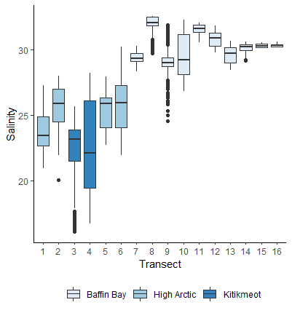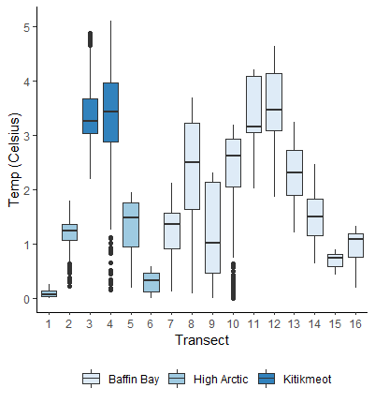

To test for associations between microplastic concentration and ship variables (water flow rate, volume sampled, ship speed) and environmental variables (Temp, Salinity, Depth), Kendall Tau was initially used:
Table 8: Kendall Tau Results
Explanatory Variable | p-value | tau
Water flow rate | 0.7158 | -0.06898859
Volume sampled | 0.5544 | -0.1116384
ship speed | 0.3396 | 0.1803389
Temperature | 0.09249 | 0.31774
Salinity | 0.5544 | 0.1116384
Depth | 0.5537 | -0.1125805

Kruskal- Wallis was used to determine whether groupings of transects based on ice extent, level of traffic, current, or regime could explain differences between in microplastic concentration:

Table 9: Kruskal- Wallis Results
Type | Grouping | Chi-squared | p-value
Total Microplastic | Ice | 1.2562 | 0.5336
Total Microplastic | Current | 1.3453 | 0.5104
Total Microplastic | Shipping | 1.009 | 0.6038
Total Microplastic | High Arc/KK/Eastern | 0.4389 | 0.803
Irregular Particles | Ice | 0.29184 | 0.8642
Irregular Particles | Current | 4.3122 | 0.1158
Irregular Particles | Shipping | 3.0998 | 0.2123
Irregular Particles | High Arc/KK/Eastern | 0.30049 | 0.8605
Microfibres | Ice | 1.5723 | 0.4556
Microfibres | Current | 1.1604 | 0.5598
Microfibres | Shipping | 0.78267 | 0.6762
Microfibres | High Arc/KK/Eastern | 0.072948 | 0.9642

Instead, cluster analysis of the surface parameters (ice, temperature, salinity, current) using hierarchical clustering with the Ward method based on Euclidean distances, stipulating 3 groups, defined three regions:

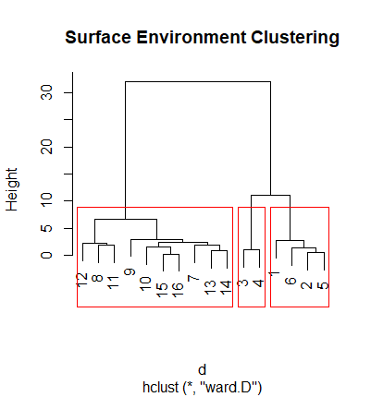

Supplementary Information
A sample of the recurring black particles were isolated for elemental investigation using a Hitachi TM3000 Scanning electron microscope and Energy Dispersive X-Ray spectroscopy via the Oxford Instrument Aztec One software. An example of particle SEM image is provided below, with the raw output of elemental and oxide ratios.

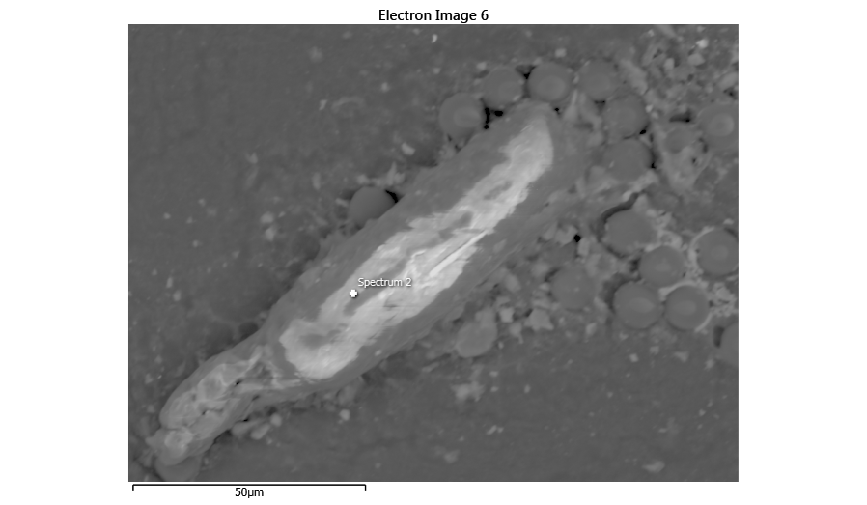
Element | Line Type | Weight % | Weight % Sigma | Atomic % | Oxide | Oxide % | Oxide % Sigma
Cl | K series | 2.82 | 0.36 | 1.86 |  | 0.00 | 0.36
F | K series | 6.01 | 1.88 | 7.40 |  | 0.00 | 1.88
Mg | K series | 0.74 | 0.48 | 0.71 | MgO | 1.22 | 0.80
Zr | L series | 0.72 | 1.55 | 0.19 | ZrO2 | 0.98 | 2.09
Ti | K series | 0.00 | 0.43 | 0.00 | TiO2 | 0.00 | 0.72
Si | K series | 4.64 | 0.47 | 3.86 | SiO2 | 9.92 | 1.00
Al | K series | 3.16 | 0.43 | 2.74 | Al2O3 | 5.96 | 0.81
Sr | L series | 1.62 | 1.34 | 0.43 | SrO | 1.91 | 1.58
Ca | K series | 2.39 | 0.42 | 1.40 | CaO | 3.35 | 0.58
K | K series | 19.90 | 0.94 | 11.91 | K2O | 23.97 | 1.13
Na | K series | 28.65 | 1.28 | 29.17 | Na2O | 38.62 | 1.73
Y | L series | 0.64 | 1.88 | 0.17 | Y2O3 | 0.81 | 2.38
Fe | K series | 0.63 | 0.61 | 0.26 | FeO | 0.81 | 0.78
Mn | K series | 0.12 | 0.56 | 0.05 | MnO | 0.15 | 0.72
P | K series | 1.24 | 0.43 | 0.94 | P2O5 | 2.84 | 0.99
S | K series | 0.25 | 0.33 | 0.18 | SO3 | 0.63 | 0.82
O | K series | 26.48 | 1.71 | 38.73
Total |  | 100.00 |  | 100.00 |  | 91.17

