Supplementary Material 2

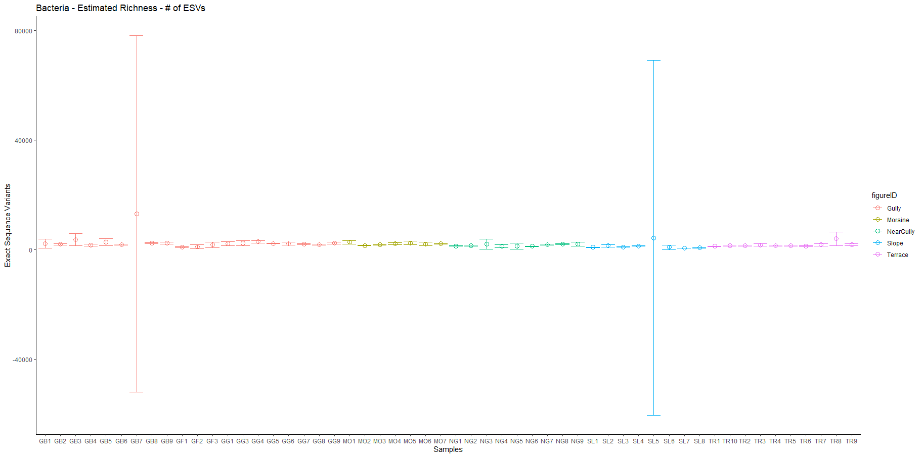

Supplementary Figure 1. Bacterial and archaeal richness estimates w/ standard errors for each sample. Samples with unusually large error bars that include negative numbers of ESVs (which is not biologically possible)- GB7 (left) and SL5 (right)- were removed for the richness estimation and null hypothesis significance testing used in the manuscript.

