X МЕЖДУНАРОДНА НАУЧНА КОНФЕРЕНЦИЯ
по АРХИТЕКТУРА И СТРОИТЕЛСТВО
ArCivE 2021
29 Май 2021 г., Варна, България
Xth INTERNATIONAL SCIENTIFIC CONFERENCE
оn ARCHITECTURE AND CIVIL ENGINEERING
ArCivE 2021
29 Мау 2021, Varna, Bulgaria

EFFECT OF GRANITE AGGREGATE ON LONGITUDINAL SPLITTING IN PRESTRESSED CONCRETE RAILROAD TIES
Savic Adrijana, Robert J. Peterman
ABSTRACT:
The experiments which were conducted in this research evaluate the influence of concrete mix using granite as aggregate on the longitudinal splitting behavior between steel and concrete. For these experiments three prisms were cast at a time having different compressive strength of concrete 4500psi and 6000psi and different cross sections. Additionally, four different wires type were used in these experiments in order to evaluate the influence of all variables on the bond between steel and concrete which is highly important for transferring the stresses between the two materials.

Keywords: prestressed concrete, edge distance, wire type, longitudinal splitting

- Introduction.

The experimental program was conducted to evaluate the influence of concrete mixture on bond performance between steel and concrete in prestressed concrete members. Three sets of prisms were cast at a time in order to understand the effect of type of aggregate used in concrete mixture on longitudinal splitting in prestressed concrete members using different maturity of concrete, different indentation of wire and different cross sections.
Shafiei et al. [1] investigated the Evaluation of splitting crack propagation in prestressed concrete ties made with different type of coarse aggregate. It has been observed that concrete properties and components can highly affect crack formation and propagation. According to this research angularity and coarseness of aggregate increases the fracture toughness of concrete by 20%. It was concluded that increasing angularity can significantly improve splitting cracks resistance.
Naga Bodapati et al. [2] investigated the variation of transfer length in pretensioned prestressed concrete railroad ties with varying prestressing steel types and concrete parameters. This experimental program included eighteen different prestressing reinforcement types that are employed in concrete railroad ties worldwide. It was concluded that transfer length is highly dependent on the reinforcing type and indentation pattern. The concrete compression strength at the time of prestress transfer is a primary factor influencing the transfer length in pretensioned concrete members utilizing both wires and strands. Transfer length is significantly important to ensure that pre-stressed forcing is introduced well before rail seat where the high impact load is applied. A consistent decrease in the transfer length was observed for both wires and strands when the release strength was increase from 3500 psi to 4500 psi.
The research was conducted at Kansas State University in order to understand the effect of concrete mixture on longitudinal splitting in prestressed concrete railroad ties. Three prisms were cast at a time having different cross sections. Four wires having different indentation and 5.32mm diameter were embedded into each cross sections. Each wire was pulled to 7000lbs and gradually de-tensioned when maturity of concrete reached 4500psi and 6000psi. The same water/cement ratio of 0.32 was used for all experiments.

- Material

For this experimental program four different types of wires were used for each individual set of prisms. All wires had a diameter of approximately 5.32 mm (0.21 in). Wire types were denoted using the following nomenclature: “WB”, “WF”, “WM” and “WQ”. Indented Wire Measurements are given in the following table.
Table 1: Indented Wire Measurements
 | Average depth (mm) | Edge wall angle (degree) | Side wall area (mm²) | Volume (mm³)
WB | 0.119 | 16.45 | 2.92 | 1.696
WF | 0.163 | 28.07 | 2.45 | 2.446
WM | 0.101 | 16.41 | 2.06 | 1.252
WQ | 0.067 | 11.58 | 2.15 | 0.776

The indentation types tested included shallow and deep chevron wire type. Figure 1 shows the main characteristics of the wires including indent depth, indent volume, indent sidewall area and indent sidewall angle.
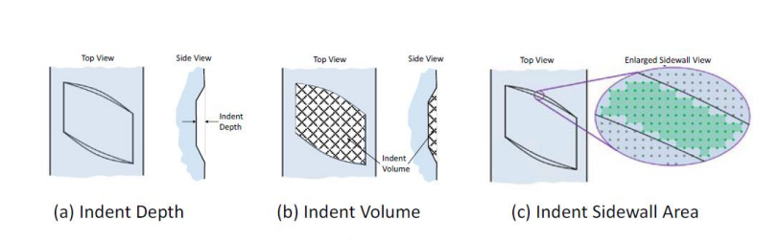
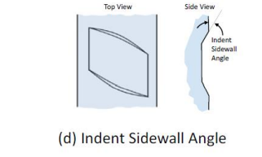
Figure 1: Wire Indent Geometrical Features [5], [6]

Shown in Figure 2 is microscope images of wire and associated 3D Cad Models.
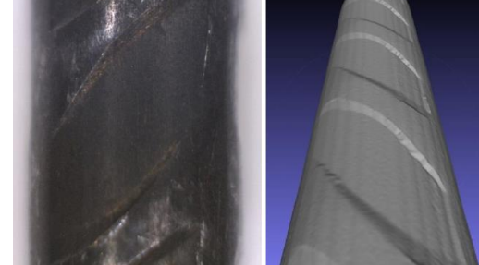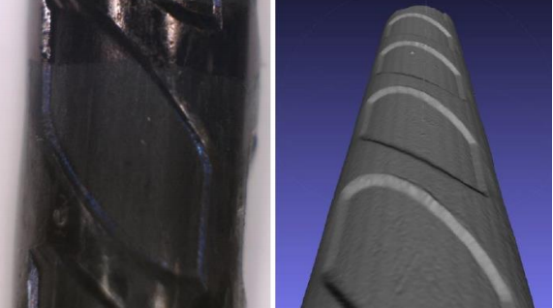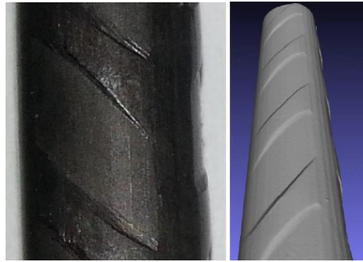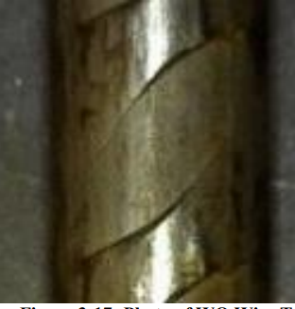
WQ
WM
WF
WB
Figure 2: Microscope Image of Wire Type and 3D Model

Cement: Monarch Type III cement was used for the concrete mix design used in this study. The
cement was obtained from Concrete Materials Inc. in Overland Park and stored in 55-galon drums until needed.
Aggregate: Granite was used as aggregate with 100% passing the 3/8 in sieve as shown in Figure 3.

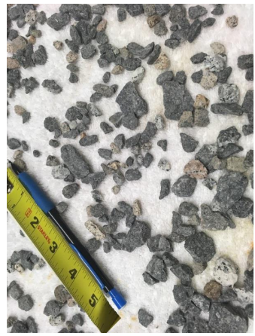
Figure 3: Granite Aggregate

To achieve the desired concrete consistencies (slump) with low water/cementitious (w/c)
ratio, ADVA CAST 530 was used for all tests.

Table 2: Concrete Mix Design
Concrete Mix
Material | Weight  (lbs.) /yd3
Cement | 813.8
Water | 260.4
Crushed Granite | 1447
Sand | 1447
Adva Cast 530 | 81 fl.oz/yd³

Table 2 shows the material and weight for the concrete mix. In this study 0.32 water/cement ratio was used.

- Methodology

For this research study, three prisms with varying cross sections were used which included center-to-center spacing of 2.0 in between wires with a maximum reinforcement edge distance of
¾ in and a minimum edge distance of ½ in. The wires in the prisms were each tensioned to 7000 lbs. The average initial compressive stress for edge distance ¾ in was equal to 28000 lb. / (3.5 in)² =2285 psi. For prisms with a ⅝ in edge distance, the value of stress was: 28000 lb. / (3.25 in)² =2650 psi
which was 59 % of the 4500-psi concrete release strength. For prisms with ½ in edge distance, average initial compressive stress was 3110 psi, which was approximately 89 % of the 4500-psi concrete release strength. This value is significantly into the nonlinear range of the concrete. Figure 4 shows the square cross section of the prism having 3/4in edge distance with four wire embedded into cross section.

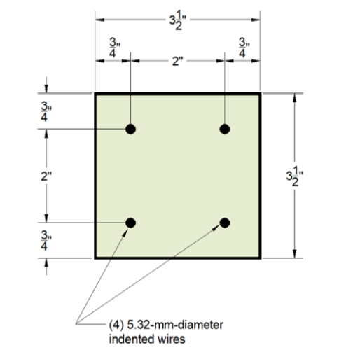
Figure 4: Prims having 3/4in edge distance. [6]

Figure 5 shows placement of concrete in the steel prism. Additionally, 12 4in x 8in compression strength cylinders were also cast simultaneously using the Sure Cure System which allowed the cylinders to have the same temperature as the prisms. Five hours after casting, cylinders were tested using the Forney machine and tests were repeated every 45 minutes. The desired strength of 4500 psi was reached approximately after 8 hours and 6000psi after 11 hours, when the process of de-tensioning commenced. In this research two maturity of concrete were investigated 4500psi and 6000psi.

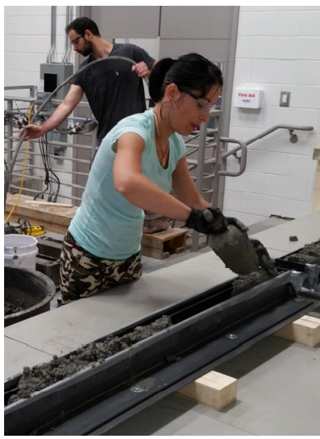
Figure 5: Placement of concrete

For prestressed concrete railroad ties to function adequately in the field, and to ensure safety, the prestressing force must be fully introduced into the railroad tie at a location well before
the rail load is applied. The length required to transfer the prestress force into the concrete member is well known as the “Transfer length”. For transfer length measurements LSI system was used [3]. The laser-speckle device was used to scan the top surface of a concrete prism before and after de-tensioning, and automatically plot the strain profile and determine the transfer length using a least-squares algorithm [3].
Additionally, each prism provided a sample of eight different and approximately independent splitting tests of edge distance for a given compressive strength of concrete. After de-tensioning procedure, all cracks that appeared on the prisms were marked, and photographs of all prism end surfaces were taken to identify the cracking field [4]. Crack length was measured by tracing out the path of a given crack with a piece of string and measuring the overall path (string) length including branches. In cases where spalling was observed, the crack width was assigned and arbitrary width value of 0.20 in. Crack area was defined as the total crack length multiplied by the maximum crack width [4]. Figure 6 shows the example of observed cracking. All prisms were investigated three months after de-tensioning procedure. Some cracks appeared immediately after de-tensioning commenced but some appeared due to sustained lateral stresses several weeks after.
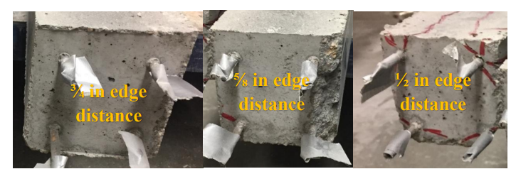
Figure 6: Observed Cracking

- Results

For this experimental research four wire types were investigated having shallow chevron and deep chevron indentation. Wires WM and WQ belong to shallow chevron type and WB and WF belong to deep chevron type. Additionally, two compressive strengths of concrete were observed: 4500psi and 6000psi and three different edge distances 3/4in, 5/8in and 1/2in. Tables 3 and 4 show the values of crack area which was defined as crack width multiplied with crack length, crack length and the values of transfer lengths. Transfer lengths values were given only for prisms having 3/4in edge distance. In case where transfer lengths have values over 17in that indicates the significant amount of cracking. Figure 7 shows the example of longitudinal strain profile along with the values of transfer lengths.

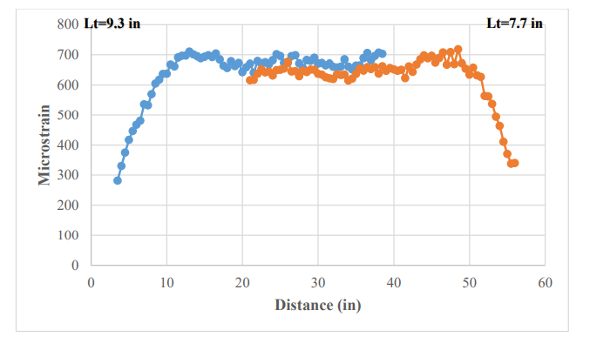
Figure 7: Longitudinal Strain Profile (WQ wire Type, 6000psi [5]

Shallow chevron type of wires performed very well with concrete mixture using granite as aggregate having no cracks on all prisms having 3/4in edge distances. With increasing the maturity of concrete these wires performed better with reducing the amount of crack areas on the prisms having 5/8in edge distances.
Deep chevron wire types performed poorly with concrete mixture using granite as aggregate. With reducing the thickness of concrete cover, the values of crack areas and crack lengths increased. WF wire type had significant amount of crack areas on the prisms having 5/8in and 1/2in edge distances, and with increasing the compressive strength of concrete these amounts are higher. High values of crack areas suggesting almost complete loss of bond in this region.

Table 4: Crack Area, Crack Length, Transfer Length-4500psi
 |  |  | 4500psi
 | 3/4in |  |  |  | 5/8in |  | 1/2in
 | Crack Area (in) | Crack Length (in) |  | Transfer Length (in) | Crack Area (in) | Crack Length (in) | Crack Area (in) | Crack Length (in)
WB | 3.6 | 170 |  | 17.25 | 10 | 354 | 9.5 | 405
WF | 1.4 | 64 |  | 10.8 | 12 | 293 | 59.4 | 471
WM | 0 | 0 |  | 10.25 | 0.2 | 16 | 2.9 | 169
WQ | 0 | 0 |  | 8.35 | 0.4 | 27 | 4.6 | 220

Table 5: Crack Area, Crack Length, Transfer Length-6000psi
 |  |  | 6000psi
 | 3/4in |  |  |  | 5/8in |  | 1/2in
 | Crack Area (in) | Crack Length (in) |  | Transfer Length (in) | Crack Area (in) | Crack Length (in) | Crack Area (in) | Crack Length (in)
WB | 2.2 | 202 |  | 27.5 | 6.0 | 377 | 8.4 | 395
WF | 0.8 | 32 |  | 5.5 | 55.7 | 411 | 74 | 520
WM | 0 | 0 |  | 8.25 | 0.04 | 4 | 18.8 | 340
WQ | 0 | 0 |  | 8.50 | 0.004 | 0.4 | 14.6 | 248

- Conclusions and Recommendations

Based on the results of this study, the following conclusions are drawn:
- Prisms manufactured with shallow chevron wire type and having granite as aggregate in concrete mixture indicated particularly good performance in all two compressive strengths 4500 psi and 6000 psi. There were no observed cracks on the prisms having ¾ in edge distance.
- Prism manufactured with deep chevron wire type had longitudinal cracks on the prisms having 5/8in and 1/2in edge distances initiating at all eight wire-end locations. Prism manufactured with deep chevron having Granite as aggregate indicated extremely poor performance. According to previous investigations this wire types performed better using crushed aggregate with no cracks on the prisms having 3/4in edge distances. It is not recommended using deep chevron wire types with granite.
- Based on the current research, concrete release strength of 4500 psi and 6000 psi and edge distances of ⅝ in and ½ in using the 5.32 mm diameter of wire are not recommended for the manufacturing of pretensioned concrete railroad ties. Likewise, the test results indicate that ¾ in is the minimum edge distance to achieve crack-free members with shallow chevron types of wire. In this case, a 1 in edge distance would provide a reasonable factor of safety against
splitting cracks from a design standpoint. For deep chevron wire type the minimum edge distance to achieve crack-free members is higher than 3/4in, and according to previous investigation it is 1in. In this case, a 1.25in edge distance would provide a reasonable safety against splitting cracks.

LITERATURE

[1] Shafiei Dastgerdi, A, Savic, A, Peterman, RJ, Riding, K, & Beck, BT. "Evaluation of Splitting
Crack Propagation in Pre-Stressed Concrete Ties Made with Different Types of Coarse
Aggregate." Proceedings of the 2019 Joint Rail Conference. 2019 Joint Rail Conference.
Snowbird, Utah, USA. April 9–12, 2019. V001T01A015. ASME.
https://doi.org/10.1115/JRC2019-1280
[2] Naga N.B. Bodapati “A Comprehensive Study of Prestressing Steel and Concrete Variables
Affecting Transfer Length in Pre-Tensioned Concrete Crossties” Thesis, Kansas State University
2019
[3] Beck, BT, Robertson, AA, Peterman, RJ, Savic, A, Wu, CJ, Riding, KA, & Bloomfield, J. "A
High Resolution Automated Prestressing Wire Indent Profiling System for Verification of Wire-
Concrete Mix Compatibility." Proceedings of the 2019 Joint Rail Conference. 2019 Joint Rail
Conference. Snowbird, Utah, USA. April 9–12, 2019. V001T01A009. ASME.
https://doi.org/10.1115/JRC2019-1269
[4] Savic, A, Beck, BT, Robertson, AA, Peterman, RJ, Clark, J, & Wu, C(. "Effects of Cover,
Compressive Strength, and Wire Type on Bond Performance in Prismatic Prestressed Concrete
Members." Proceedings of the 2018 Joint Rail Conference. 2018 Joint Rail Conference.
Pittsburgh, Pennsylvania, USA. April 18–20, 2018. V001T01A007. ASME.
https://doi.org/10.1115/JRC2018-6153
[5] Savic Adrijana, “Developing a prism qualification test to ensure adequate splitting resistance in
pretensioned concrete railroad ties” Thesis, Kansas State University 2019
[6] Savić, A., Dastgerdi, A.S., Beck, T., Peterman, R.J., Robertson, A., 2021. The Influence of
Concrete Cover, Type of Wire Indentation and Concrete Mix on Bond between Steel and Concrete
in Prismatic Prestressed Concrete Members. AEF 39, 103–126.
https://doi.org/10.4028/www.scientific.net/aef.39.103

Savic Adrijana, Dr., WSP company, adrisavic@gmail.com
Robert J. Peterman, Prof., Kansas State University, bob@ksu.edu Citation: (leave blank) _____________________________ _____________________________ _____________________________

