Supplementary Material

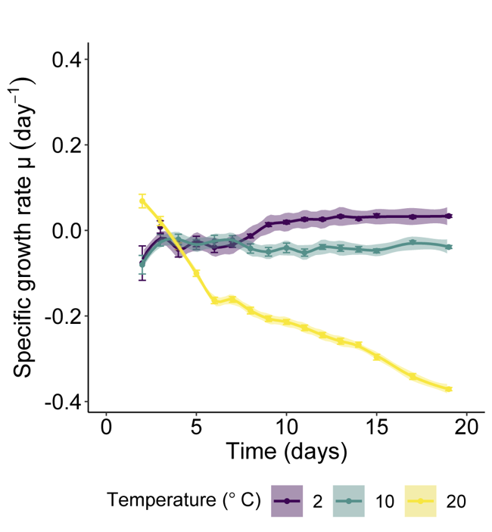
Supplementary Figure 1. Specific growth rate of Chlorominima collina CCAP 6/1 exposed to 2ºC, 10ºC and 20ºC. The lines show the trends, and the shading indicates the confidence intervals (CI). Each point is the mean of 24 replicates and the bars represent the standard error (SE).

Supplementary Table 1. Summary of the effects of temperature and time on F_{v}/F_{m} and RFU signals of Chlorominima collina.
Response variable | Model used | Predictor variable | Estimate | SE | t/z value | p value
F_{V}/F_{M} | Beta (GLMM) | Intercept  Temp.10  Temp.20  Time  Temp.10:Time | 0.3798  -0.1107  -0.1153  0.0086  -0.0325 | 0.0209  0.0221  0.0460  0.0016  0.0017 | 18.13  -5.00  - 2.51  5.21  -18.93 | < 0.0001 ***  < 0.0001 ***  0.0122 *  < 0.0001 ***  < 0.0001 ***
 |  | Temp.20:Time | -1.0246 | 0.0289 | -35.42 | < 0.0001 ***
RFU | Gamma  (GLMM) | Intercept  Temp.10  Temp.20  Time  Temp.10:Time  Temp.20:Time | 2.5082  0.2324  1.2128  0.0462.  -0.0818  -0.4023 | 0.0331  0.0553  0.0556  0.0048  0.0074  0.0076 | 75.747  4.203  21.810  9.558  -11.000  -52.936 | < 0.0001 ***  < 0.0001 ***  < 0.0001 ***  < 0.0001 ***  < 0.0001 ***  < 0.0001 ***
Signif. codes: 0 ‘***’ 0.001 ‘**’ 0.01 ‘*’ 0.05 ‘.’ 0.1 ‘ ’ 1

Supplementary Table 2. List of taxa used in this study, sisters to Chlorominima collina CCAP 6/1. Collection sites are specified.
 | Genbank accession no.
Taxon | 18S | rbcL | Collection site/Habitat | Reference
Chloromonas sp. KOPRI AnM0048 | JQ926737 |  | King Sejong Station, Antarctica/ freshwater | Choi,H.G. and Kang,S.H.; Unpublished
Chloromonas sp. KNF0032 | KU886306 |  | Dasan Station, Arctic/ freshwater | Jung et al. 2016a
Chlamydomonas sp. CCMP681 | EF106784 |  | Palmer Station, Antarctica/high intertidal | Raymond et al. 2009
Chloromonas sp. CCCryo273-06 | HQ404890 |  | Ecology Glacier, Polish Arctowski Station, Antarctica/green snow | Leya,T. and Bey,T.D; Unpublished
Uncultured alga clone: Otu011 | LC371433 |  | Antarctica: Yukidori Valley/ red-snow samples | Segawa et al. 2018
Chlamydomonas sp. CCMP681 |  | EU421061 & EU421062 | Palmer Station, Antarctica/High intertidal | Raymond et al. 2009
Chloromonas sp. ANT1 |  | AF089834 | Petrel Island, Antarctica/ green snow | Devos et al. 1998; Raymond et al. 2009

