Impact of transient fault location on voltage profile to increase customer satisfaction in distribution network

Hamidreza. Amiri

*Electricity power distribution company*

*Sari, Mazandaran, Iran*

[hamidrezaamiry@yahoo.com](mailto:hamidrezaamiry@yahoo.com)

***Abstract*—In the present paper, the effect of transient fault location on voltage profile to increase customer satisfaction at different points of distribution network is investigated. Since fault occurrence is inevitable in the power grids, it is necessary to investigate various faults in the power grid to minimize their effects by protective equipment. Both the permanent and transient faults, as two categories of faults, have different effects on power grids; but, since the cause of the permanent fault is visible and can be rectified in most cases, this study will investigate transient faults in a 20 kv distribution network. Transient faults affect all the components and equipment; however, depending on where the fault occurs in the network, it has a different effect on the distribution network and its components. Hence, the effects of these faults on the voltage profile are examined in this study since it is the most important component for the consumers of power distribution networks. Then, the DIGSILENT software is applied to simulate the transient fault behavior at different distances on the voltage profile of a sample distribution network and simulation results and the proposals are presented in Tables.**

***Keywords—transient fault, power distribution network, voltage Profile, customer satisfaction***

# Introduction

Nowadays, because of the growing use of electricity, the requirement for more production and more equipment in power grids becomes more vital. There are different types of electric equipment in our daily life that are growing every day. These are continuously being used from the power generation moment to consumption to provide stable and acceptable electric power for consumers. Whether our place of residence is rural or urban, Companies and organizations associated with the power grid are committed to delivering permanent electricity through a given cycle which consists of the generation, transmission, and distribution sectors. As the production and transmission sectors require detailed discussions and are out of the present study scope, we will focus on the electricity distribution networks. In a distribution network, regardless of its aerial or ground type, components such as transformers, switches, conductors, control, and protective devices, is applied to transmit electricity from the transmission line to the consumer side. However, a given function is specified for every component in use, which falls into uncertainty and inconsistency when a fault occurs. Many faults in power grids can be predicted and prevented while they are unpredictable and unavoidable in some cases. Therefore, any equipment and type of power grid have one or more protective systems to isolate itself or a determined part in fault occurrence events and prevent the spread of fault in consumers. All these factors characterize stability and reliability requirements in the distribution network managed by different methods and equipment to provide uninterrupted and stable electricity for final consumers. It should be noted that faults in power grids are temporally divided into permanent and transient categories, which have different effects on the distribution network and its equipment [1]. Since permanent faults and their occurrence reason in most situations are predictable and recoverable, the effects of the transient faults on power distribution networks are examined here. Regardless of why transient faults occur, the performance of the equipment used in the distribution network will be negatively affected when such faults occur. This will result in changes in the characteristics of the distribution network, leading to customer dissatisfaction. Therefore, in this project, we will investigate the effects of transient faults on the voltage profile, as the most important commitment of the power distribution network to the consumer Therefore, different methods (e.g., trial and error and some theoretical methods) and equipment are used in power distribution networks to minimize the impact of the transient faults in order to improve consumer satisfaction. A fault analysis method is conducted using single-phase ground fault modeling without considering other faults [2]. Another implemented method is transient faults simulation in the coupled network, which examines voltage and current based on exponential approximations [3]. Another method presented for examining the voltage profile in distribution networks is employed the whale algorithm to improve the voltage profile in distribution networks [4]. It is worthy to note that there are also different techniques and methods for detecting and comparing faults in distribution networks, which are examine different methods [5]-[6]. The influence of distributed generation resources on the voltage profile in power distribution networks is also investigated, which is out of the scope of this project because of its extent [7]-[8]. Finally, considering different methods presented in previous studies, we evaluate the transient fault and voltage profile in the power distribution network in the following section.

# TRANSIENT FAULT AND VOLTAGE PROFILE

## Transient fault

As discussed in the previous section, there are two types of faults in the grid, including transient and permanent faults. The group of faults that require a relatively long time and repair to resolve is called permanent or persistent faults. The permanent fault is the difference between the input and output of a system or grid for t→∞. However, the faults that disappear after a short time and effects are eliminated or attenuated with protective equipment are called transient faults. In these faults, after generating the electric arc and passage of the connection current, the cause of the arc disappears automatically and the grid is re-connected by cutting the power off for a short time to deionize and clean the arc [9]. This type of fault in consumers is usually seen as a blink or interruption in a fraction of a second. However, sometimes the transient faults could lead to permanent faults such as the leakage of the overhead lines' insulators break the insulator and lead to permanent fault over time. Some common causes of the transient fault include lightning, the instant presence or collision of external objects (birds, etc.) in the distance between the phases, or reducing the air distance between the phases due to the movement of conductors by the wind and storm [10]. Therefore, link breaker equipment is used in distribution networks to prevent the grid's spread of fault and isolate the damaged grid. Re-closer is another device known as the automatic switch that switches the grid in the event of a transient fault and prevents the total cutoff. Another system called the surge arrester is also used to reduce the effect of transient fault. Generally, factors such as climate changes, voltage level, ground level, network layout, etc., affect the number of transient faults in the distribution networks. The voltage waveform vs. time in figure (1) helps to understand a transient fault's behavior.

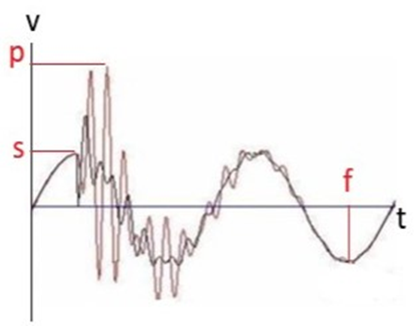

Fig.1. voltage waveform during the transient fault

The point "s" is the moment of starting the transient fault, "p" is the peak of the transient voltage and "f" is the moment of finishing or loss of transient voltage energy. According to the above figure, a transient fault (red wave) acts as a damping wave, which disappears after a few cycles.

*B. Voltage profile*

There are many units and components in a distribution network, each of which indicates the units' scale or size. The amount of current as the loading unit, kilowatt/hour as the amount of power consumption, and network voltage as the basis of power distribution are essential components of a distribution network. Each unit is regularly measured and controlled to stabilize the network stability but sometimes all units change because of the incidence of fault in the network. Given that the current and power units are strongly dependent on the amount and type of consumer in normal operation, and their quantity is less important for the end-user, it is critical to check the distribution network's end-user as a basic unit. Stability and uniform voltage over time are the major concerns of the distribution network, which will change or suffer from imbalance due to factors such as different consumer loads and the network's fault. Distributed generation is one of the most effective loads in the grid voltage that numerous methods are applied to control them [11]-[12]. Hence, it is attempted to keep the voltage level in the numerical network almost constant. This is because with regard to customer satisfaction, another critical problem in distribution networks involves their voltage imbalance. Although the existing voltage in the transmission network at the power generators' terminals is perfectly balanced, the voltage becomes unbalanced at the distribution networks level due to single-phase loads and unequal line impedance. If this imbalance exceeds a standard limit, besides increasing system losses, it could negatively affect consumers. Voltage profile is an important issue in the grid voltage balance, which includes dynamic and static profiles. Dynamic voltage is associated with the voltage shape, and the static profile is related to the amount of voltage examined in the static voltage profile. Improving this type of voltage profile is of particular importance in all distribution networks, which is discussed as the following function:

$$I= \sum_{i=1}^{n}{\left|v_{ref}\right.-\left.v_{i}\right|} (1)$$

Where "n" is the number of network buses, and “ $v_{ref}$”is considered as equal to one. As discussed before, a network's voltage is not constant throughout the day and undergoes (even minor) variations. These variations are expressed using the following equation:

$$F_{v}=max\left|v_{i}-\left.v_{1}\right|\right. (2)$$

“ $v_{i}$“Is a constant voltage value and “ $v_{1}$”is the varied voltage level. A distribution network's performance from the consumer's point of view depends on the delivery of a particular voltage level, which will be measured under various transient faults in the next section.

# MODELING AND SIMULATION

*A. modeling*

As stated in previous sections, transient fault behavior has been investigated at different points of a 20 kV distribution. The distribution network is composed of 9 buses and four distribution transformers of step-down type. To better understand the number of elements, their characteristics, and their location in the network, Figure (2) shows the typical distribution network.

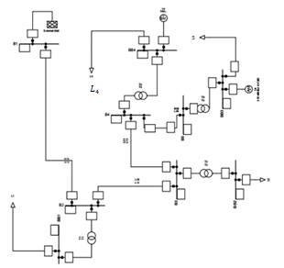

Fig.2. An example of a distribution network

As shown above, the network includes a swing bus and six different types of load or consumer.

*B. Simulation*

As discussed above, the present study has applied Digsilent software for simulating the distribution network. For examining the typical network performance, all elements should be correctly named while determining their exact value. For such a purpose, Table (1) shows the values corresponding to all elements used in the typical distribution network.

TABLE1 PARAMETRIC VALUES

|  |  |
| --- | --- |
| value | Parameters |
| 20Km | $$L_{12}$$ |
| 7Km | $$L_{23}$$ |
| 4Km | $$L_{34}$$ |
| 4Km | $$L_{45}$$ |
| 20Kv | $$V_{slack}$$ |
| 100Kva | $$T_{1}$$ |
| 100Kva | $$T_{2}$$ |
| 315Kva | $$T_{3}$$ |
| 315Kva | $$T_{4}$$ |
| 60Kw,32Kvar | $$L_{1}$$ |
| 52Kw,24Kvar | $$L_{2}$$ |
| 108Kw,59Kvar | $$L_{3}$$ |
| 110Kw,59Kvar | $$L_{4}$$ |
| 150Kva | $$L_{a}$$ |
| 50Kva | $$L_{s}$$ |

It should be noted that grid busses are connected using three $300 mm^{2}$ aerial power cables with aluminum conductors, but the line $L_{45}$ utilizes a power cable of 75 mm size. According to the standard table, the networks applied by the electrical distribution company are characterized by $R_{L}=0.338 ohm/km$ and $X_{L}=0.349 ohm/km$ [13]. Other than the usual loads, two loads of asynchronous and synchronous motors characterized in the previous table have been also considered. All of the typical grid transformers perform in the intermediate load condition. It is worth noting that this typical network is assumed to be a sustainable rural grid that can be implemented. For a better understanding of events that occurred in the network and their measurement criteria, we will evaluate simulation results in the next section.

*C. Simulation Results*

Based on the previous descriptions and typical grid schematic, simulations are carried out, and the circuit is investigated in terms of single-phase ground fault. Results are demonstrated as follows. Before applying the fault, the network was balanced, and the vector representation of consumer single-phase voltage and voltage profile of $L_{4}$ consumer for the phase “a” were as Figures (3) and (4).

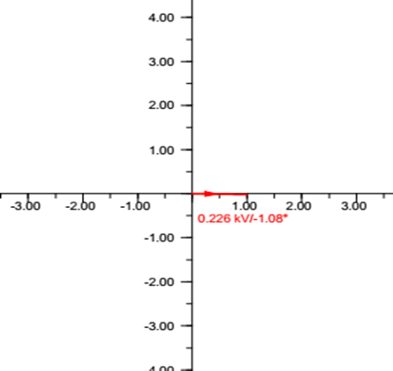

Fig.3. Vector representation of $L_{4}$ consumer voltage before applying the fault

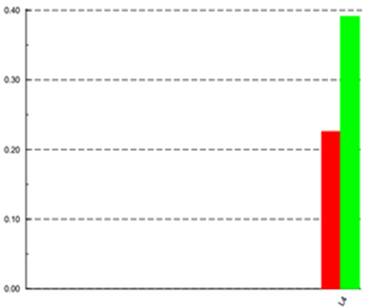

Fig.4. voltage profile of $L_{4}$ consumer before applying the fault

Based on the above Figures, the single-phase and three-phase voltage of the consumer is 226 V and 392 V, respectively. After applying the transient single-phase ground fault in the mentioned points, all indicators will be changed in the network. To observe this phenomenon in graphical mode, the vector representation of $L_{4}$ consumer voltage and its profile for the phase “a” is demonstrated for transient fault application at 1 km far from the swing bus in Figures (5) and (6), respectively.

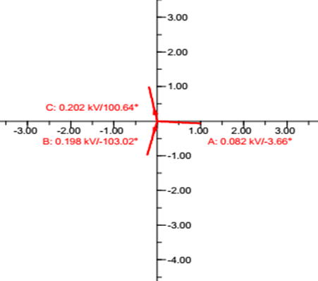

Fig.5. Vector representation of the consumer voltage for the first fault

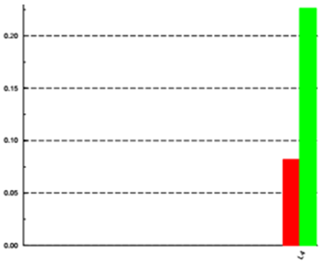

Fig.6. Voltage profile of phase “a” consumer for the first fault

As shown in Figures (5) and (6), the voltage value in phase “a” severely drops due to transient fault occurrence, and this causes changes in other phases so that the voltage value for $L_{4}$ consumer becomes about 82 V for single-phase supply and about 226.3 V for three-phase supply. Now for the second part, the transient single-phase ground fault is applied at a point of 19 km far from the swing bus, whose results are presented in the form of voltage vector in Figure (7) and voltage profile of phase “a” in Figure (8).

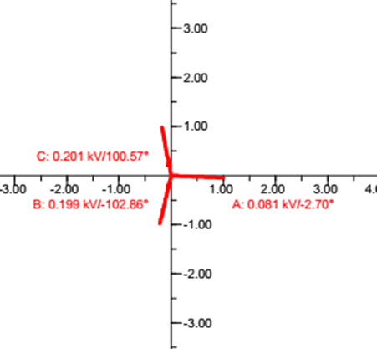

Fig.7. Vector representation of the $L_{4}$ consumer voltage for the second fault

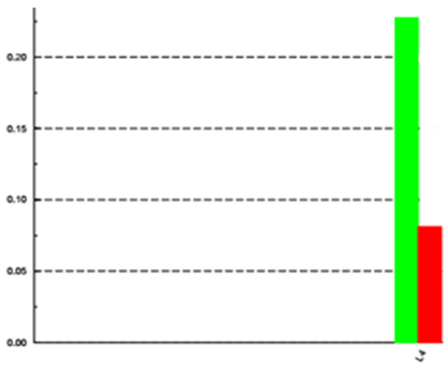

Fig.8. voltage profile of phase “a” $L_{4}$ consumer for the second fault

According to the output results of the second transient fault, $L_{4}$ consumer voltage values of 81.1 V for single-phase supply and about 226.1 V for three-phase supply indicate a further reduction of the voltage in the second part. Now, by examining the results of transient fault application at different points, it is found that the distance or position of transient fault affects the voltage variations and changes the obtained results. However, consumers cannot recognize these variations, and the transient fault is considered the same in both modes.

IV. CONCLUSION

Based on what was mentioned above, the simulation and analysis of a distribution network under transient single-phase-to-ground fault at different points were carried out, and this showed the significant contribution of the said fault in the voltage profile. Regardless of the sub-transmission substation performance, the simulation results indicated that the end-user of the network feels the occurrence of transient faults in the transmission lines in any case. However, it is very important for monitoring systems to be informed about where the fault has occurred in the network because the farther the location of transient fault from the consumer, the lower the voltage drop and its tangibility on the consumer side. On the other hand, if the location of the transient fault is closer to the consumer, it leads to higher voltage drops on the consumer side. Therefore, the location of faults is an effective item for network operation and consumer satisfaction. It should be noted that the transient faults also have some effects on the phase angles proportional to the voltage magnitude and cause some changes in their orientation. However, the occurrence of other transient faults such as three-phase line-to-ground and line-to-line faults affects intensely on the voltage profile and result in greater values of voltage drop. Concerning the simulation results, the occurrence of transient faults on one phase will affect other phases as well as leading to a decrease in their voltage value while changing their phase angle, and this is affected by the fault location on the network. Finally, the effect of different fault location on the voltage profile in the consumer is presented numerically in Table (2) and since distribution network companies mainly concern about customers’/consumers’ satisfaction, it is recommended to move from the consumer side towards the sub-transmission substation for examining the network in terms of transient faults. In this condition, the faults near the consumer are resolved first, and then, the possible transient fault proportionally becomes intangible on the consumer side.

TABLE2 NUMERICAL RESULTS OF DIFFERENT FAULT LOCATION

|  |  |  |
| --- | --- | --- |
| fault distance to substation | Single-phase voltage after fault  ( $L_{4})$ | Three-phase voltage after fault  ( $L_{4})$ |
| 1km | 82v | 226.3v |
| 7km | 81.7v | 226.3v |
| 15km | 81.3v | 226.1v |
| 19km | 81.1v | 226.1v |

(As mentioned earlier, the consumer voltage before the fault was 226 volts single-phase and 392 volts three-phase)

REFERENCES

1. C. G. Kaloudas and G. K. Papagiannis, "FDTD analysis using constant parameter modeling for the calculation of transient responses and voltage profiles on multiconductor overhead transmission lines," 49th International Universities Power Engineering Conference (UPEC), Cluj-Napoca, Romania, pp. 1-6, 2014.
2. Li Juan, Xue Yongduan, Bingyin Xu and Sun Bo, "Error analysis of transient model of single-phase earth fault," IEEE PES Innovative Smart Grid Technologies, Tianjin, China, pp. 1-4, 2012.
3. P. Dan-klang and E. Leelarasmee, "Transient Simulation of Coupled Transmission Lines based on Piecewise Exponential Approximation of Voltage and Current Distributions," Asia-Pacific Microwave Conference, Bangkok, Thailand, pp. 1-4, 2007.
4. B. C. Neagu, O. Ivanov and M. Gavrilaş, "Voltage profile improvement in distribution networks using the whale optimization algorithm," 9th International Conference on Electronics, Computers and Artificial Intelligence (ECAI), Targoviste, Romania, 2017.
5. H. Y. Li, Z. Q. Bo, B. Caunce and S. Potts, "A fault transient comparison technique for multi-ended distribution feeders," Seventh International Conference on Developments in Power System Protection (IEE), Amsterdam, Netherlands, pp. 153-156, 2001.
6. Z. Lini, L. Yongliang, S. Yong, X. Yongduan, L. Lisheng and J. Xin, "Fault Type Recognition of Over-head Lines of Distribution Networks Based on Fault Indicator Waveform Data," China International Conference on Electricity Distribution (CICED), Tianjin, China, pp. 1444-1448, 2018.
7. Q. Sun, Z. Li and H. Zhang, "Impact of Distributed Generation on Voltage Profile in Distribution System," International Joint Conference on Computational Sciences and Optimization, Sanya, China, pp. 249-252, 2009.
8. T. Maseva and S. Chowdhury, "Impact of Integrating Residential Solar PV Clusters on Voltage Profile in Urban Distribution Network," International SAUPEC/RobMech/PRASA Conference, Cape Town, South Africa, pp. 1-6, 2020.
9. J. E. O. Pessanha and G. Gela, "A distribution system model with frequency-dependent parameters to simulate electromagnetic transients," 38th Midwest Symposium on Circuits and Systems. Proceedings, Rio de Janeiro, Brazil, pp. 1289-1292, vol2, 1995.
10. R. D. Evans, A. C. Monteith and R. L. Witzke, "Power-system transients caused by switching and faults," in Electrical Engineering, vol. 58, no. 8, pp. 386-396, Aug 1939.
11. O. Mashhadi and M. O. Sadegh, "The influence of smart controller of the distributed generation sources and capacitor banks on loss minimization and profile improvement in the electricity distribution networks voltage,"20th Conference on Electrical Power Distribution Networks Conference (EPDC), Zahedan, Iran, pp. 272-276, 2015.
12. F. Jiang, Z. Zhang, T. Cao, B. Hu and Z. Piao, "Impact of distributed generation on voltage profile and losses of distribution systems," Proceedings of the 32nd Chinese Control Conference, Xi'an, China, pp. 8587-8591, 2013.
13. R. Hasanpour, S.H. Hoseini Kordkheili, T. Sadr, M.M. Mohamadi Takami and H. Yousefi, “Design and Calculation of Electricity Distribution Networks”, Vareshva Publisher in Amol, Iran, Mazandaran Power Distribution Company, Iran, October, 2019.