Yellowfin tuna behavioural ecology and catchability in the South Atlantic: The right place at the right time (and depth)

Serena R. Wright^{a*}, David Rightonª, Joachim Naulaerts^{b}, Robbie Schallert^{c}, Chris Griffiths^{d}, Taylor Chapple^{ce}, Daniel Madigan^{c}, Vladimir Laptikhovskyª, Victoria Bendallª, Rhys Hobbs^{b}, Doug Beare^{f}, Elizabeth Clingham^{b}, Barbara Block^{c}, Martin A. Collins^{g}

ª Centre for Environment Fisheries and Aquaculture Science, Lowestoft, NR33 0HT, UK.
^{b} Marine Section, Environmental and Natural Resources Directorate, St Helena Government, Essex House, Jamestown, St Helena Island, South Atlantic, STHL 1ZZ.
^{c} Tuna Research and Conservation Center, Stanford University, Hopkins Marine Station, Pacific Grove, CA 93950, USA.
^{d} Department of Animal and Plant Sciences, University of Sheffield, Western Bank, Sheffield, S10 2TN, UK.
^{e} Hatfield Marine Science Center, Oregon State University, Newport, OR 97365, USA
^{f} ICCAT Secretariat, 28002 Madrid, España.
^{g} British Antarctic Survey, NERC, High Cross, Madingley Road, Cambridge, CB23 0ET, UK.

*Corresponding author: serena.wright@cefas.co.uk

Keywords: tagging; satellite tags; archival tags; acceleration; fast-start

Supplementary Tables

Table S1.
Month | LPUE (Mean)
January | 0.21
February | 0.22
March | 0.21
April | 0.22
May | 0.19
June | 0.16
July | 0.14
August | 0.13
September | 0.16
October | 0.11
November | 0.16
December | 0.18

Supplementary Figures

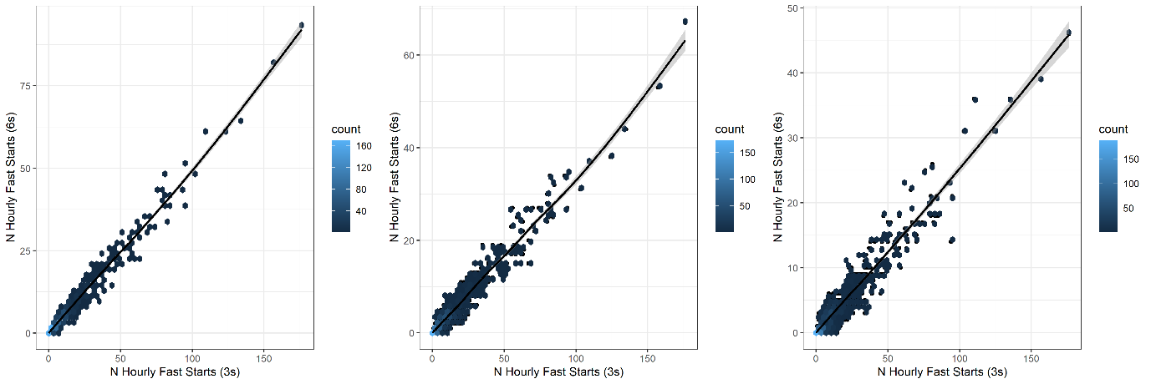
Figure S1. Comparison between the number of hourly fast starts identified for data recorded at 3 second vs 6 second (left), 3 second vs 9 second (middle) and 3 second vs 12 second.

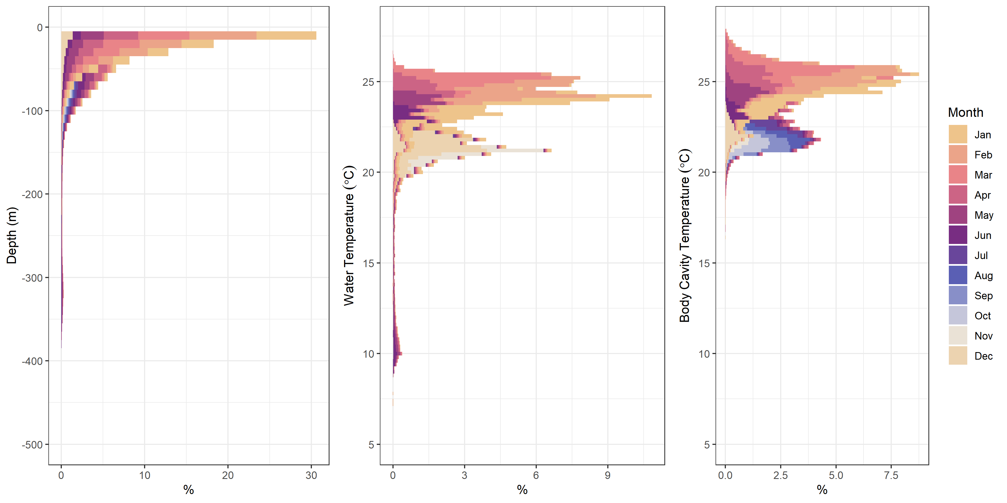
Figure S2. Summary of depth and temperature experience for yellowfin tuna tagged within St Helena’s EEZ. Depth experience for all individuals is shown on the left. Water temperature is shown in the centre for tuna tagged with Lotek archival tags and satellite tags. Internal body cavity temperature is shown on the right for tuna tagged with archival tags.

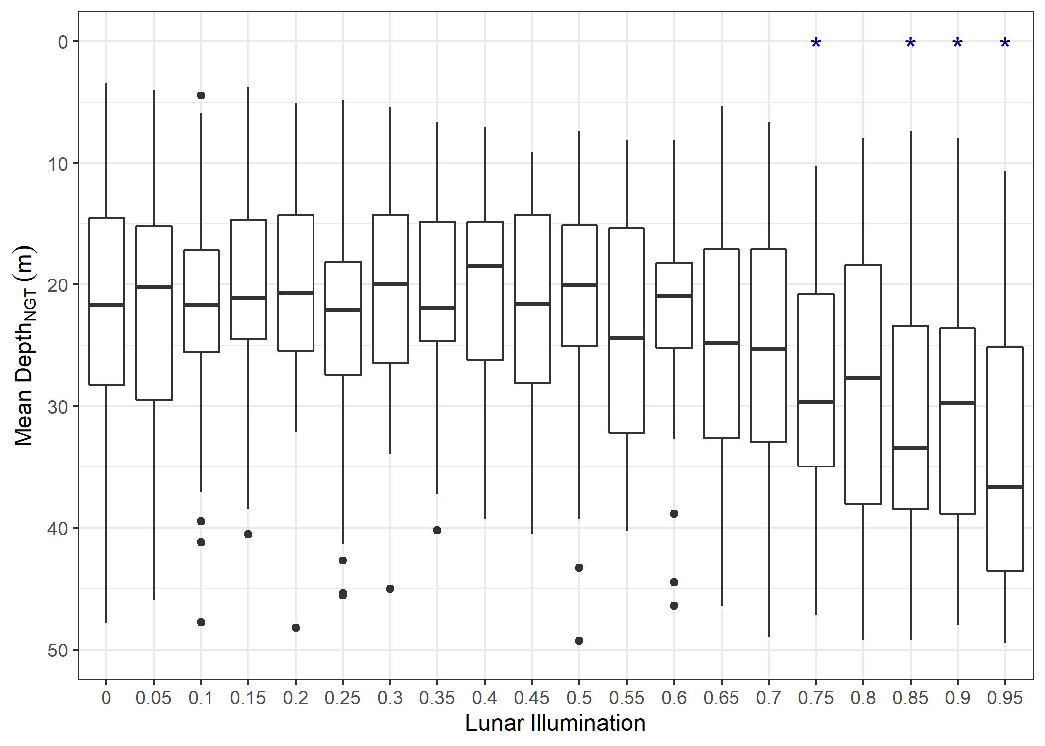
Figure S3. Mean depth at night for yellowfin tuna in relation to lunar illumination. Significantly lower mean depth at night compared to other lunar illumination levels denoted with a * (P<0.05).

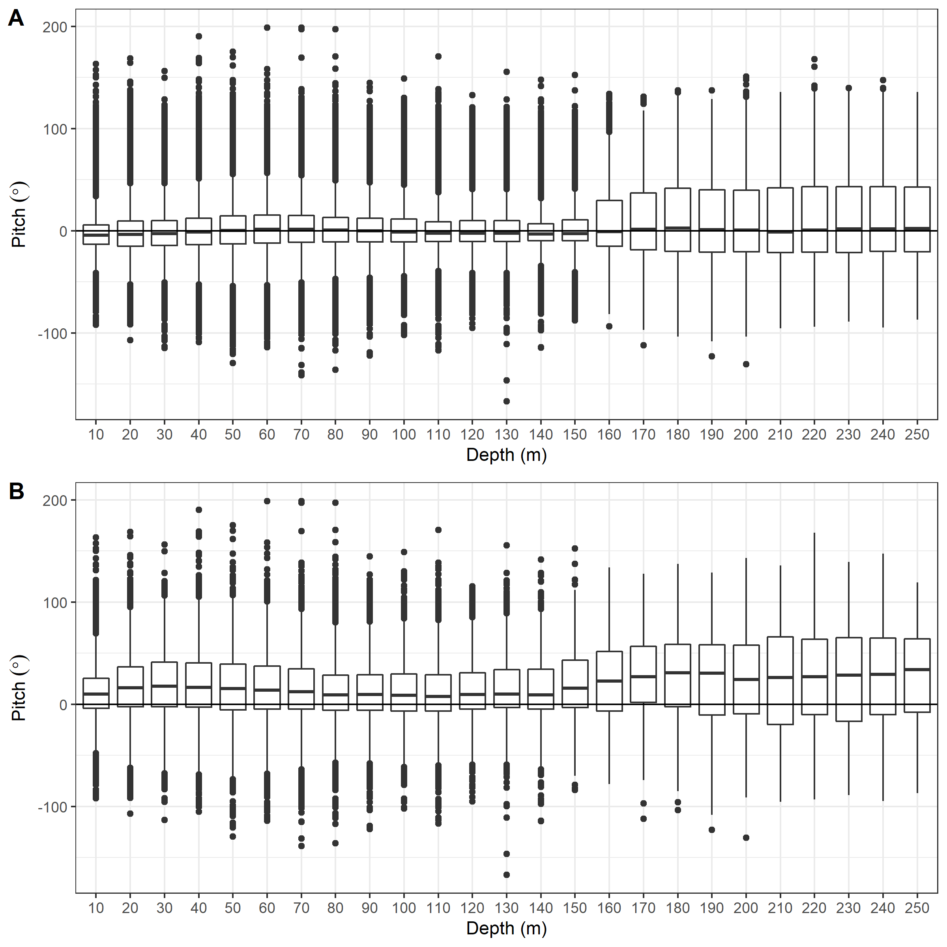
Ascent
Descent
Figure S4. Pitch angle in relation to the depth of yellowfin tuna 1116009 for (A) the entire time at liberty and (B) during fast start events only.

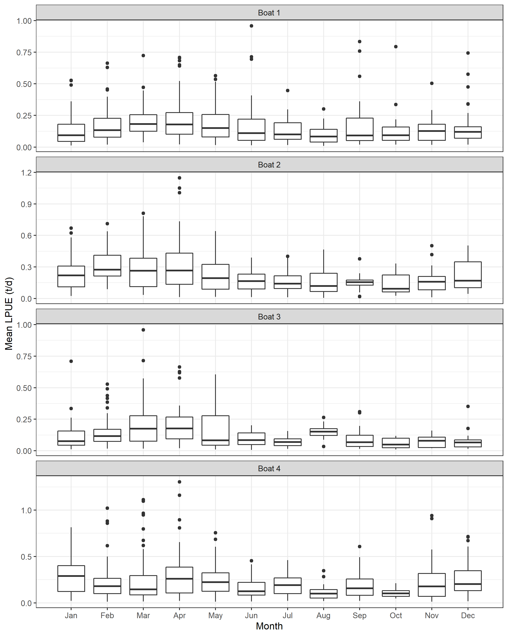
Figure S6. Summary of yellowfin tuna LPUE (tonnes landed per vessel per day) for four commercial fishing vessels within St Helena’s inshore region.

