Supplementary Material: Biographies
The authors shared their perspectives in roundtable discussions, to create this paper and its online component. The written paper is an invitation to explore correlations between stories from scientific data, and stories from Indigenous knowledge of ourselves as part of nature, expressed through languages of the arts.
The authority and authenticity they brought to this work are described here.
Andrew Constable: I am an Australian marine scientist with a long connection with Antarctica and the Southern Ocean. I grew up listening to stories of the harsh south, then working in the field and in meeting rooms to bring science into policy for conserving and managing Southern Ocean ecosystems, as well as on how to manage climate change and its impacts on Earth systems generally. I grew up also appreciating Aboriginal Australia and the arts for education, such as through my great uncle Bill Constable, who designed the sets and costumes for the ballet, 'Corroboree'.
Cat Kutay: I come from the saltwater people of Celtic and Aboriginal Australian origin, linked to the Yugambeh/Bundjalung area where I work with language reclamation. I am a web developer on this project living on Larrakia country and teaching Indigenous Knowledge in Engineering and IT.
Danae Fiore: I am an archaeologist and most of my research focuses on the diverse art forms produced by Indigenous Societies of Fuego-Patagonia (Argentina). My first fieldwork was in 1988, when I was 19 years old, and ever since I have been engaged with the systematic study of the ways in which rock art, portable art and body art were produced, displayed and interacted with in the “prehistoric” past, the recent past and in the contemporary world. The Indigenous peoples in Argentina have been subject of genocide, land plundering and enslavement: I see my work as a way of acknowledging their rich creativity in the past and in the present.
Ellery Johnson: I am an estuarine ecologist and scientific communicator. I am interested in free flowing fresh water and whole catchment ecology. I hope to introduce people to the beauty of ecology through stories.
Jess Melbourne-Thomas: I am a climate change scientist and knowledge exchange specialist with a relationship with the Southern Ocean that comes from my birthplace in an Antarctic gateway city in Tasmania, and from my science and fieldwork to understand and respond to change in the world’s oceans, including the Southern Ocean. I work to help connect ways of knowing, in science, policy, and practice.
Katherina Petrou: I am a marine biologist and children's book author who works in Antarctica and the Southern Ocean. I collaborate with artists to expand understanding of science. For example, I co-authored 'Climate Science for Babies' with Chris Ferrie as a basic introduction for youngsters (and grownups!) to the complex questions of what climate change is and what we can do about it. My voice in this project is to harmonise Western science with Indigenous knowledge.
Lisa Roberts: My role in this project is to bring to scientific data expressions of relationship to nature, from people around the world. My relationship to Aboriginal Australian cultural arts comes from my mother whose mother was from a stolen generation dispossessed of knowledge of her traditional country and language. Mum worked as an artist at Bill Onus's 'Aboriginal Enterprises' studio in the Dandenong Ranges in Victoria, near where we lived in the house built by my great grandfather, the artist Tom Roberts. My relationship to science and the Southern Ocean comes from sailing by ship to work as an artist in Antarctica (in 2002), and co-authoring the scientific paper revealing, through art and science, the first sighting of the entire mating dance of Antarctic krill.
Melissa Silk: I have lived on the land of the Darug people for most of my life and acknowledge with gratitude, that my own connection with country exists from a human perspective, decolonised, and very much influenced by the earth and the air, the flora and fauna, the sun, and the moon, and the stars. I design human experiences where the universal truth of mathematics collides with the joy of making, so together, we construct metaphors, with a singular aim: to remind us of the connectedness of all things and the responsibility we have to acknowledge and maintain those connections.
Paul Fletcher: I am a musician, composer, maker and animator with lifelong experience in horticulture, teaching and performing. I collaborate with scientists, other artists, and Indigenous knowledge holders, to immerse people in diverse perspectives of the natural world.
Tracey M Benson: I am an interdisciplinary artist and researcher with Norse, Celtic, Saxon and Briton heritage. I was born on Gubbi Gubbi Country in Queensland and now living on Ngunnawal Country in Canberra. I have a small understanding of the place where I now live. One thing I do know is that millions of years ago, the capital region was under water and part of an inland sea.
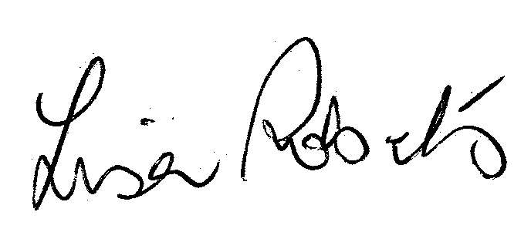
Víctor Vargas Filgueira: Belonging to an Indigenous Community or First Nation is a fact that gives us a deeper vision of our environment: being part of it and not considering ourselves as its owners is what makes us have a deeper connection with Nature than other inhabitants of our cosmopolite City.

