Supplementary Material
Table S1: Ingredients of the experimental diets (FD = fish oil diet. VD = vegetable oil diet).
Ingredients | FD | VD
 | % | %
Fishmeal 70 LT FF Skagen | 10.000 | 10.000
Fish protein concentrate (CPSP 90) | 15.000 | 15.000
Squid meal | 25.000 | 25.000
Shrimp hydrolisate | 5.000 | 5.000
Fish gelatin | 2.000 | 2.000
Pea protein concentrate | 7.500 | 7.500
Wheat Gluten | 12.500 | 12.500
Potato starch gelatinised | 2.500 | 2.500
Fish oil | 7.200 | 0.000
Tuna oil | 2.300 | 0.000
Rapeseed oil | 0.000 | 2.900
Linseed oil | 0.000 | 2.400
Palm oil | 0.000 | 4.200
Vit & Min Premix | 1.500 | 1.500
Lutavit C35 | 0.030 | 0.030
Lutavit E50 | 0.120 | 0.120
Brewer's yeast | 5.000 | 5.000
Betaine HCl | 1.000 | 1.000
MAP (Monoammonium phosphate) | 3.000 | 3.000
L-Taurine | 0.350 | 0.350
NTNU - Phospholipids | 0.000 | 0.000
Total | 100.000 | 100.000
As fed basis | FD | VD
Crude protein | 65.00 | 65.00
Crude fat | 14.10 | 14.10
Fiber | 0.29 | 0.29
Starch | 4.33 | 4.33
Ash | 6.34 | 6.34
Gross Energy | 20.43 | 20.43
C14 | 0.83 | 0.18
C16 | 2.01 | 2.64
C18:1n9 | 1.66 | 4.42
LNA | 0.41 | 1.48
ALA | 0.20 | 1.52
ARA | 0.01 | 0.01
EPA | 1.15 | 0.25
DHA | 1.26 | 0.48
EPA+DHA | 2.40 | 0.73
DHA/EPA | 1.10 | 1.90
SFA | 3.51 | 3.44
MUFA | 5.10 | 5.03
PUFA | 3.35 | 3.50
TPL | 1.31 | 1.28

Table S2: Number of pooled replicate DNA samples/replicate tank/time point of the pre-feeding S. salar life stages: Eggs (EG). yolk sac larvae (YS) and “D0” and feeding stages of a) fish oil group (FD): D35F, D65F and D93F and b) vegetable oil group (VD): D35V, D65V and D93V. *DNA extracts from 5 individual samples were pooled, resulting in 2 pooled samples/tank/time point
Sample code | Number of replicate tanks | Number of pooled replicate DNA samples*/replicate tank
EG | 1 | 2
YS | 1 | 2
D0 | 1 | 2
D35F | 2 | 2
D65F | 2 | 2
D93F | 2 | 2
D35V | 2 | 2
D35V | 2 | 2
D35V | 2 | 2

Table S3: List of Barcode sequences used for labeling the different samples.
Sample code | Sample code in manuscript | Barcode
AFOAWS | FW | CATAATAG
AFOBWS | FW | CATATTCT
ASTWS | STW | CATAACAA
AVOAWS | VW | CATCAACA
AVOBWS | VW | CATCACCG
D0AG1P | D0 | CATTCGTG
D0AG2P | D0 | CATTCTAA
D35.AFOAG1P | D35F | CATTGCGT
D35.AFOAG2P | D35F | CCACCTTA
D35.AFOBG1P | D35F | CCACGGTG
D35.AFOBG2P | D35F | CCAGCGGT
D35.AVOAG1P | D35V | CCAGCTCA
D35.AVOAG2P | D35V | CCAGGACT
D35.AVOBG1P | D35V | CCAGGCTG
D35.AVOBG2P | D35V | CCAGTCGT
D65.AFOAG1P | D65F | CCATGATT
D65.AFOAG2P | D65F | CCATTGAG
D65.AFOBG1P | D65F | ATCGATGA
D65.AFOBG2P | D65F | ATCGATGG
D65.AVOAG2P | D65V | ATCGGCGG
D65.AVOBG1P | D65V | ATCTAGCG
D65.AVOBG2P | D65V | ATCTAGGA
D93.AFOAG1P | D93F | ATCTCGAT
D93.AFOAG2P | D93F | ATGAACAG
D93.AFOBG1P | D93F | ATGAACTT
D93.AFOBG2P | D93F | ATGAGCGA
D93.AVOAG1P | D93V | ATGATTAG
D93.AVOAG2P | D93V | ATGATTGT
D93.AVOBG1P | D93V | CGTAGGTG
D93.AVOBG2P | D93V | CGTATCTC
EGA1P | EG | CATGCGCA
EGA2P | EG | CATGGAAG
FOD | FD | CAGTTCAT
VOD | VD | CAGTTGCA
YSA1P | YS | CATGTTGT
YSA2P | YS | CATTCCGT

Table S4: Body weight (g) and total length (cm) of S. salar at D0, D35, D65, D93 in dietary treatments Fish oil (FD) and Vegetable oil (VD) diets (mean ± SD).
Dietary treatment | Life stage | N | Body weight (g) | Total length (cm)
 | D0 | 20 | 0.23 ± 0.030 | 29.9 ± 1.60
FD | D35 | 20 | 0.57 ± 0.211 | 38.9 ± 5.40
 | D65 | 20 | 2.29 ± 0.482 | 61.5 ± 5.10
 | D93 | 20 | 4.58 ± 1.74 | 76.0 ± 8.90
VD | D35 | 20 | 0.58 ± 0.228 | 38.2 ± 4.90
 | D65 | 20 | 2.18 ± 4.54 | 61.2 ± 5.20
 | D93 | 20 | 4.54 ± 1.78 | 73.8 ± 9.20

Table S5: Chao 1 and Simpson1-D values (mean ± SD) in all sample categories. Pre-feeding S. salar life stages: Eggs (EG), yolk sac larvae (YS) and “D0”. Feeding stages of a) fish oil group (FD): D35F, D65F and D93F and b) vegetable oil group (VD): D35V, D65V and D93V. Rearing water: Pre-feeding tank (STW). fish oil group (FW) and vegetable oil group (VW). Feed: vegetable oil (VD) and fish oil feed (FD). N: Number of biological replicates analyzed. D: Day.
Sample category | N | Chao1 | Coverage (observed OTUs/Chao1) | Simpson1-D
EG | N=2 | 222 ± 113.9 | 77.5% | 0.89 ± 0.010
YS | N=2 | 127 ± 28.9 | 68.5% | 0.84 ± 0.088
D0 | N=2 | 167 ± 33.6 | 79.0% | 0.72 ± 0.277
D35F | N=4 | 143 ± 67.5 | 84.6% | 0.95 ± 0.021
D35V | N=4 | 151 ± 46.4 | 89.4% | 0.96 ± 0.010
D65F | N=4 | 135 ± 30.9 | 81.5% | 0.96 ± 0.011
D65V | N=3 | 144 ± 10.2 | 91.7% | 0.93 ± 0.048
D93F | N=4 | 109 ± 10.7 | 85.3% | 0.96 ± 0.021
D93V | N=4 | 85 ± 30.6 | 92.9% | 0.95 ± 0.014
FD | N=1 | 306 | 84.6% | 0.81
VD | N=1 | 249 | 86.7% | 0.82
STW | N=1 | 2466 | 98.2% | 0.98
FW | N=2 | 1769 ± 179.6 | 95.1% | 0.95 ± 0.008
VW | N=2 | 1213 ± 156.3 | 90.7% | 0.93 ± 0.012

Table S6: P values of Tukey’s operational taxonomic units test for the detection of statistically significant differences of the (OTU) in S. salar larvae from Egg to day 93 dpff in both dietary treatments (FD, VD). *: p < 0.05 Pre-feeding S. salar life stages: Eggs (EG), yolk sac larvae (YS) and “D0”. Feeding stages of a) fish oil group (FD): D35F. D65F and D93F and b) vegetable oil group (VD): D35V, D65V and D93V. D: Day.
 | EG | YS | D0 | D35F | D65F | D93F | D35V | D65V | D93V
EG |  | 0.619 | 1.000 | 0.006* | 0.001* | 0.001* | 0.997 | 0.001* | 0.001*
YS | 2.677 |  | 0.788 | 0.715 | 0.062 | 0.035* | 0.113 | 0.324 | 0.018*
D0 | 0.369 | 2.308 |  | 0.015* | 0.001* | 0.001* | 0.979 | 0.003* | 0.001*
D35F | 5.369 | 2.448 | 4.944 |  | 0.904 | 0.810 | 0.001* | 0.998 | 0.666
D65F | 7.151 | 4.290 | 6.757 | 1.958 |  | 1.000 | 0.001* | 1.000 | 1.000
D93F | 7.421 | 4.559 | 7.027 | 2.250 | 0.291 |  | 0.001* | 0.998 | 1.000
D35V | 1.114 | 3.975 | 1.508 | 6.969 | 8.927 | 9.218 |  | 0.001* | 0.001*
D65V | 5.973 | 3.297 | 5.605 | 1.048 | 0.765 | 1.035 | 7.500 |  | 0.990
D93V | 7.727 | 4.866 | 7.333 | 2.581 | 0.623 | 0.331 | 9.549 | 1.341

Figure S1: Mean weight and length of S. salar individuals at the time points D0, D35, D65 and D93, in both diet treatments (FD and VD).

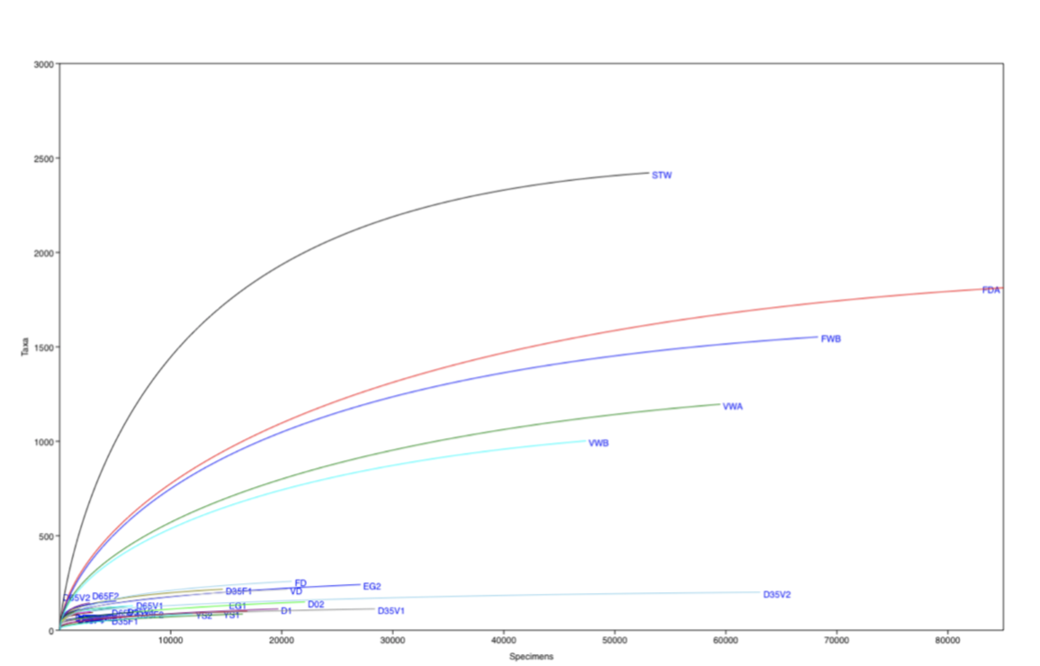

Figure S2: Rarefaction curves for the number of Taxa (OTUs) observed in all individual samples that analyzed in this study (water. diets and S. salar samples).
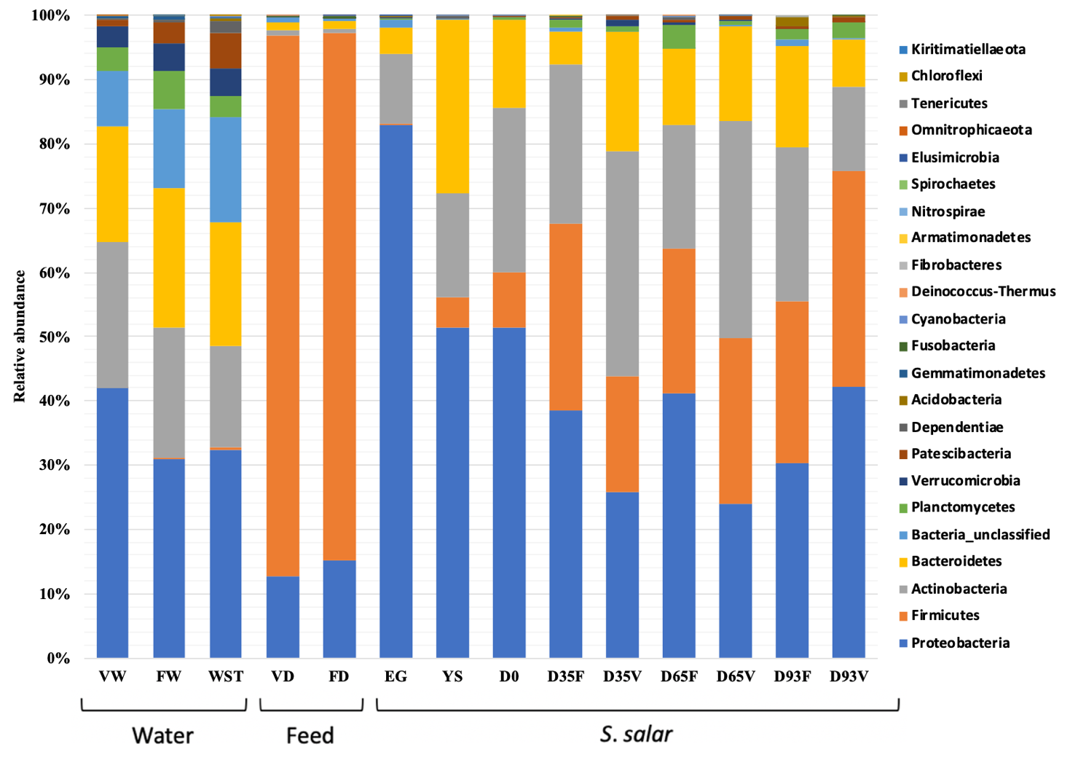
Figure S3: Relative abundance of bacterial phyla in all samples. grouped according to category. Pre-feeding S. salar life stages: Eggs (EG). yolk sac larvae (YS) and “D0”. Feeding stages of a) fish oil group (FD): D35F, D65F and D93F and b) vegetable oil group (VD): D35V, D65V and D93V. Rearing water: Pre-feeding tank (STW). fish oil group (FW) and vegetable oil group (VW). Feed: vegetable oil (VD) and fish oil feed (FD).
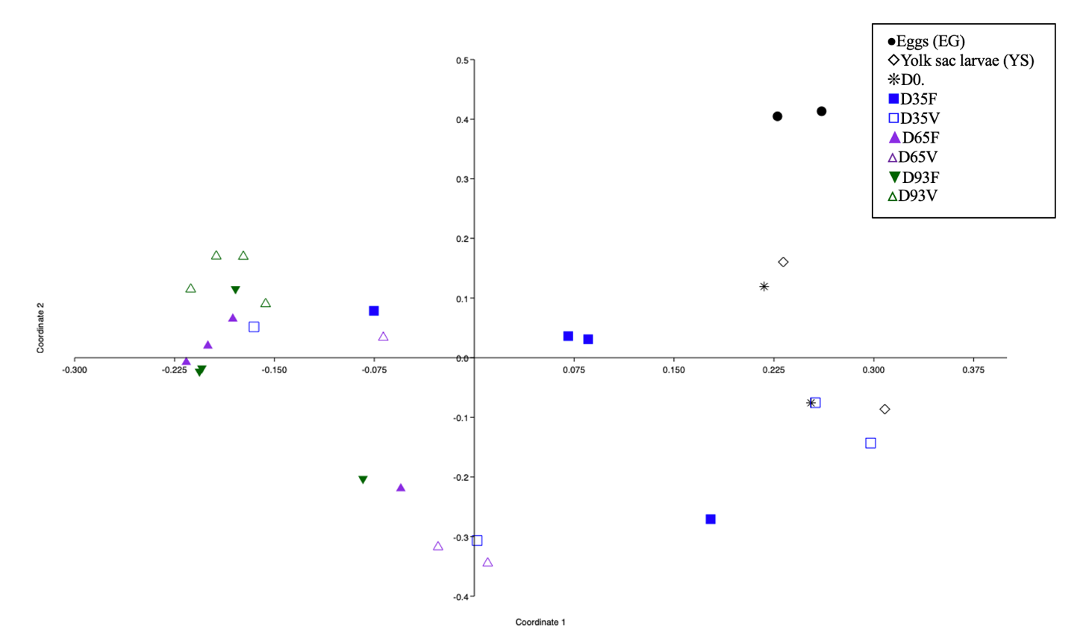
Figure S4. PCoA displays the bacterial communities of S. salar groups based on Bray-Curtis distance. Each feeding stage represented by different color: black = pre-feeding S. salar life stages (EG, YS, D0), blue = D35, purple = D65 and green = D93 . Different symbols correspond to the following dietary treatments: Fish oil group (FD) D35F, D65F and D93F and b) vegetable oil group (VD) D35V, D65V and D93V. D=day.
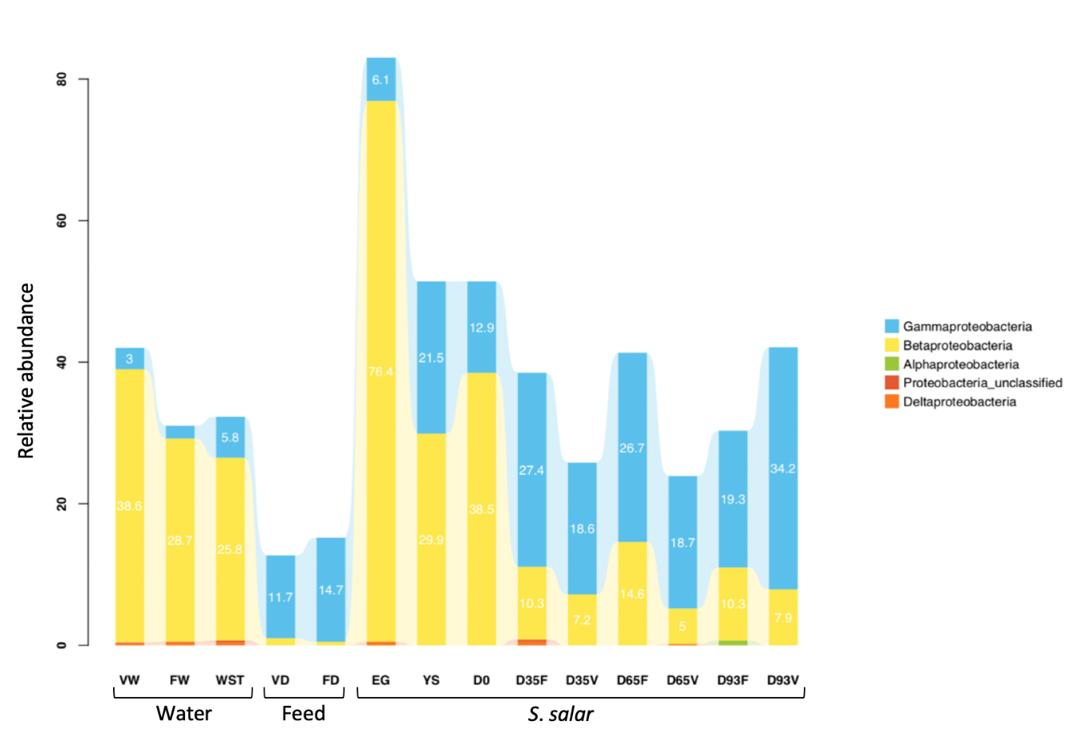
Figure S5: Relative abundance of Proteobacterial subphyla in all sample categories. Pre-feeding S. salar life stages: Eggs (EG). yolk sac larvae (YS) and “D0”. Feeding stages of a) fish oil group (FD): D35F, D65F and D93F and b) vegetable oil group (VD): D35V, D65V and D93V. Rearing water: Pre-feeding tank (STW), fish oil group (FW) and vegetable oil group (VW). Feed: vegetable oil (VD) and fish oil feed (FD).

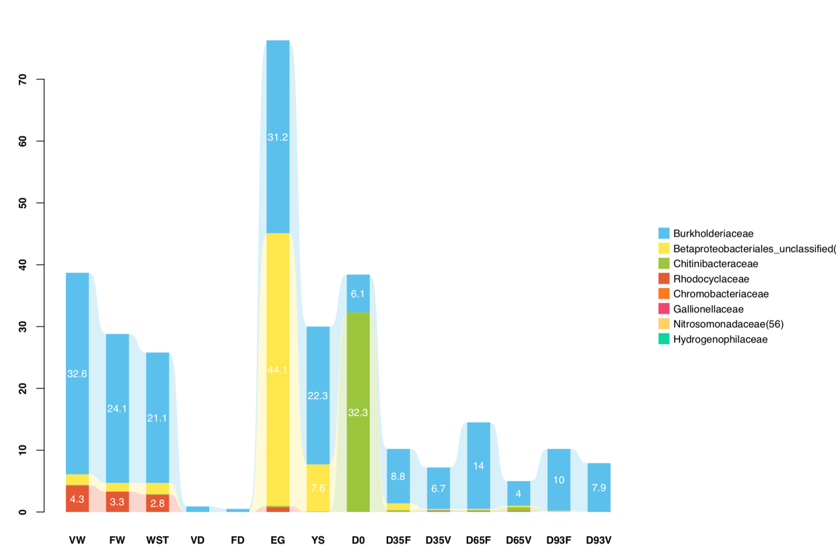

Figure S6: Pre-feeding S. salar life stages: Eggs (EG). yolk sac larvae (YS) and “D0”. Feeding stages of a) fish oil group (FD): D35F, D65F and D93F and b) vegetable oil group (VD): D35V, D65V and D93V. Rearing water: Pre-feeding tank (STW), fish oil group (FW) and vegetable oil group (VW). Feed: vegetable oil (VD) and fish oil feed (FD).
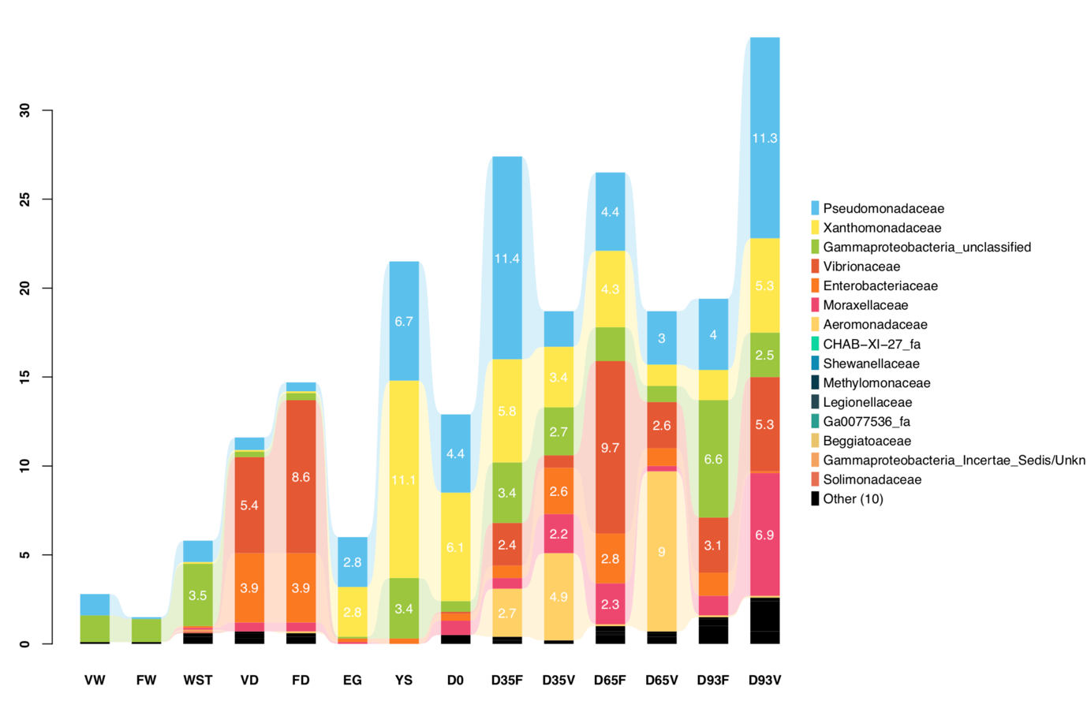
Figure S7: Relative abundance of γ-proteobacterial families in all sample categories. Pre-feeding S. salar life stages: Eggs (EG). yolk sac larvae (YS) and “D0”. Feeding stages of a) fish oil group (FD): D35F. D65F and D93F and b) vegetable oil group (VD) FD= D35V. D65V and D93V. Rearing water: Pre-feeding tank (STW). fish oil group (FW) and vegetable oil group (VW). Feed: vegetable oil (VD) and fish oil feed (FD).

