Supplementary Material
- Supplementary Figures

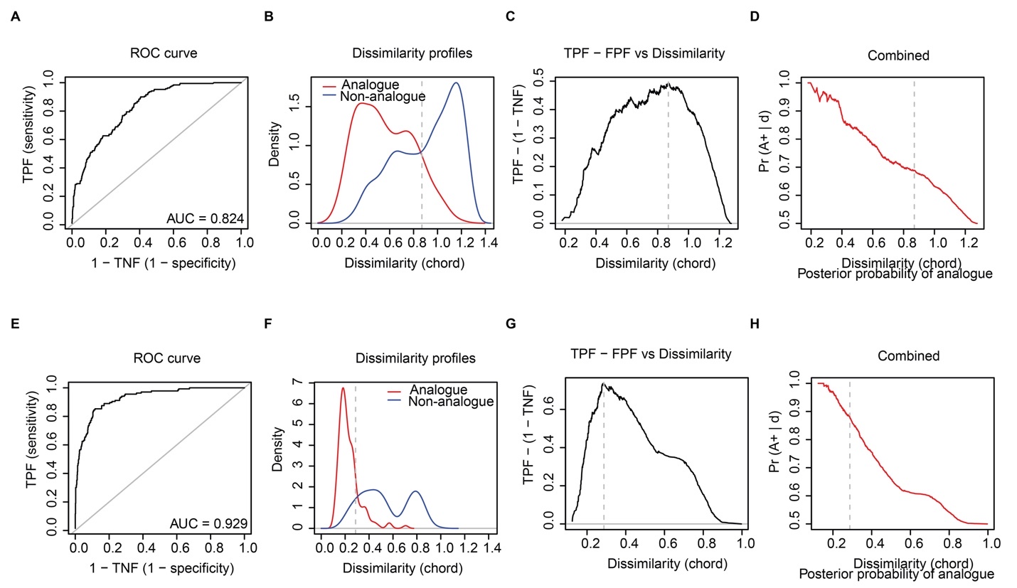
Supplementary Figure 1 | Receiver operating characteristic (ROC) curve analysis with chord distance applied to the log(x+1) transformed modern sedDNA and modern pollen data for Omoloy lake I. The results indicate that vegetation types can be well discriminated based on modern sedDNA (A-D) and modern pollen assemblages (E-H). The ROC curve and the area under curve (AUC) value assess the optimal dissimilarity threshold (d_{crit}) (A and E). Dissimilarity curves show the kernel density estimates of the distribution of pair-wise dissimilarities for analogue and non-analogue samples (B and F). The sensitivity (true positive fraction: TPF) and the specificity (true negative fraction: TNF) against dissimilarity suggest a good performance of ROC curve analysis (C and G). The posterior probability that any two samples are analogues is calculated based on TPF and false positive fraction (FPF) (D and H). Vertical dashed lines mark d_{crit}. All curves are based on the results of combined vegetation types.

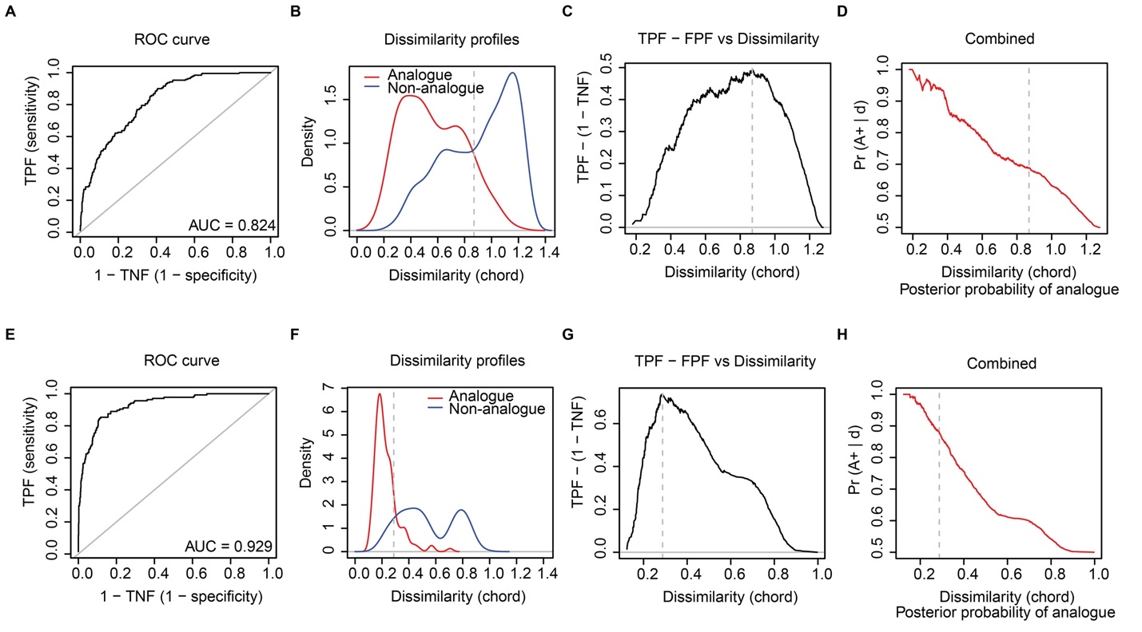
Supplementary Figure 2 | Receiver operating characteristic (ROC) curve analysis with chord distance applied to the log(x+1) transformed modern sedDNA and modern pollen data for Omoloy lake III. The results indicate that vegetation types can be well discriminated based on modern sedDNA (A-D) and modern pollen assemblages (E-H). The ROC curve and the area under curve (AUC) value assess the optimal dissimilarity threshold (d_{crit}) (A and E). Dissimilarity curves show the kernel density estimates of the distribution of pair-wise dissimilarities for analogue and non-analogue samples (B and F). The sensitivity (true positive fraction: TPF) and the specificity (true negative fraction: TNF) against dissimilarity suggest a good performance of ROC curve analysis (C and G). The posterior probability that any two samples are analogues is calculated based on TPF and false positive fraction (FPF) (D and H). Vertical dashed lines mark d_{crit}. All curves are based on the results of combined vegetation types.

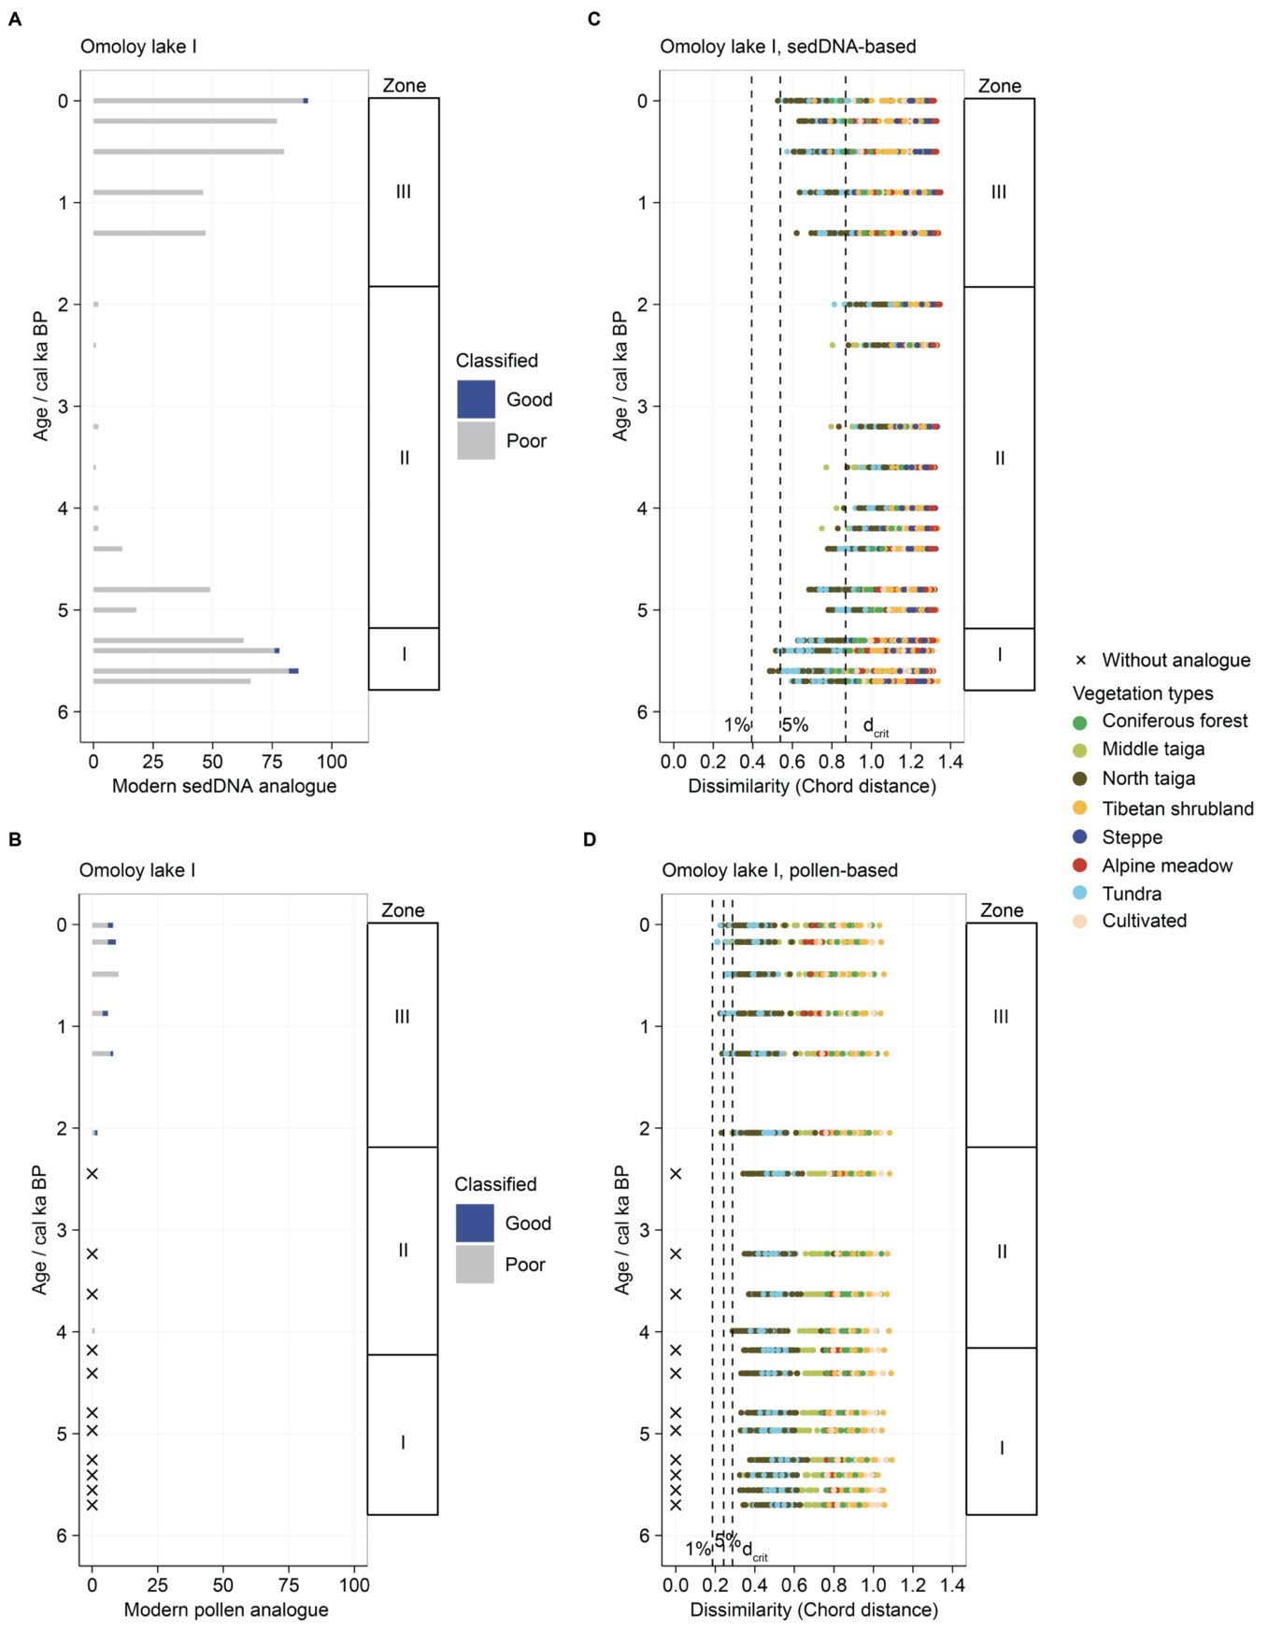
Supplementary Figure 3 | Quality and number of the modern analogues (left) and reconstructed vegetation types (right) for Omoloy lake I based on sedDNA (top) and pollen (bottom). The number of modern analogues is estimated via receiver operating characteristic (ROC) curve analysis. The modern analogues are classified as close (<1% percentile), good (1–5%), or poor (>5%). Fossil sediment samples without modern analogues are marked with an x. The point plots illustrate the reconstructed vegetation types based on sedDNA (C) and pollen data (D). Vertical dashed lines mark dissimilarity of 1%, 5%, and the optimal dissimilarity threshold (d_{crit}).
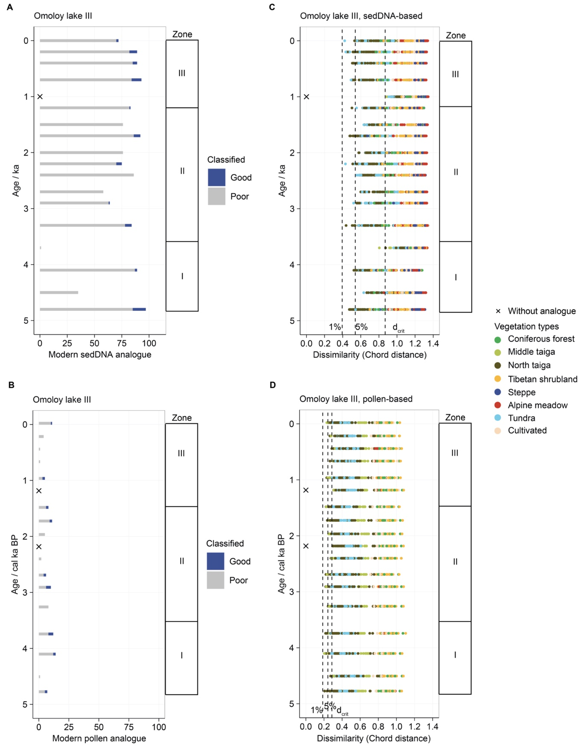
Supplementary Figure 4 | Quality and number of the modern analogues (left) and reconstructed vegetation types (right) for Omoloy lake III based on sedDNA (top) and pollen (bottom). The number of modern analogues is estimated via receiver operating characteristic (ROC) curve analysis. The modern analogues are classified as close (<1% percentile), good (1–5%), or poor (>5%). Fossil sediment samples without modern analogues are marked with an x. The point plots illustrate the reconstructed vegetation types based on sedDNA (C) and pollen data (D). Vertical dashed lines mark dissimilarity of 1%, 5%, and the optimal dissimilarity threshold (d_{crit}).
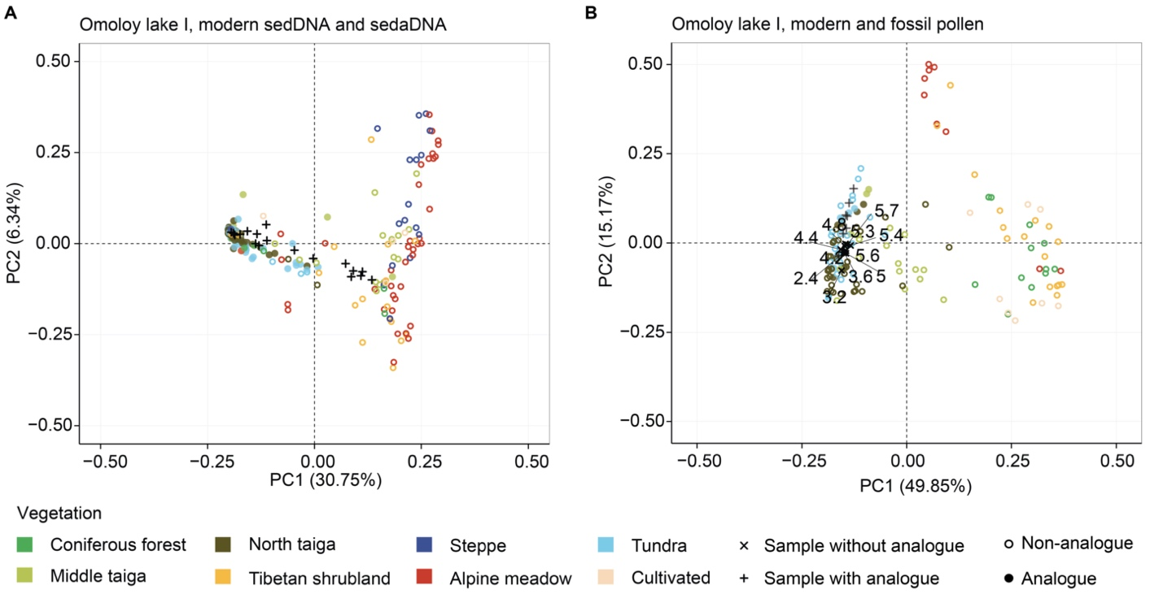
Supplementary Figure 5 | Plot of the principal component analysis (PCA) showing which modern samples (coloured according to vegetation type) have been matched to sediment assemblages (black) of Omoloy lake I. (A) PCA site scores explain 37.09% of the total variance of the log(1+x) chord transformed modern sedDNA training-set. (B) PCA site scores explain 65.02% of the total variance of the log-chord transformed modern pollen training-set.
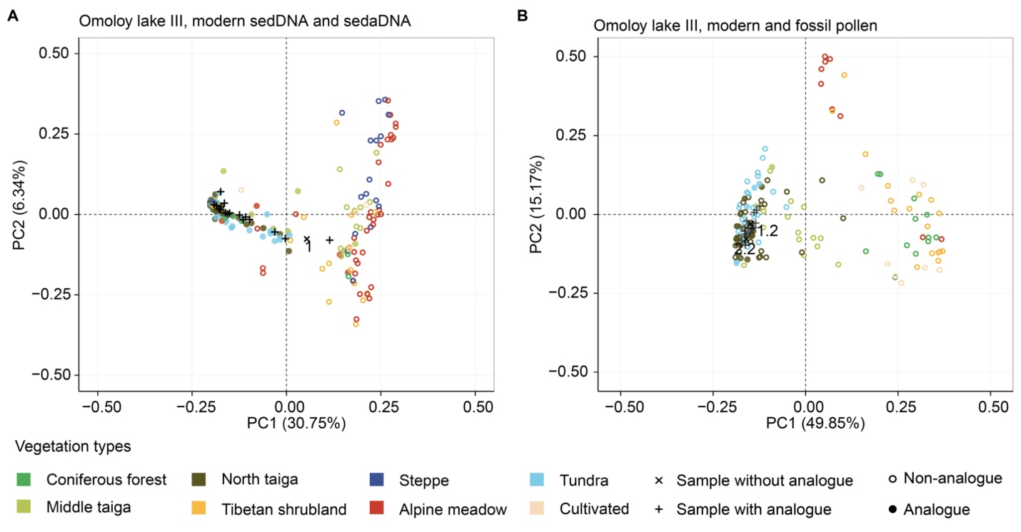
Supplementary Figure 6 | Plot of the principal component analysis (PCA) showing which modern assemblages (coloured according to vegetation type) have been matched to sediment assemblages (black) of Omoloy lake III. (A) PCA site scores explain 37.09% of the total variance of the log(1+x)-chord transformed modern sedDNA training-set. (B) PCA site scores explain 65.02% of the total variance of the log-chord transformed modern pollen training-set.
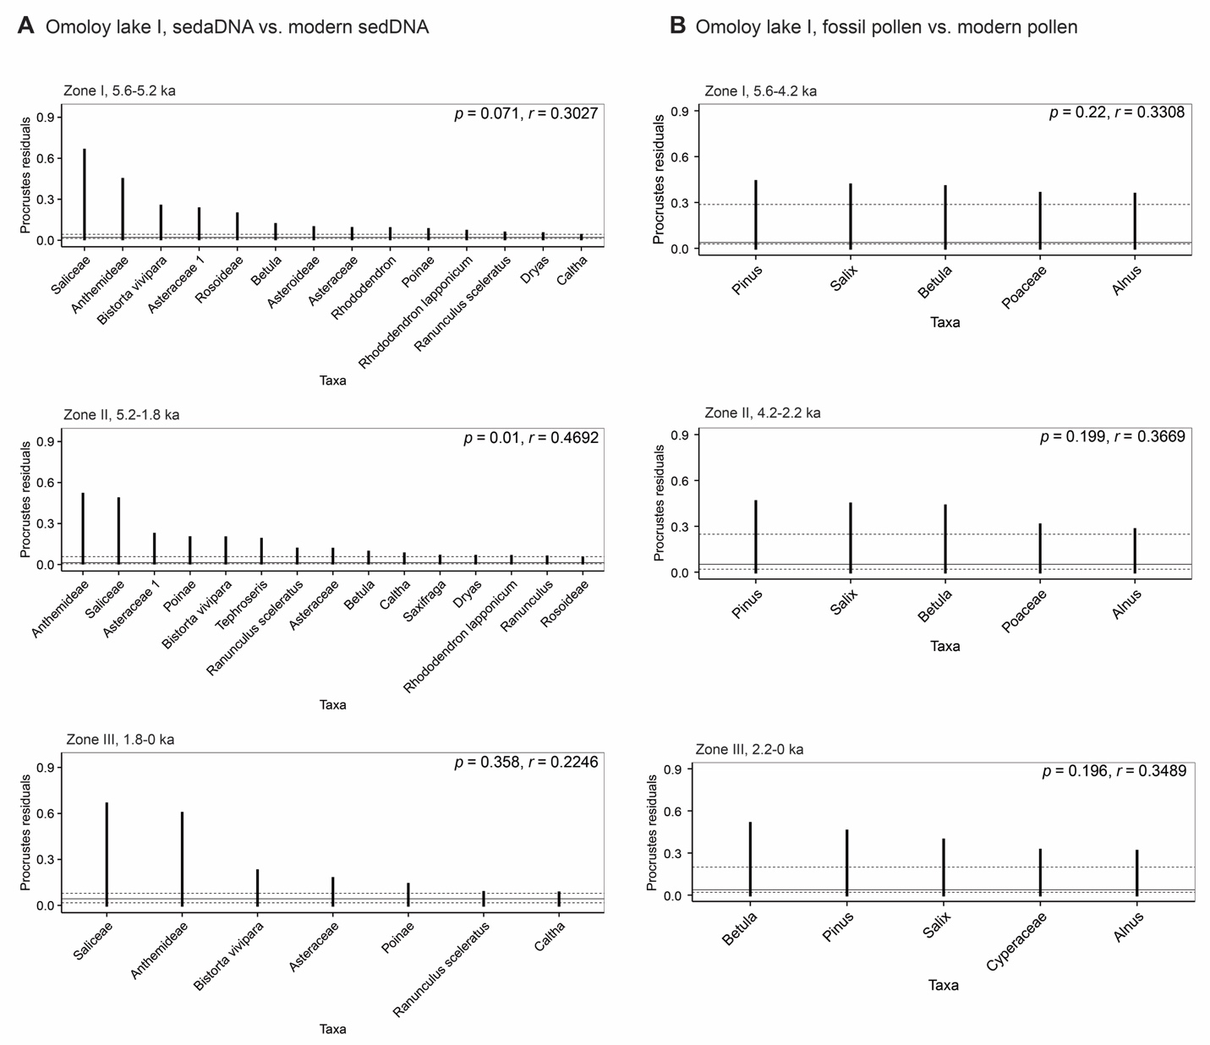
Supplementary Figure 7 | Procrustes analysis showing the residuals of principal component analysis (PCA) species scores between fossil data and their modern training-set for sedDNA (left) and pollen (right) for Omoloy lake I. Dashed and solid lines are the first, second, and third quartiles. The p-value indicates the likelihood of the relationship occurring by chance and r is the correlation between the two ordination results by superimposition. Taxa whose residuals are greater than the third quartile are shown.
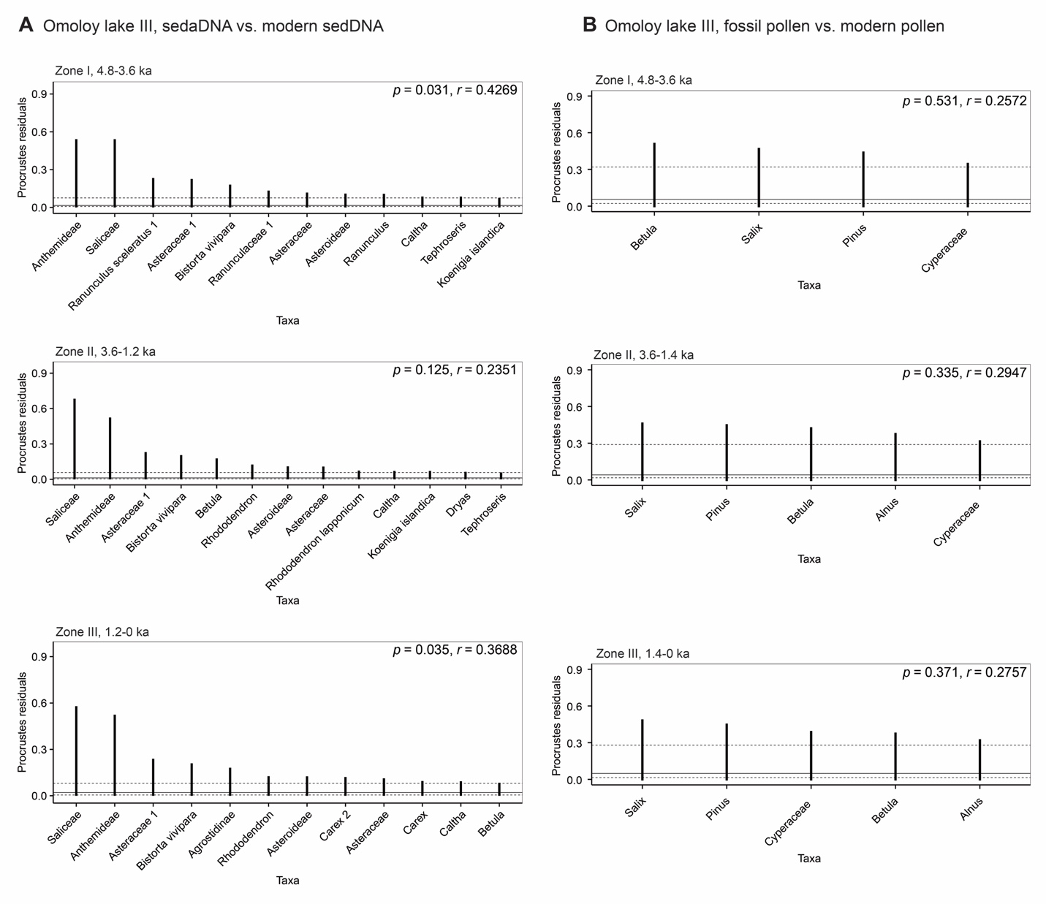
Supplementary Figure 8 | Procrustes analysis showing the residuals of principal component analysis (PCA) species scores between fossil data and their modern training-set for sedDNA (left) and pollen (right) for Omoloy lake III. Dashed and solid lines are the first, second, and third quartiles. The p-value indicates the likelihood of the relationship occurring by chance and r is the correlation between the two ordination results by superimposition. Taxa whose residuals are greater than the third quartile are shown.
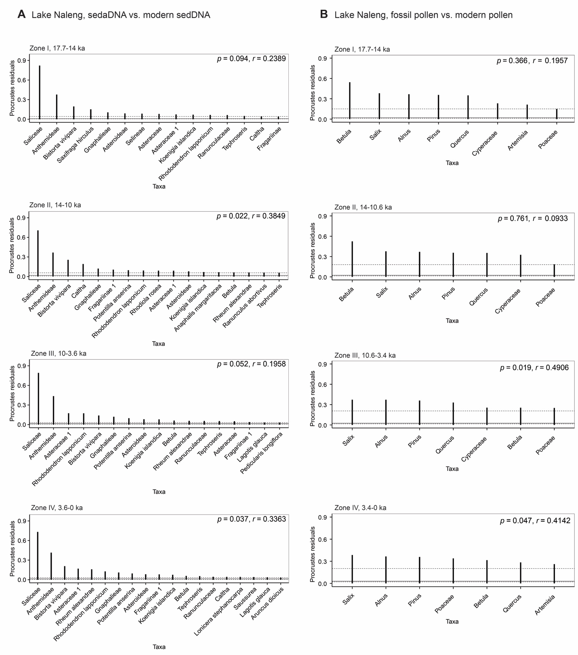
Supplementary Figure 9 | Procrustes analysis showing the residuals of principal component analysis (PCA) species scores between fossil data and their modern training-set for sedDNA (left) and pollen (right) for Lake Naleng. Dashed and solid lines are the first, second, and third quartiles. The p-value indicates the likelihood of the relationship occurring by chance and r is the correlation between the two ordination results by superimposition. Taxa whose residuals are greater than the third quartile are shown.
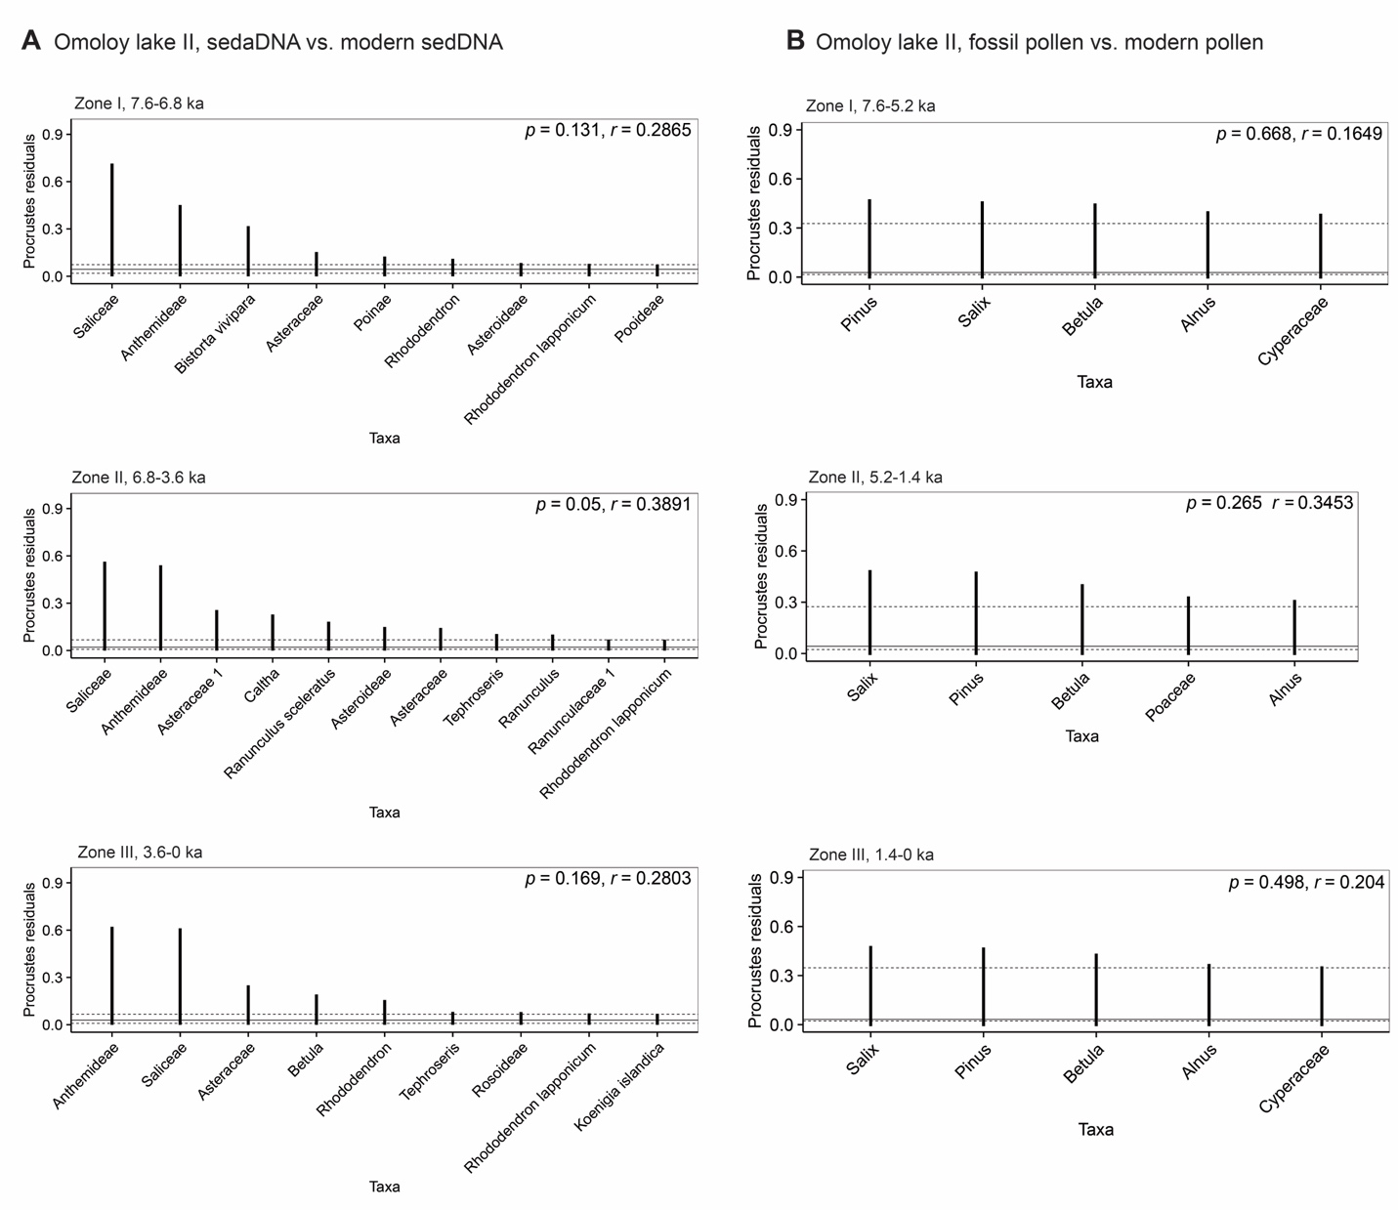
Supplementary Figure 10 | Procrustes analysis showing the residuals of principal component analysis (PCA) species scores between fossil data and their modern training-set for sedDNA (left) and pollen (right) for Omoloy lake II. Dashed and solid lines are the first, second, and third quartiles. The p-value indicates the likelihood of the relationship occurring by chance and r is the correlation between the two ordination results by superimposition. Taxa whose residuals are greater than the third quartile are shown.
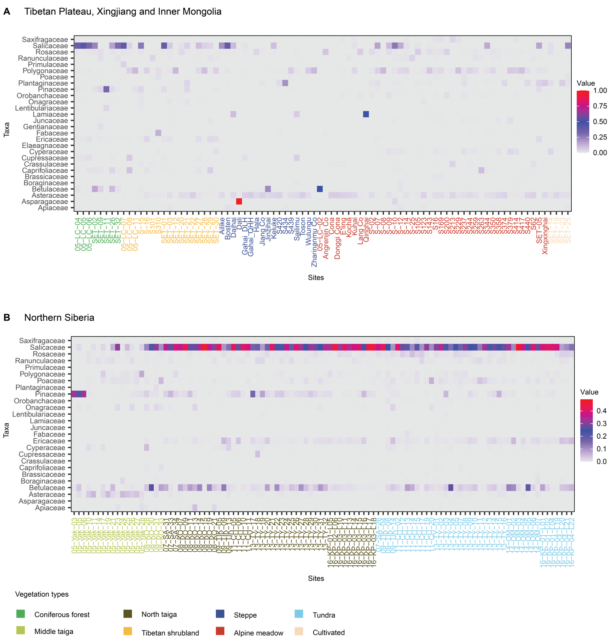
Supplementary Figure 11 | Relative read abundance of the modern sedDNA data. The percentages of taxa on the family-level are present. The taxonomic resolution used in statistical analyses is described in Supplementary Data 2.
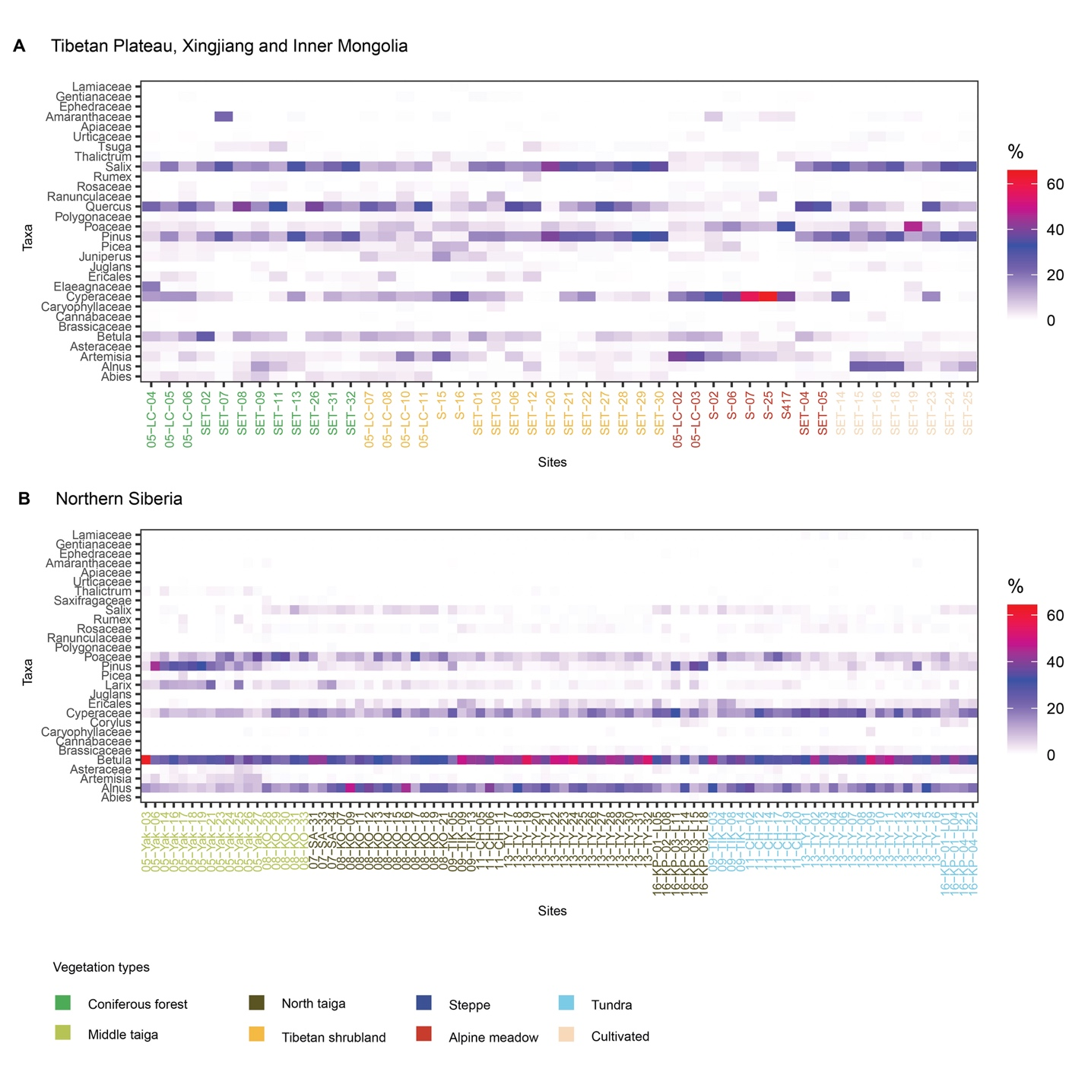
Supplementary Figure 12 | Relative abundance of the modern pollen data. The percentages of taxa on the family-level are present. The taxonomic resolution used in statistical analyses is described in Supplementary Data 2.
- Supplementary Tables
Supplementary Table 1 | The overview of modern sedDNA and sedaDNA datasets
 | Rarefied modern sedDNA data |  |  |  | Rarefied sedaDNA data
 | Original |  | Selection / max. 2% at least + 5 occurrences |  | Original |  | Selection / max. 2% at least +  5 occurrences
Core | Sample size | Number of taxa | Sample size | Number of taxa | Sample size | Number of taxa | Sample size | Number of taxa
Lake Naleng | 190 | 385 | 190 | 125 | 71 | 153 | 71 | 87
Lake Omoloy I | 190 | 385 | 190 | 117 | 18 | 156 | 18 | 64
Lake Omoloy II | 190 | 385 | 190 | 115 | 18 | 85 | 18 | 51
Lake Omoloy III | 190 | 385 | 190 | 119 | 18 | 110 | 18 | 59

Supplementary Table 2 | The overview of modern and fossil pollen datasets
 | Modern pollen data |  |  |  | Fossil pollen data
 | Original |  | Selection / max. 2% at least + 5 occurrences |  | Original |  | Selection / max. 2% at least +  5 occurrences
Core | Sample size | Number of taxa | Sample size | Number of taxa | Sample size | Number of taxa | Sample size | Number of taxa
Lake Naleng | 136 | 54 | 136 | 33 | 191 | 40 | 191 | 29
Lake Omoloy I | 136 | 54 | 136 | 29 | 18 | 33 | 18 | 20
Lake Omoloy II | 136 | 54 | 136 | 29 | 18 | 34 | 18 | 20
Lake Omoloy III | 136 | 54 | 136 | 29 | 18 | 37 | 18 | 21

Supplementary Table 3 | Overview of the receiver operating characteristic (ROC) curve analysis of the modern sedDNA and modern pollen training-set corresponding to Omoloy lakes I and III.
Data | Vegetation | In | Out | Opt. Dis. | AUC | SE | p-value
Omoloy lake I
sedDNA | Coniferous forest | 8 | 182 | 1.008 | 0.880 | 0.079 | 2.81E-04
sedDNA | Cultivated | 4 | 186 | 0.817 | 0.991 | 0.034 | 8.09E-04
sedDNA | Alpine meadow | 40 | 150 | 0.625 | 0.672 | 0.051 | 8.74E-04
sedDNA | Middle taiga | 19 | 171 | 0.602 | 0.796 | 0.063 | 2.38E-05
sedDNA | North taiga | 44 | 146 | 0.793 | 0.746 | 0.046 | 7.46E-07
sedDNA | Tibetan shrubland | 17 | 173 | 1.033 | 0.598 | 0.076 | 1.82E-01
sedDNA | Steppe | 17 | 173 | 0.813 | 0.724 | 0.072 | 2.39E-03
sedDNA | Tundra | 41 | 149 | 0.504 | 0.914 | 0.031 | 5.05E-16
sedDNA | Combined | 190 | 1330 | 0.870 | 0.824 | 0.019 | 2.07E-47
pollen | Coniferous forest | 12 | 124 | 0.384 | 0.948 | 0.045 | 3.29E-07
pollen | Cultivated | 8 | 128 | 0.270 | 0.996 | 0.016 | 2.68E-06
pollen | Alpine meadow | 9 | 127 | 0.314 | 0.892 | 0.072 | 9.11E-05
pollen | Middle taiga | 18 | 118 | 0.257 | 0.934 | 0.041 | 3.27E-09
pollen | North taiga | 43 | 93 | 0.204 | 0.974 | 0.017 | 7.71E-19
pollen | Tibetan shrubland | 17 | 119 | 0.440 | 0.943 | 0.040 | 3.88E-09
pollen | Tundra | 29 | 107 | 0.282 | 0.934 | 0.033 | 8.59E-13
pollen | Combined | 136 | 816 | 0.287 | 0.929 | 0.015 | 7.77E-58
Omoloy lake III
sedDNA | Coniferous forest | 8 | 182 | 1.008 | 0.880 | 0.079 | 2.81E-04
sedDNA | Cultivated | 4 | 186 | 0.817 | 0.991 | 0.034 | 8.09E-04
sedDNA | Alpine meadow | 40 | 150 | 0.625 | 0.672 | 0.051 | 8.64E-04
sedDNA | Middle taiga | 19 | 171 | 0.602 | 0.796 | 0.063 | 2.38E-05
sedDNA | North taiga | 44 | 146 | 0.793 | 0.749 | 0.046 | 5.95E-07
sedDNA | Tibetan shrubland | 17 | 173 | 1.033 | 0.600 | 0.076 | 1.74E-01
sedDNA | Steppe | 17 | 173 | 0.813 | 0.724 | 0.072 | 2.36E-03
sedDNA | Tundra | 41 | 149 | 0.523 | 0.909 | 0.032 | 1.08E-15
sedDNA | Combined | 190 | 1330 | 0.870 | 0.824 | 0.019 | 2.49E-47
pollen | Coniferous forest | 12 | 124 | 0.384 | 0.948 | 0.045 | 3.29E-07
pollen | Cultivated | 8 | 128 | 0.270 | 0.996 | 0.016 | 2.68E-06
pollen | Alpine meadow | 9 | 127 | 0.314 | 0.892 | 0.072 | 9.11E-05
pollen | Middle taiga | 18 | 118 | 0.257 | 0.934 | 0.041 | 3.27E-09
pollen | North taiga | 43 | 93 | 0.204 | 0.974 | 0.017 | 7.71E-19
pollen | Tibetan shrubland | 17 | 119 | 0.440 | 0.943 | 0.040 | 3.88E-09
pollen | Tundra | 29 | 107 | 0.282 | 0.934 | 0.033 | 8.59E-13
pollen | Combined | 136 | 816 | 0.287 | 0.929 | 0.015 | 7.77E-58
Combined: all vegetation types
In: the number of analogues;
Out: the number of non-analogues;
Opt. Dis.: the optimal dissimilarity;
AUC: the area under the ROC curve;
SE: the standard error of AUC;
p-value: a Wilcoxon rank
Supplementary Table 4 | Results of Procrustes analysis and associated PROTEST indicating the significant sequences/taxa fit between fossil assemblages and modern training-sets for Omoloy lakes I and III
 | p-value | r | m¹² | RMSE | Age zone
Omoloy lake I
Modern sedDNA vs. sedaDNA | 0.071 | 0.3027 | 0.9083 | 0.1285 | 5.6-5.2 ka
 | 0.01 | 0.4692 | 0.7799 | 0.117 | 5.2-1.8 ka
 | 0.358 | 0.2246 | 0.9495 | 0.1875 | 1.8-0 ka
Modern pollen vs. Fossil pollen | 0.22 | 0.3308 | 0.8905 | 0.211 | 5.6-4.2 ka
 | 0.199 | 0.3669 | 0.8654 | 0.2134 | 4.2-2.2 ka
 | 0.196 | 0.3489 | 0.8783 | 0.2096 | 2.2-0 ka
Omoloy lake III
Modern sedDNA vs. sedaDNA | 0.031 | 0.4269 | 0.8178 | 0.1348 | 4.8-3.6 ka
 | 0.125 | 0.2351 | 0.9447 | 0.1375 | 3.6-1.2 ka
 | 0.035 | 0.3688 | 0.864 | 0.1342 | 1.2-0 ka
Modern pollen vs. Fossil pollen | 0.531 | 0.2572 | 0.9338 | 0.2416 | 4.8-3.6 ka
 | 0.335 | 0.2947 | 0.9131 | 0.2252 | 3.6-1.4 ka
 | 0.371 | 0.2757 | 0.924 | 0.2205 | 1.4-0 ka
p-value: Classical t-test statistic
r: Correlation between the two ordination results
m¹²: Procrustes rotation sum of squares
RMSE: Root mean square error

- Supplementary Codes
Supplementary Code 1: Analogue matching
# MAT for sedDNA-sedaDNA / modern-fossil pollen
# Here is an example for sedDNA-sedaDNA.
#

library(readxl)
library(readr)
library(reshape2)
library(data.table)
library(analogue)
library(dplyr)
library(tidyr)
library(forcats) # "fct_inorder"

# set path
setwd("~/")

# modern vegetation information
# modern sites: 190
# a subset of SI1: Environmental data of lake localities from https://doi.org/10.3897/BDJ.8.e57089
#
veg=as.data.frame(read_excel("Supplementary-Data1.xlsx", sheet = "sedDNA-sites"))

# sedDNA data, the rarefied dataset
# modern sites: 190
# the rarefied dataset, the raw data was downloaded from https://doi.org/10.3897/BDJ.8.e57089, SI3: Taxa list of # identified plant sequences and occurrences

finaleper=as.data.frame(read_excel("Supplementary-Data2.xlsx", sheet = "sedDNA-rarefied counts-m"))

## set the rownames
rownames(finaleper)=finaleper$sequence.x
## set the frame
mdna=finaleper[-c(1:3)]
mdna=as.data.frame(t(mdna)) # sites x species
# check if total count per site = base count (1000)
rowSums(mdna)

## core name
core=c("NC", "OM12A", "OM02B", "OM20B")
# data type
dataT="DNA_roc"
# option: 2% + 5 times
opt="p002-s5"
# transformation
trans="log1p"

# MAT and ROC
# sedaDNA data
# Omoloy lakes: https://doi.org/10.3389/fevo.2020.560243
# Naleng (NC): in review
for (corei in core) {
# Prepaer aDNA
print(corei)
pdata=read.csv(paste0(corei, "_c10_rarefied_mean_specieslevel_C10_05_18.csv"), stringsAsFactors = FALSE, check.names = FALSE)
sdata=pdata[-c(2:3)]
rownames(sdata)=sdata$sequence.x
sdata$sequence.x=NULL
## remove sequence = 0
sdata=sdata[apply(sdata, 1, function(x) !all(x==0)),]
sdata=as.data.frame(t(sdata))
sdata$age=as.numeric(rownames(sdata))
sdata=sdata[order(sdata$age, decreasing = TRUE), ]
rownames(sdata)=sdata$age
sdata$age=NULL
# data%, remove NaN
# adna=sdata[complete.cases(sdata), ] # ages x seq
## store ages
adna=sdata
age=as.numeric(rownames(adna))

# Calculate %
## sample/age x species
mdna.per=prop.table(as.matrix(mdna), 1)
adna.per=prop.table(as.matrix(adna), 1)
## check if
rowSums(mdna.per) # should be 1
rowSums(adna.per) # should be 1

# Filter
mdna.per=as.data.frame(mdna.per)
adna.per=as.data.frame(adna.per)
## combine modern and fossil data
m.f.data=analogue::join(mdna.per, adna.per, verbose = TRUE)
mrd=m.f.data[[1]]
frd=m.f.data[[2]]
m.f.rd=rbind(mrd, frd)
## max >= 2% and times >= 5
max.abb <- apply(m.f.rd, 2, max)
n.occ <- colSums(m.f.rd > 0)
spp.want <- which(max.abb >= 0.02 & n.occ >= 5)
## select spp.want from modern and fossil data
mrd.want=mrd[, spp.want]
frd.want=frd[, spp.want]
## save (SI Table)
write.csv(mrd.want, paste0(corei, "_", dataT, "_", opt, "mDNA_relabun.csv"))
write.csv(frd.want, paste0(corei, "_", dataT, "_", opt, "aDNA_relabun.csv"))

# Transformation, log(1+x)
mrd.ln <- log1p(mrd.want)
frd.ln <- log1p(frd.want)

# Analog matching
## combine data
m.f.ln=analogue::join(mrd.ln, frd.ln, verbose = TRUE)
mrd.ln=m.f.ln[[1]]
frd.ln=m.f.ln[[2]]

## chord distance
core.analog <- analog(mrd.ln, frd.ln, method = "chord",
keep.train = T, na.rm=T)
## store analog results
outfile=summary(core.analog)

## store the analog
core.analogues=as.data.frame(core.analog[["analogs"]])
core.train=as.data.frame(core.analog[["train"]])
## output the data
write.csv(core.analogues, paste0("analogs_", corei,"_", dataT, "_",opt,"_",trans,".csv"))
write.csv(core.train, paste0("train_", corei,"_", dataT, "_",opt,"_",trans,".csv"))

# Assign the vegetation types to analog
vegT=veg[c("ana.Site", "Vegetation_type")]
names(vegT)=c("ana.Site", "VEG_TYPE")
vegT=vegT[vegT$ana.Site %in% rownames(mrd.ln), ]
## format vegT
vegType=as.vector(vegT$VEG_TYPE)
names(vegType)=as.vector(vegT$ana.Site)

# Calcualte the dcrit values for each vegetation type and combined vegetation types
core.analog.roc <- roc(core.analog, groups = vegType, method = "chord")
## make table
core.analog.roc.sta=core.analog.roc$statistics
core.analog.roc.sta$Dtype=dataT
## output
write.csv(core.analog.roc.sta, paste0(corei,"_", dataT, "_ROC_statistic_", opt, "_",trans,".csv"))

# Plot ROC curve
pdf(file = paste0(corei,"_", dataT, "_ROC_curves_", opt, "_",trans, ".pdf"), width = 8, height = 8)
opar <- par(mfrow = c(2,2))
plot(core.analog.roc, abline.col="gray", inGroup.col = "red", outGroup.col = "blue")
par(opar)
dev.off()

# Find the cutoff value
dcrit=core.analog.roc$roc[["Combined"]]$optimal
cutoff.value=dcrit

# check the analog quality
## plot
core.mdc=minDC(core.analog, probs = c(0.01, 0.02, 0.05, 0.1))
pdf(file = paste0(corei, "_mdc_r1000_", opt,"_",trans, ".pdf"), width=6,height=4)
plot(core.mdc, use.labels = TRUE, xlab = "Age / cal yr BP", main = " ", cex.axis=.5, cex.lab=.5)
title(main = list(paste0("Percentiles of the dissimilarities: ", corei, " sedaDNA vs. sedDNA training-set"), cex = .5,
col = "black", font = .5))
dev.off()
## make a table
core.mdc.sta=as.data.frame(core.mdc$minDC)
names(core.mdc.sta)="Dissimilarity"
write.csv(core.mdc.sta, paste0(corei,"_", dataT,"_mdc_", opt, "_",trans,".csv"))

core.mdc.quantiles=as.data.frame(core.mdc$quantiles)
names(core.mdc.quantiles)="quantiles"
core.mdc.quantiles$core=corei
write.csv(core.mdc.quantiles, paste0(corei,"_", dataT,"_mdc_quantiles_", opt, "_",trans,".csv"))

# Output: modern analogues
core.cma <- cma(core.analog, cutoff = cutoff.value, prob = c(0.01, 0.025, 0.05, 0.1))
closeSites.core.ana=core.cma[["close"]] # list
# output the modern analog
core.age=as.character(age)
buff.closeSites=NULL
for (agei in core.age) {
print(agei)
if (length(closeSites.core.ana[[agei]])>0) {
buff.closeSites=rbind(buff.closeSites, data.frame(T=agei,ana.Site=names(closeSites.core.ana[[agei]]),
ana.value=closeSites.core.ana[[agei]],
num.ana=length(closeSites.core.ana[[agei]])))
} else {
next
}
}
if (is.null(buff.closeSites) != TRUE) {
rownames(buff.closeSites)=rep(1:dim(buff.closeSites)[1])
# add veg. type
core.veg=merge(buff.closeSites, veg, by="ana.Site")
core.veg=core.veg[order(core.veg$T, decreasing = TRUE), ]
# for mapping and plot veg.
write.csv(buff.closeSites, paste0(corei, "_", dataT, "_modernAnalog_Veg_", opt, "_",trans,".csv"))
}
}

Supplementary Code 2: Ordination
# Ordination
# sedDNA-sedaDNA / modern-fossil pollen
# Here is an example for sedDNA-sedaDNA.

library(readr)
library(data.table)
library(analogue)
library(adespatial)
library(dplyr)
library(reshape2)
library(sf)
library(maps)
library(rnaturalearth)
library(rnaturalearthdata) # world
library(ggspatial) # annotation_
library(ggrepel) # needed for geom_text_repel()
library(gridExtra)
library(grDevices)
library(grid)
library(maptools)
library(rgdal)
library(forcats) # "fct_inorder"
library(RColorBrewer) # colorbar
library(easyGgplot2)
library(ggtext)
# set path
setwd("~/")

# modern vegetation information
# modern sites: 190
# a subset of SI1: Environmental data of lake localities from https://doi.org/10.3897/BDJ.8.e57089
#
veg=as.data.frame(read_excel("Supplementary-Data1.xlsx", sheet = "sedDNA-sites"))

# sedDNA data, the rarefied dataset
# modern sites: 190
# the rarefied dataset, the raw data was downloaded from https://doi.org/10.3897/BDJ.8.e57089, SI3: Taxa list of identified plant sequences and occurrences

finaleper=as.data.frame(read_excel("Supplementary-Data2.xlsx", sheet = " Supplementary-Data2.xlsx "))

## set the rownames
rownames(finaleper)=finaleper$sequence.x
## set the frame
mdna=finaleper[-c(1:3)]
mdna=as.data.frame(t(mdna)) # sites x species
# check if total count per site = base count (1000)
rowSums(mdna)

## core name
core=c("NC", "OM12A", "OM02B", "OM20B")
# data type
dataT="DNA_roc"
# option: 2% + 5 times
opt="p002-s5"
# transformation
trans="log1p"
# Forward selection
PCApre="PCAforward"

# sedaDNA data
# Omoloy lakes: https://doi.org/10.3389/fevo.2020.560243
# Naleng (NC): in review

##################
# ggplot colour, shapes, theme, codes in final position
##################

# prepare the colour
mycols=c(
# blue
rgb(61, 80, 147, maxColorValue = 255),
# red
rgb(199, 58, 43, maxColorValue = 255),
# orange
rgb(243, 186, 68, maxColorValue = 255),

# dark green
rgb(88, 83, 34, maxColorValue = 255),
# grass green
rgb(184, 196, 83, maxColorValue = 255),
# light green
rgb(79, 171, 88, maxColorValue = 255),

# light blue
rgb(126, 201, 229, maxColorValue = 255),
# yellow
rgb(245, 218, 186, maxColorValue = 255),
# purple
rgb(145, 140, 203, maxColorValue = 255),

# analogue quality
rgb(19, 49, 88, maxColorValue = 255),
rgb(54, 100, 168, maxColorValue = 255),
# < 1%
rgb(119, 186, 199, maxColorValue = 255),
# 1-5%
rgb(218, 214, 108, maxColorValue = 255),
# >5%
rgb(194, 194, 194, maxColorValue = 255)
)

cols.ana = c("Close" = mycols[2], "Good" = mycols[1], "Poor" = mycols[14])
# prepare the theme
my.theme <- theme(# Title
plot.title = element_text(#margin=margin(b=-20),
hjust = 0,
size = 8, family = "Helvetica", colour = "black"),
#aspect.ratio=4/2,
plot.margin = unit(c(0.4,0.4,0.4,0.4), "cm"),
panel.border = element_rect(colour = "black", fill=NA, size = 0.11),
# y axis right
axis.line.y.right = element_line(size = 0.233, colour = "black"),
axis.ticks.y.right = element_blank(),
axis.ticks.length.y.right = element_blank(),
axis.text.y.right = element_blank(),
axis.title.y.right = element_blank(),
# y axis left
axis.line.y.left = element_line(size = 0.233),
axis.ticks.y.left = element_line(size = 0.233, colour = "black"),
axis.ticks.length.y.left = unit(.10, "cm"),
axis.text.y.left = element_text(size = 8, family = "Helvetica", colour = "black"),
axis.title.y.left = element_text(size = 8, family = "Helvetica", colour = "black"),
# x axis top
axis.line.x.top = element_line(size = 0.233),
axis.ticks.x.top = element_blank(),
axis.text.x.top = element_blank(),
axis.title.x.top = element_blank(),
# x axis bottom
axis.line.x.bottom = element_line(size = 0.233),
axis.ticks.x.bottom = element_line(size = 0.233, colour = "black"),
axis.ticks.length.x.bottom = unit(.10, "cm"),
axis.text.x.bottom = element_text(size = 8, family = "Helvetica", colour = "black"),
axis.title.x.bottom = element_text(size = 8, family = "Helvetica", colour = "black"),
# legend
legend.position = "right",
#legend.background = element_rect(color = "black", fill = "grey90", size = 1, linetype = "solid"),
legend.text = element_text(size = 8, family = "Helvetica"),
legend.title = element_text(size = 8, family = "Helvetica"),
# grid
#panel.grid = element_blank()
panel.grid.major = element_line(size = 0.1),
panel.grid.minor.y = element_blank(),
panel.grid.minor.x = element_blank()
)

cols=c("Coniferous forest" = mycols[6],
"Middle taiga" = mycols[5],
"North taiga" = mycols[4],

######### shrub
"Tibetan shrubland" = mycols[3],

######## steppe
"Steppe" = mycols[1],

######## Alpine meadow
"Alpine meadow" = mycols[2],

# tundra
"Tundra" = mycols[7],

# others
"Cultivated" = mycols[8]
)
cols.fill=c("Coniferous forest" = mycols[6],
"Middle taiga" = mycols[5],
"North taiga" = mycols[4],

######### shrub
"Tibetan shrubland" = mycols[3],

######## steppe
"Steppe" = mycols[1],

######## Alpine meadow
"Alpine meadow" = mycols[2],

# tundra
"Tundra" = mycols[7],

# others
"Cultivated" = mycols[8]
)
#
# Ordination
for (corei in core) {
print(corei)
# fossil composition
cdata=read.csv(paste0(corei, "_c10_rarefied_mean_specieslevel_C10_05_18.csv"), stringsAsFactors = FALSE, check.names = FALSE)
tdata=cdata[-c(2:3)]
rownames(tdata)=tdata$sequence.x
tdata$sequence.x=NULL
tdata=as.data.frame(t(tdata))
tdata$age=as.numeric(rownames(tdata))
tdata=tdata[order(tdata$age, decreasing = TRUE), ]
rownames(tdata)=tdata$age
tdata$age=NULL
# buff, fossil data
fdata=tdata

# Calculate %
## sample/age x species
mrdata=prop.table(as.matrix(mdna), 1)
frdata=prop.table(as.matrix(fdata), 1)
## check if
rowSums(mrdata) # should be 1
rowSums(frdata) # should be 1

# data frame
mrdata=as.data.frame(mrdata)
frdata=as.data.frame(frdata)
# joint data
m.f.data=analogue::join(mrdata, frdata, verbose = TRUE)
#
mrd=m.f.data[[1]]
frd=m.f.data[[2]]

m.f.rd=rbind(mrd, frd)
# max > 2% and present in 5 sites
max.abb <- apply(m.f.rd, 2, max)
n.occ <- colSums(m.f.rd > 0)
spp.want <- which(max.abb > 0.02 & n.occ >= 5)
#
mrd.p002.s5=mrd[, spp.want]
frd.p002.s5=frd[, spp.want]
#
mrd.st=mrd.p002.s5
frd.st=frd.p002.s5

# matrix
mrd.st=as.matrix(mrd.st)
frd.st=as.matrix(frd.st)
#
mrd.st.ln <- log1p(mrd.st)
frd.st.ln <- log1p(frd.st)
#
mrd.st.ln.norm <- decostand(mrd.st.ln, "norm")
frd.st.ln.norm <- decostand(frd.st.ln, "norm")

mrd.st.ln.norm=as.data.frame(mrd.st.ln.norm)
frd.st.ln.norm=as.data.frame(frd.st.ln.norm)
# joint data
m.f.bcbox.data=analogue::join(mrd.st.ln.norm, frd.st.ln.norm, verbose = TRUE)
#
mrd.bcbox=m.f.bcbox.data[[1]]
frd.bcbox=m.f.bcbox.data[[2]]

# PCA for log-chord transformed training-set
mrd.box.cox.chord.pca=rda(mrd.bcbox)
#
mrd.box.cox.chord.pca.sum=summary(mrd.box.cox.chord.pca)
pro.ex=as.data.frame(mrd.box.cox.chord.pca.sum[["cont"]][["importance"]])
pro.ex.pc1=round(pro.ex$PC1[2]*100, digits = 2)
pro.ex.pc2=round(pro.ex$PC2[2]*100, digits = 2)

# process the fossil data with the predict.PCA
f.m.pred=as.data.frame(predict(mrd.box.cox.chord.pca, newdata=frd.bcbox, type = "wa", scaling = 3, model = "CA"))

# data1
f.m.pred.pc12=f.m.pred[c("PC1", "PC2")]
f.m.pred.pc12$age=rownames(f.m.pred.pc12)
f.m.pred.pc12$age=as.numeric(f.m.pred.pc12$age)

write.csv(f.m.pred.pc12, paste0("fPCA_", corei,"_", dataT, "_",opt,"_",trans,".csv"))

# summary
perta.pca=mrd.box.cox.chord.pca
perta.pca.site <- scores(perta.pca, display = "sites", scaling = 3)
perta.pca.spp <- scores(perta.pca, display = "species", scaling = 3)
# output the PCA data
m.site.pc=as.data.frame(perta.pca.site)
m.sp.pc=as.data.frame(perta.pca.spp)
m.sp.pc$sequence.x=rownames(m.sp.pc)
m.sp.pc.m=merge(m.sp.pc, sp.rarefied.full[1:3], by = "sequence.x")
m.sp.pc.f=merge(m.sp.pc, cdata[1:3], by = "sequence.x")
names(m.sp.pc.f)=c("sequence.x", "PC1", "PC2", "Species_R", "Family_R")
m.sp.pc.name=rbind(m.sp.pc.m, m.sp.pc.f)
# remove duplicated
deduped.m.sp.pc <- unique(m.sp.pc.name[, 1:5] )
rownames(deduped.m.sp.pc)=make.names(deduped.m.sp.pc$Species_R, unique = T)
deduped.m.sp.pc$taxa=rownames(deduped.m.sp.pc)

# add veg
m.site.pc$ana.Site=rownames(m.site.pc)
veg.msite=subset(veg, veg$ana.Site %in% m.site.pc$ana.Site)
m.site.pc=merge(m.site.pc, veg.msite, by="ana.Site")

# modern PCA + Veg infor
m.pdata=m.site.pc[c("ana.Site", "PC1", "PC2", "Vegetation_type", "Geographic region")]
names(m.pdata)=c("ana.Site", "PC1", "PC2", "Veg_Plot", "Region")
#
write.csv(m.pdata, paste0("mPCA_", corei,"_", dataT, "_",opt,"_",trans,".csv"))

# Full ana and non-ana for AM
fam=read.csv(paste0("analogs_", corei,"_", dataT, "_",opt,"_",trans,".csv"), check.names = F)
names(fam)[1]="ana.Site"
#
fam.mdata <- melt(setDT(fam), id=c("ana.Site"), variable.factor = FALSE)
names(fam.mdata)=c("ana.Site", "age", "ana.value")
fam.mdata=type_convert(fam.mdata)

#
core.quant=read.csv(paste0(corei,"_", dataT,"_mdc_quantiles_", opt, "_",trans,".csv"))
names(core.quant)[1]="qua"

fam.5=fam.mdata
# dcrit
dcrit=read.csv(paste0(corei,"_", dataT, "_ROC_statistic_", opt, "_",trans,".csv"))
names(dcrit)[1]="vegG"
dcrit.value=as.data.frame(dcrit[dcrit$vegG == "Combined", "Opt..Dis."])
names(dcrit.value)="dcrit.value"
#
fam.5$analogues=ifelse(fam.mdata$ana.value < core.quant$quantiles[1], "Close",
ifelse(fam.mdata$ana.value >= core.quant$quantiles[1] & fam.mdata$ana.value < core.quant$quantiles[3], "Good",
ifelse(fam.mdata$ana.value >= core.quant$quantiles[3] & fam.mdata$ana.value < dcrit.value$dcrit.value, "Poor", "Non-analogue")))

fam.an=subset(fam.5, !(fam.5$analogues %in% c("Non-analogue")))
fam.ana=subset(fam.5, fam.5$analogues %in% c("Non-analogue"))
# as analogue one time at least
anS=as.data.frame(unique(fam.an$ana.Site))
names(anS)=c("ana.Site")
anS.veg=subset(m.pdata, m.pdata$ana.Site %in% anS$ana.Site)
# never as analogue
non.anS=subset(m.pdata, !(m.pdata$ana.Site %in% anS$ana.Site))
# good ana
fam.good=subset(fam.5, fam.5$analogues %in% c("Close", "Good"))
ana.good=as.data.frame(unique(fam.good$ana.Site))
names(ana.good)=c("ana.Site")
ana.good=subset(m.pdata, m.pdata$ana.Site %in% ana.good$ana.Site)
# read ana
fd.an=read.csv(paste0(corei, "_", dataT, "_modernAnalog_Veg_", opt, "_",trans,".csv"))
names(fd.an)[2]="age"
fd.an.T=as.data.frame(unique(fd.an$age))
names(fd.an.T)="age"
# fossil samples having analogue
fd.an.pca=subset(f.m.pred.pc12, f.m.pred.pc12$age %in% fd.an.T$age)
fd.non.an.pca=subset(f.m.pred.pc12, !(f.m.pred.pc12$age %in% fd.an.T$age))

# Veg level
anS.veg$fVEG <- factor(anS.veg$Veg_Plot, levels=c("Coniferous forest", "Tibetan shrubland", "Steppe", "Alpine meadow", "Middle taiga",
"North taiga", "Tundra", "Cultivated"))
non.anS$fVEG <- factor(non.anS$Veg_Plot, levels=c("Coniferous forest", "Tibetan shrubland", "Steppe", "Alpine meadow", "Middle taiga",
"North taiga", "Tundra", "Cultivated"))
ana.good$fVEG <- factor(ana.good$Veg_Plot, levels=c("Coniferous forest", "Tibetan shrubland", "Steppe", "Alpine meadow", "Middle taiga",
"North taiga", "Tundra", "Cultivated"))

# plot
if (corei %in% c("OM12A", "OM02B")) {
cor.geo.p=corei
p1=ggplot() +
# x and y
scale_x_continuous(name = paste0("PC1 (", pro.ex.pc1, "%)"), limits = c(-0.5, 0.5)) +
scale_y_continuous(name = paste0("PC2 (", pro.ex.pc2, "%)"), limits = c(-0.5, 0.5)) +
# pc1 = 0, pc2 = 0
geom_hline(yintercept = 0, lty = 2, size = 0.15) +
geom_vline(xintercept = 0, lty = 2, size = 0.15) +

# analgoues
geom_point(data =anS.veg, aes(x = PC1, y = PC2, color = fVEG, fill = fVEG), shape = 16, show.legend = FALSE, size = 1.5, alpha = 0.8) +
# label good
#geom_text_repel(data = ana.good, aes(x = PC1, y = PC2, label = ana.Site, color = fVEG), nudge_y = -0.01, size = 2.5, segment.size = 0.1, show.legend = FALSE) +

# non-ana
geom_point(data = non.anS, aes(x = PC1, y = PC2, color = fVEG, fill = fVEG), shape = 1, size = 1) +
#geom_text_repel(data = non.anS, aes(x = PC1, y = PC2, label = ana.Site, color = fVEG),
# nudge_y = -0.01, size = 2, segment.size = 0.1, show.legend = FALSE) +

#fossil samples prediction, am
geom_point(data = fd.an.pca, aes(x = PC1, y = PC2), color = "black", shape = 3, size = 1) +

scale_color_manual(name = "Vegetation types",
values = cols) +
scale_fill_manual(name = "Vegetation types",
values = cols.fill) +
labs(title = cor.geo.p) +
# theme
theme_bw() +
my.theme
} else if (corei %in% c("NC")){
cor.geo.p=corei
p1=ggplot() +
# x and y
scale_x_continuous(name = paste0("PC1 (", pro.ex.pc1, "%)"), limits = c(-0.5, 0.5)) +
scale_y_continuous(name = paste0("PC2 (", pro.ex.pc2, "%)"), limits = c(-0.5, 0.5)) +
# pc1 = 0, pc2 = 0
geom_hline(yintercept = 0, lty = 2, size = 0.15) +
geom_vline(xintercept = 0, lty = 2, size = 0.15) +

# analgoues
geom_point(data =anS.veg, aes(x = PC1, y = PC2, color = fVEG, fill = fVEG), shape = 16, show.legend = FALSE, size = 1.5, alpha = 0.8) +
# label good
#geom_text_repel(data = ana.good, aes(x = PC1, y = PC2, label = ana.Site, color = fVEG), nudge_y = -0.01, size = 2.5, segment.size = 0.1, show.legend = FALSE) +

# non-ana
geom_point(data = non.anS, aes(x = PC1, y = PC2, color = fVEG, fill = fVEG), shape = 1, size = 1) +
#geom_text_repel(data = non.anS, aes(x = PC1, y = PC2, label = ana.Site, color = fVEG),
# nudge_y = -0.01, size = 2, segment.size = 0.1, show.legend = FALSE) +

#fossil samples prediction, am
geom_point(data = fd.an.pca, aes(x = PC1, y = PC2), color = "black", shape = 3, size = 1) +
geom_text_repel(data = fd.an.pca[1:21,], aes(x = PC1, y = PC2, label = age),
color = "black", nudge_y = -0.01, size = 2, segment.size = 0.1) +
# fossil non
geom_point(data = fd.non.an.pca, aes(x = PC1, y = PC2), color = "black", shape = 4, size = 1) +
geom_text_repel(data = fd.non.an.pca, aes(x = PC1, y = PC2, label = age),
color = "black", nudge_y = -0.01, size = 2, segment.size = 0.1) +

# legend
#scale_shape_manual(name = "Vegetation types",
# values = shapes) +
scale_color_manual(name = "Vegetation types",
values = cols) +
scale_fill_manual(name = "Vegetation types",
values = cols.fill) +
labs(title = cor.geo.p) +
# theme
theme_bw() +
my.theme
} else {
cor.geo.p=corei
p1=ggplot() +
# x and y
scale_x_continuous(name = paste0("PC1 (", pro.ex.pc1, "%)"), limits = c(-0.5, 0.5)) +
scale_y_continuous(name = paste0("PC2 (", pro.ex.pc2, "%)"), limits = c(-0.5, 0.5)) +
# pc1 = 0, pc2 = 0
geom_hline(yintercept = 0, lty = 2, size = 0.15) +
geom_vline(xintercept = 0, lty = 2, size = 0.15) +

# analgoues
geom_point(data =anS.veg, aes(x = PC1, y = PC2, color = fVEG, fill = fVEG), shape = 16, show.legend = FALSE, size = 1.5, alpha = 0.8) +
# label good
#geom_text_repel(data = ana.good, aes(x = PC1, y = PC2, label = ana.Site, color = fVEG), nudge_y = -0.01, size = 2.5, segment.size = 0.1, show.legend = FALSE) +

# non-ana
geom_point(data = non.anS, aes(x = PC1, y = PC2, color = fVEG, fill = fVEG), shape = 1, size = 1) +
#geom_text_repel(data = non.anS, aes(x = PC1, y = PC2, label = ana.Site, color = fVEG),
# nudge_y = -0.01, size = 2, segment.size = 0.1, show.legend = FALSE) +

#fossil samples prediction, am
geom_point(data = fd.an.pca, aes(x = PC1, y = PC2), color = "black", shape = 3, size = 1) +

# fossil non
geom_point(data = fd.non.an.pca, aes(x = PC1, y = PC2), color = "black", shape = 4, size = 1) +
geom_text_repel(data = fd.non.an.pca, aes(x = PC1, y = PC2, label = age),
color = "black", nudge_y = -0.01, size = 2, segment.size = 0.1) +

scale_color_manual(name = "Vegetation types",
values = cols) +
scale_fill_manual(name = "Vegetation types",
values = cols.fill) +

labs(title = cor.geo.p) +
# theme
theme_bw() +
my.theme
}
#ggplot2
ggsave(paste0(corei, "_",dataT, "_",PCApre, "_", opt, "_",trans,".pdf"), plot = p1, width = 15, height = 10, units = "cm")
}

