Antibodies
Name | Supplier &Catalog No. | note
Anti-Smoothened antibody | Abcam, Cat. No. ab72130
Anti-Gli1 antibody | Affinity Biosciences, Cat. No.DF7523
Anti-Gli2 antibody | Affinity Biosciences, Cat. No. DF7541
Anti-Hcn4 antibody | Millipore, Cat. No. AB5808
Anti-Tbx5 antibody | Sigma, Cat. No. HPA008786
Anti-Cdk6 antibody | Abclonal, Cat. No. A0705
Anti-phospho Smad1/5/8 | Millipore, Cat. No. AB3848-I
Phospho-histone H3(Ser10) | Cell Signaling Technology, Cat. No.9701s
Chemicals, Recombinant Proteins and Reagents
BMP2 recombinant human protein | ThermoFisher, Cat. No. phc7145
Rat tail collagen I | ThermoFisher, Cat. No.1048301
Blocking reagent | Sigma, Cat. No. 11096176001
BM purple AP substrate | Sigma, Cat. No. 11442074001
Anti-digoxigenin-AP, Fab fragments from sheep | Sigma, Cat. No. 11093274910
NTP Dig labelling mix | Sigma, Cat. No. 11277073910
RevertAid Firs-Strand cDNA Synthesis Kit | ThermoFisher, Cat. No. K1622
SYBR Green Powerup Master Mix | ThermoFisher, Cat. No. A25776
Lipofectamine 3000 | ThermoFisher, Cat. No. L3000001
TriPure | Roche, Cat. No. 11667165001
EdU cell proliferation kit | RiboBio Co., Ltd., Cat.No.C10321
pCEFL3xHAmGli2 | Addgene, Cat. No. 37671
pTbx5-hrGFPII | Homemade
pcDNA3.1-Gli1 | YouBio
DNA Oligos (5’ to 3’) for RNA Probes
TATAGCAGCTGTACCGTCACCAC | CTGTCTCTGCTCTCCCTCCATTC | Tbx5
GGAACCACCTGCTGCACATAAG | TTCTAAGGTGTTGGCTGACAGGA | Wnt2
GCAGGAGAGGGTTAAGTCAGCA | AGATTCCCCACCATCAGCAACA | Hcn4
TATGAATTCGACCCAGCCAAAGACCCTCGG | TATGGATCCCAGGCTCCCGGTCCTAGTG | Nkx2.5
TATAAGCTTGTAGCCTGCAGCCGACAGCTC | TATGGATCCTCTCCGGACTAGCAGCCACCA | Isl1
TATGAATTCAAGCGGATAGAAGGCGGGAGC | TATGGATCCAGAGTGGGCTGTGGGTCACCT | Myl7
ATGCAGGAGAACCATCCGAAGT | GTTGTTGTTGCATGGGGACGAT | Meis1
AATCAACGGCAGGGAAGACAGA | AAAGTCTGGTGATCCTGGGGTG | Arid3b
CCTCTCAGTTGCCTTCTGTGGA | TACTGTTAGGTCGGTCGAAGCG | Egln1
GACGGACTGCGGTCTCCTAAAG | CATCTCTGGAAGTTCCTCCACGG | Bmp2
GCCGGAGACCTAGATGTCATTG | TTTGCAGGCCAGTTTGATCCCA | Twist1
DNA Oligos (5’ to 3’) for qPCR, *: from PrimerBank, **: self-designed
AGATCCGGTTATCCCTGGGAC | CAGCAGCCCCCACTAACTG | Tbx3*
CTTACGGCGTTCGTCTCCAAG | CTCTCTAGCACCTCCCGGTA | Shox2*
GTACCTGGCTTGGCACGAC | GCATTGCTGGAAACATGCG | Tbx18*
CTTCACCCAGCAGGGCATGG | CTAGGAAACATTCTCCTCCCTGCC | Tbx5**
GCAGGAGAGGGTTAAGTCAGCA | AGATTCCCCACCATCAGCAACA | Hcn4**
GCTCCAGGTCCCTCGGACAGA | GACCTGGGGAAGCAGCAACACT | Bmp2**
CAGAAGACTGTAACACAGGGGAAGAAG | CTTCCTTCTCTGCCCCTTCGAC | Mybpc3**
ACGGCGACCATCCACAAAG | AAAGTCTGTTGCCAAATCCTTCT | RyR2**
GGCTGTATTCCCCTCCATCG | CCAGTTGGTAACAATGCCATGT | β-actin
Table S1. Materials and chemicals
Table S2. Survival rate of Smo mKO mutants
Embryonic stages | E7.5-8.5 | E9.0 | E9.5 | E10.5 | E11.5 | E14-15
Smo mKO | 147 | 51 | 378 | 32 | 1 | 1
Total | 551 | 190 | 1445 | 171 | 33 | 81
Smo mKO/total (%) | 26.6 | 26.8 | 26.1 | 18.7 | 3.0 | 1.2
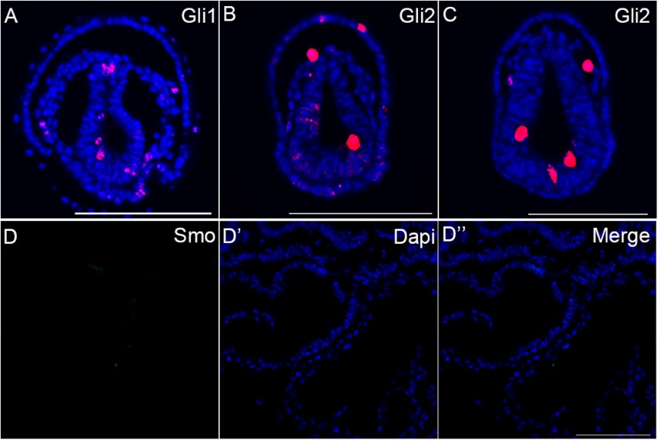
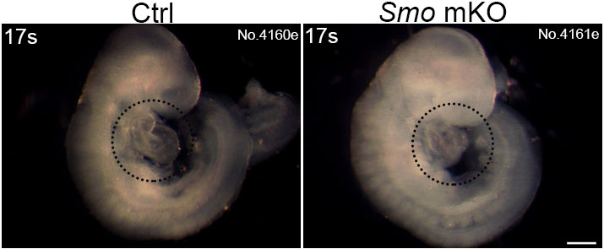
Figure S1 Expression of Hh pathway components in normal developing embryos. (A) Expression of Gli1 in the mesoderm at E7.25. (B and C) Expression of Gli2 in the mesoderm at E7.25. (D-D’’) A very low level of Smo expression was detected in the primitive heart tube at ~E8.5. Scale bars: 100 µm.
Figure S2. Gross appearance of the Smo mKO mutant embryo. Smo mKO mutant embryo displayed normal turning at E8.75. The dashed circles indicate the heart. Scale bar: 200 µm.
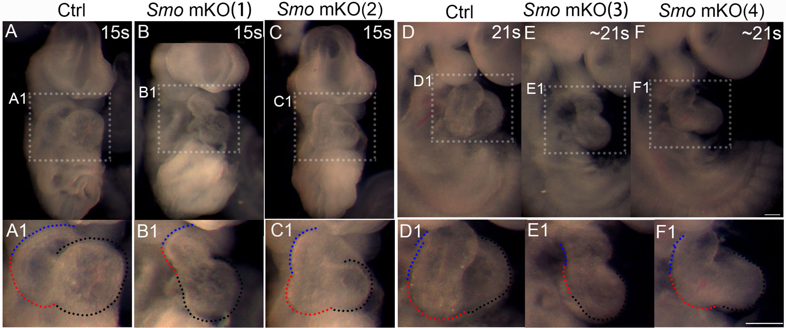
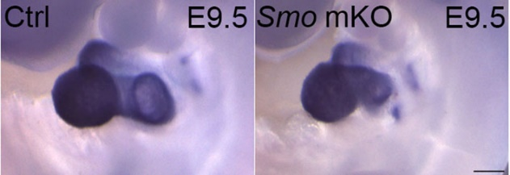
Figure S3. Impaired outflow tract and right and left ventricles of Smo mKO mutants. (A-C1) A smaller outflow tract and reduced right and left ventricles were detected in the Smo mKO mutants at ~E8.75. (D-F1) A smaller outflow tract and reduced right and left ventricles were observed in the Smo mKO mutants at ~E9.0. Blue dashed lines: outflow tract; red dashed lines: right ventricle; black dashed lines: left ventricle. Scale bars: 200 µm.
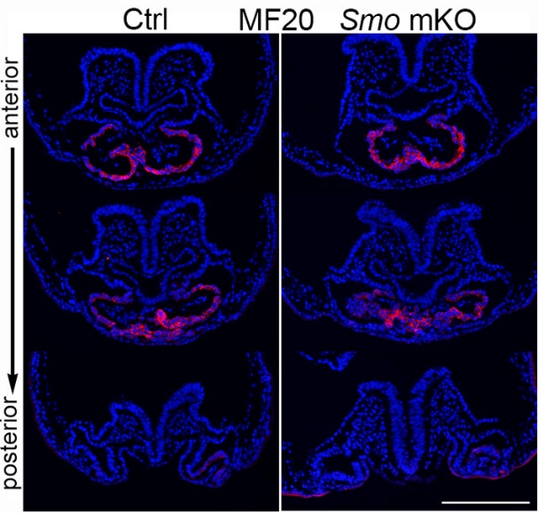
Figure S4. Expression of Nkx2.5 mRNA in the developing heart at E9.5. Whole-mount in situ hybridization indicated that the expression of Nkx2.5 mRNA in the mutant heart returned to a normal level by E9.5. Scale bar: 200 µm.
Figure S5. Expression of MF20 in the developing heart tube. Immunostaining of serial sections indicated that the expression of MF20 in the mutant heart was identical to that in the control hearts at the E8.25-8.5 stages. Scale bar: 100 µm.

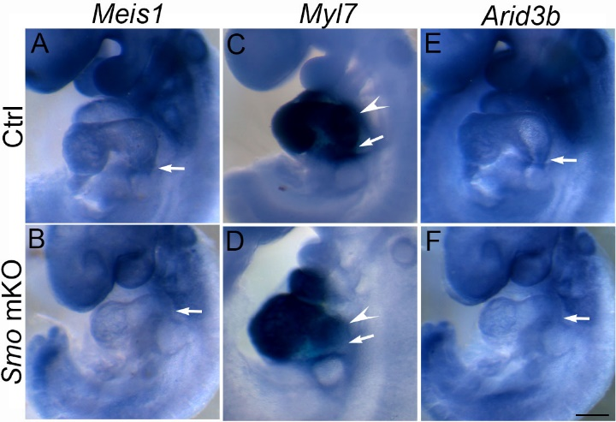
Figure S6. Altered expression of genes related to cardiac development in the atrium/IFT of the Smo mKO mutants at E9.5. (A and B) Reduced expression of Meis1 mRNA in the inflow tract of the mutant (arrows). (C and D) Reduced expression of Myl7 mRNA in the atrium/IFT of the mutant (arrows: IFT; arrowheads: atrium). (E and F) Reduced expression of Arid3b mRNA in the IFT of the mutant. Scale bars: 200 µm.
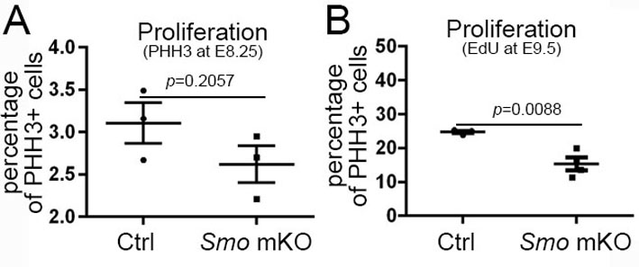
Figure S7. Proliferation of cardiac progenitor cells in the developing heart. (A) Phospho-histone H3 immunostaining indicated that the proliferation of cardiac progenitor cells exhibited a decreasing trend in the Smo mKO mutants at E8.25. (B) EdU incorporation showed that the proliferation of cardiomyocytes was decreased in the mutants at E9.5.

