Supplementary Material

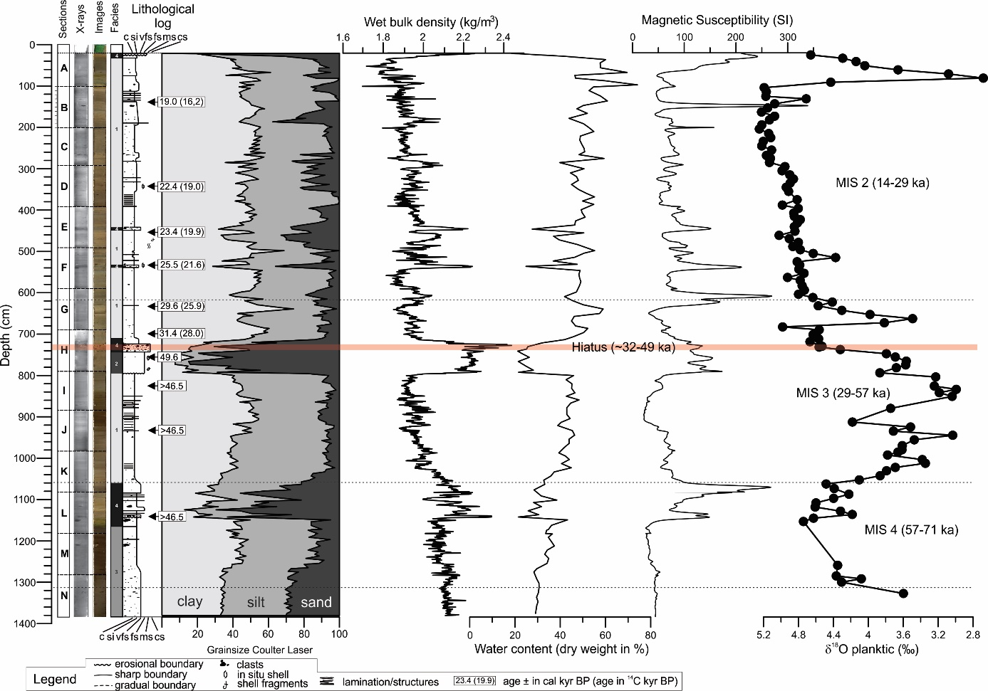

Supplementary Figure 1. Sedimentological, physical properties, and stable oxygen isotopes from planktonic foraminifera Neoglobaquadrina pachyderma (sin.) of GS14-190-01PC (0-1380 cm). Available calibrated radiocarbon AMS¹⁴C datings (uncalibrated ages in parenthesis) between 0 and 700 cm are published in Knies et al. (2018). Below 700 cm, we present 3 infinite AMS¹⁴C ages between 823 and 1140 cm measured on planktonic foraminifera Neogloboquadrina pachyderma (sin). An AMS¹⁴C age of 49.6 ka at 758.9 cm on bivalve shell Macoma calcarea constrain the hiatus between ~725-740 cm corresponding to ~32-49 ka. AMS¹⁴C analyses were conducted at the CHRONO Centre at Queen’s University Belfast, Northern Ireland (UBA-30874-76, 21639).

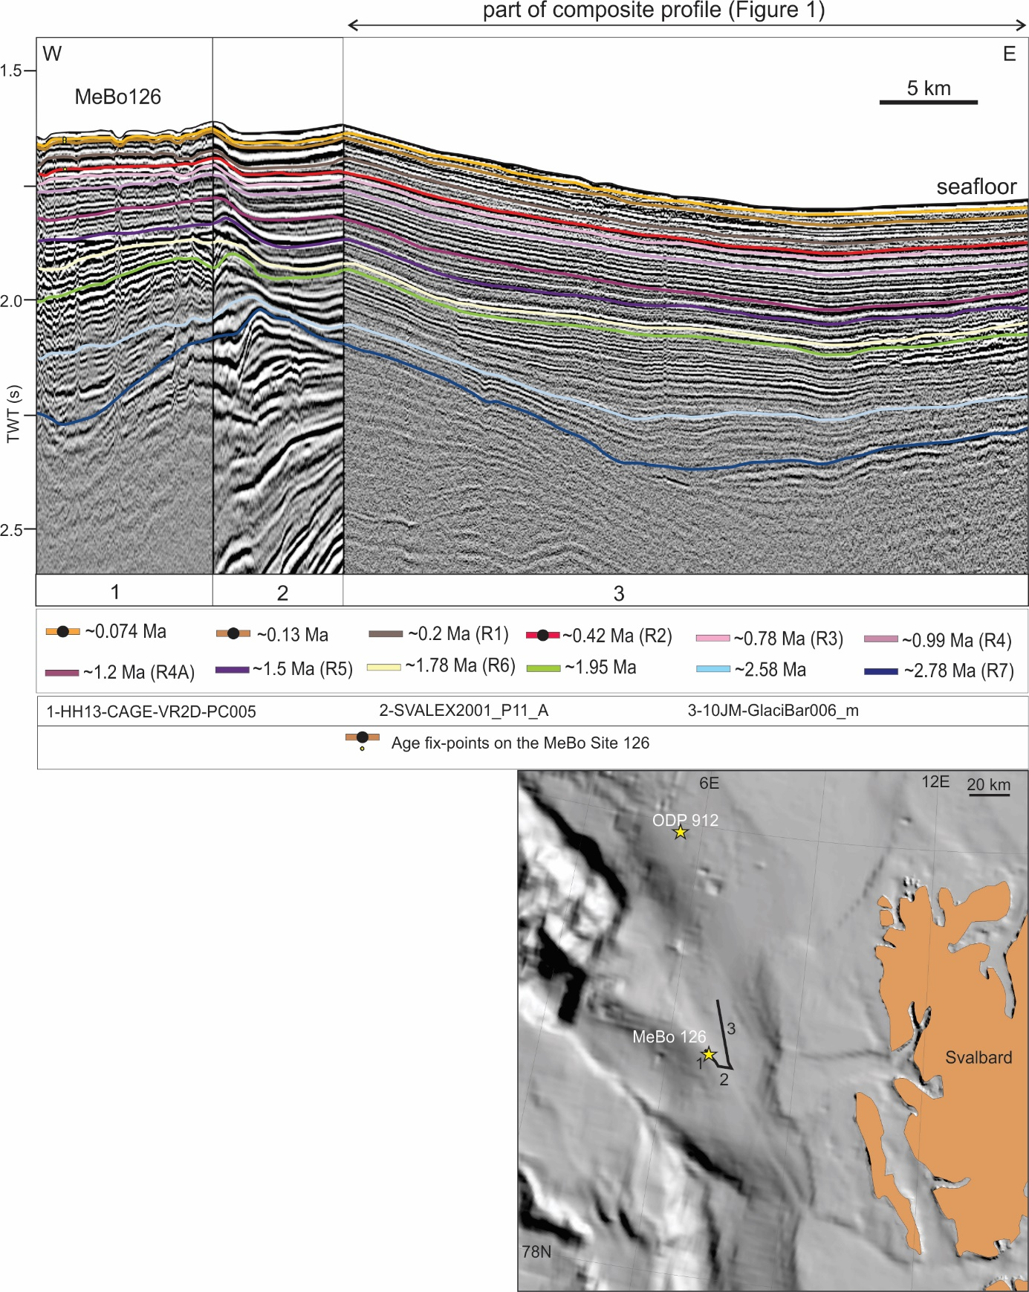
Supplementary Figure 2. shows a seismic profile crossing the Vestnesa MeBo Site 126 and connecting to the composite profile that is presented in Figure 1. The seismic reflections that are tied to MeBo Site 126 are marked with a dot. 1-3: the name of the seismic profiles.

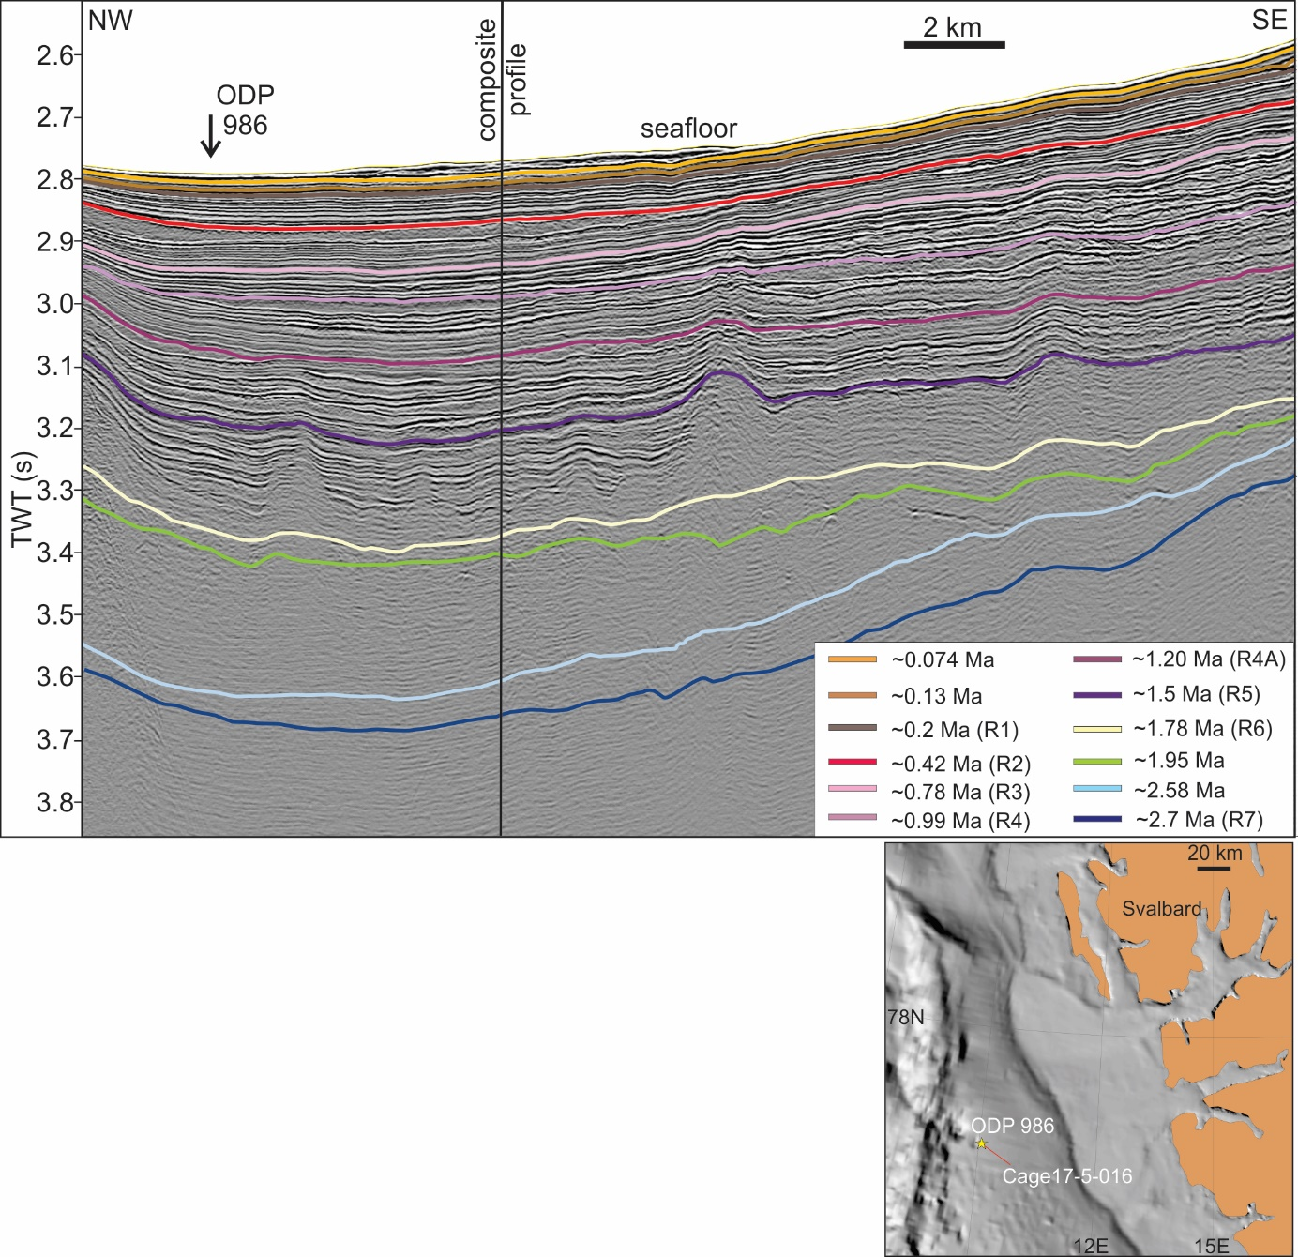

Supplementary Figure 3. shows Cage17-5-016 2D seismic line (Andreassen, 2017) crossing ODP Site 986. Based on the depth at which the seismic horizons corresponding to ~0.42 Ma, ~1.2 Ma, and ~1.78 Ma ages cross the ODP Site 986 we correlate them to the R7-R1 seismic stratigraphy (Faleide et al., 1996; Jansen et al., 1996). Composite profile: see Figure 1 and 3 for location).

Section | Seismic line | Seismic provider
1 | 10JM-GlaciBar 001_m-2 | UiT
2 | 10JM-GlaciBar 0021_m | UiT
3 | 10JM-GlaciBar 006_m | UiT
4 | 09KA-JK129 | UiT
5 | CAGE14-2_Line01 | CAGE-UiT
6 | MAGE04-CM15-20-3 | MAGE
7 | MAGE04-CM15-42 | MAGE
8 | EG-02A | OGS
9 | MAGE-05-06-CM15-200536-01-WGS-15 | MAGE
10 | MAGE-05-06-CM15-200537-WGS-15 | MAGE
11 | MAGE-05-06-CM15-200544-WGS-15 | MAGE
12 | MAGE-b89241 | MAGE
13 | BV-06-87 | DISKOS
14 | NBR09-419789 | TGS
15 | GVH-90-203 | DISKOS
16 | GVH-90-301 | DISKOS
17 | NBR11-215100 | TGS

Supplementary Table 1. presents the seismic profiles 1-17 that comprise the composite seismic profile (see Figures 1 and 3 for location), and the seismic providers. CAGE: Centre for Arctic Gas Hydrate, Environment and Climate, UiT: The Arctic University of Norway in Tromsø. OGS: National Institute of Oceanography and Applied Geophysics, Trieste, Italy. DISKOS: Norwegian Diskos National Data Repository (NDR) database. MAGE: Russian Joint Stock Company ‘Marine Arctic Geological Expedition’. TGS: TGS-NOPEC Geophysical Company Pty Ltd.

