Supplementary Table S1: Summary details of Ross seal deployments that were used (n = 19) in the habitat models. S55 - SA Agulhas II expedition 2016-2017 (deployed = 11, used = 7), PS111 – Polarstern expedition 2018 (deployed and used = 2); SCALE – South African Seasonal cycle experiment 2019 (deployed and used = 2); NARE 2000/01 – Norwegian expedition 2000-2001 (deployed = 10, used = 8)
ID | Campaign | Device type | Sex | Length (cm) | Deployment date | Deployment latitude | Deployment longitude | Total tracking  duration (days)
Ross1 | NARE 2000/01 | SDR-T16 | Female | 190 | 2001/02/05 | 72° 19' S | 17° 24' W | 69
Ross2 | NARE 2000/01 | SDR-T16 | Male | 210 | 2001/02/05 | 72° 19' S | 17° 33' W | 368
Ross3 | NARE 2000/01 | SDR-T16 | Male | 195 | 2001/02/05 | 72° 09' S | 17° 45' W | 358
Ross5 | NARE 2000/01 | SDR-T16 | Female | 230 | 2001/02/06 | 72° 03' S | 17° 08' W | 364
Ross7 | NARE 2000/01 | SDR-T16 | Female | 232 | 2001/02/08 | 72° 08' S | 17° 03' W | 325
Ross8 | NARE 2000/01 | SDR-T16 | Female | 200 | 2001/02/09 | 69° 59' S | 7° 31' W | 345
Ross9 | NARE 2000/01 | SDR-T16 | Male | 192 | 2001/02/11 | 69° 58' S | 6° 40' W | 24
Ross10 | NARE 2000/01 | SDR-T16 | Female | 227 | 2001/02/11 | 69° 58' S | 6° 39' W | 363
Ross002 | S55 | Splash9 | Female | NA | 2016/01/13 | 70° 06' S | 3° 04' W | 36
Ross011 | S55 | SPOT-300s | Female | NA | 2016/01/22 | 69° 52' S | 2° 00' W | 357
Ross012 | S55 | SPLASH10-309A | Female | NA | 2016/01/22 | 69° 53' S | 2° 02' W | 115
Ross015 | S55 | SPOT-300s | Female | NA | 2016/01/22 | 69° 55' S | 2° 05' W | 57
Ross018 | S55 | SPLASH10-309A | Female | NA | 2016/01/23 | 70° 02' S | 2° 09' W | 176
Ross019 | S55 | SPOT-300s | Female | 186 | 2016/01/23 | 70° 04' S | 2° 13' W | 349
Ross021 | S55 | SPOT-300s | Male | 167 | 2016/01/27 | 70° 30' S | 8° 06' W | 253
Ross022 | PS111 | SPLASH10-309A | Female | 176 | 2018/01/28 | 70°32' S | 8° 06' W | 160
Ross023 | PS111 | SPLASH10-309A | Male | 172 | 2018/01/31 | 71° 06' S | 13° 39' W | 141
Ross024 | SCALE | SPOT-300s | Female | 196 | 2019/10/27 | 59° 17’ S | 5° 12’ W | 83
Ross025 | SCALE | SPOT-300s | Female | 222 | 2019/11/02 | 58° 46’ S | 21° 04’ W | 101

Supplementary Table S2: Environmental variables used as covariates in habitat models for Ross seals (Ommatophoca rossii).
Environmental variable (abbreviation) | Unit | Spatial resolution | Temporal resolution | Data source
Bathymetry (bathym) | m | 0.02° | NA | General Bathymetric Chart of the Oceans (British Oceanographic Data Centre)  http://www.gebco.net
Ocean floor slope (slope) | ° | 0.02° | NA | Bathymetry derivative
Sea surface temperature (sst) | °C | 0.25° | Monthly | National Centres for Environmental Information  https://www.ncdc.noaa.gov/oisst
Sea surface temperature anomalies (sstA) | °C | 0.25° | Monthly | Sea surface temperature derivative
Sea surface temperature gradient (sst_grad) | ° | 0.25° | Monthly | Sea surface temperature derivative
Sea surface height anomalies (sshA) | m | 0.12° | Daily | Ssalto/Duacs (Copernicus Marine and Environment Monitoring Service)  http://marine.copernicus.eu
Sea surface height gradient (ssh_grad) | ° | 0.25° | Daily | Ssalto/Duacs (Aviso and Centre national d'études spatiales)  http://www.aviso.altimetry.fr/duacs/
Mixed layer depth (mld) | m | 2° | Seasonal climatology | (de Boyer Montégut, 2004; Raymond, 2018)  http://www.ifremer.fr/cerweb/deboyer/mld/home.php  https://data.aad.gov.au/metadata/records/Polar_Environmental_Data
Geostrophic current velocity (currmag) | cm/s | 0.25° | Weekly | Ssalto/Duacs (Aviso and Centre national d'études spatiales)  http://www.aviso.altimetry.fr/duacs/
Eddy kinetic energy (eke) | cm²/s² | 0.25° | Weekly | Zonal and meridional geostrophic velocity derivative, calculated as eke = 0.5(curru2 + currv2);  where curru = horizontal geostrophic velocity; currv = vertical geostrophic velocity.  Ssalto/Duacs (Aviso and Centre national d'études spatiales) http://www.aviso.altimetry.fr/duacs/
Wind magnitude (windmag) | m/s | 1.9° | Daily | National Centres for Environmental Information http://www.esrl.noaa.gov/psd/
Distance to ice edge (dist_iceedge) | m | 25 km | Daily | Derived from National Snow and Ice Data Center http://nsidc.org/data/NSIDC-0081
Sea ice concentration (ice) | % | 25 km | Daily | Derived from National Snow and Ice Data Center http://nsidc.org/data/NSIDC-0081
Sea ice concentration standard deviation (ice_sd) | NA | 25 km | Daily | Sea ice concentration derivative
Vertical mixing (vmix) |  | 0.1 | 10-year climatology | Upward sea water velocity at 250 m depth  (Raymond, 2018)  Gordon et al. (2010) The CSIRO Mk3.5 Climate Model. CAWCR Technical Report 21. http://www.cawcr.gov.au/technical-reports/CTR_021.pdf
Vertical mixing standard deviation (vmix_sd) | NA | 0.1 | 10-year climatology | Vertical mixing derivative

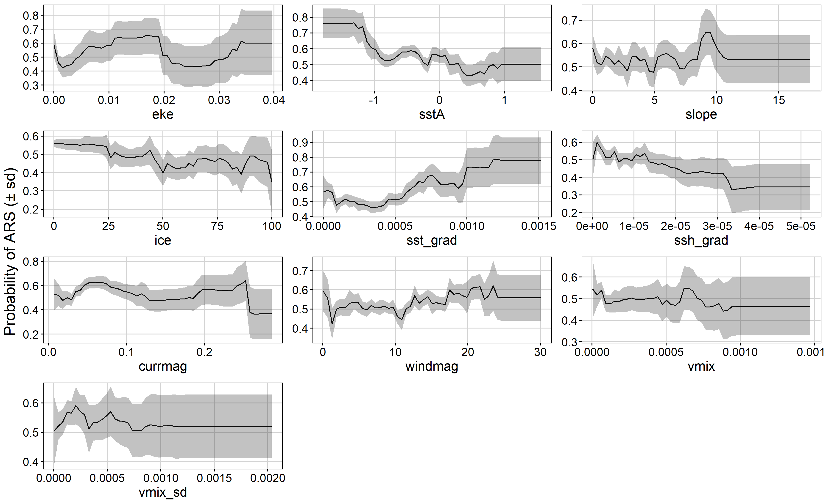
Supplementary Figure S1
Partial dependence plots showing ensemble model predictions of the effect of environmental variables on the probability of area-restricted search behaviour by Ross seals in King Haakon VII Sea during summer. Mean probability (solid line) of area-restricted search behaviour ± sd (grey-shaded) across the 500 bootstraps are shown.
Abbreviations: slope – slope of the sea floor, eke - eddy kinetic energy, ice - sea ice concenration, sstA – sea surface temperature anomaly, ssh_grad - sea surface height gradient, sst_grad - sea surface temperature gradient, vmix – vertical mixing speed, vmix_sd – vertical mixing speed standard deviation, currmag – current magnitude, windmag – wind magnitude
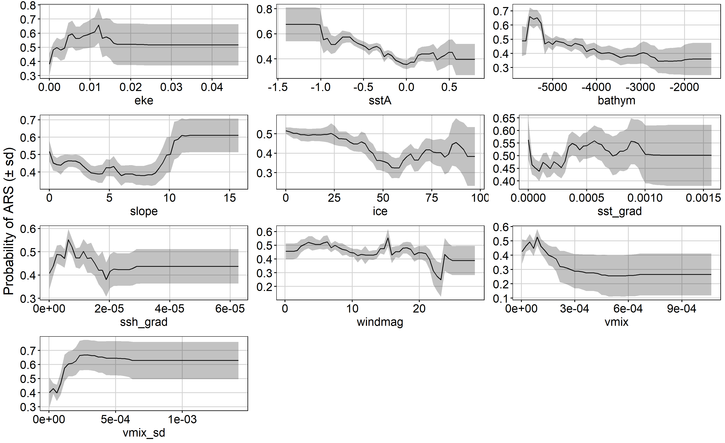
Supplementary Figure S2
Winter partial dependence plots showing ensemble model predictions of the effect of environmental variables on probability of area-restricted search behaviour by Ross seals in King Haakon VII Sea during winter. Mean probability (solid line) of area-restricted search behaviour ± sd (grey shaded) across the 500 bootstraps are shown.
Abbreviations: bathym – bathymetry, slope – slope of the sea floor, eke - eddy kinetic energy, ice - sea ice concentration, ssh_grad – sea surface height gradient, sst_grad – sea surface temperature gradient, vmix – vertical mixing speed, vmix_sd – vertical mixing speed standard deviation, windmag – wind magnitude.

Animation 1 Legend: Animation of the annual movements of the satellite-tracked Ross seals. The blue line represents the ice edge (15% ice concentration) and the coloured dots represent individual seals.

Animation 2 Legend: Animation of the annual movements of the satellite-tracked Ross seals closely zoomed in, in the eastern Weddell Sea. The blue line represents the ice edge (15% ice concentration) and the coloured dots represent individual seals.

References
de Boyer Montégut, C. (2004). Mixed layer depth over the global ocean: An examination of profile data and a profile-based climatology. J. Geophys. Res. 109, C12003. doi:10.1029/2004JC002378.
Greenwell, B. M. (2017). pdp: An R Package for Constructing Partial Dependence Plots. R J. 9, 421–436.
R Core Team (2019). R: A language and environment for statistical computing. R Foundation for Statistical Computing. http://www.R-project.org. Available at: https://www.r-project.org/.
Raymond, B. (2018). Polar Environmental Data Layers Australian Antarctic Data Centre - CAASM Metadata (https://data.aad.gov.au/metadata/records/Polar_Environmental_Data).

