SUPPLEMENTARY MATERIAL

Acremolin D, a new acremolin alkaloid from the deep-sea sediment derived *Aspergillus sydowii* fungus

Siwen Niua,b,1, Ziming Chenc,1, Shengxiang Peia, Zongze Shaoa, Gaiyun Zhanga,* and Bihong Hongb,*

*a Key Laboratory of Marine Biogenetic Resources, Third Institute of Oceanography, Ministry of Natural Resources, 184 Daxue Road, Xiamen 361005*

*b Technology Innovation Center for Exploitation of Marine Biological Resources, Third Institute of Oceanography, Ministry of Natural Resources, Xiamen 361005, People’s Republic of China*

*c School of Chemistry and Chemical Engineering, Lingnan Normal University, Zhanjiang 524048, China*

*Corresponding authors: Gaiyun Zhang (e-mail: zhgyun@tio.org.cn) and Bihong Hong (e-mail: bhhong@tio.org.cn)

1Author Contributions: Siwen Niu and Ziming Chen contributed equally to this work.

**ABSTRACT**

Chemical investigation of the deep-sea-derived fungus *Aspergillus sydowii* MCCC 3A00324 led to the isolation of one new acremolin type alkaloid (acremolin D, **1**) and five known alkaloids (**2‒6**). The planar structure of **1** was established by the extensive analyses of the NMR and HRESIMS data, while its absolute configuration was assigned by the comparison of the experimental and calculated ECD data. Acremolin D (**1**) represented the second analogue of acremolin found in nature. All compounds were evaluated for their cytotoxic activities against six human cancer cell lines (A549, Hela-S3, MCF-7, HepG2, K562, and SF-268). As a result, compounds **1** and **2** exhibited a certain inhibitory effects against the proliferation of the A549, Hela-S3, HepG2, and K562 cell lines at the concentration of 20 *µ*M.

**Keywords:** Deep-sea-derived fungus, *Aspergillus sydowii*, alkaloids, acremolins, cytotoxic activities

**List of supporting information**

|  |
| --- |
| **Computation Section** |
| **Figure S1.** COSY () and HMBC () correlations of **1**. |
| **Figure S2.** Experimental ECD curve of **1** in MeOH and the calculated ECD data of **1** at the B3LYP/6-311+g(2d,p) level. |
| **Figure S3.** Ninelow-energy conformers of **1**. |
| **Table S1** 1H (400 MHz) and 13C (100 MHz) NMR data of **1** in CD3OD |
| **Table S2** Energies of the conformers of compound **1** at the B3LYP/6-31+g(d) level |
| **Table S3** Inhibitory effects of compounds **1‒6** against six cancer cell lines |
| **Figure S4.** HRESIMS spectrum of **1**. |
| **Figure S5.** 1H NMR spectrum of **1** in CD3OD (400 MHz). |
| **Figure S6.** 13C NMR spectrum of **1** in CD3OD (100 MHz). |
| **Figure S7.** HSQC spectrum of **1** in CD3OD. |
| **Figure S8**. COSY spectrum of **1** in CD3OD. |
| **Figure S9.** HMBC spectrum of **1** in CD3OD. |
| **Figure S10.** The enlarged HMBC spectrum of **1** in CD3OD. |

**Computation Section**

Systematically conformational searches were performed by the Maestro 10.2 program at the OPLS3 molecular mechanics force field within an energy window of 3.0 kcal/mol. The results showed nine lowest energy conformers for 3′*S*\*-**1** (Figure S3). The conformers with the Boltzmann population of over 1% were chosen for the ECD calculations. The conformers were re-optimized by dependent density functional theory (DFT) method at the B3LYP/6-31+g(d) level according to the Gaussian 09 program . (Gaussian 09, revision. D.01; Gaussian, Inc.: Wallingford, CT). The energies, oscillator strengths, and rotational strengths of the first 60 electronic excitations were calculated using the time-dependent density functional theory (TD-DFT) method at the B3LYP/6-311+g(2d,p) level in methanol. The ECD spectra were simulated using the SpecDis (Bruhn et al. 2013) by applying Gaussian band shapes with sigma = 0.3 eV, and the finally calculated ECD data were weighted and summed up of each stable conformers according to the Boltzmann population.



**Figure S1.** COSY () and HMBC () correlations of **1**.



**Figure S2.** Experimental ECD curve of **1** in MeOH and the calculated ECD data of **1** at the B3LYP/6-311+g(2d,p) level.

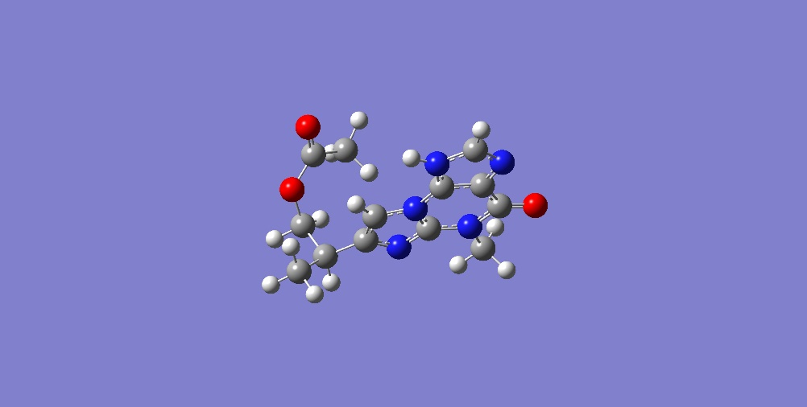 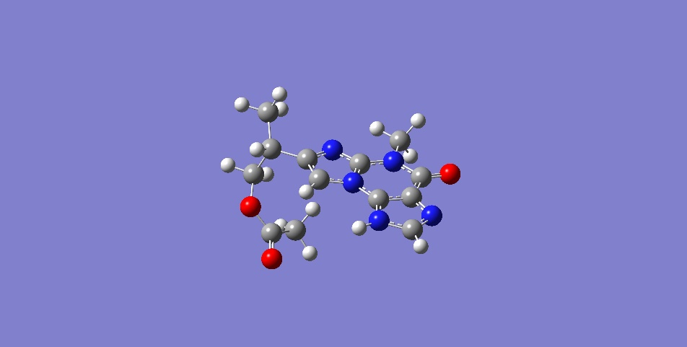 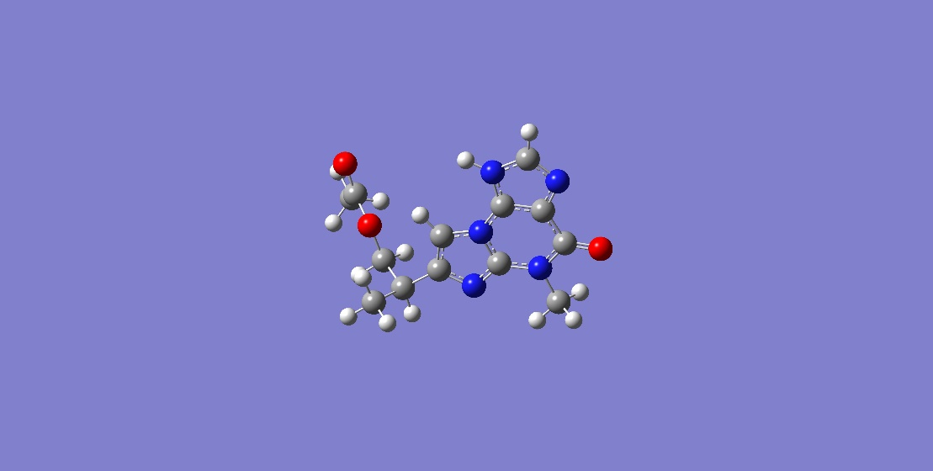

**a b c**

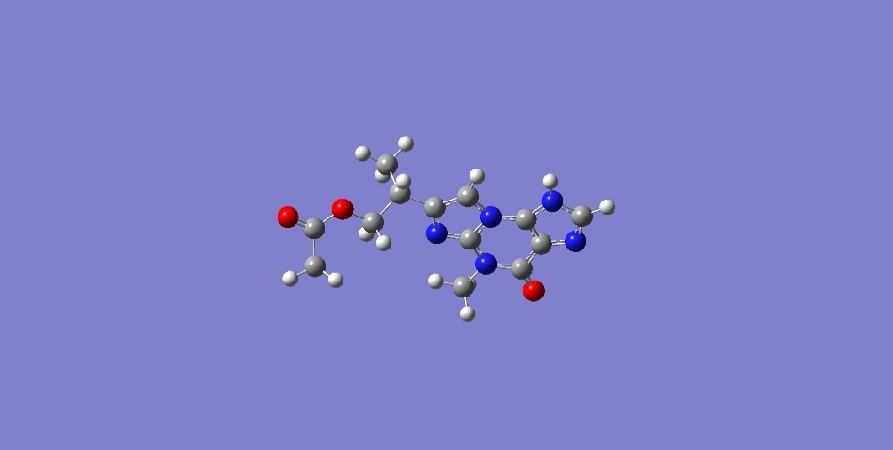 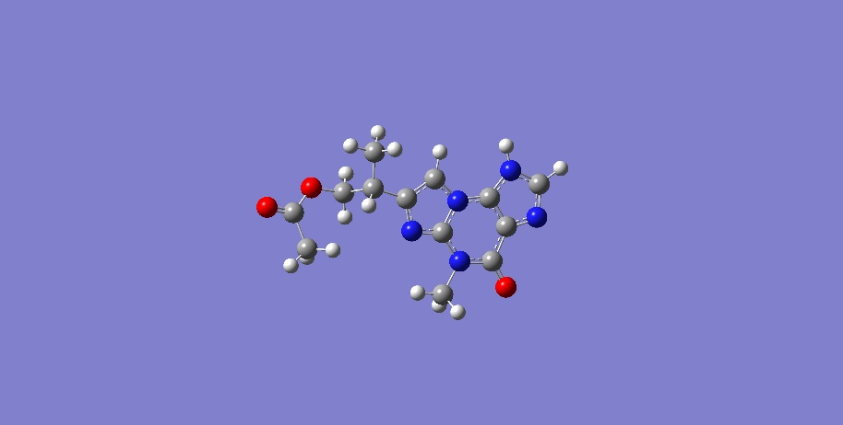 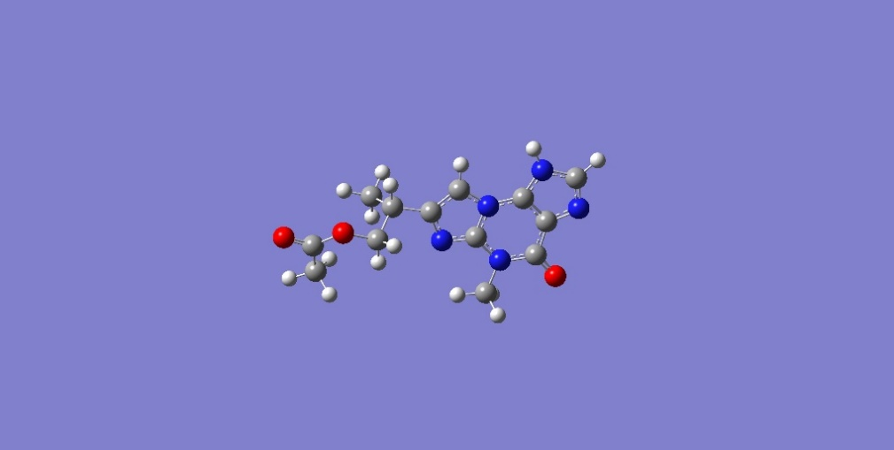

**d e f**

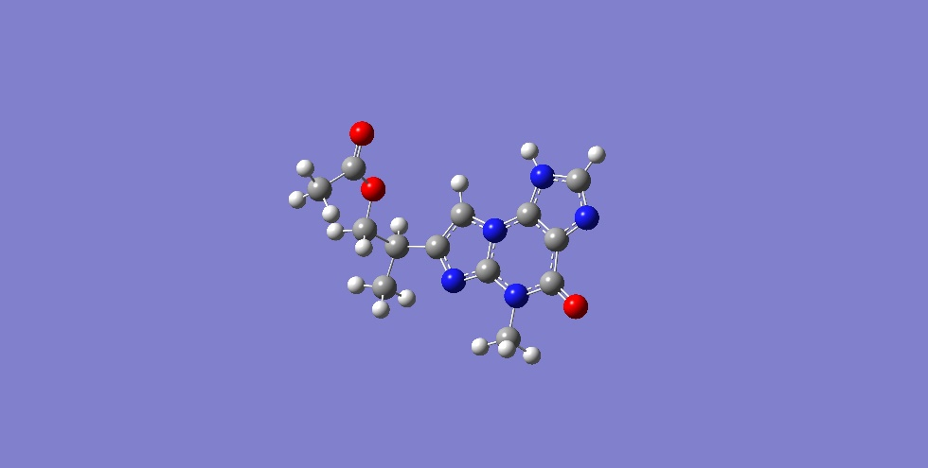 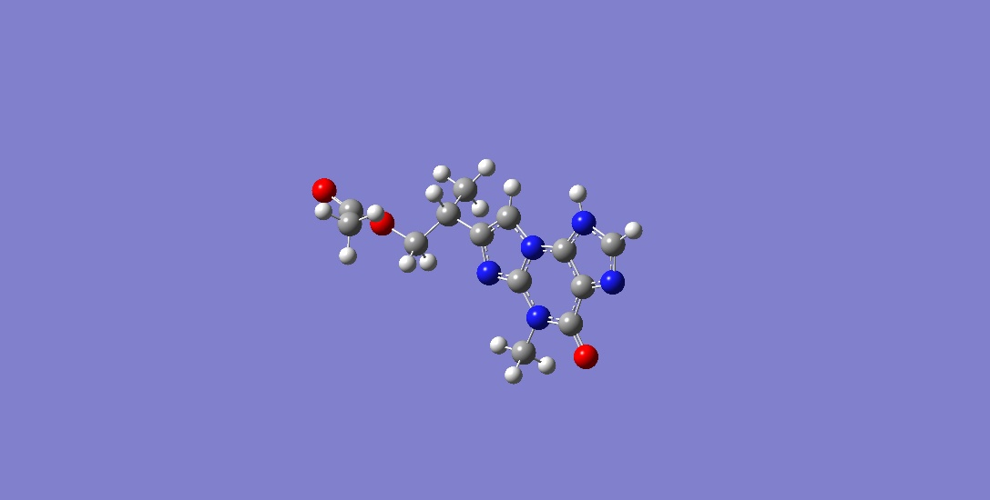 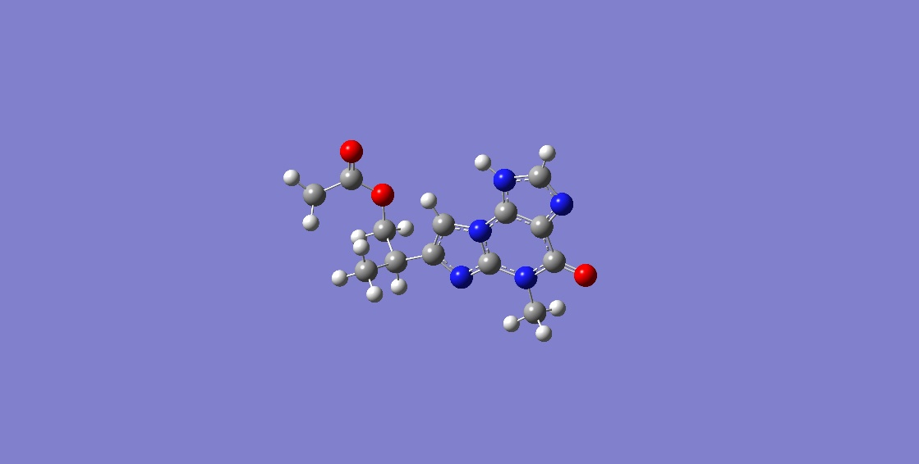

**g h i**

**Figure S3.** Ninelow-energy conformers of **1**.

**Table S1** 1H (400 MHz) and 13C (100 MHz) NMR data of **1** in CD3OD

|  |  |  |
| --- | --- | --- |
| no. | *δ*C, type | *δ*H, (mult, *J* in Hz) |
| 2 | 144.5, C |  |
| 4 | 143.1, C |  |
| 5 | 110.5, C |  |
| 6 | 154.6, C |  |
| 8 | 141.4, CH | 8.16 (s) |
| 1′ | 106.3, CH | 7.51 (s) |
| 2′ | 145.2, C |  |
| 3′ | 34.4, CH | 3.22 (m) |
| 4′ | 17.0, CH3 | 1.39 (d, 7.0) |
| 5′ | 69.2, CH2 | 4.38 (dd, 10.6, 6.2)  4.23 (dd, 10.6, 6.7) |
| NCH3 | 29.6, CH3 | 3.72 (s) |
| OAc | 20.7, CH3  171.0, C | 2.05 (s) |

**Table S2** Energies of the conformers of compound **1** at the B3LYP/6-31+g(d) level

|  |  |  |
| --- | --- | --- |
| Conformers | Hartree | Population（%） |
| **a** | -1003.923856 | 6.91% |
| **b** | -1003.924794 | 18.68% |
| **c** | -1003.924831 | 19.41% |
| **d** | -1003.924529 | 14.10% |
| **e** | -1003.923356 | 4.07% |
| **f** | -1003.924528 | 14.09% |
| **j** | -1003.92216 | 1.14% |
| **h** | -1003.924831 | 19.41% |
| **i** | -1003.922779 | 2.21% |

**Table S3** Inhibitory effects of compounds **1‒6** against six cancer cell lines

|  |  |  |  |  |  |  |  |
| --- | --- | --- | --- | --- | --- | --- | --- |
|  | Inhibitory rate (20 *μ*M) (%) | | | | | | |
| Compounds |  | A549 | Hela-S3 | MCF-7 | HepG2 | K562 | SF-268 |
| **1** |  | 6.4 | 30.6 | 18.3 | 10.7 | 25.1 | 5.2 |
| **2** |  | 20.9 | 11.8 | 7.7 | 30.4 | 35.5 | 17.4 |
| **3** |  | 15.6 | 4.2 | 8.0 | 13.8 | 9.8 | 6.5 |
| **4** |  | 9.3 | 14.7 | 16.0 | 5.9 | 18.4 | 8.0 |
| **5** |  | 6.4 | 9.4 | 16.2 | 13.4 | 8.7 | 6.5 |
| **6** |  | 14.1 | 11.7 | 7.4 | 6.5 | 9.0 | 12.3 |



**Figure S4.** HRESIMS spectrum of **1**.

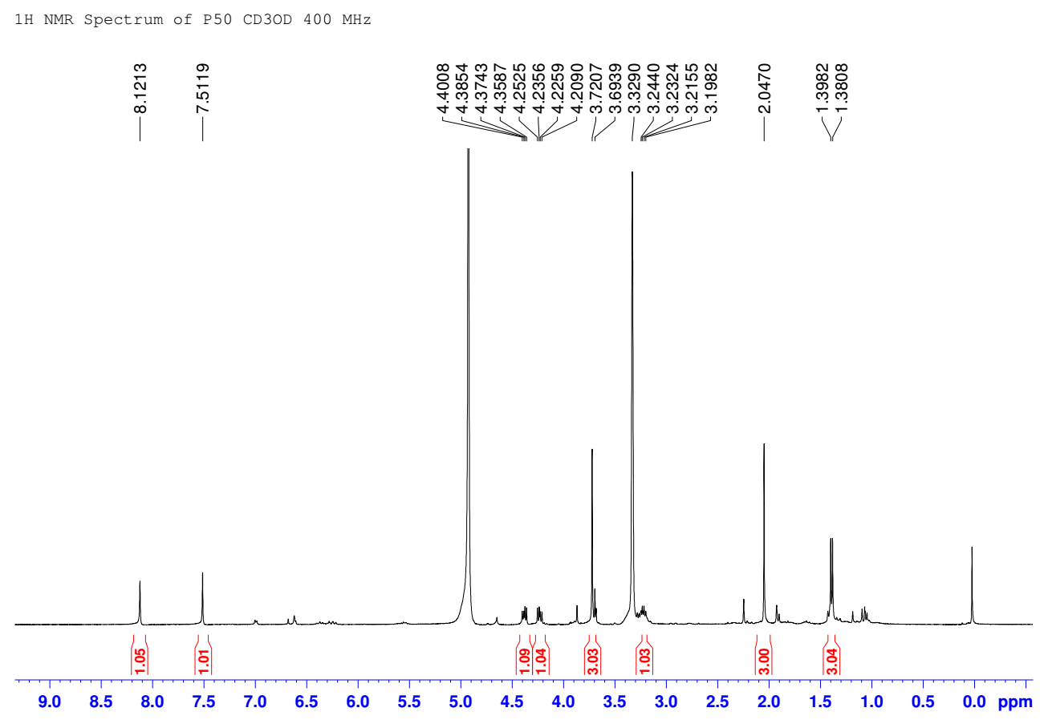

**Figure S5.** 1H NMR spectrum of **1** in CD3OD (400 MHz).

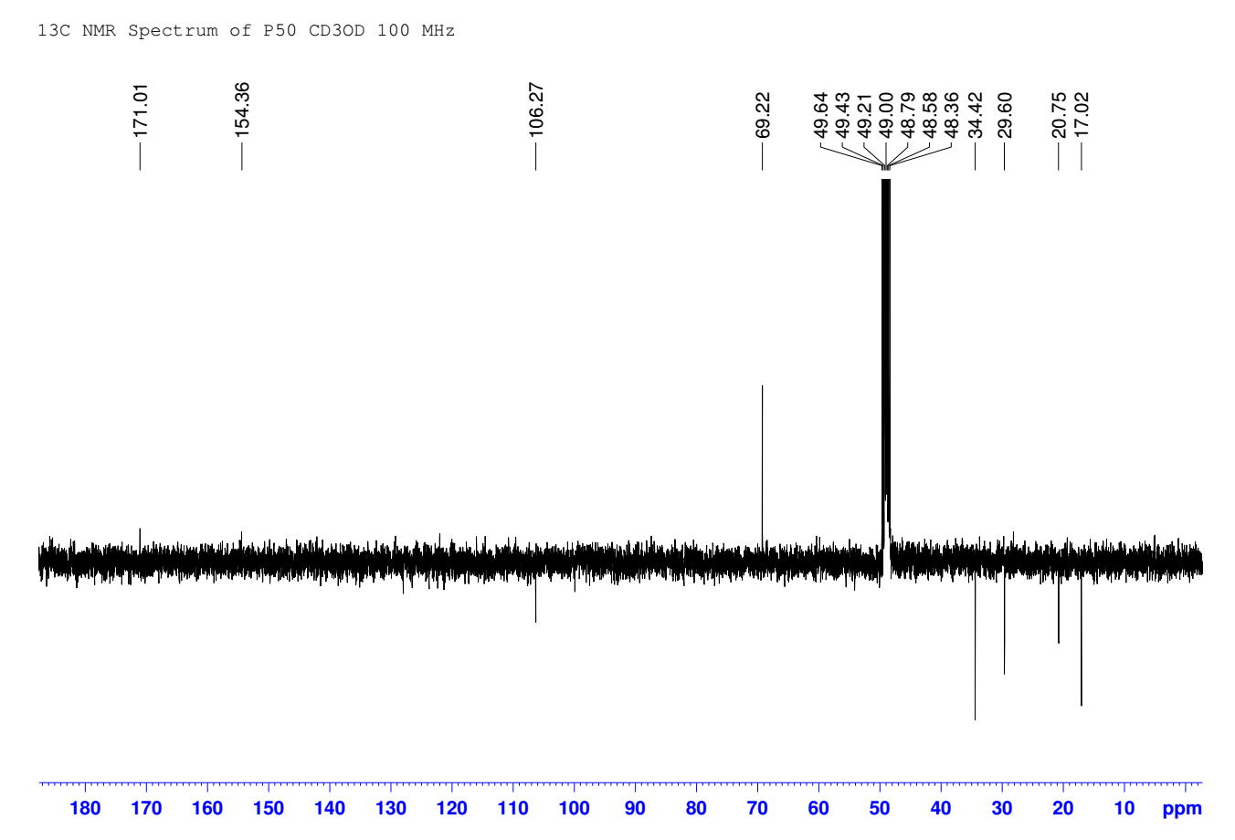

**Figure S6.** 13C NMR spectrum of **1** in CD3OD (100 MHz).

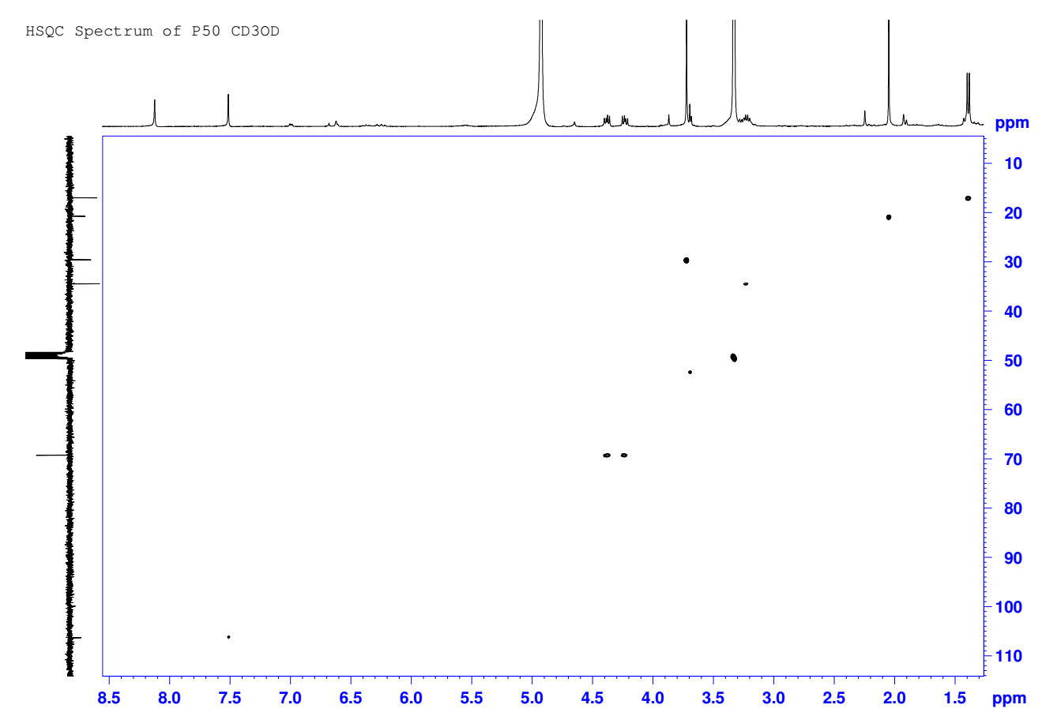

**Figure S7.** HSQC spectrum of **1** in CD3OD.

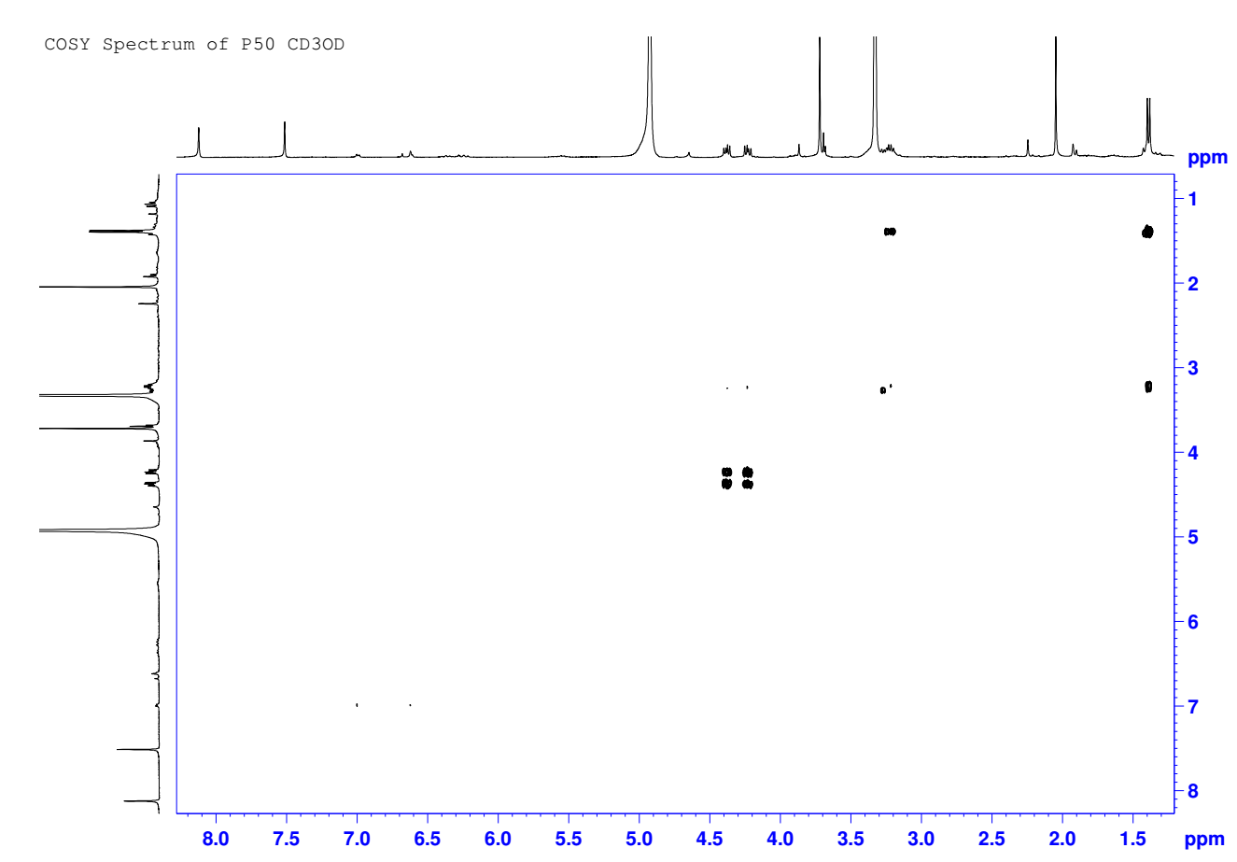

**Figure S8**. COSY spectrum of **1** in CD3OD.

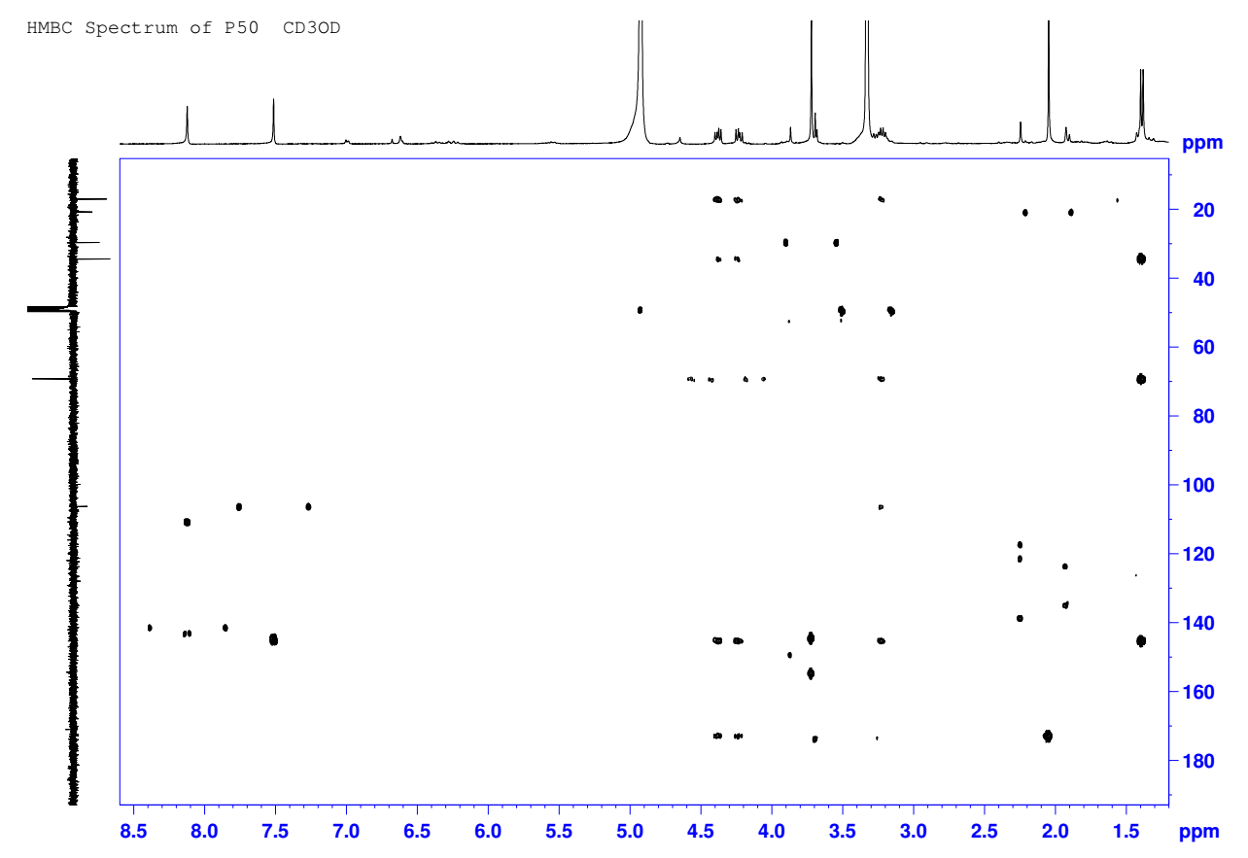

**Figure S9.** HMBC spectrum of **1** in CD3OD.

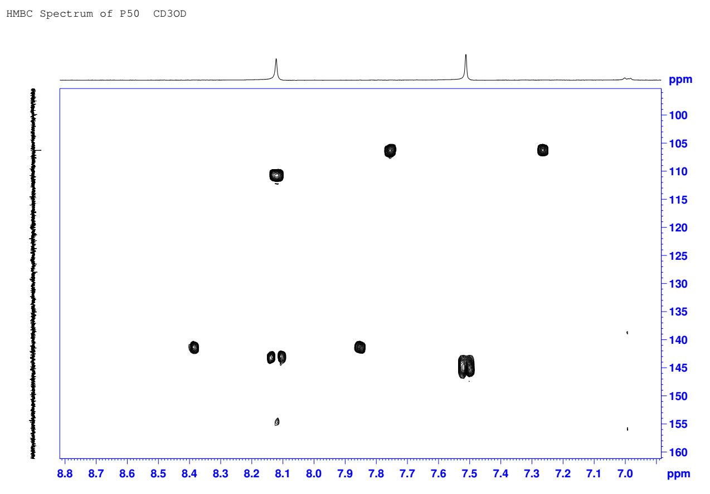

**Figure S10.** The enlarged HMBC spectrum of **1** in CD3OD.

**References**

Bruhn T, Schaumlöffel A, Hemberger Y, Bringmann G. 2013. SpecDis: quantifying the comparison of calculated and experimental electronic circular dichroism spectra. Chirality. 25(4):243−249. eng.

Frisch MJT, G. W.; Schlegel, H. B.; Scuseria, G. E.; Robb, M. A.; Cheeseman, J. R.; Scalmani, G.; Barone, V.; Mennucci, B.; Petersson, G. A.; Nakatsuji, H.; Caricato, M.; Li, X.; Hratchian, H. P.; Izmaylov, A. F.; Bloino, J.; Zheng, G.; Sonnenberg, J. L.; Hada, M.; Ehara, M.; Toyota, K.; Fukuda, R.; Hasegawa, J.; Ishida, M.; Nakajima, T.; Honda, Y.; Kitao, O.; Nakai, H.; Vreven, T.; Montgomery, Jr., J. A.; Peralta, J. E.; Ogliaro, F.; Bearpark, M.; Heyd, J. J.; Brothers, E.; Kudin, K. N.; Staroverov, V. N.; Kobayashi, R.; Normand, J.; Raghavachari, K.; Rendell, A.; Burant, J. C.; Iyengar, S. S.; Tomasi, J.; Cossi, M.; Rega, N.; Millam, J. M.; Klene, M.; Knox, J. E.; Cross, J. B.; Bakken, V.; Adamo, C.; Jaramillo, J.; Gomperts, R.; Stratmann, R. E.; Yazyev, O.; Austin, A. J.; Cammi, R.; Pomelli, C.; Ochterski, J. W.; Martin, R. L.; Morokuma, K.; Zakrzewski, V. G.; Voth, G. A.; Salvador, P.; Dannenberg, J. J.; Dapprich, S.; Daniels, A. D.; Farkas, Ö.; Foresman, J. B.; Ortiz, J. V.; Cioslowski, J.; Fox, D. J. *Gaussian 09*, revision. D.01; Gaussian, Inc.: Wallingford, CT, 2009.