Supplementary Material

Appendix A – Data Filter
The Gulf of Alaska Data were filtered using a 100m bathymetric filter and by excluding remotely sensed data in the Bering Sea. Figure 1 shows the GOA from ${48.5}^{∘}N-{169.5}^{∘}W$ to ${61.5}^{∘}N {-130.5}^{∘}$, we applied the 100m bathymetric filter seen in Supplementary Figure 2, shown in black. Finally, we excluded data from the bearing sea seen in Supplementary Figure 2, shown in dark grey.
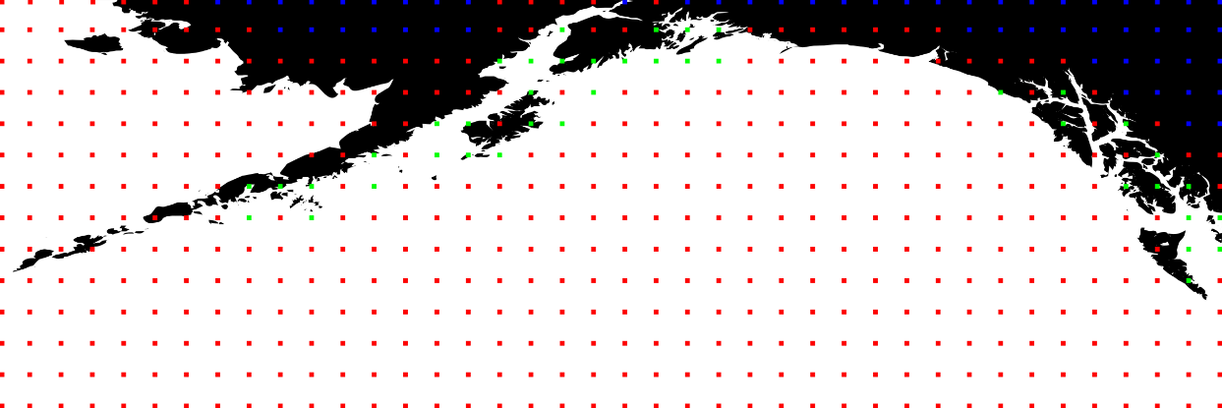
Supplementary Figure 1. Gulf of Alaska. The spatial extent of our data from ${48.5}^{∘}N-{169.5}^{∘}W$ to ${61.5}^{∘}N {-130.5}^{∘}$ (NOAA, 2009). The red points are points that were excluded from training because they dot satisfy the Bathymetric and Bering Sea filters. The blue points are missing remotely sensed pCO₂. The green points are data that were used to train the prSOM. Note that the data that was used to train the prSOM is a subset of the data that was classified.

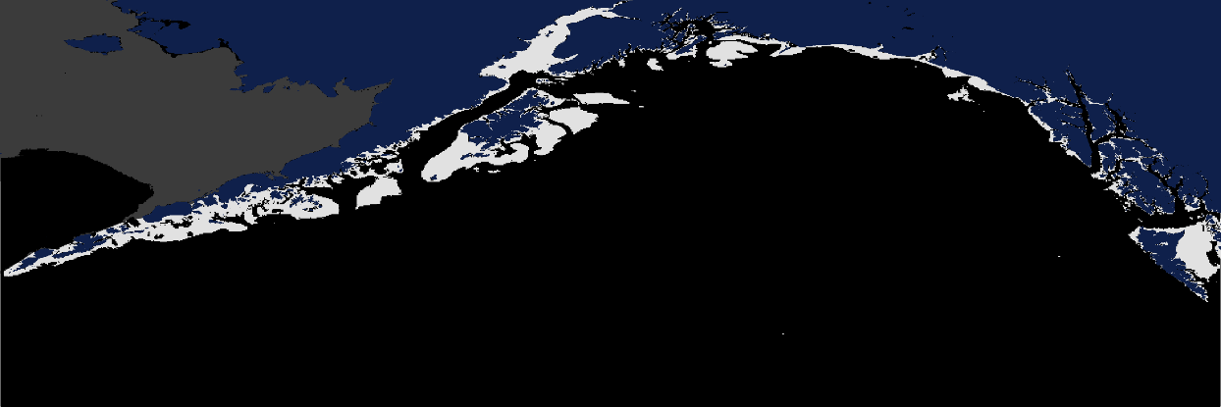
Supplementary Figure 2. Gulf of Alaska with Bathymetric Filter. Land is shown in blue. The bathymetry filter is shown in black. The Bering Sea filter is shown in dark grey. Pixels that were included in the training and classification of stress-scapes are shown in light grey.

Appendix B – Spatial Extent of Missing Data
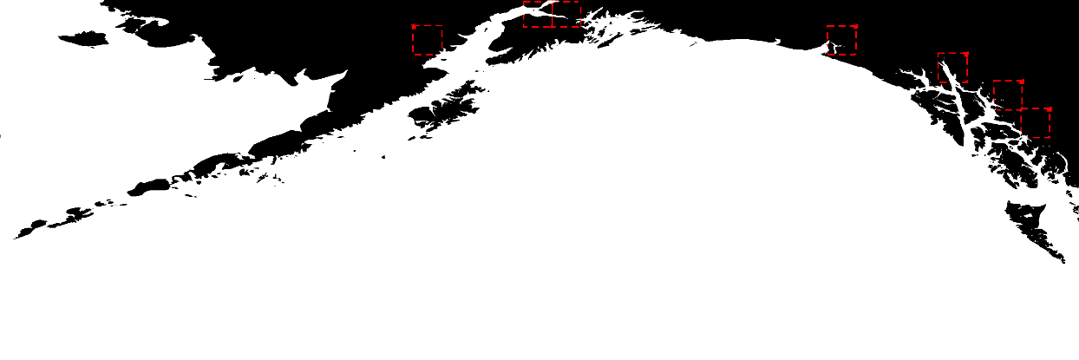
Supplementary Figure 3. Missing Data. This shows the six missing data and the tiles for which interpolation fails. Limitations in the pCO₂ data product prevented interpolation and classification of stress-scapes near these points.
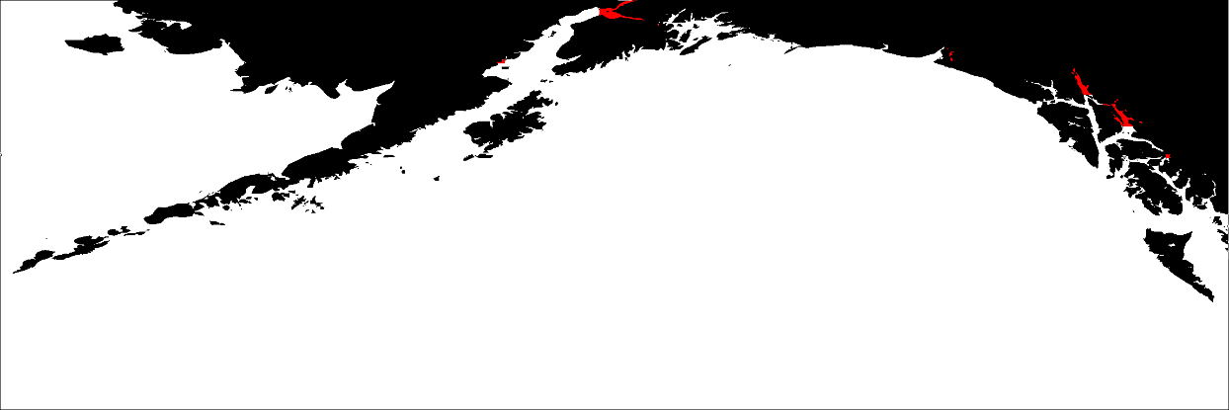
Supplementary Figure 4. Spatial Extent of Missing Data. This figure shows the pixels we were not able to classify correctly because of missing pCO₂ data (shown in red).

Appendix C – Stress-scape Classification Details
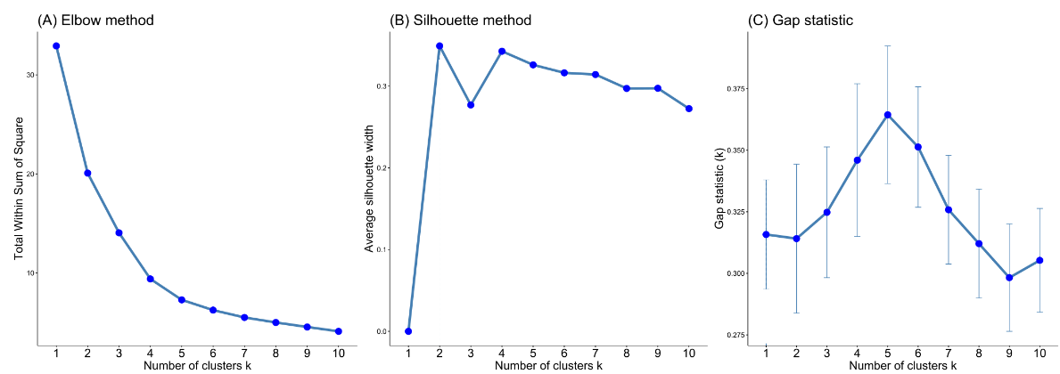
Supplementary Figure 5. The three plots show three different methods of evaluating how well the neurons of the prSOM trained using three variables (SST, SGR and pCO₂can be classified into different number of stress-scapes. (Left) Elbow curve showing the explained variation (y-axis) as a function of the number of clusters (x-axis). Four or five clusters is optimal. (Middle) Silhouette method for choosing number of clusters, the x-axis shows number of clusters, and the y-axis shows how well the data are grouped in the clusters. Two stress-scapes is optimal, four or five stress-scapes are tied for second optimal choice. (Right) Gap statistic method for choosing the number of clusters. The x-axis gives the number of clusters, the y-axis shows how well randomly generated data from the distribution of these clusters matches up with the actual data. The gap statistic strongly suggests optimal number of stress-scapes is 5, the other methods support that 5 stress-scapes is reasonable.
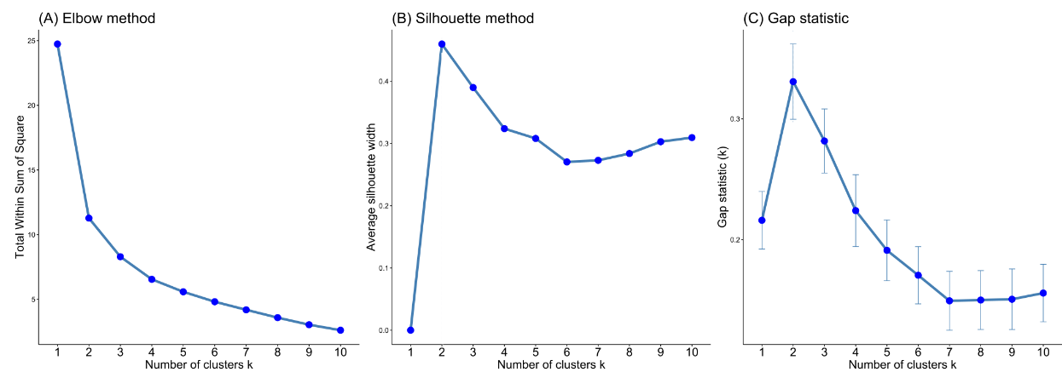
Supplementary Figure 6. The three plots show three different methods of evaluating different number of stress-scapes for sensitivity analysis. (Left) Elbow curve showing the explained variation (y-axis) as a function of the number of clusters (x-axis). 2-4 clusters is optimal because this is where the curve changes direction. (Middle) Silhouette method for choosing number of clusters, the x-axis shows number of clusters, and the y-axis shows how well the data are grouped in the clusters. 2 stress-scapes is optimal by a wide margin. (Right) Gap statistic method for choosing the number of clusters. The x-axis gives the number of clusters, the y-axis shows how well randomly generated data from the distribution of these clusters matches up with the actual data. This plot suggests all clusterings are poor. Even the least parsimonious model (number of clusters is 4) shows no variation in the stress-scape classification near Kodiak island for the month of July prior to and during heatwave conditions.

prSOM Background. Machine learning techniques have been used to classify open ocean regions in order to predict dominant wind forcing (Richardson et al., 2003), constrain prediction of the carbonate system (Hales et al., 2012), and create biophysical regions for later analyses (Saraceno et al., 2006; Oliver and Irwin, 2008; Reygondeau et al., 2013). More recently, Kavanaugh et al. (2012; 2014; 2016; 2018) combined a probabilistic self-organizing map (prSOM) and hierarchical agglomerative clustering (HAC) algorithm to classify dynamic hierarchical regions in the Pacific and globally. The prSOM takes advantage of an earlier competitive learning algorithm called the Self-Organizing Map (SOM) (Kohonen, 1990). The SOM was identified early as a helpful tool for fisheries and oceanography because it preserves the underlying data's topology and can identify and correctly classify non-linear relationships in the data (Chen & Ware, 1999; Richardson, 2003). However, the SOM struggles with classifying anomalous events in time series data correctly (Anouar et al., 1998; Barreto, 2009; Lebbah, 2015). Hence there was a need to improve the SOM to detect anomalies in atmospheric and oceanographic conditions. The Probabilistic Self Organizing Map (Anouar, 1998) was an early improvement to the SOM and incorporated a probabilistic formalism. The formalism resembles both the expectation-maximization (EM) and K-Means algorithms.
The prSOM estimates the multivariate distribution of $SST$, $pCO_{2}$, and $SGR$ z-scores as a convex combination of multivariate spherical normal distributions. Each normal distribution is represented in the prSOM algorithm as a “neuron”, each neuron has a mean and variance and is connected to neighboring neurons using a mesh data-structure. The mixture of multiple spherical normal distributions captures covariance in distinct but closely grouped classes (similar mean values) that would otherwise be missed by similar classification algorithms such as K-Means or Expectation Maximization where different estimates of the number of distinct means in the data can change the results. Two coastal GOA regions belong to the same stress-scape if the observed temperatures are likely to belong to the same distribution. For example, the coastal region near Kodiak Island will share the same color as the coastal Aleutian Islands if the observed z-scores for each variable, in both locations, belong to the same distribution of z-scores. If Kodiak Island coastal waters are significantly warmer than average temperature, and the coastal water near the Aleutians is close to average, then the two regions will be assigned, different stress-scape classes.
prSOM Training. Our implementation of the prSOM algorithm follows Anouar (1998) and Lebbah (2015). The prSOM begins in a way very similar to the Expectation-Maximization algorithm. As it converges on an approximation of the multivariate distribution of the SST, pCO2, and SST, it becomes more like the K-Means algorithm. Thus, initially, the neurons estimate the multivariate distribution with covariance. As the algorithm progresses, the clusters are approximated, and the covariate terms are removed from the training process. The prSOM algorithm assumes that the data belong to a multivariate distribution with one or more means. It classifies observations by identifying the multivariate mean value and variance that is most likely to generate each measurement of SST, Growth rate and across the GOA from 2010 to 2016.
The combination of the SOM, EM and the K-Means algorithms allows more provides a better representation of covariance structure while maintaining computational efficiency. The input to both algorithms is the assumed number of means (k) in the data. At each iteration, the K-Means algorithm chooses a single mean value most likely to generate nearby data and adjusts the mean to be closer to the mean of nearby data, this is known as a “hard learning rule”. The EM algorithm iterates over all the data and estimates how responsible each of the $k$ means are for generating that observation. First, in the expectation step, the observation is classified as belonging to the gaussian function that is most responsible for generating the observation. Next, in the maximization step, the mean value of the gaussian function approximating the distribution is adjusted according to the responsibility of nearby means that also contribute to generating the observation. The K-Means algorithm identifies a labeling of the data that minimizes the variance amongst data associated with each label and maximizes the variance across the different label centers. However, with multivariate applications, K-Means falls short because it assumes a constant covariance structure across all clusters, which is unrealistic. For example, there is covariance between sea-surface temperature and SGR. Near the minimum tolerable temperature appears linear, but as the temperature increases the relationship is evidently quadratic (see Figure 5). A stress-scape representing cold water temperatures in the winter should have different covariance with SGR than warm waters in the summer. K-Means would assume that all possible clusters covary in the same way, and so this difference cannot be accounted for.
The prSOM data structure is comprised of neurons and edges connecting the neurons. Each neuron represents a spherical Gaussian. The weight vector, mean and position of a neuron are interchangeable terms referring to the mean of a spherical Gaussian. The variance of a neuron is the variance of the spherical Gaussian centered on the neuron’s weight vector. The edges between the neurons represent conditional dependence of the stress-scapes on each other. Each iteration of the prSOM can be thought of as a competition between all the neurons to classify the stress-scapes with the highest probability. A temperature parameter, denoted T, controls the width of a neuron’s neighborhood. For small values of T, a stress-scape is not conditionally dependent on any other stress-scapes. For large values of T, a stress-scape depends on its neighboring stress-scapes (up to T edges out). In our application, we set the maximum (initial value) of T to 3 and the minimum (final value) to 1.01. Initially, all the stress-scapes are conditionally independent of one another and the weight vector update resembles the EM algorithm. As the approximation of the distribution becomes more precise, we slowly decrease the neighborhood width (T) to a value of 1.01 and the weight vector update resembles the K-Means algorithm.
The prSOM algorithm fits a mixture of spherical Gaussians (multivariate normal distributions with no covariance) to approximate the distribution of SST, SGR, and pCO₂ through time. Like the Expectation-Maximization algorithm, the prSOM is trained by adjusting the neuron centers to minimize the least-squares error “$E$” between the estimated remotely sensed data at each pixel and the mean values of each class assigned to the pixel:
$$E=\sum{{\left|\left|y\left(z_{i}\left(θ,ϕ,m\right)\right)-t_{i}\right|\right|}^{2}}$$
Where $y(z_{i}\left(θ,ϕ,m\right))$ is the predicted stress-scape of an ocean pixel and $t_{i}$ is a desired stress-scape that minimizes $E$. Since the GOA is not labeled, the correct stress-scapes are not known. So, we use an unsupervised iterative algorithm to first estimate each ocean class label according to the data and neurons that are nearby. Hence, $t_{i}$ is the remotely sensed data at each ocean pixel. At each iteration of the prSOM algorithm, the centers of all the neurons are updated to maximize the probability that the neuron generates nearby data. The probability that the $k^{th}$ neuron generated the $i^{th}$observation in the $j^{th}$ iteration of the prSOM is given by:
$$p\left(z_{i}\left(θ,ϕ,m\right),μ_{k}^{j},σ_{k}^{j}\right)=\frac{1}{σ_{k}}\exp\left(-\frac{{\left|\left|z_{i}\left(θ,ϕ,m\right)-μ_{k}^{j}\right|\right|}^{2}}{2{\left(σ_{k}^{j}\right)}^{2}}\right)$$
At iteration $j$, an observation is labeled $k_{0}$ if
$$p\left(z_{i}\left(θ,ϕ,m\right),μ_{k_{0}}^{j},σ_{k_{0}}^{j}\right)=\max_{k}{p\left(z_{i}\left(θ,ϕ,m\right),μ_{k}^{j},σ_{k}^{j}\right).}$$
The prSOM seeks a placement of the spherical Gaussians that maximize $p_{k}\left(x\left(θ,ϕ,t\right)\right)$ across the entire dataset. To do this, it proceeds iteratively in two steps as described by Anouar (1998). First the neuron means and variances are computed. Then, the $z_{i}$ (remotely sensed SST and the SGR data) are all reclassified according to the stress-scapes given by the new means and variances of the neurons according to the new classification. These two steps are repeated until the algorithm converges. A proof of convergence can be found in Anouar (1998). But the key point of the proof is that the likelihood that the stress-scapes at iteration $i$ generate the data is less than the probability that the stress-scapes at iteration $i+1$ generate the data (the probability is an increasing sequence), and the probability is bounded above by $1$. However, the stress-scapes are only one of many “most likely”, not the most likely generative stress-scapes, so convergence is to a local maximum, not the global maximum. Our prSOM is initialized using the weight vectors of a self-organizing map trained for 50 iterations. Our prSOM is trained for 40 iterations. We modified Anouar’s original algorithm so that at each iteration a random subset (batch) was used to update the weights. This substantially improved the performance of the algorithm while preventing overfitting by preserving the variance in the underlying data.
We used the hierarchical agglomerative algorithm implemented by ALGLIB (a portmanteau of Algorithm Library) (Bochkanov, 2013), a collection of numerical analysis and data processing algorithms that are implemented in C++ with source code publicly available for peer review. We applied the HAC algorithm using Ward Linkages in order to minimize the dispersion of the data within each cluster of neurons and maximize the difference between the cluster centers. Using Ward linkages, the HAC algorithm proceeds by merging pairs of nearby clusters of neurons until the 225 neurons are agglomerated into the desired number of stress-scapes.
Additional References
Bochkanov, S., and Bystritsky, V. (2013). "Alglib". Available from: www.alglib.net 1 Jan. 2020
Chen, D. G., and Ware, D. M. (1999). A neural network model for forecasting fish stock recruitment. Can. J. Fish. Aquat. Sci. 56, 2385–2396. doi: 10.1139/f99-178
Oliver, M. J., and Irwin, A. J. (2008). Objective global ocean biogeographic provinces. Geophys. Res. Lett. 35:L15601. doi: 10.1029/2008GL
Reygondeau, G., Longhurst, A., Martinez, E., Beaugrand, G., Antoine, D., and Maury, O. (2013). Dynamic biogeochemical provinces in the global ocean. Glob. Biogeochem. Cy. 27, 1046–1058. doi: 10.1002/gbc.20089

Appendix D – Otolith Back Calculation Models

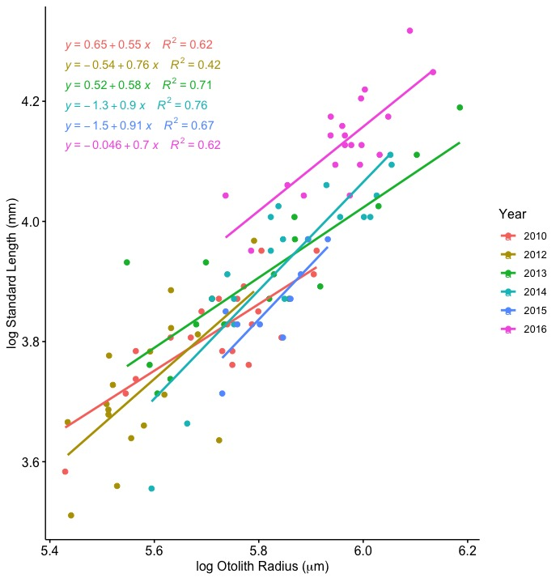

Supplementary Figure 7: Relationship between the natural log-transformed Kodiak Island juvenile Pacific Cod (Gadus macrocephalus) standard length (mm) and otolith radius (µm) in July 2010 and 2012-2016.
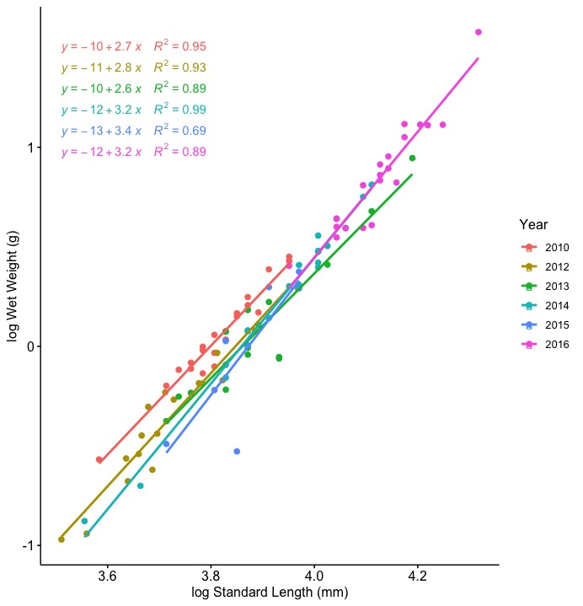

Supplementary Figure 8: Relationship between the natural log-transformed Kodiak Island juvenile Pacific Cod (Gadus macrocephalus) wet weight (g) and standard length (mm) in July 2010 and 2012-2016.

Supplementary Table 1: Juvenile Pacific Cod capture dates for July 2010, and 2012-2016, and prSOM 8-day composites for mid- and late-July for 2010, and 2012-2016. No juvenile Pacific Cod samples were available in 2011.
Year | Sample Size (n) | Fish size (SL; mm) | July Temperature (°C) |  | July pCO2 (μatm) | Ocean Conditions
2010 | 23 | 45.35 ± 0.82 | 10.07 ± 0.15 | 288.31 |  | Normal
2012 | 17 | 41.47 ± 1.17 | 10.04 ± 0.32 | 291.00 |  | Normal
2013 | 19 | 50.00 ± 1.43 | 11.64 ± 0.40 | 295.02 |  | Normal
2014 | 19 | 51.79 ± 1.53 | 12.52 ± 0.23 | 287.90 |  | Heatwave
2015 | 9 | 47.67 ± 1.29 | 11.69 ± 0.21 | 300.08 |  | Heatwave
2016 | 20 | 62.40 ± 1.16 | 12.85 ± 0.25 | 313.57 |  | Heatwave

Standard Length to Otolith Radius | Parameter Estimates:  ln(Standard Length) = y₀ + a[ln(Otolith Radius)] + b[Year] + c[ln(Otolith Radius) * Year]
 | y₀ mean ± SE | a mean ± SE | b mean ± SE |  | c mean ± SE |  | R² adj
 | 0.647 ± 0.705 | 0.554 ± 0.123 | Year2012 | -1.186 ± 1.188 | Year2012 | 0.209 ± 0.211 | 0.847
 |  |  | Year2013 | -0.128 ± 0.880 | Year2013 | 0.030 ± 0.153
 |  |  | Year2014 | -1.988 ± 0.973 | Year2014 | 0.347 ± 0.168
 |  |  | Year2015 | -2.114 ± 1.992 | Year2015 | 0.360 ± 0.343
 |  |  | Year2016 | -0.693 ± 1.202 | Year2016 | 0.146 ± 0.205
Wet Weight to Standard Length | Parameter Estimates:  ln(Wet Weight) = y0 + a[ln(Standard Length) + b[Year]
 | y₀ mean ± SE | a mean ± SE | b mean ± SE |  |  |  | R² adj
 | -11.169 ± 0.354 | 2.939 ± 0.092 | Year2012 | -0.126 ± 0.033 |  |  | 0.961
 |  |  | Year2013 | -0.193 ± 0.033
 |  |  | Year2014 | -0.157 ± 0.033
 |  |  | Year2015 | -0.217 ± 0.039
 |  |  | Year2016 | -0.113 ± 0.042

Supplementary Table 2: Model parameters for juvenile Pacific Cod otolith back calculation models. Top: ln(Standard Length) ~ ln(Otolith Radius) model. Bottom: ln(Wet Weight) ~ ln(Standard Length) model.

Appendix E – Animated Stress-scape Figures
Supplementary Video 1 Link: https://figshare.com/articles/media/14356751 (DOI: 10.6084/m9.figshare.14356751)
Supplementary Figure 1: Animated multi-panel figure showing the progression of stress-scapes near Kodiak Island from 2010-2016 (see Figure 2). The leftmost column shows the classified stress-scape per pixel for each time step, while the next three columns show the z-scores of the SST, pCO2, and SGR variables used to classify each stress-scape. The last column is a ribbon plot for each year that shows the areal extent of each stress-scape at each time step.
Supplemental Figure 2 Link: https://figshare.com/articles/media/14356793 (DOI: 10.6084/m9.figshare.14356793)
Supplementary Figure 2: Similar to Supplemental Figure 1, this is an animated multi-panel figure showing the progression of stress-scapes within the study area for the whole GOA from 2010-2016. The top figure shows the classified stress-scape per pixel for each time step, while the middle of the figure is a ribbon plot showing the areal extent of each stress-scape class at each time step. The mean values for each of the classification variables is shown in the legend.

