Critical dependence of butterflies on a non-native host plant in the urban tropics
Anuj Jain^{1,2*#}, Yiwen Zeng¹, Edward L. Webb^{1*}
¹ Department of Biological Sciences, National University of Singapore, Singapore.
² Nature Society (Singapore), 510 Geylang Road, Singapore.

Supplementary Material

Supplementary Table 1 - Source populations for Common Birdwing (BW) and Common Rose (CR) in Singapore as identified by experts, survey effort and BW & CR abundance recorded as part of our study. BW and CR prediction values represent the probability of occurrence in Singapore based on the random forest models.
S. No. | Site Code | Distance to another nearest source population | Site description | Habitat Type | Survey effort (hours) | BW abundance | CR abundance | BW prediction | CR prediction
1 | JBG-EVO | 3.4 km (IST) | Singapore Botanic Gardens (Jacob Ballas Children's Garden & Evolution Garden) | Urban park | 117 | 24 | 59 | 0.66 | 0.69
2 | IST | 3.4 km (JBG) |  | Urban park | 97 | 11 | 15
 |  |  | Istana and Penang Road Open Space |  |  |  |  | 0.65 | 0.66
3 | UBH | 12km (SCC) | Ubin Butterfly Hill | Urban park | 58 | 79 | 22 | 0.60 | 0.42
4 | BTNR - DFNP | 4.9 km (Zoo) | Bukit Timah Nature Reserve & Dairy Farm Nature Park | Forest | 56 | 26 | 0 | 0.38 | 0.15
5 | JEG | 5km (TFM) | Jurong Eco Garden | Urban park | 42 | 14 | 3 | 0.61 | 0.65
6 | AHG-HOR | 3.5 km (IMB) | Alexandra Hospital Butterfly Garden & Hort Park | Urban park | 37 | 10 | 9 | 0.66 | 0.69
7 | IMB | 3.5 km (AHG) | Imbiah Garden in Sentosa | Private | 31 | 11 | 1 | 0.65 | 0.69
8 | CLW | 2.5 km (BTNR) | Clementi Woods & Maju Camp | Forest | 25 | 12 | 5 | 0.3 | 0.14
9 | Zoo | 4.9 km (DFNP) | Mandai zoo | Private | 15 | 8 | 4 | 0.64 | 0.65
10 | WNU | 4.2 km (JBG) | Windsor estate | Private | 157 | 5 | 2 | 0.34 | 0.14
11 | KTPH | 2.7km (SCC) | Khoo Teck Puat Hospital | Private | 80 | 2 | 15 | 0.37 | 0.20
12 | SCC | 2.7km (KTP) | Seletar Country Club | Private | 101 | 3 | 6 | 0.37 | 0.21
13 | VPG | 3.5 km (CLW) | Varsity Park Garden | Private | 46 | 0 | 10 | 0.34 | 0.32
14 | TFM | 5km (JEG) | Tengah Farm | Private | 30 | 4 | 0 | 0.34 | 0.15

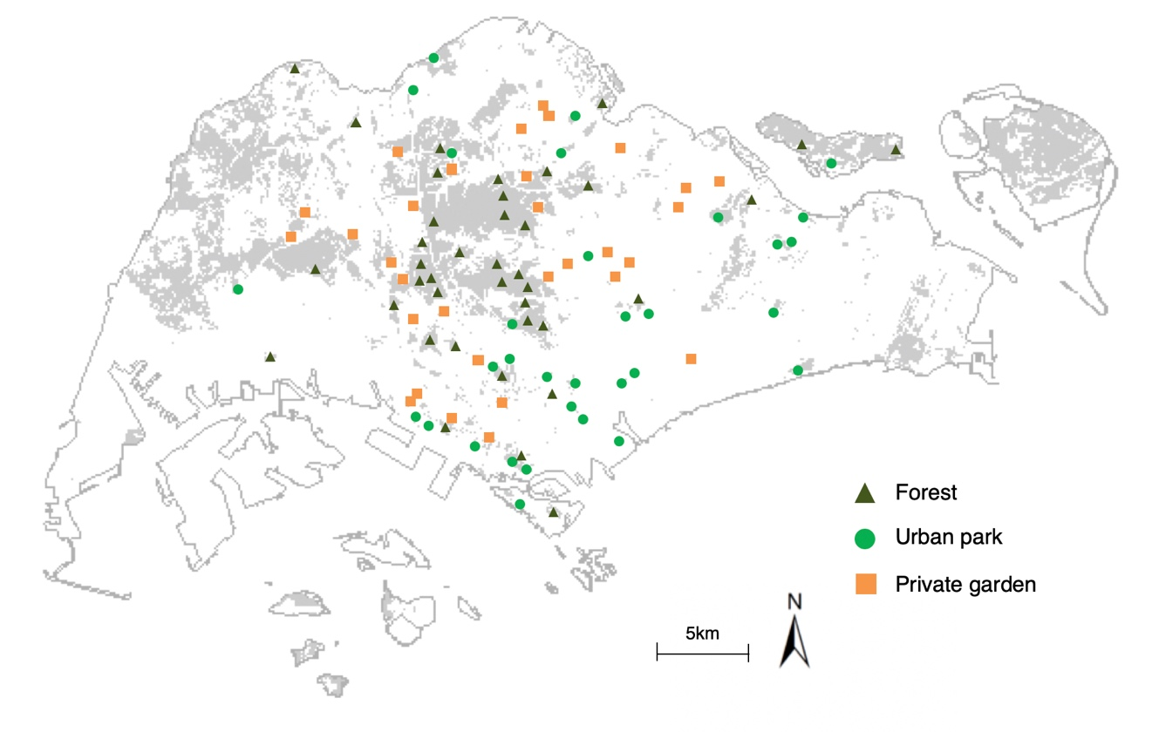
Supplementary Figure 1 - Survey locations for BW and CR butterflies divided by habitat types

