Supplemental Material for Exploring the Pacific Arctic Seasonal Ice Zone with Saildrones
A.M. Chiodi^{1,2*}, Chidong Zhang², Edward D. Cokelet², Qiong Yang^{1,2†}, Calvin W. Mordy^{1,2}, Chelle Gentemann³, J. Cross², N. Lawrence-Slavas², C. Meinig², Michael Steele⁴, D.E. Harrison², Phyllis Stabeno², Heather Tabisola^{1,2}, Dongxiao Zhang^{1,2}
¹Cooperative Institute for Climate, Ocean and Ecosystem Studies, University of Washington, Seattle, WA, USA
²Pacific Marine Environmental Laboratory, National Oceanic and Atmospheric Administration, Seattle, WA, USA
³ Farallon Institute, Petaluma, California, and Earth and Space Research, Seattle, Washington, USA
⁴Polar Science Center, Applied Physics Lab, University of Washington, Seattle, WA, USA
†Current affiliation: The Climate Corporation, Seattle, WA, USA
* Correspondence:
Corresponding Author
andy.chiodi@noaa.gov

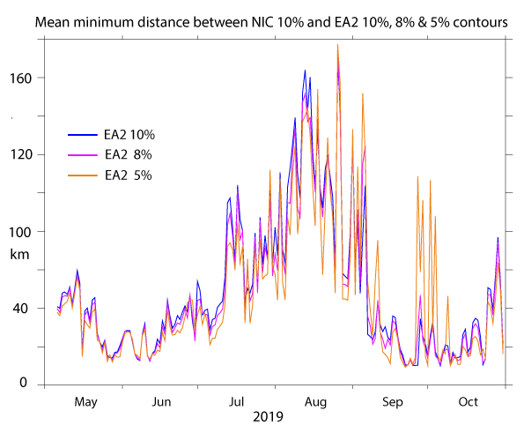
Figure S1. Mean minimum-distances between the NIC 10% ice concentration contour and the 10% (blue), 8% (pink) and 5% (orange) EA2 ice concentration contours. The blue line is repeated from Fig. 6 in the main text. Results here are based on doing the contour-separation calculation in both directions; that is, starting with the EA2 contour and starting with the NIC contour.

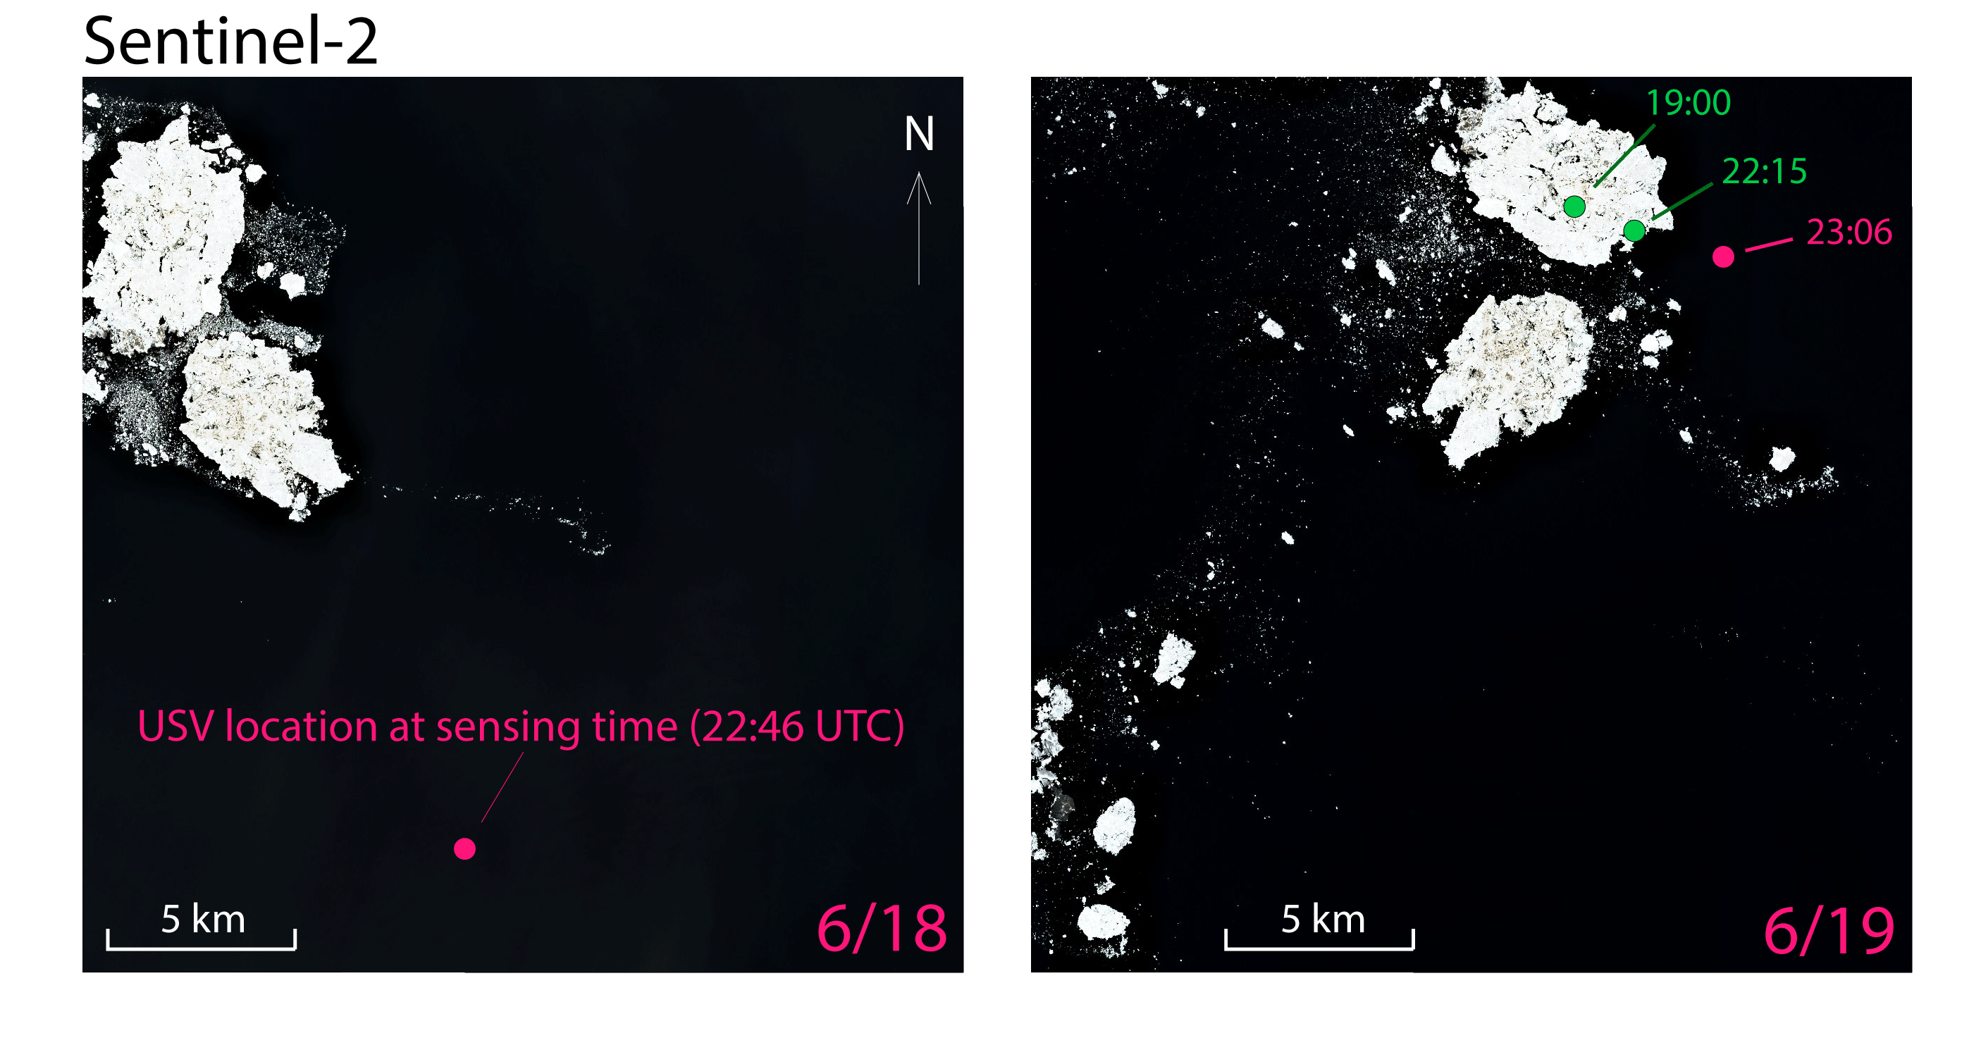
Figure S2. Sentinel-2 images and sd-1034 positions on 18 June 2019 and 19 June 2019. The same region is shown in both images, with south-north bounds of 70.9200° N and 71.1350° N and west-east bounds of -164.5000° W and -161.0000° W. Pink dots in each panel show the location of sd-1034 when the images were collected (sensed) at 22:46 UTC (6/18; left panel) and 23:06 UTC (6/19; right panel). Sd-1034 images revealed a band of ice impeding its route from ~19:00 -22:15 UTC, June 19th. We infer that the pack of dense ice visible in the upper-left corner of the 6/18 image traveled east during the next 24 hours, and some sparse ice ahead of the denser pack blocked sd-1034 between 19 June 2019 19:00 and 22:15 UTC. Evidently, sd-1034 was freed in time to sail ~1.5 km east of the denser pack ice by the next Sentinel-2 image collection time at 23:06 on 19 June 2019.

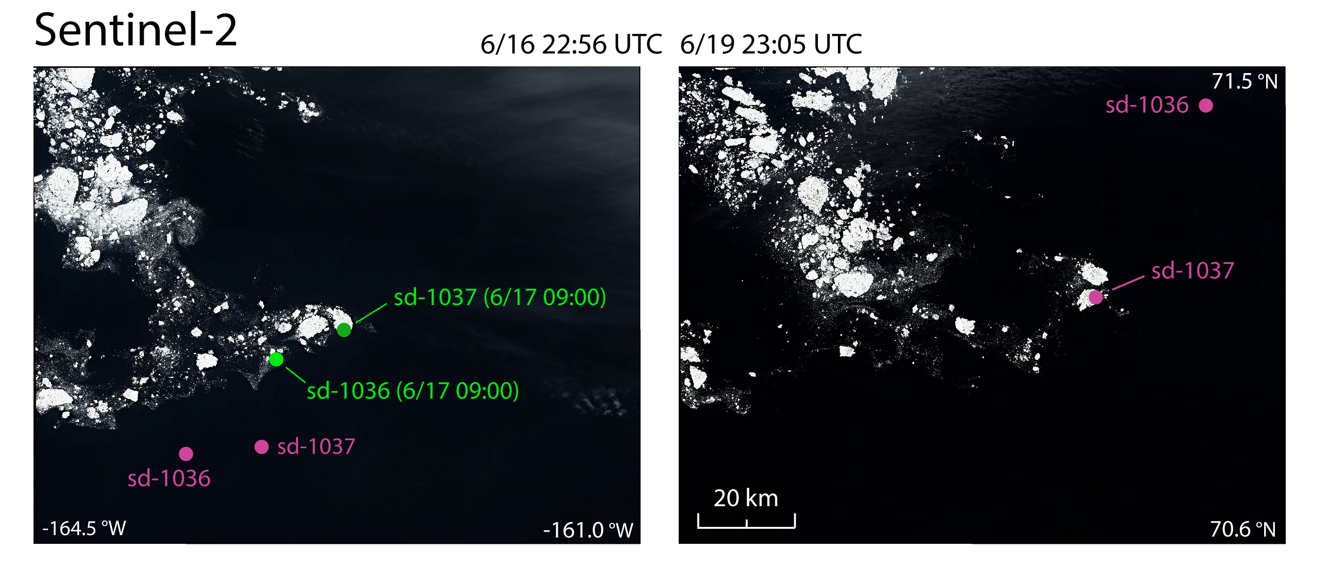

Figure S3. Sentinel-2 images sensed on 16 June 2019 22:56 UTC (left) and 19 June 2019 23:05 (right). The pink dots in the left panel show saildrone positions at the image sensing time. Green dots in the left panel show the saildrone positions when their routes were blocked by ice at the times listed. The dots in the right panel show saildrone positions at the sensing time, when sd-1036 was in ice-free water, but sd-1037 was still encumbered in ice.

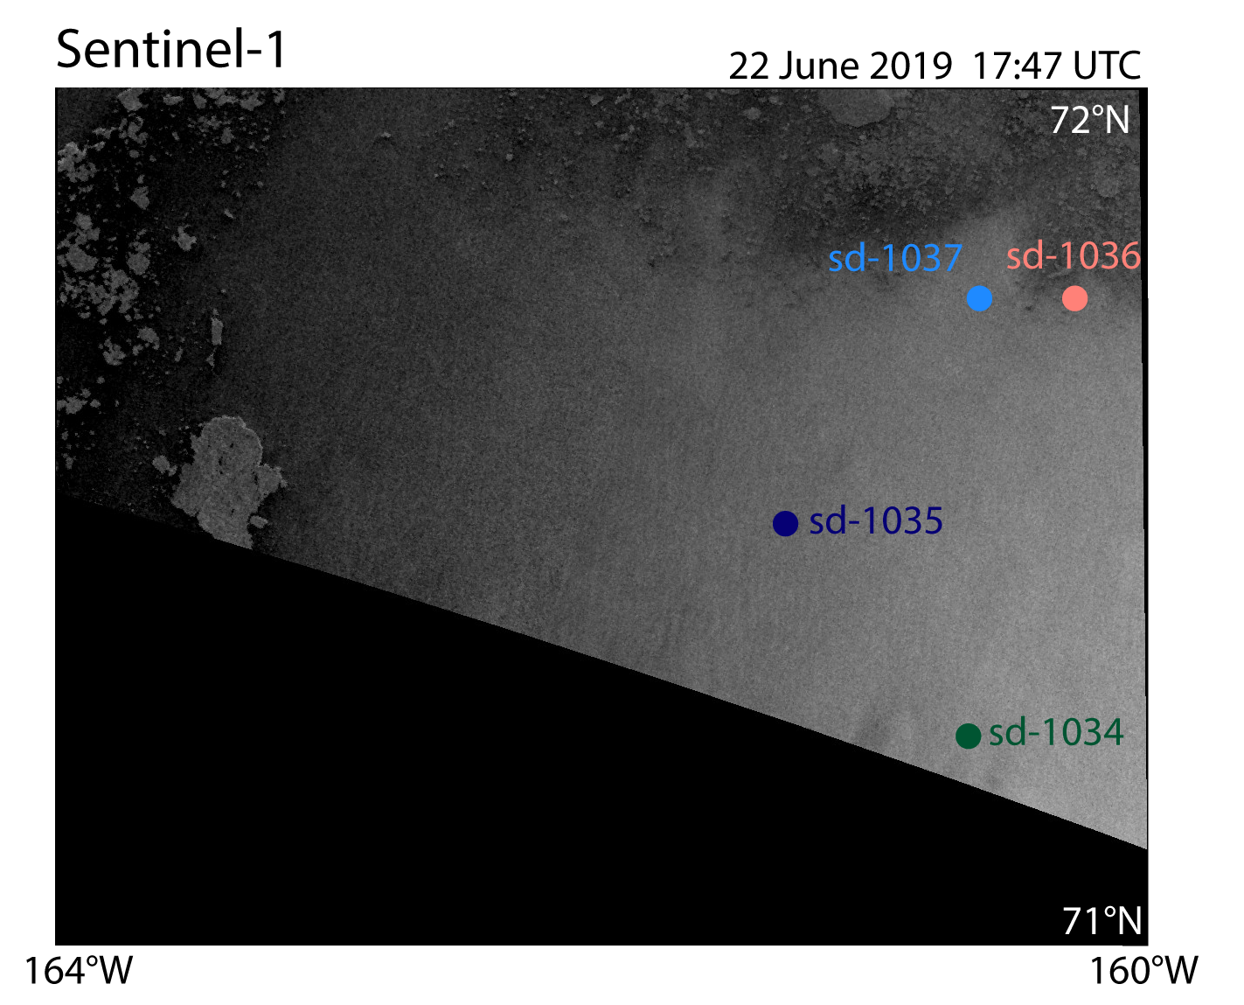

Figure S4. An example Sentinel-1 SAR image covering the saildrone positions (filled circles) at its sensing time.

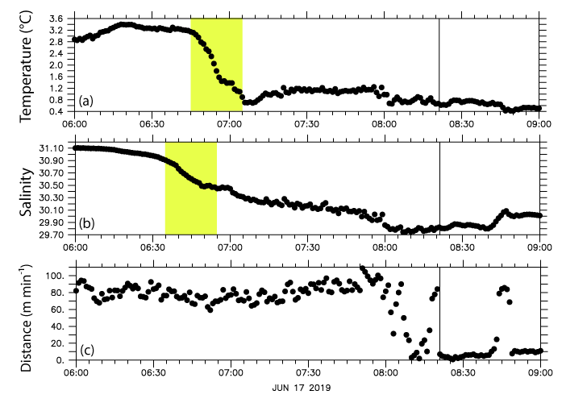
Figure S5. (a) 1-minute average temperature observations preceding and shortly after the point sd-1036 was impeded by sea ice on 17 June 2019, 08:26 UTC. The ice-blockage time is shown by a vertical line in each panel. Yellow shading delineates the maximum 20-minute temperature drop in the 3 hours preceding the ice blockage. (b) 1-minute average salinity observations. Yellow shading delineates the maximum 20-minute salinity drop in the 3 hours preceding the ice blockage. (c) Distance traveled per minute.

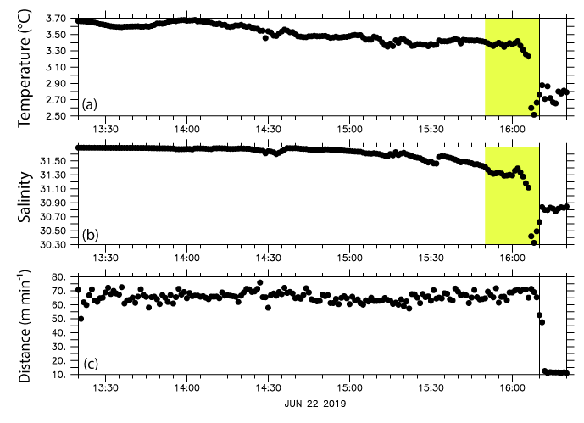
Figure S6. (a) 1-minute average temperature observations preceding and shortly after the point sd-1036 was impeded by sea ice on 22 June 2019, 16:10 UTC. The ice-blockage time is shown by a vertical line in each panel. Yellow shading delineates the maximum 20-minute temperature drop in the 3 hours preceding the ice blockage. (b) 1-minute average salinity observations. Yellow shading delineates the maximum 20-minute salinity drop in the 3 hours preceding the ice blockage. (c) Distance traveled per minute.

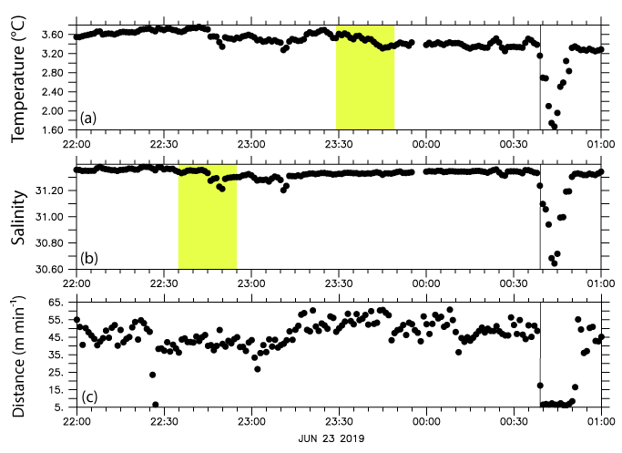
Figure S7. (a) 1-minute average temperature observations preceding and shortly after the point sd-1036 was impeded by sea ice on 23 June 2019, 00:38 UTC. The ice-blockage time is shown by a vertical line in each panel. Yellow shading delineates the maximum 20-minute temperature drop in the 3 hours preceding the ice blockage. (b) 1-minute average salinity observations. Yellow shading delineates the maximum 20-minute salinity drop in the 3 hours preceding the ice blockage. (c) Distance traveled per minute.

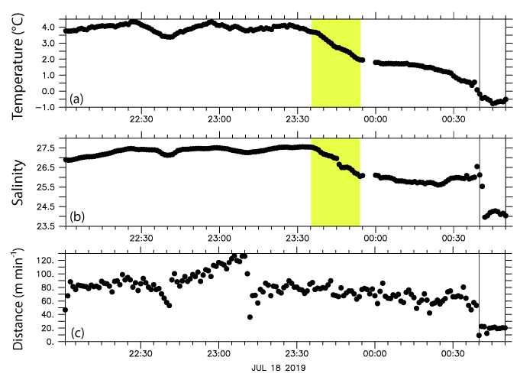
Figure S8. (a) 1-minute average temperature observations preceding and shortly after the point sd-1036 was impeded by sea ice on 18 July 2019, 00:40 UTC. The ice-blockage time is shown by a vertical line in each panel. Yellow shading delineates the maximum 20-minute temperature drop in the 3 hours preceding the ice blockage. (b) 1-minute average salinity observations. Yellow shading delineates the maximum 20-minute salinity drop in the 3 hours preceding the ice blockage. (c) Distance traveled per minute.

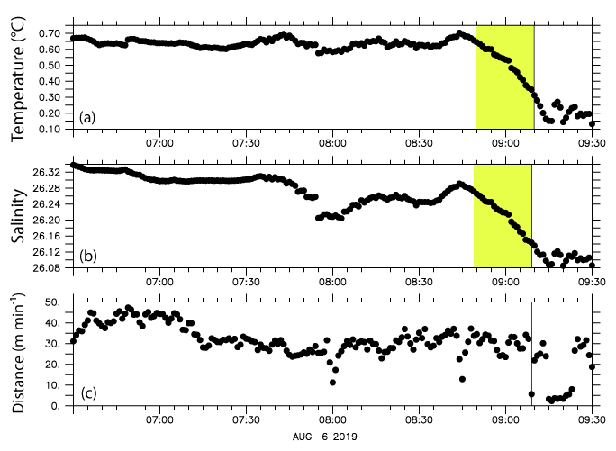
Figure S9. (a) 1-minute average temperature observations preceding and shortly after the point sd-1036 was impeded by sea ice on 6 August 2019, 09:08 UTC. The ice-blockage time is shown by a vertical line in each panel. Yellow shading delineates the maximum 20-minute temperature drop in the 3 hours preceding the ice blockage. (b) 1-minute average salinity observations. Yellow shading delineates the maximum 20-minute salinity drop in the 3 hours preceding the ice blockage. (c) Distance traveled per minute.

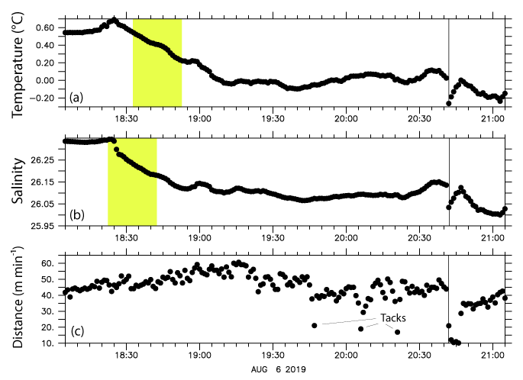
Figure S10. (a) 1-minute average temperature observations preceding and shortly after the point sd-1036 was impeded by sea ice on 6 August 2019, 20:42 UTC. The ice-blockage time is shown by a vertical line in each panel. Yellow shading delineates the maximum 20-minute temperature drop in the 3 hours preceding the ice blockage. (b) 1-minute average salinity observations. Yellow shading delineates the maximum 20-minute salinity drop in the 3 hours preceding the ice blockage. (c) Distance traveled per minute.

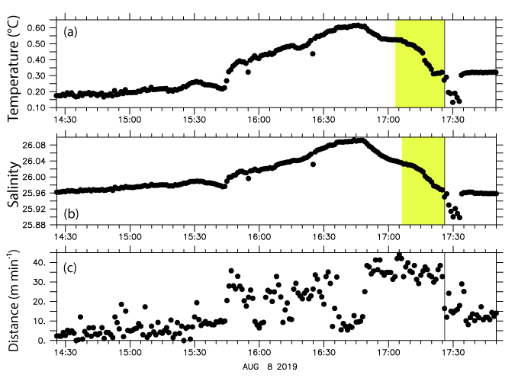
Figure S11. (a) 1-minute average temperature observations preceding and shortly after the point sd-1036 was impeded by sea ice on 8 August 2019, 17:26 UTC. The ice-blockage time is shown by a vertical line in each panel. Yellow shading delineates the maximum 20-minute temperature drop in the 3 hours preceding the ice blockage. (b) 1-minute average salinity observations. Yellow shading delineates the maximum 20-minute salinity drop in the 3 hours preceding the ice blockage. (c) Distance traveled per minute.

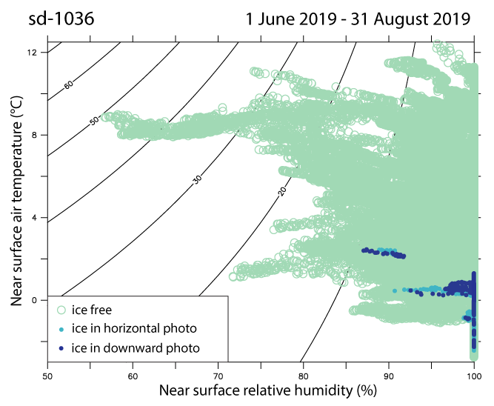
Figure S12. 1-minute averaged temperature and relative humidity collected by sd-036 during June, July and August of 2019. Light green circles denote times when no ice was visible by the saildrone; light blue dots denote times when ice was visible in the horizontal but not in the downward saildrone photos; dark blue dots denote times when ice was visible in the downward-looking saildrone images. Contours of vapor pressure deficit are drawn every 10 hPa.

