Supplementary material
Participants
Exclusion criteria for both groups included the presence of substance abuse in the past year; use of psychotropic medications within 4 weeks, history of psychosis, general anxiety disorder, attention deficit disorder or learning disability; neurological illness. These criteria were evaluated through an anamnestic questionnaire.
Antisaccade task: design description
Each trial began with a blank screen of 500ms, followed by a central fixation cross (1.5° x 1.5°) displayed for 1000ms. Participants were instructed to stare at it until it disappeared. A picture (12.9°x 8.53°) then appeared at 9.5° on either the left or right side of the screen. The participants were then required to perform either an antisaccade or a prosaccade. Images appeared an equal number of times on the right and left side, whether in anti- or prosaccade. After 500ms of presentation, an arrow (1.6° x 0.8°) either replaced the picture (on prosaccade trials) or appeared on the side of the screen opposite to it (on antisaccade trials). In either case, the arrow appeared at 9.5° eccentricity from the fixation cross. The participants were required to identify the direction of the arrow (up or down) by pressing the relevant button on the button press box. The target arrow was shown until the production of an answer. While in the single condition participants completed blocks of only pro or antisaccade; in the mixed condition the color of the fixation cross (either green or red) provided instructions for the type of saccade to be performed on that trial (i.e., the green cross indicate a prosaccade trial, and the red one an antisaccade trial).
The experiment included eight blocks of 20 trials each, half of which were antisaccade and half of which were prosaccade (320 trials in total, half of which were switch and half repeat trials). As described by Ansari et coll. (2008), the orders in which the anti- and prosaccade trials (AB–BA) and the single and mixed conditions (ABBA–BAAB) were presented were counterbalanced in a between-subjects design. Participants performed twenty-four practice trials (i.e., 12 switch, 12 repeat), at the end of which they were asked to verbalize the instructions in order to ensure that these have been fully understood. The eye tracker was then calibrated. Speed and accuracy were emphasized in the instructions given to the participants.
Based on Ehlers and Clark’s cognitive model of PTSD (2000) and on Olatunji et al.’s (2015) comparison of pertinent stimuli for the investigation of attentional bias in PTSD, we decided to used pictures as emotional stimuli instead of faces (as in Reinhard et al. (2017)). Pictures were taken from the International Affective Picture System and sorted into positive (e.g., puppies), negative (e.g., crying baby) and inter-personal violence (e.g., physical assault) categories. Because the number of positive and inter-personal violence was not sufficient to fill the categories, additional slides (positive, n = 16; inter-personal violence, n = 8) were added from a database depicting positive and negative interpersonal situations (Blekić et al. 2021). Those pictures match the IAPS slides on valence and arousal, as well as visual complexity, luminosity and content.
Data reduction
Regarding the behavioural data, incorrect or missed trials (3.4%) and outliers (3.8%) were manually deleted by the authors. Data were distributed normally [Kolmogorov-Smirnov p = .405; skewness = .787 (SD = .427); kurtosis = .039 (SD = .833)]. Regarding the Eye-Tracking data, SMI software automatically performed data reduction and exported only usable eye-movements. Using high-speed saccade detection in the iView software, fixations were required to have >80ms duration and <100 pixels dispersion, meaning that within any given window of 80ms, the eye location did not move further than 100 pixels in any direction. Saccades were required to have 75–800° s–1 peak velocity, with peak velocity occurring between 20 and 80% of saccade length. Using these criteria and position data from the right eye, fixations and saccades were identified automatically by the iView Event Detector software. Saccades considered by the iView Event Detector software were identified as invalid and excluded from analyses if they met any of the following criteria: (a) latency <75ms or >1000ms after target onset; (b) amplitude <4.67° (i.e., width of face stimulus); (c) end position was within the central area of the screen (width of central area = 4.67°); or (d) start or end positions were located off the extent of the computer screen.
On a pre-processing stage, we placed rectangular Areas Of Interest (AOI) on the side of the picture and on the side of the white space on the other side of the screen (see supplemental Fig. 1). These two AOIs were used to highlight trials in which the participants performed incorrect saccades. These were defined for antisaccade trials as saccade towards the picture, and away from the picture for prosaccade trials. The fixation count within the picture AOI among antisaccade trials was used as an indicator of inhibition difficulties. The corresponding AOIs are available from the first author on reasonable request pending the approval of the coauthors.
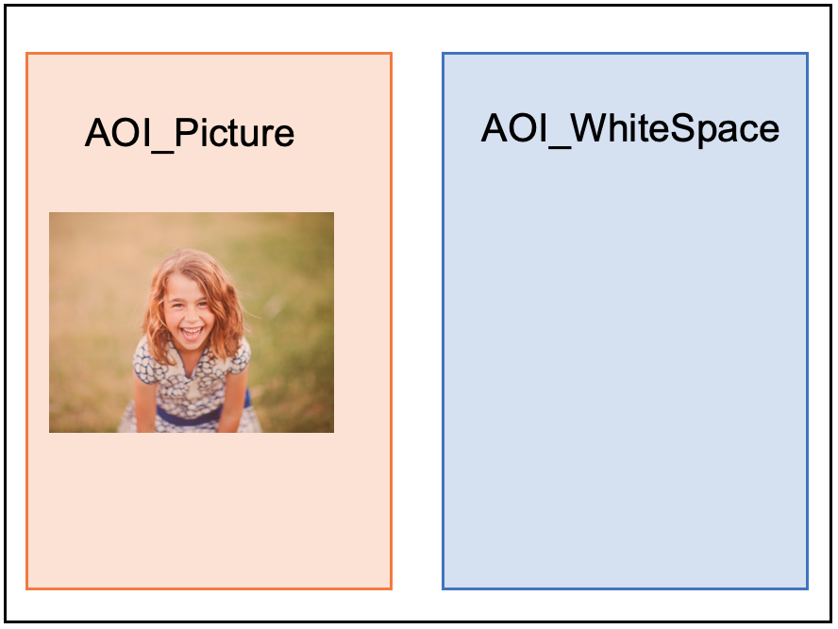
Supplemental Figure 1. Areas Of Interest developed for the present study

