Supplementary Material

pH  treatment | pH  observed | TA  (μmol/L) | pCO₂  (μatm) | CO₂  (μmol/kg-SW) | HCO₃–  (μmol/kg-SW) | CO₃^{2–}  (μmol/kg-SW) | Ω_{arag} | Temperature  (℃) | Salinity  (ppt) | PO₄³⁺-P  (μmol/L) | NO₂–-N  (μ mol/L) | NO₃–-N  (μmol/L) | SiO₃^{2–}-Si  (μmol/L) | NH₄⁺-N  (μmol/L)
pH 8.1 | 8.11 ± 0.01 | 2610.25 ± 45.75 ª | 497.42 ± 9.05 ª | 13.44 ± 0.24 ª | 2030.49 ± 36.95 ª | 241.69 ± 4.39 ^{c} | 5.84 ± 0.01 ^{c} | 27 ± 0.3ª | 34 ± 0.1ª | 0.03 ± 0.01 ª | 0.45 ± 0.43 ª | < 0.05 | 0.18 ± 0.18 ª | 0.35 ± 0.35 ª
pH 7.7 | 7.69 ± 0.01 | 2608.00 ± 41.98 ª | 1115.37 ± 18.30 ^{b} | 30.13 ± 0.49 ^{b} | 2282.09 ± 37.51 ^{b} | 136.14 ± 2.23 ^{b} | 3.29 ± 0.05 ^{b} | 27 ± 0.3ª | 34 ± 0.1ª | 0.03 ± 0.01 ª | 0.49 ± 0.33 ª | < 0.05 | 0.36 ± 0.18 ª | 0.51 ± 0.33 ª
pH 7.4 | 7.39 ± 0.02 | 2657.50 ± 42.52 ª | 2419.20 ± 39.12 ^{c} | 65.36 ± 1.05 ^{c} | 2480.71 ± 40.12 ^{c} | 74.17 ± 1.19 ª | 1.79 ± 0.02 ª | 27 ± 0.3ª | 34 ± 0.1ª | 0.05 ± 0.01 ª | 0.58 ± 0.32 ª | < 0.05 | 0.51 ± 0.26 ª | 0.84 ± 0.45ª
Table S1. Carbonate chemistry and water quality parameters in the three experimental pH treatments. Values are expressed as the mean ± SE of six determinations (n = 6). Different superscript letters represent statistically significant differences among the pH treatments for each parameter measured (p < 0.05). The carbonate seawater chemistry parameters were calculated from pH, TA, temperature, and salinity using the free-access CO2SYS.

Dependent variable | SS | df | MS | F | p
TA | 6250.5 | 2 | 3125.2 | 1.655 | 0.244
pCO₂ | 7700054 | 2 | 3850027 | 5930.5 | 0.000
CO₂ | 5621.4 | 2 | 2810.7 | 5945.9 | 0.000
HCO₃– | 407275 | 2 | 203637 | 139.386 | 0.000
CO₃² | 57392.0 | 2 | 28696.02 | 3337.6 | 0.000
Ω_{arag} | 33.510 | 2 | 16.755 | 3352.868 | 0.000
PO₄³⁺-P | 0.001 | 2 | 0.001 | 1.546 | 0.287
NO₂–-N | 0.03 | 2 | 0.015 | 0.037 | 0.964
NO₃–-N | 0.000 | 2 | 0.000
SiO₃^{2–}-Si | 0.167 | 2 | 0.083 | 0.633 | 0.563
NH₄⁺-N | 0.378 | 2 | 0.189 | 0.437 | 0.665
Table S2. One-way ANOVA comparing carbonate chemistry and water quality parameters in the three experimental pH treatments. Significant differences (p < 0.05) are highlighted in bold. SS: type III sum of squares; df: degree of freedom; MS: mean square; F: F-ratio; p: p-value.

Table S3. Effect of ocean acidification on photochemical efficiency, and PFC and DDN assimilation in G. fascicularis. Values are expressed as mean ± SE. Different superscript letters represent statistically significant differences among the pH treatments for each parameter measured (p < 0.05).
Duration | pH treatment | ΔF/F_{m}′ | F_{v}/F_{m} | Calcification rate % week^{–1} | PFC assimilation  (nmol C_{tracer} µmol C_{tissue}^{–1} d^{–1}) | DDN assimilation  (nmol N_{tracer} µmol N_{tissue}^{–1} d^{–1}) | δ¹³C (‰) | δ¹⁵N (‰)
0 days | 8.1 | 0.57 ± 0.01 ª | 0.66 ± 0.01 ª | _ | 6.80 ± 0.83 ª | 0.17 ± 0.03 ^{b} | -27.97 ± 2.30 ª | 4.59 ± 0.13 ª
 | 7.7 | 0.55 ± 0.02 ª | 0.65 ± 0.01 ª | _ | 6.79 ± 0.82 ª | 0.16 ± 0.04 ^{b} | -28.41 ± 0.02 ª | 4.70 ± 1.43 ª
 | 7.4 | 0.57 ± 0.02 ª | 0.66 ± 0.01 ª | _ | 6.55 ± 0.77 ª | 0.17 ± 0.03 ^{b} | -29.06 ± 0.35 ª | 4.69 ± 0.38 ª
14 days | 8.1 | 0.58 ± 0.02 ª | 0.67 ± 0.01 ª | 0.22 ± 0.05 ^{b} | _ | _ | _ | _
 | 7.7 | 0.56 ± 0.01 ª | 0.66 ± 0.01 ª | 0.09 ± 0.05 ^{b} | _ | _ | _ | _
 | 7.4 | 0.56 ± 0.01 ª | 0.65 ± 0.01 ª | -0.01 ± 0.03 ª | _ | _ | _ | _
28 days | 8.1 | 0.58 ± 0.01 ^{b} | 0.67 ± 0.01 ª | 0.18 ± 0.05 ^{b} | 9.24 ± 0.99 ª | 0.16 ± 0.02 ^{b} | -27.78 ± 0.40 ª | 5.64 ± 0.26 ^{b}
 | 7.7 | 0.55 ± 0.02 ^{ab} | 0.63 ± 0.01 ª | -0.04 ± 0.03 ^{ab} | 6.84 ± 1.04 ª | 0.13 ± 0.03 ^{ab} | -28.75 ± 0.58 ª | 4.80 ± 0.41 ^{ab}
 | 7.4 | 0.49 ± 0.02 ª | 0.63 ± 0.02 ª | -0.14 ± 0.13 ª | 7.11 ± 1.95 ª | 0.03 ± 0.02 ª | -30.56 ± 0.40 ª | 4.45 ± 0.06 ª

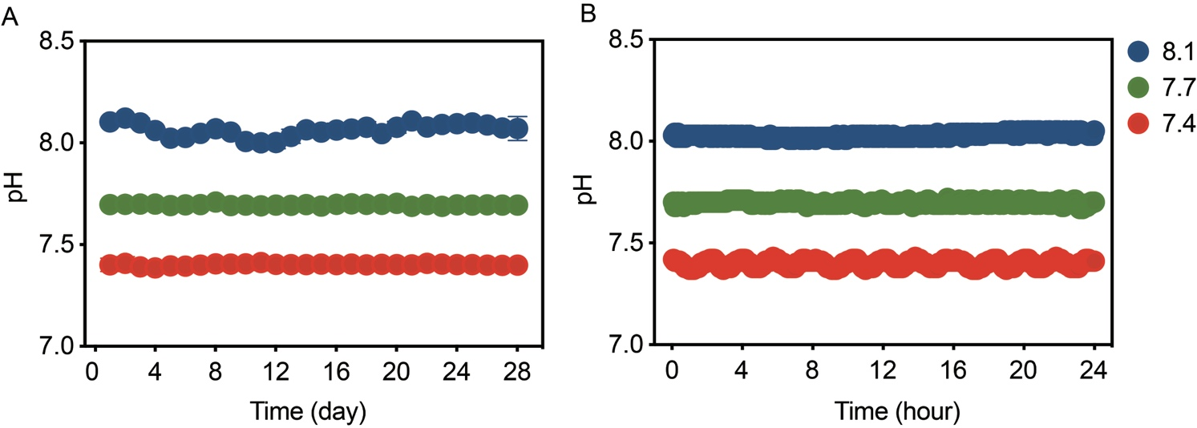
Fig. S1. Fluctuations in the seawater pH over the course of the experiment. The real-time pH values of seawater during the period of (A) 24 days and (B) 24 hours for each pH treatment were recorded using CO2SYS ZB-LS 3.0. Values are expressed as mean ± SE.

