Supplementary appendix

Table 1: Statistical fit of alternative PFS and OS extrapolations
Extrapolation | One-piece |  |  |  | Two-piece*
 | AIC |  |  | BIC | AIC | BIC
OS for pembrolizumab
Exponential | 212.6 |  |  | 214.5 | 74.1 | 75.8
Weibull | 212.7 |  |  | 216.5 | 75.9 | 79.1
Log-normal | 210.9 |  |  | 214.7 | 75.4 | 78.7
Log-logistic | 212.1 |  |  | 215.8 | 75.8 | 79.1
Gompertz | 210.5 |  |  | 214.3 | 75.7 | 79.0
Generalized gamma | 211.9 |  |  | 217.6 | 73.7 | 78.6
OS for chemotherapy
Exponential | 1275.1 |  |  | 1278.6 | NA | NA
Weibull | 1266.1 |  |  | 1273.1 | NA | NA
Log-normal | 1257.9 |  |  | 1265.0 | NA | NA
Log-logistic | 1258.7 |  |  | 1265.7 | NA | NA
Gompertz | 1274.9 |  |  | 1281.9 | NA | NA
Generalized gamma | 1259.9 |  |  | 1270.4 | NA | NA
PFS for pembrolizumab
Exponential |  | 281.0 | 282.9 |  | 164.8 | 166.4
Weibull |  | 276.8 | 280.6 |  | 163.2 | 166.4
Log-normal |  | 271.8 | 275.6 |  | 162.9 | 166.1
Log-logistic |  | 274.2 | 278.0 |  | 163.0 | 166.2
Gompertz |  | 270.8 | 274.6 |  | 163.6 | 166.8
Generalized gamma |  | 266.8 | 272.5 |  | 164.9 | 169.7
* For OS Kaplan-Meier data was used until week 40, for PFS Kaplan-Meier data was used until week 10
Key: AIC, Akaike information criterion; BIC, Bayesian information criterion; KM, Kaplan–Meier; OS, overall survival; PFS, progression free survival.

Figure 1: Visual fits of alternative PFS and OS extrapolations
- Overall survival for pembrolizumab using one-piece models
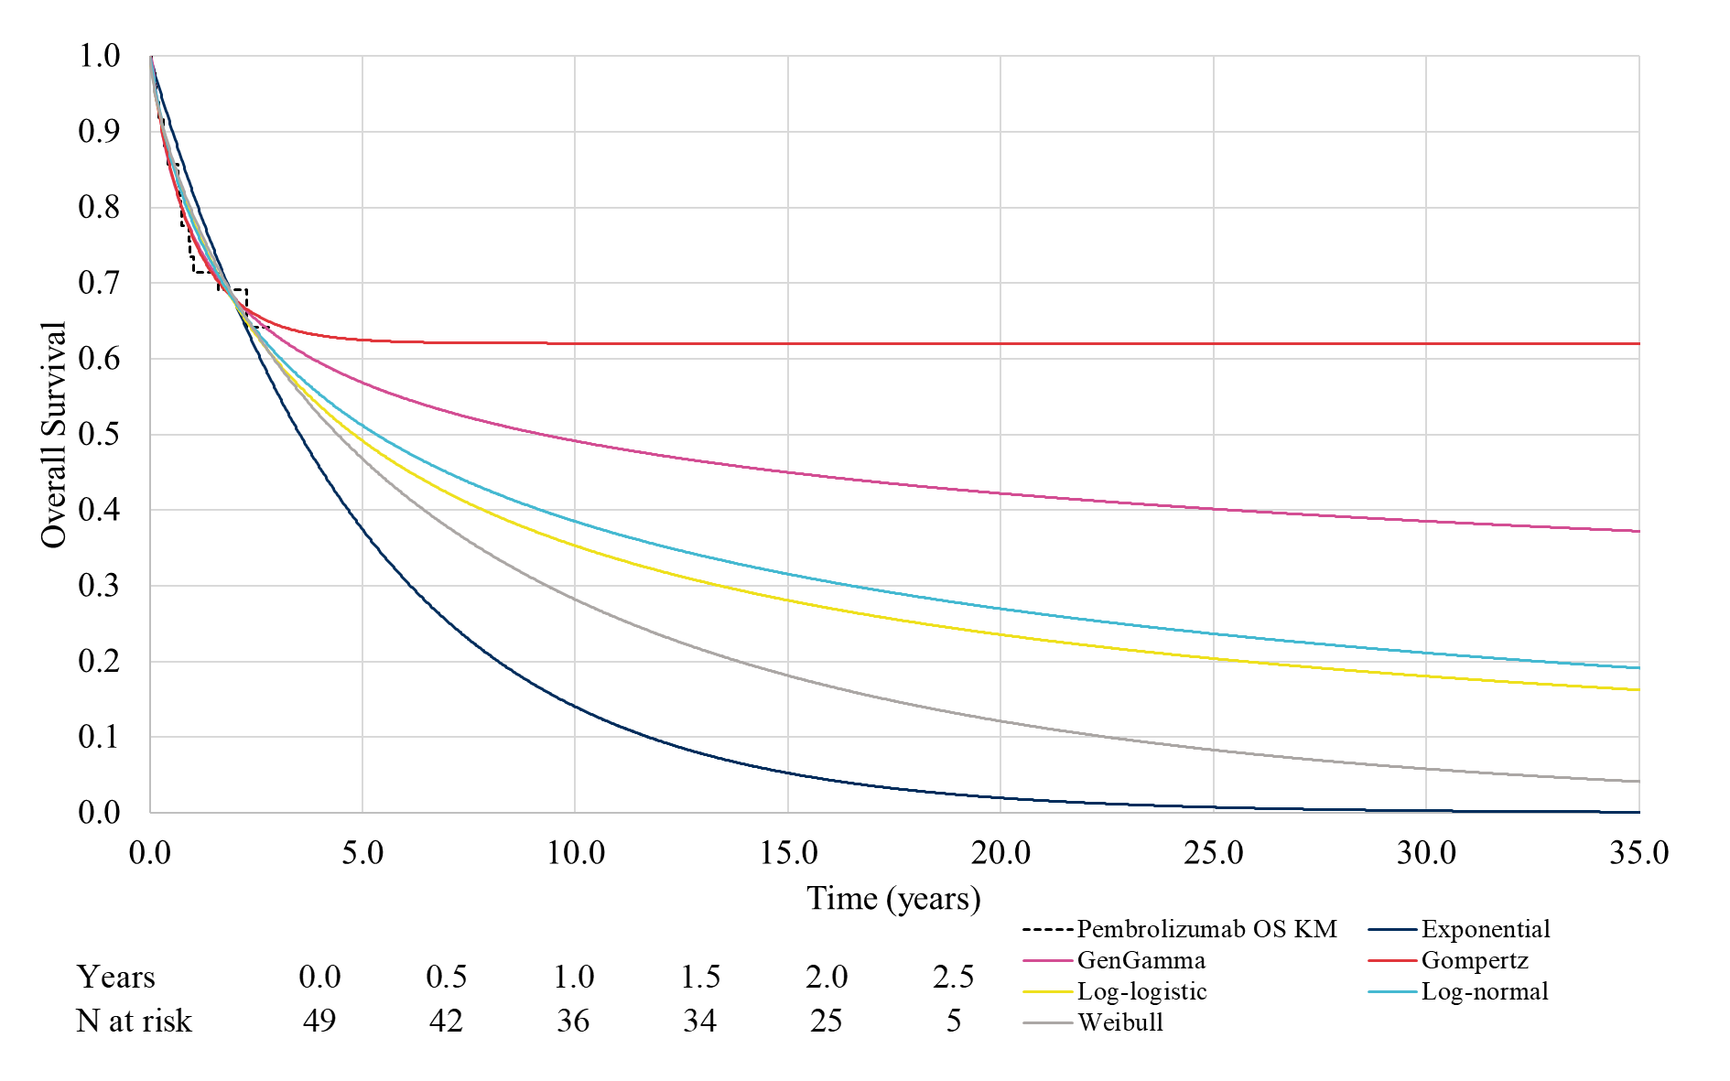
Note: The plot includes all curves fitted to all KM data, including clinically implausible selections.
- Overall survival for pembrolizumab using two-piece models
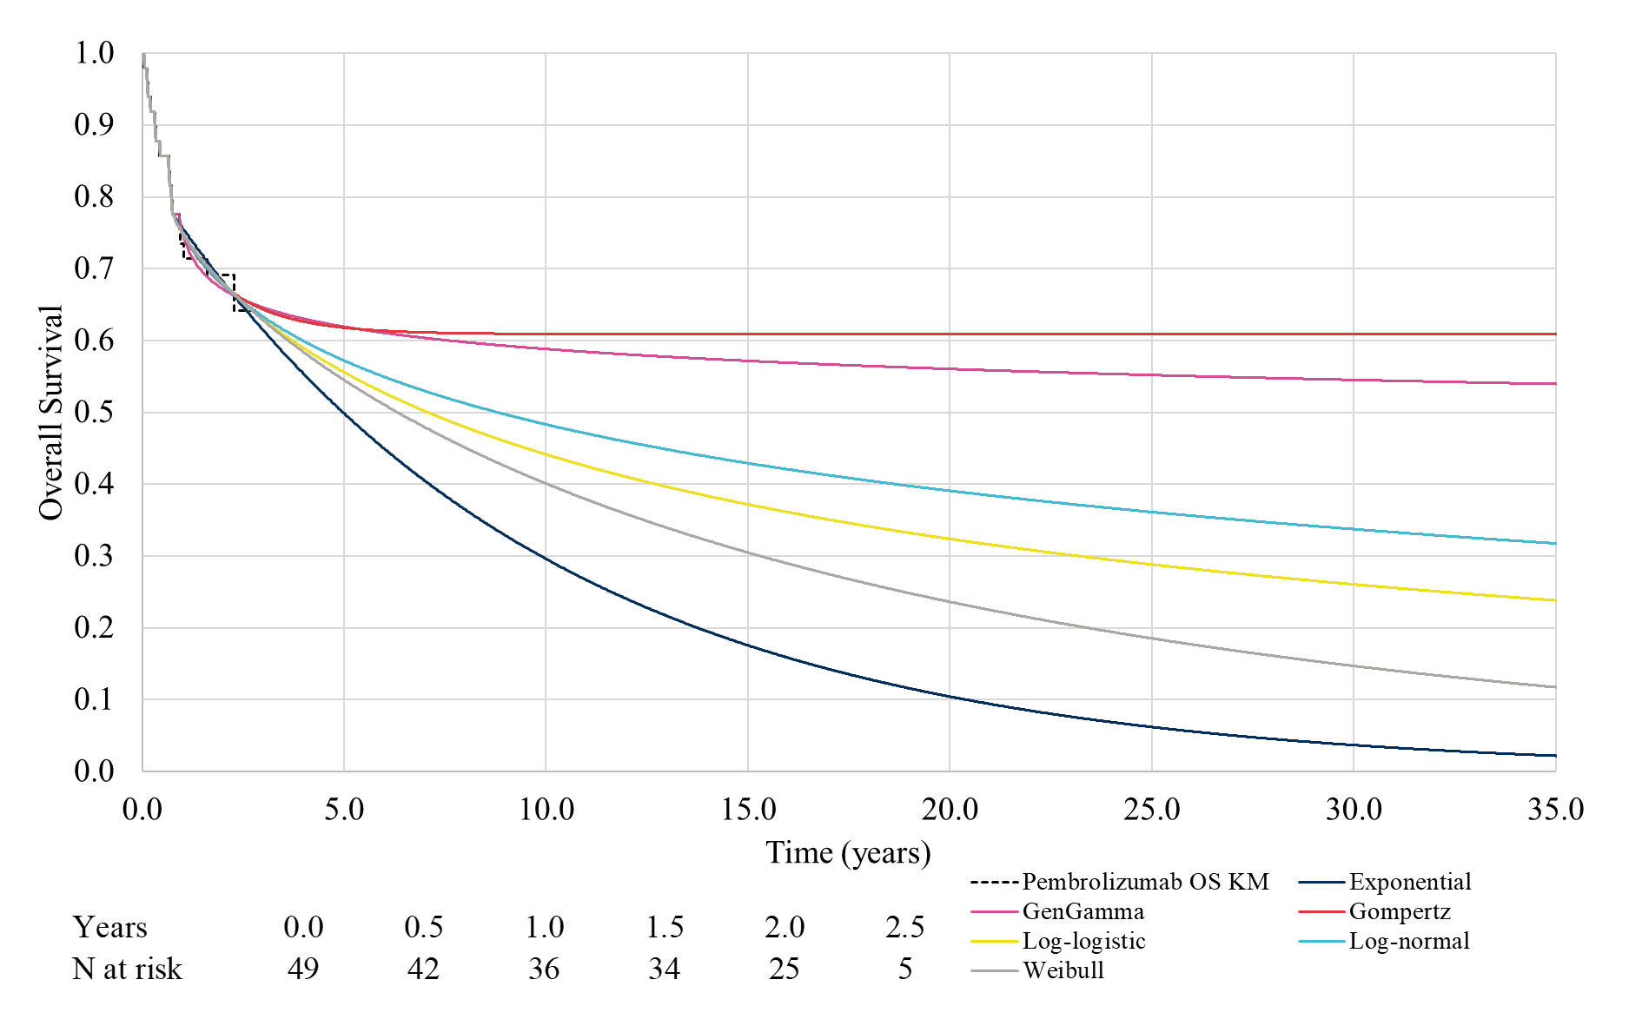
Note: The plot includes all curves fitted to all KM data, including clinically implausible selections.
- Overall survival for chemotherapy using one-piece models
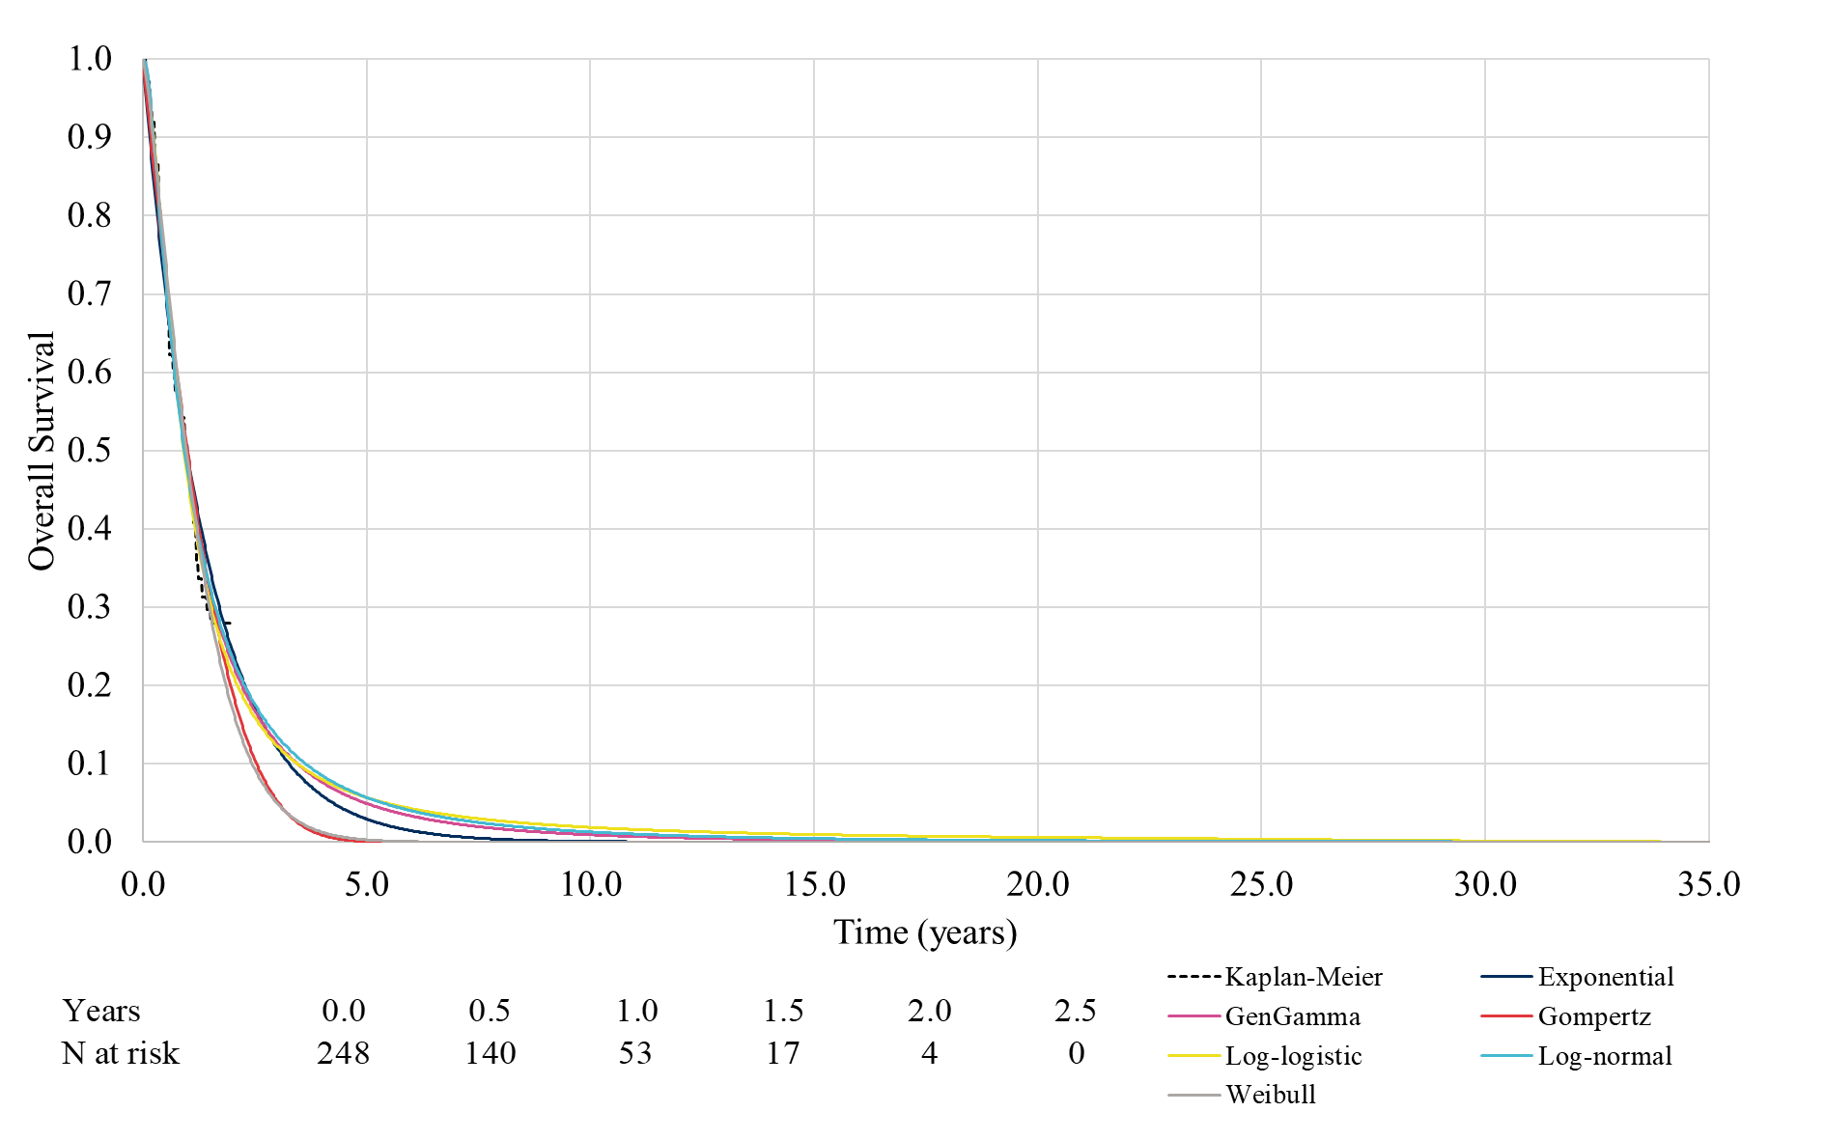
Note: The plot includes all curves fitted to all KM data, including clinically implausible selections.
- Progression-free survival for pembrolizumab using a one-piece model
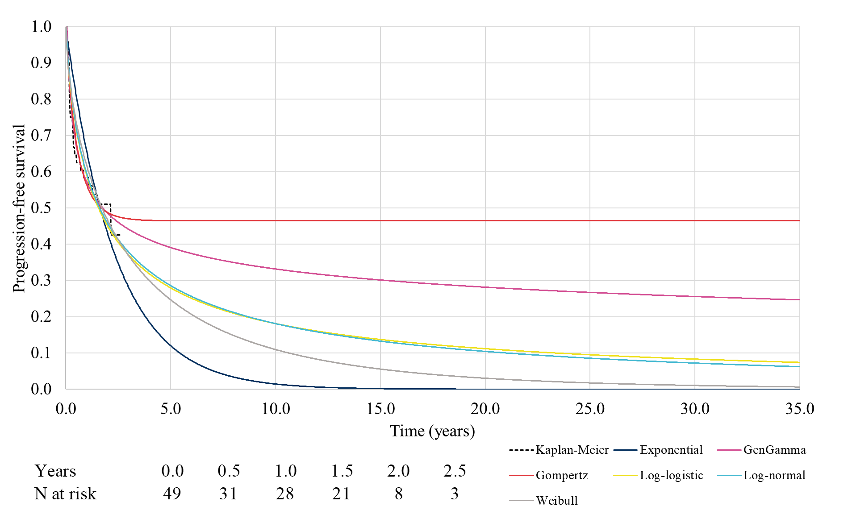
Note: The plot includes all curves fitted to all KM data, including clinically implausible selections.
- Progression-free survival for pembrolizumab using a two-piece model
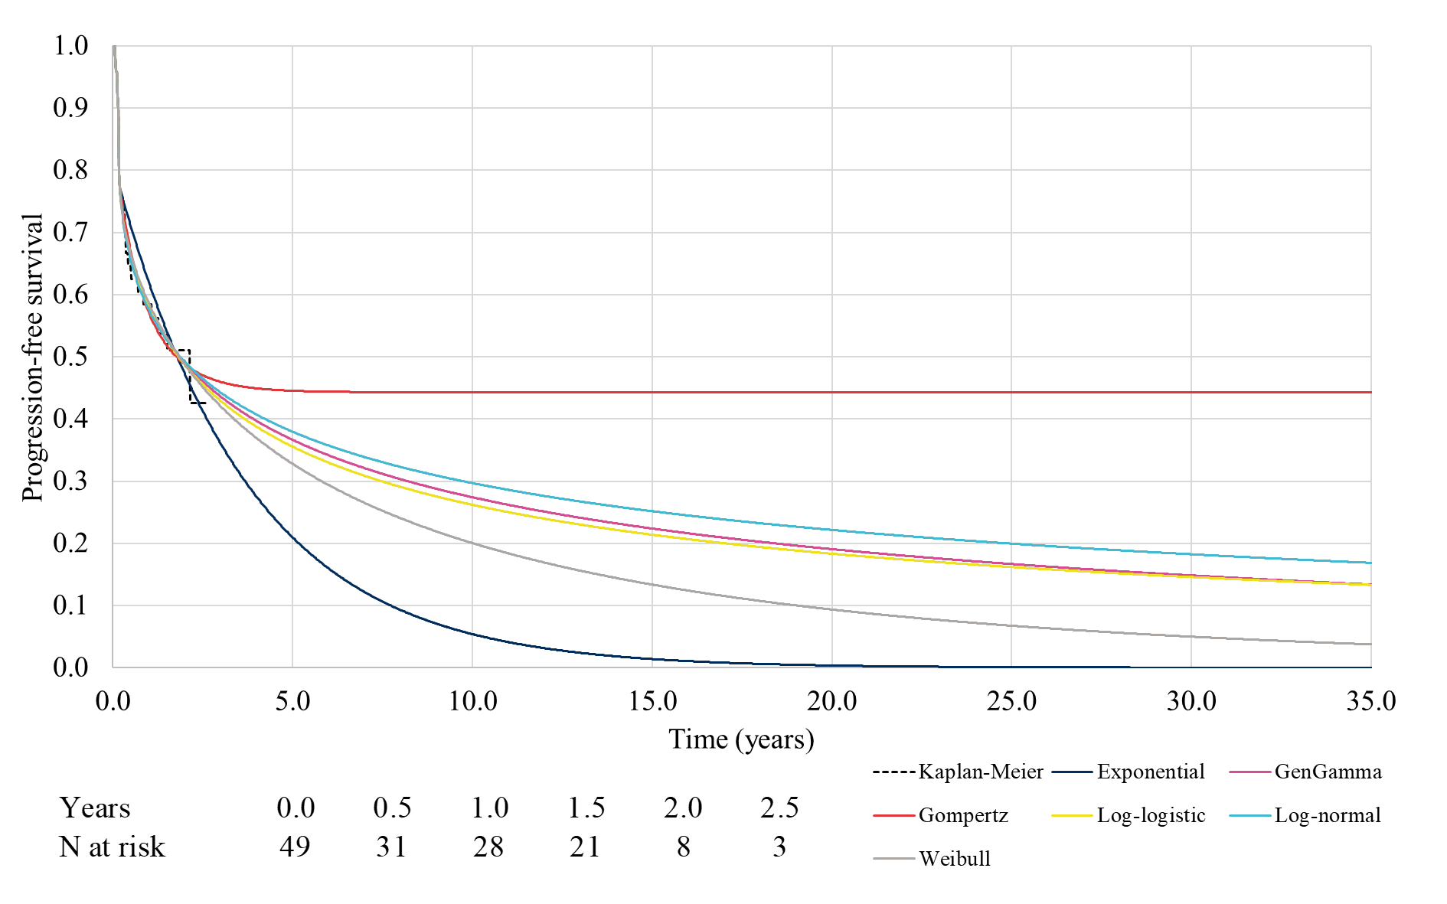
Note: The plot includes all curves fitted to all KM data, including clinically implausible selections.

