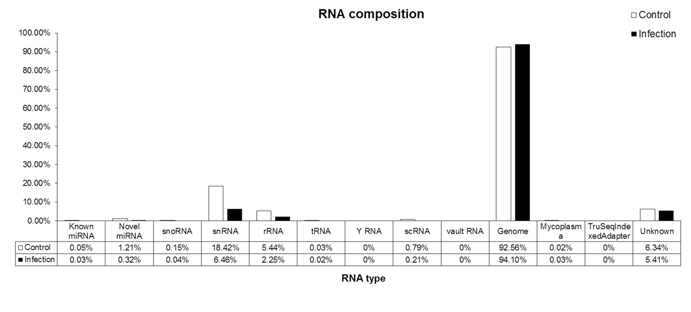
Figure S4. Bar plot of RNA composition in the control and avian influenza virus-infected samples. Final processed reads were aligned to small RNAs (≤50; piRNA) of the database using bowtie (http://bowtie-bio.sourceforge.net/index.shtml) and other small RNAs (≥50 nt; tRNA, snoRNA, etc.) of the database using bowtie2, which assigned a result of ≥90% coverage to the corresponding RNA.

