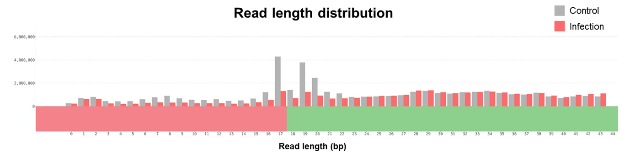
Figure S3. Read length distribution of control and infection samples. Generally mature miRNAs are 20~25 nt in length.

