

**Figure S1.** Resolved arithmetic standard deviation of surface chlorophyll variability against Log10 surface chlorophyll *a* concentration for underway ship observations. Raw data shown in gray and 9 km interpolated data in orange.

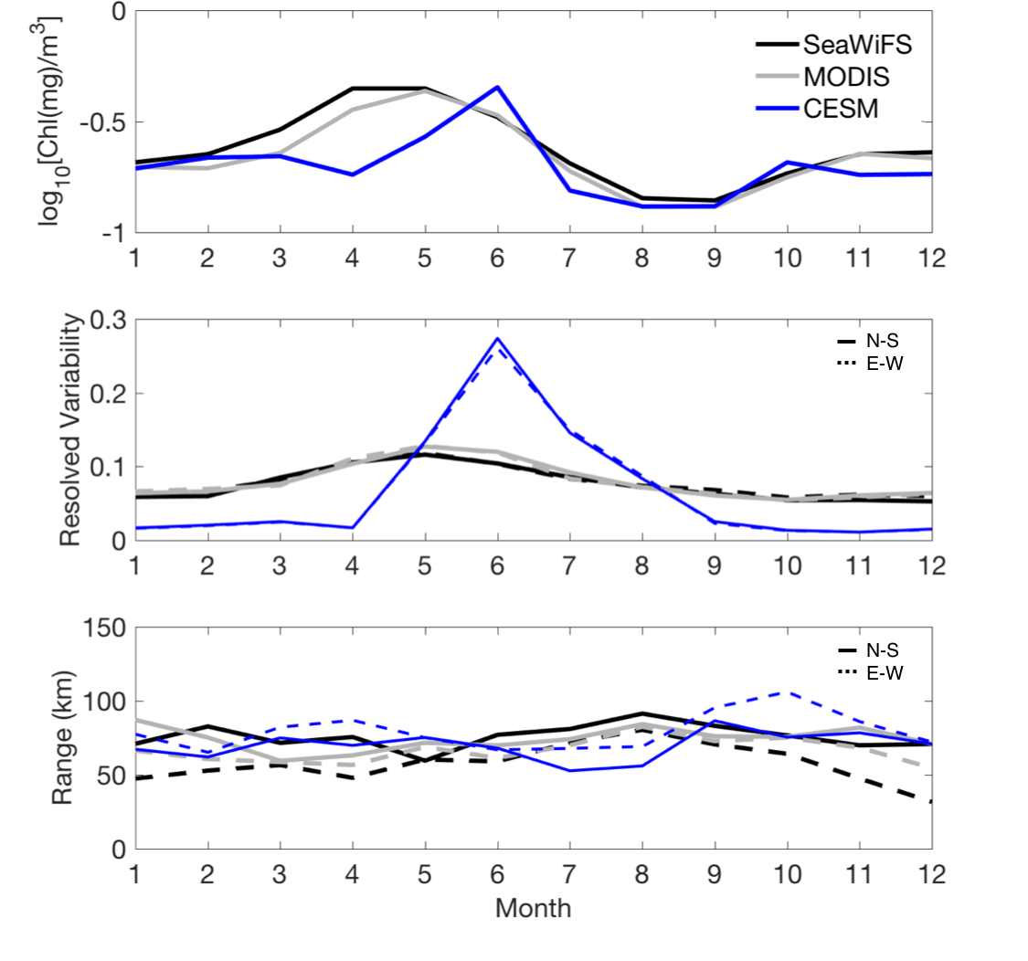

**Figure S2.** Seasonal cycle of Log10 chlorophyll *a* (top), resolved variability from Eq. 2 (middle) and range (bottom) for CESM (blue), MODIS (gray) and SeaWiFS (black) for a representative 5º x 5º box (45º-50ºN, 35º-40ºW) in the temperate region of the western North Atlantic. Geostatistical results in for the North-South direction are shown with solid lines while East-West is represented by dotted lines.

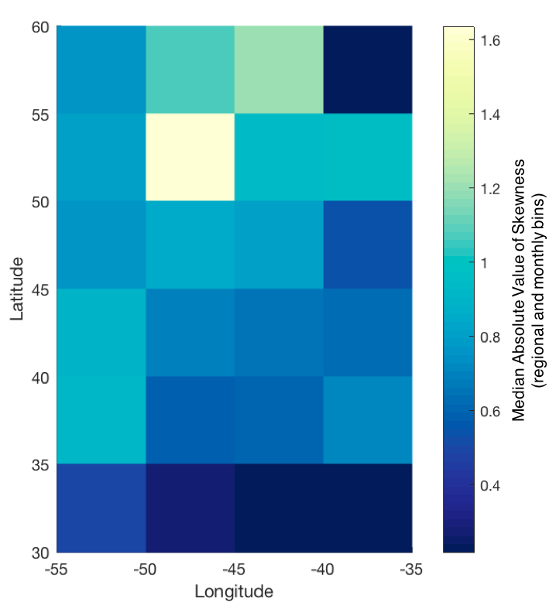

**Figure S3.** Median of the absolute value of skewness coefficient of Log10 chlorophyll *a* over the study area. Log10 chlorophyll *a* skewness for each 5º x 5º box grid box was calculated for each month of the simulation. The median of the skewness magnitude over the 24 months was then calculated for each box.

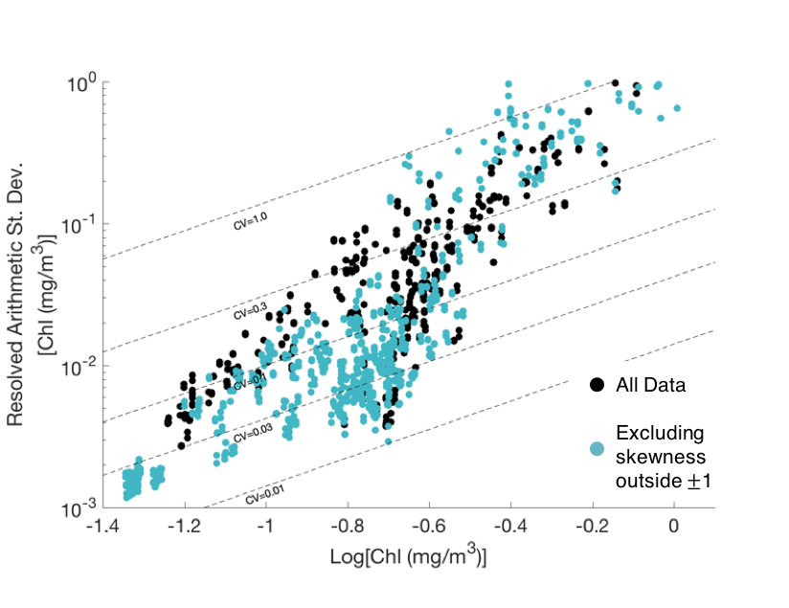

**Figure S4.** Resolved arithmetic standard deviation of surface chlorophyll variability against Log10 surface chlorophyll *a* concentration for all CESM data (as shown in Figure 5, black), and for CESM data only when Log10 chlorophyll *a* skewness within the regional and temporal domain used for variogram analysis was within the bounds of ±1 (teal).