Genome-wide identification, characterization and expression analysis of BES1 gene family in tomato

Deding Su^{1,2 †}, Wei Xiang^{1,2 †}, Ling Wen^{1,2}, Wang Lu^{1,2}, Yuan Shi^{1,2}, Yudong Liu^{1,2 *} and Zhengguo Li^{1,2 *}

¹ Key Laboratory of Plant Hormones and Development Regulation of Chongqing, School of Life Sciences, Chongqing University, 401331 Chongqing, China.
² Center of Plant Functional Genomics, Institute of Advanced Interdisciplinary Studies, Chongqing University, 401331 Chongqing, China.

* Correspondences:
Yudong Liu, yudongliu@cqu.edu.cn;
Zhengguo Li, zhengguoli@cqu.edu.cn. Tel and Fax, +86-23-65678902.

† Deding Su and Wei Xiang contributed equally to this work.

Table S1 Summary of the responsiveness of SlBES1 family to hormone treatments
 | IAA | 6-BA | GA3 | ABA | Ethephon | EBL | SA | MeJA | GR24
SlBES1.1 | - | - | Y | Y | - | - | Y | Y | Y
SlBES1.2 | - | - | - | - | Y | Y | Y | - | -
SlBES1.3 | Y | - | - | - | - | Y | Y | Y | Y
SlBES1.4 | - | Y | - | - | - | Y | - | - | Y
SlBES1.5 | Y | - | - | Y | - | - | Y | Y | Y
SlBES1.6 | Y | Y | Y | Y | - | Y | Y | Y | Y
SlBES1.7 | - | - | - | - | - | Y | - | - | Y
SlBES1.8 | Y | - | Y | Y | - | Y | Y | Y | Y
SlBES1.9 | - | - | - | - | - | - | - | - | Y
Note: ‘Y’ indicates the presence of responsiveness, ‘-’ indicates no responsiveness.

Table S2 Summary of the responsiveness of SlBES1 family to stress treatments
 | Drought | Osmosis | Salt | Oxidization | Dehydration | Wound
SlBES1.1 | Y | Y | Y | Y | - | Y
SlBES1.2 | Y | Y | Y | Y | Y | Y
SlBES1.3 | Y | Y | Y | Y | Y | Y
SlBES1.4 | Y | Y | Y | Y | Y | Y
SlBES1.5 | Y | Y | Y | Y | Y | Y
SlBES1.6 | Y | Y | - | Y | Y | -
SlBES1.7 | Y | Y | Y | Y | - | Y
SlBES1.8 | - | Y | Y | Y | Y | Y
SlBES1.9 | Y | Y | Y | Y | Y | -
Note: ‘Y’ indicates the presence of responsiveness, ‘-’ indicates no responsiveness.

Table S3 Primers used in this study
Gene | Primer | Sequence (5’-3’) | Purpose
Solyc01g094580 | qSlBES1.1-F | TTTGGCAAGGGAAGCAGGTT | qRT-PCR
 | qSlBES1.1-R | ACCCAGAAGGCACACCTTTC
Solyc02g063010 | qSlBES1.2-F | ACTGGCTTACGAACTCAAGGT
 | qSlBES1.2-R | GAGGCCTGTGTCCCTTGC
Solyc02g071990 | qSlBES1.3-F | AAGCTACCGAAGCACTGTGA
 | qSlBES1.3-R | CACCAGGGCTGAGTTGGTAA
Solyc03g005990 | qSlBES1.4-F | TAAACGGAGAGAACGACGGC
 | qSlBES1.4-R | CACATGTCCTACTGGCTTGC
Solyc04g079980 | qSlBES1.5-F | GTGGATTAAGAGCACAGGGGA
 | qSlBES1.5-R | TGGCTGAAGTGCCTCCAATC
Solyc07g062260 | qSlBES1.6-F | AAGCCGGATGGACAGTTGAG
 | qSlBES1.6-R | AAAGGAAGAGGAAGCAGGGC
Solyc08g005780 | qSlBES1.7-F | GCAAGCTGGTTGGACTGTTG
 | qSlBES1.7-R | GCCAGAAACTGGGCTCTCAA
Solyc10g076390 | qSlBES1.8-F | TCCTAAGCATGCAGACACCA
 | qSlBES1.8-R | TTGGCAAGTCCTTCACCGGA
Solyc12g089040 | qSlBES1.9-F | CTTATCGCAAGGGATGCAAGC
 | qSlBES1.9-R | CATGTTGGCATCAGCACGAG
Solyc04g081240 | qARF5-F | CTGAGATGGCCTAGTTCCAAGT
 | qARF5-R | CAGTTTGTGCTCCCAAAAAGGT
Solyc03g006880 | qGA20ox1-F | ACCATCTCGGGAATGTTTATCA
 | qGA20ox1-R | CTCCGGTTTCTGGCATGGT
Solyc04g008480 | qCLAU-F | ACCAACAAAAAGAGCTAGAATAGAG
 | qCLAU-R | TCATTGCTTGTTGTGAGAGGA
Solyc02g084850 | qTAS14-F | CTCAAGGCATGGGTACTGGT
 | qTAS14-R | CATCCTCCGACGAGCTAGAG
Solyc03g111720 | qE4-F | GACCACTCTAAATCGCCAGG
 | qE4-R | TTCCTGAGCGGTATTGCTTT
Solyc06g051750 | qCPD-F | CAAGGCCATTCAAGCGAGAAC
 | qCPD-R | GCAACAAGCAACGCCAGTAT
Solyc09g007010 | qPR1-F | GTGTCCGAGAGGCCAGACTA
 | qPR1-R | ATTGTTGCAACGAGCCCGA
Solyc01g079360 | qWRKY37-F | GCTCAGAAGGTTGTTATGACAGTGCA
 | qWRKY37-R | TTAGCTGAACAACCCTTTGAACTGC
Solyc09g065750 | qD27-F | ATCTAAGTGGGCGAGGGAGT
 | qD27-R | AGTGCACATTCCCACACAAT
Solyc01g056940 | qUBI-F | GCCGACTACAACATCCAGAAGG
 | qUBI-R | TGCAACACAGCGAGCTTAACC
Solyc01g094580 | GFP-SlBES1.1-F | ATGGCATCAGAGATGCAGAGATATG | Subcellular localization assay
 | GFP-SlBES1.1-R | CGATGGGAACTCAAGGACTGCTT
Solyc02g063010 | GFP-SlBES1.2-F | ATGACGGCCGGCACCGGCGGTGGAG
 | GFP-SlBES1.2-R | AGCACGTGCTTTTGCACTACCAAG
Solyc02g071990 | GFP-SlBES1.3-F | ATGACTTCCGGCACGAGGCTACCGA
 | GFP-SlBES1.3-R | TCTAGTGCTGGAGTTCCCAAGTGT
Solyc03g005990 | GFP-SlBES1.4-F | ATGACTTCCGGCACGAGGTTACCGA
 | GFP-SlBES1.4-R | TCTAGTGCTAGAGTTGCCAAGTGT
Solyc04g079980 | GFP-SlBES1.5-F | ATGATGTGGGAAGGTGGAGGGTTGC
 | GFP-SlBES1.5-R | CATCCGAGCAGTCCCACTTCCGA
Solyc07g062260 | GFP-SlBES1.6-F | ATGACGTCGGGAACAAGGATG
 | GFP-SlBES1.6-R | TCTTGTCTTTGAACTCCCAAGAGT
Solyc08g005780 | GFP-SlBES1.7-F | ATGAGCAATCCCCATCACCACATTTC
 | GFP-SlBES1.7-R | AGATTCCACATTGTTGATTTCTCC
Solyc10g076390 | GFP-SlBES1.8-F | ATGGGGGAAGATAAGAAAATTAGTG
 | GFP-SlBES1.8-R | AGAAGAGAGTGATAGAGTCAAAT
Solyc12g089040 | GFP-SlBES1.9-F | ATGATGTGGGAAGCTGGAGAATCAC
 | GFP-SlBES1.9-R | TATGCGAGCATTGCCACTTCCAAG
Solyc01g094580 | pGBKT7-SlBES1.1-F | ATGGCATCAGAGATGCAGAGATATGATA | Transcriptional activation activity assay
 | pGBKT7-SlBES1.1-R | CTACGATGGGAACTCAAGGACTGCTTCCC
Solyc02g063010 | pGBKT7-SlBES1.2-F | ATGACGGCCGGCACCGGCGGTGGAGGAT
 | pGBKT7-SlBES1.2-R | TTAAGCACGTGCTTTTGCACTACCAAGAG
Solyc02g071990 | pGBKT7-SlBES1.3-F | ATGACTTCCGGCACGAGGCTACCGA
 | pGBKT7-SlBES1.3-R | CTATCTAGTGCTGGAGTTCCCAAGTGTA
Solyc03g005990 | pGBKT7-SlBES1.4-F | ATGACTTCCGGCACGAGGTTACCGACAT
 | pGBKT7-SlBES1.4-R | CTATCTAGTGCTAGAGTTGCCAAGTGTAA
Solyc04g079980 | pGBKT7-SlBES1.5-F | ATGATGTGGGAAGGTGGAGGGTTGCCGG
 | pGBKT7-SlBES1.5-R | TCACATCCGAGCAGTCCCACTTCCGAGAG
Solyc07g062260 | pGBKT7-SlBES1.6-F | ATGACGTCGGGAACAAGGATG
 | pGBKT7-SlBES1.6-R | TTATCTTGTCTTTGAACTCCCAAGAGTAA
Solyc08g005780 | pGBKT7-SlBES1.7-F | ATGAGCAATCCCCATCACCACATTTCGA
 | pGBKT7-SlBES1.7-R | TTAAGATTCCACATTGTTGATTTCTCCGT
Solyc10g076390 | pGBKT7-SlBES1.8-F | ATGGGGGAAGATAAGAAAATTAGTGGTG
 | pGBKT7-SlBES1.8-R | TTAAGAAGAGAGTGATAGAGTCAAATTGA
Solyc12g089040 | pGBKT7-SlBES1.9-F | ATGATGTGGGAAGCTGGAGAATCACCAG
 | pGBKT7-SlBES1.9-R | TCATATGCGAGCATTGCCACTTCCAAGTG
Solyc02g063010 | pEAQ-SlBES1.2-F | ATGACGGCCGGCACCGGCGGTGGAGGAT | Dual-luciferase assay
 | pEAQ-SlBES1.2-R | TTAAGCACGTGCTTTTGCACTACCAAGAG
Solyc10g076390 | pEAQ-SlBES1.8-F | ATGGGGGAAGATAAGAAAATTAGTG
 | pEAQ-SlBES1.8-R | TTAAGAAGAGAGTGATAGAGTCAAA

Figure S1 The detailed sequence logos of those 10 conserved motifs in MEME analysis.

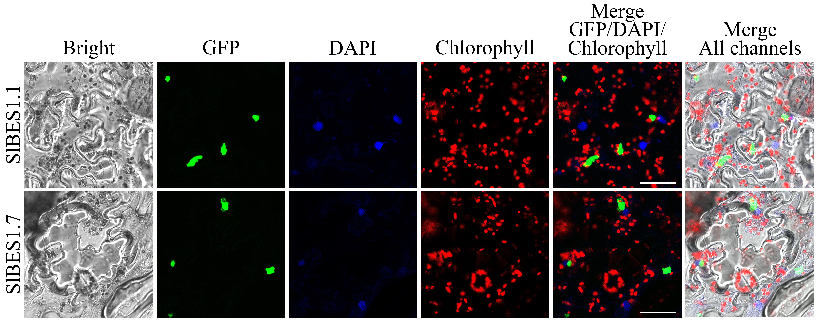
Figure S2 Subcellular localization analysis of SlBES1.1 and SlBES1.7. Tobacco leaves transiently expressed SlBES1.1-GFP and SlBES1.7-GFP fusion proteins were treated with DAPI followed by the observation through the laser scanning confocal microscope. Scale bars represent 50 μm.

Figure S3 Relative expression of the reference genes under corresponding hormone treatments. The relative expressions of reference genes were detected by qRT-PCR after treated for 1 h, 2 h, 4 h, 8 h and 16 h. Blue and gray columns represent the relative expression level of reference genes under hormone treatment and control respectively. Value of each column represents mean ± SE of three biological replicates.

