Supplementary Material

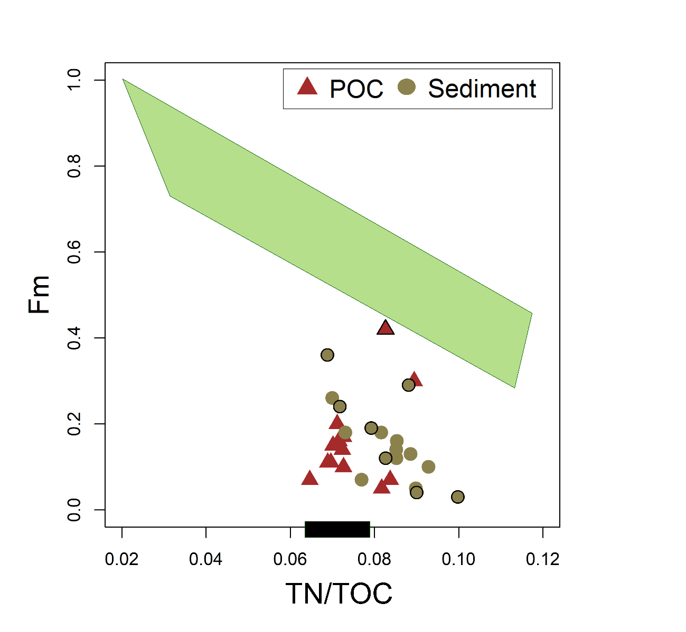
Supplementary Figure 1. Fraction modern (Fm) of ¹⁴C and total nitrogen to total organic carbon (TN/TOC) ratio for particulate organic carbon (POC) and streambank sediments along the ~12 km transect on the Peel Plateau. Symbols with a black stroke represent headwall (active layer, Holocene permafrost, headwall debris) and scar zone sediments and scar zone POC within retrogressive thaw slump (RTS) FM3. Ranges for biospheric POC (green shape) and petrogenic POC (black rectangle) according to Hilton et al. (2015).
Supplementary Table 1. Coordinates of sampling sites on the Peel Plateau, Canada.

Sampling site | Latitude | Longitude
Thaw slump FM3 | W135.27302 | N67.25547
Thaw slump FM2 | W135.23171 | N67.25703
T1 | W135.27570 | N67.25491
T2 | W135.27286 | N67.25346
T3 | W135.26504 | N67.25173
T4 | W135.26022 | N67.25185
T5 | W135.24760 | N67.25430
T6 | W135.23941 | N67.25789
T7 | W135.23569 | N67.25997
T8 | W135.20425 | N67.27359
T9 | W135.20473 | N67.27393
T10 | W135.17557 | N67.29484
T11 | W135.13873 | N67.32426
T12a | W135.11501 | N67.32733
T12b | W135.12213 | N67.32703
T12c | W135.12160 | N67.32732
B1 (FM2 outflow) | W135.23171 | N67.25703
N1 (unimpacted stream) | W135.26022 | N67.25185
N2 (unimpacted stream) | W135.20374 | N67.27362
S1 (Stony Creek) | W134.98360 | N67.39076
P1 (Peel River) | W134.87656 | N67.33857

Supplementary Table 2. Total suspended solids (TSS) and stable water isotopes (δ¹⁸O, δ²H) in the scar zone of retrogressive thaw slumps (RTS) FM3 and FM2, sampling site B1 and unimpacted streams N1-N2, and along the ~12 km transect (sampling sites T1-T12) on the Peel Plateau.

Sampling site | TSS (mg L⁻¹) | δ¹⁸O (‰) | δ²H (‰)
Scar zone 2, FM3 | 158 | -21.72 | -174.4
T1 | 31407 | -23.95 | -195.0
T2 | 11925 | -25.45 | -204.9
T3 | 8617 | -21.35 | -165.7
T4 | 6818 | -22.57 | -181.1
T5 | 631 | -22.45 | -179.4
T6 | 55.9 | -20.88 | -165.1
T7 | 5385 | -20.22 | -155.8
T8 | 4958 | -20.11 | -155.4
T9 | 9247 | -20.07 | -154.9
T10 | 4550 | -20.33 | -158.8
T11 | 1757 | -20.14 | -155.3
T12a | 1430 | -20.16 | -155.1
T12b | 1724 | -20.1 | -154.8
T12c | 902 | -20.19 | -155.2
N1 | 41.2 | -20.54 | -157.4
N2 | 28.6 | -19.80 | -153.5
B1 | 492900 | n/a | n/a
Scar zone 1, FM2 | 251095 | -24.45 | -195.7
Scar zone 2, FM2 | 648800 | -21.49 | -172.3

Supplementary Table 3. Total organic carbon (TOC) , δ¹³C, total nitrogen (TN) and molar TOC:TN ratio for active layer, headwall debris, Holocene permafrost of retrogressive thaw slump (RTS) FM3, and scar zone sediments within RTS features FM3 and FM2, and for streambank sediments along the ~12 km transect on the Peel Plateau. Sediments within RTS feature FM3 (active layer, Holocene permafrost and headwall debris) and sediment samples B1 and T1 are previously reported in Bröder et al. (2021).

 | Sampling site | TOC (%) | δ¹³C (‰) | TN (%) | TOC:TN
In slump FM3 | Active layer 1 | 9.21 | -26.28 | 0.63 | 14.5
 | Active layer 2 | 3.98 | -26.23 | 0.35 | 11.4
 | Headwall debris | 1.46 | -26.80 | 0.13 | 11.1
 | Holocene permafrost | 1.31 | -26.40 | 0.13 | 10.0
 | Scar zone 1 | 2.34 | -26.44 | 0.17 | 13.9
 | Scar zone 2 | 1.84 | -28.21 | 0.15 | 12.1
 | Scar zone 3 | 1.77 | -26.45 | 0.14 | 12.6
Transect | T1 | 1.38 | -26.90 | 0.12 | 11.1
 | T2 | 1.42 | -26.55 | 0.13 | 10.8
 | T4 | 1.01 | -26.67 | 0.09 | 11.3
 | T5 | 1.67 | -26.58 | 0.12 | 13.7
 | T6 | 1.24 | -26.19 | 0.11 | 11.7
 | T7 | 0.74 | -26.86 | 0.06 | 13.0
 | T8 | 0.61 | -26.81 | 0.05 | 11.7
 | T9 | 0.75 | -26.78 | 0.06 | 11.8
 | T10 | 0.82 | -27.08 | 0.07 | 12.3
 | T11 | 1.13 | -26.62 | 0.08 | 14.3
FM2 | B1 | 1.23 | -26.47 | 0.09 | 14.2
 | Scar zone 1 | 1.11 | -26.60 | 0.09 | 12.5
 | Scar zone 2 | 1.16 | -26.67 | 0.09 | 12.5

Supplementary Table 4. Particulate organic carbon (POC) and dissolved organic carbon (DOC) concentrations, δ¹³C for POC and DOC for scar zone sediments within retrogressive thaw slumps (RTS) FM3 and FM2, transect samples, sample B1 and unimpacted streams N1-N2. Also shown are total nitrogen (TN) and molar total organic carbon (TOC) to TN ratio (TOC:TN) for suspended particulate matter (SPM).

Sampling site | SPM |  |  |  | DOC
 | POC (mg L⁻¹) | δ¹³C (‰) | TN (mg L⁻¹) | TOC:TN | DOC (mg L⁻¹) | δ¹³C (‰)
Scar zone 2, FM3 | 6.27 | -26.50 | 0.52 | 12.1 | 18.16 | -25.77
T1 | 570 | -26.63 | 54.3 | 10.5 | 8.68 | -26.02
T2 | 249 | -26.49 | 20.9 | 12 | 13.16 | -25.99
T3 | 203 | -26.50 | 16.3 | 12.5 | 13.32 | -26.16
T4 | 138 | -26.35 | 11.3 | 12.2 | 14.34 | -26.15
T5 | 21.3 | -26.29 | 1.49 | 14.3 | 14.78 | -25.91
T6 | 1.75 | -26.43 | 0.16 | 11.2 | 12.45 | -25.46
T7 | 98.3 | -26.50 | 6.35 | 15.5 | 8.97 | -27.29
T8 | 111 | -26.49 | 7.67 | 14.5 | 8.80 | -27.80
T9 | 182 | -26.49 | 12.7 | 14.4 | 9.70 | -27.12
T10 | 81.2 | -26.60 | 5.89 | 13.8 | 11.77 | -28.04
T11 | 44.3 | -26.49 | 3.20 | 13.8 | 13.57 | -28.23
T12a | 34.0 | -26.49 | 2.47 | 13.8 | 10.38 | -27.83
T12b | 38.9 | -26.55 | 2.77 | 14.1 | 12.65 | -27.80
T12c | 20.8 | -26.38 | 1.49 | 14 | 5.13 | -27.18
N1 | 1.65 | -26.37 | 0.14 | 12.2 | 14.22 | -26.36
N2 | 1.00 | -26.54 | 0.09 | 11.5 | 13.59 | -27.8
B1 | 8073 | -26.48 | 528 | 15.3 | 6.07 | -26.22
Scar zone 1, FM2 | 3897 | -26.31 | 261 | 14.9 | 3.20 | -24.73
Scar zone 2, FM2 | 8878 | -26.47 | 599 | 14.8 | 3.56 | -25.92

Supplementary Table 5. The ¹⁴C data with fraction modern (Fm), Δ¹⁴C (‰) and ETH identification codes for sediments and particulate organic carbon (POC) within retrogressive thaw slumps (RTS) FM3 and FM2, and along the ~12 km transect on the Peel Plateau. The sediment samples within RTS feature FM3 (active layer, Holocene permafrost and headwall debris) and sediment samples B1 and T1 are previously reported in Bröder et al. (2021).
 |  | POC |  |  |  | Sediment OC
 | Sampling site | ETH code | Fm | Error (%) | Δ¹⁴C (‰) | ETH code | Fm | Error (%) | Δ¹⁴C (‰)
In slump FM2 | Scar zone 1 | 85552.1.1 | 0.04 | 3.79 | -959 | n/a | n/a | n/a | n/a
 | Scar zone 2 | 87968.1.1 | 0.08 | 2.57 | -919 | 85540.1.1 | 0.10 | 2.34 | -900
 | B1 | 87967.1.1 | 0.17 | 1.81 | -835 | 85530.1.1 | 0.15 | 1.94 | -846
In slump FM3 | Active layer 1 | n/a | n/a | n/a | n/a | 92483.1.1 | 0.36 | 1.32 | -640
 | Active layer 2 | n/a | n/a | n/a | n/a | 85600.1.1 | 0.29 | 1.37 | -711
 | Headwall debris | n/a | n/a | n/a | n/a | 85596.1.1 | 0.04 | 3.42 | -958
 | Permafrost | n/a | n/a | n/a | n/a | 87970.1.1 | 0.03 | 4.71 | -974
 | Scar zone 1 | n/a | n/a | n/a | n/a | 85546.1.1 | 0.24 | 1.56 | -758
 | Scar zone 2 | 86949.1.1 | 0.42 | 3.83 | -579 | 85557.1.1 | 0.12 | 2.18 | -882
 | Scar zone 3 | n/a | n/a | n/a | n/a | 85571.1.1 | 0.19 | 1.74 | -814
Transect | T1 | 86955.1.1 | n/a | n/a | n/a | 85542.1.1 | 0.05 | 3.26 | -948
 | T2 | 86956.1.1 | 0.07 | 29.1 | -934 | 85531.1.1 | 0.10 | 2.49 | -903
 | T3 | n/a | n/a | n/a | n/a | n/a | n/a | n/a | n/a
 | T4 | 86958.1.1 | 0.05 | 40 | -952 | 85534.1.1 | 0.13 | 2.10 | -874
 | T5 | 86959.1.1 | 0.15 | 13.2 | -856 | 85536.1.1 | 0.18 | 1.73 | -823
 | T6 | 86960.1.1 | 0.30 | 6.66 | -699 | 85535.1.1 | 0.12 | 2.07 | -881
 | T7 | 86954.1.1 | 0.07 | 30.4 | -934 | 85567.1.1 | 0.07 | 2.88 | -935
 | T8 | 86952.1.1 | 0.11 | 17.7 | -894 | 85566.1.1 | 0.16 | 1.87 | -845
 | T9 | 86953.1.1 | 0.11 | 17.6 | -893 | 85565.1.1 | 0.14 | 2.01 | -858
 | T10 | 86951.1.1 | 0.10 | 18.9 | -903 | 85556.1.1 | 0.18 | 1.76 | -820
 | T11 | 86950.1.1 | 0.14 | 13.7 | -866 | 85549.1.1 | 0.26 | 1.51 | -747
 | T12a | 86965.1.1 | 0.17 | 10.3 | -828 | n/a | n/a | n/a | n/a
 | T12b | 86966.1.1 | 0.20 | 9.2 | -806 | n/a | n/a | n/a | n/a
 | T12c | 86964.1.1 | 0.16 | 11.4 | -839 | n/a | n/a | n/a | n/a
 | N1 | 86944.1.1 | 0.32 | 15.1 | -680 | n/a | n/a | n/a | n/a
 | N2 | 86941.1.1 | 0.51 | 4.15 | -495 | n/a | n/a | n/a | n/a
 | S1 | 86967.1.1 | 0.19 | 18.2 | -810 | 85550.1.1 | 0.58 | 1.07 | -429
 | P1* | 86963.1.1 | 0.26 | 6.46 | -740 | 54637.1.1 | n/a | n/a | -810
*Sediment data from Vonk et al. (2015).

Supplementary Table 6. Data from pyrolysis-gas chromatography-mass spectrometry. The results are given as relative amounts of the compound group to all identified compound groups in each sample, not as absolute amounts. The targeted compound groups shown are aromatics (toluene, ethylbenzene, naphthalene), phenols (phenol, 2-methylphenol, 3-methylphenol and 4-methylpehenol), lignin markers (guaiacol, creosol and 4-ethylguaiacol), nitrogen (N) - containing compounds (pyridine, 2-methylpyridine and benzonitrile), polysaccharides (3-furaldehyde, furfural, 5-methylfurfural) and alkanes (carbon chain lengths C9-14). The sediments within retrogressive thaw slump (RTS) FM3 active layer, Holocene permafrost and headwall debris) and streambank sediment sample T1 are previously reported in Bröder et al. (2021).
 | Sampling site | Aromatics (%) | Polysaccharides (%) | Lignin (%) | Phenols (%) | N containing compounds (%) | Alkanes (%)
Sediment | Active layer 1 | 42.8 | 19.2 | 1.4 | 22.7 | 9.1 | 4.9
 | Active layer 2 | 35.0 | 9.0 | 6.0 | 35.0 | 7.3 | 7.6
 | Holocene permafrost | 67.3 | 0.2 | 0 | 17.3 | 3.7 | 11.6
 | Headwall debris | 79.6 | 0 | 0 | 6.6 | 3.7 | 10.1
 | Scar zone 1 | 66.8 | 1.4 | 0 | 19.5 | 3.7 | 8.5
 | Scar zone 2 | 65.9 | 0.9 | 0 | 16.5 | 10.8 | 5.8
 | Scar zone 3 | 63.1 | 1.5 | 0 | 21.5 | 8.2 | 5.7
 | T1 | 68.7 | 0 | 0 | 19.1 | 4.2 | 8.0
 | T2 | 71.8 | 0.6 | 0 | 10.0 | 9.6 | 8.0
 | T4 | 80.0 | 0.3 | 0 | 2.7 | 6.9 | 10.1
 | T5 | 51.3 | 0 | 0 | 36.8 | 4.4 | 7.3
 | T6 | 80.3 | 0.4 | 0 | 6.6 | 3.8 | 9.0
 | T7 | 87.1 | 0 | 0 | 0 | 0 | 12.9
 | T9 | 88.1 | 0 | 0 | 0 | 0 | 12.0
 | T10 | 77.5 | 0.8 | 0 | 6.0 | 5.5 | 10.1
 | T11 | 73.1 | 0 | 0 | 8.9 | 7.5 | 10.6
 | Stony creek | 47.5 | 2.8 | 2.0 | 38.9 | 5.4 | 3.5
 | Peel fresh bank* | 81.3 | 0 | 0 | 2.0 | 5.0 | 11.7
 | Peel upper bank* | 72.0 | 0 | 0 | 12.5 | 6.7 | 9.6
POC | T1 | 57.6 | 0.2 | 0 | 28.8 | 6.8 | 6.6
 | T3 | 64.1 | 0.7 | 0 | 19.1 | 7.5 | 8.7
 | T5 | 60.5 | 0.7 | 0 | 20.1 | 13.1 | 5.6
 | T7 | 78.7 | 0 | 0 | 15.4 | 1.8 | 4.1
 | T9 | 73.5 | 1.3 | 0 | 9.7 | 2.4 | 13.1
 | T10 | 75.9 | 0 | 0 | 8.7 | 1.9 | 13.6
 | T12a | 68.5 | 2.1 | 0 | 17.0 | 3.8 | 8.7
 | T12c | 69.6 | 2.2 | 0 | 17.4 | 2.4 | 8.4
 | Stony creek | 61.0 | 1.1 | 0 | 21.3 | 8.2 | 8.3
*Sediments sampled in 2011 by J. Vonk (data not published before).

Supplementary Table 7. Lipid biomarker (n-alkane and n-alkanoic acid) concentrations (ug g⁻¹ OC and ug m⁻²) for high molecular weight (HMW, carbon chain lengths C27-33 for n-alkanes and C24-32 for n-alkanoic acids) and low molecular weight (LMW, carbon chain lengths C17-19 for n-alkanes and C16-18 for n-alkanoic acids), Carbon preference index* (CPI) for sediments within retrogressive thaw slump (RTS) FM3 (active layer, Holocene permafrost, headwall debris and scar zone) and along the ~12 km transect on the Peel Plateau. The sediments within RTS feature FM3 (active layer, Holocene permafrost and headwall debris) and sediment samples B1 and T1 are same samples as those reported in Bröder et al. (2021), but were extracted separately for this manuscript.

 | Sediment | n-alkanes |  |  |  |  | n-alkanoic acids
 | Sampling site | HMW_{C27-33}  _{ug g}⁻¹ _{OC} | LMW_{C17-19}  _{ug g}⁻¹ _{OC} | HMW_{C27-33}  _{ug m}⁻² | LMW_{C17-19}  _{ug m}⁻² | CPI | HMW_{C24-32}  _{ug g}⁻¹ _{OC} | LMW_{C16-18}  _{ug g}⁻¹ _{OC} | HMW_{C24-32}  _{ug m}⁻² | LMW_{C16-18}  _{ug m}⁻² | CPI*
In slump FM3 | Active layer 1 | 246 | 10.32 | 0.47 | 0.02 | 7.56 | 3491 | 1273 | 6.62 | 2.41 | 5.66
 | Active layer 2 | 362 | 10.74 | 0.31 | 0.01 | 6.10 | 5504 | 2349 | 4.71 | 2.01 | 4.73
 | Holocene permafrost | 94.4 | 19.34 | 0.06 | 0.01 | 8.05 | 628 | 192 | 0.43 | 0.13 | 5.74
 | Headwall debris | 2041 | 357 | 1.12 | 0.20 | 4.14 | 461 | 157 | 0.25 | 0.09 | 5.36
 | Scar zone 1 | 396 | 39.6 | 0.58 | 0.06 | 6.53 | 1343 | 677 | 1.96 | 0.98 | 5.06
 | Scar zone 2 | 384 | 46.8 | 0.23 | 0.03 | 6.07 | 842 | 627 | 1.50 | 0.92 | 5.39
Transect | T1 | 118 | 40.6 | 0.06 | 0.02 | 5.26 | 276 | 476 | 0.15 | 0.25 | 5.98
 | T2 | 104 | 30.9 | 0.06 | 0.02 | 5.10 | 380 | 505 | 0.20 | 0.27 | 4.57
 | T4 | 152 | 25.6 | 0.09 | 0.01 | 4.47 | 77.2 | 179 | 0.04 | 0.10 | 4.00
 | T5 | 132 | 24.2 | 0.11 | 0.02 | 6.82 | 24.2 | 33.2 | 0.02 | 0.03 | 5.05
 | T6 | n/a | n/a | n/a | n/a | n/a | n/a | n/a | n/a | n/a | n/a
 | T7 | 123 | 64.4 | 0.11 | 0.06 | 2.11 | 236 | 212 | 0.21 | 0.19 | 5.20
 | T8 | 203 | 152 | 0.11 | 0.08 | 1.83 | 23.1 | 173 | 0.01 | 0.09 | 2.97
 | T9 | 104 | 92.5 | 0.05 | 0.04 | 1.84 | 81.8 | 105 | 0.04 | 0.05 | 4.31
 | T10 | 169 | 95.9 | 0.12 | 0.07 | 2.67 | 136 | 221 | 0.09 | 0.15 | 4.31
 | T11 | 154 | 46.3 | 0.14 | 0.04 | 3.32 | 465 | 525 | 0.41 | 0.46 | 4.63
*CPI is defined as $\frac{1}{2}\sum{(X_{i}+X_{i+2}+..+X_{n})/\sum{(X_{i-1}+X_{i+1}}}+..{+X}_{n-1})+\frac{1}{2}\sum{(X_{i}}+X_{i+2}+..+X_{n})/\sum{(X_{i+1}}+X_{i+3}+..+X_{n+1})$, where X is concentration.

Supplementary Table 8. Lipid biomarker (n-alkane and n-alkanoic acid) concentrations (ug g⁻¹ OC and ug m⁻²) for high molecular weight (HMW, carbon chain lengths C27-33 for n-alkanes and C24-32 for n-alkanoic acids) and low molecular weight (LMW, carbon chain lengths C17-19 for n-alkanes and C16-18 for n-alkanoic acids), Carbon preference index* (CPI) for particulate organic carbon (POC) along the ~12 km transect on the Peel Plateau.

POC | n-alkanes |  |  |  |  | n-alkanoic acids
Sampling site | HMW_{C27-33}  _{µg g}⁻¹ _{OC} | LMW_{C17-19}  _{µg g}⁻¹ _{OC} | HMW_{C27-33}  _{µg m}⁻² | LMW_{C17-19}  _{µg m}⁻² | CPI | HMW_{C24-32}  _{µg g}⁻¹ _{OC} | LMW_{C16-18}  _{µg g}⁻¹ _{OC} | HMW_{C24-32}  _{µg m}⁻² | LMW_{C16-18}  _{µg m}⁻² | CPI*
T1 | 57.3 | 21.9 | 0.05 | 0.02 | 4.30 | 375 | 330 | 0.35 | 0.31 | 4.61
T2 | n/a | n/a | n/a | n/a | n/a | n/a | n/a | n/a | n/a | n/a
T3 | 173 | 32.3 | 0.11 | 0.02 | 6.52 | 1133 | 1078 | 0.75 | 0.71 | 5.80
T4 | 190 | 43.5 | 0.11 | 0.02 | 6.21 | 319 | 1065 | 0.18 | 0.60 | 5.73
T5 | 131 | 62.3 | n/a | n/a | 3.48 | 88.2 | 722 | n/a | n/a | 3.57
T6 | n/a | n/a | n/a | n/a | n/a | n/a | n/a | n/a | n/a | n/a
T7 | 133 | 41.9 | n/a | n/a | 3.56 | 149 | 323 | n/a | n/a | 5.14
T8 | 346 | 78.8 | 0.35 | 0.08 | 4.19 | 326 | 755 | 0.33 | 0.77 | 5.39
T9 | 121 | 28.7 | n/a | n/a | 4.54 | 449 | 493 | n/a | n/a | 4.52
T10 | 234 | 45.8 | 0.19 | 0.04 | 6.59 | 273 | 810 | 0.22 | 0.66 | 4.16
T11 | 207 | 38.0 | 0.18 | 0.03 | 5.29 | 182 | 578 | 0.16 | 0.51 | 4.32
T12 | 182 | 28.4 | n/a | n/a | 8.48 | 812 | 1448 | n/a | n/a | 4.55
*CPI is defined as $\frac{1}{2}\sum{(X_{i}+X_{i+2}+..+X_{n})/\sum{(X_{i-1}+X_{i+1}}}+..{+X}_{n-1})+\frac{1}{2}\sum{(X_{i}}+X_{i+2}+..+X_{n})/\sum{(X_{i+1}}+X_{i+3}+..+X_{n+1})$, where X is concentration.
References

Bröder, L., Keskitalo, K., Zolkos, S., Shakil, S., Tank, S.E., Kokelj, S.V. et al. (2021). Preferential export of permafrost-derived organic matter as retrogressive thaw slumping intensifies. Environ. Res. Lett. https://doi.org/10.1088/1748-9326/abee4b

Hilton, R. G., Galy, V., Gaillardet, J., Dellinger, M., Bryant, C., O’Regan, M. et al (2015). Erosion of organic carbon in the Arctic as a geological carbon dioxide sink. Nature. 524, 84-87. doi:10.1038/nature14653.

Vonk, J. E., Giosan, L., Blusztajn, J., Montlucon, D., Graf Pannatier, E., McIntyre, C. et al. (2015). Spatial variations in geochemical characteristics of the modern Mackenzie Delta sedimentary system. Geochim. Cosmochim. Acta. 171, 100-120. doi:10.1016/j.gca.2015.08.005.

