Supplementary Material

Supplementary Figure S1. The three different species of Calanus from top to bottom: Calanus hyperboreus (4.5-7 mm, 1-1.8 mg lipids), Calanus glacialis (3-4.6 mm, 0.4-0.45 mg lipid) and Calanus finmarchicus (2-3.2 mm, 0.04-0.08 mg lipids). Besides differences in size, C. glacialis and C. finmarchicus can be distinguished by differences in the pigmentation of their antennas; C. glacialis often has red antennas, while C. finmarchicus often has pale antennas (Nielsen et al., 2014; Choquet et al., 2018). Photo: Malin Daase.

A B
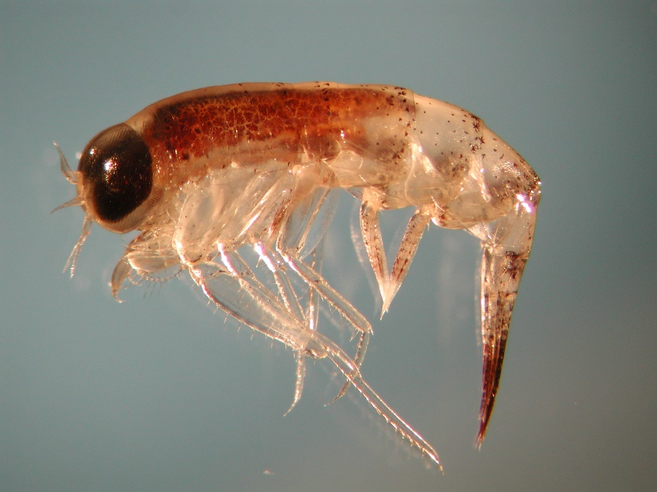
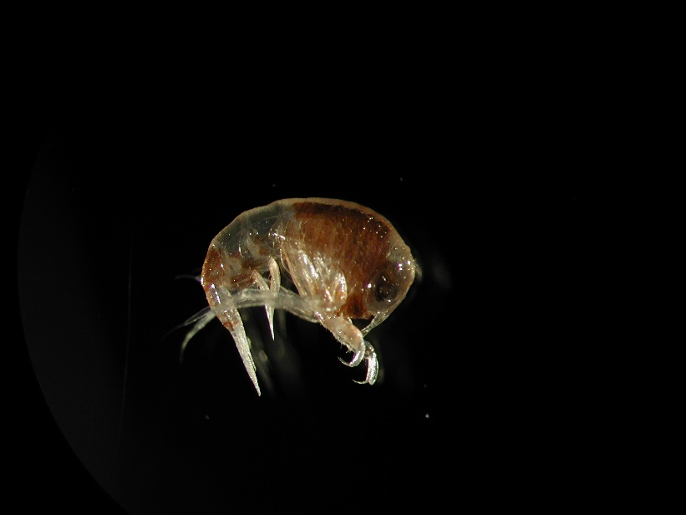

Supplementary Figure S2. The two most abundant species of Themisto in the sampling region: A) Themisto libellula and B) Themisto abyssorum. Photos: Haakon Hop.

Supplementary Table S1. Relative proportions (mean ± SD) of the most abundant lipid classes (≥ 1 % of total lipid content) in zooplankton collected during RV Kronprins Haakon seasonal Nansen Legacy cruises Q3 during August 2019 and Q4 during November/December 2019 in the Barents Sea. Not detected: ‘-‘.
 | Q3  (n = 3) | Q4  (n = 3) | Q3  (n = 3) | Q4  (n = 3) | Q3  (n = 3) | Q4  (n = 3) | Q3  (n = 4) | Q4  (n = 3) | Q3  (n = 3) | Q4  (n = 3)
Lipid classes (%) | Calanus glacialis |  | Calanus hyperboreus |  | Calanus finmarchicus |  | Themisto libellula |  | Themisto abyssorum
WE | 78.7 ± 6.0 | 89.4 ± 0.9 | 90.0 ± 3.3 | 96.7 ± 1.1 | 87.7 ± 2.9 | 89.1 ± 2.7 | 19.0 ± 8.2 | 33.9 ± 18.8 | 17.5 ± 5.9 | 33.1 ± 11.3
TAG | 14.9 ± 6.4 | 6.2 ± 3.1 | 4.7 ± 2.7 | 0.8 ± 0.9 | 6.6 ± 2.4 | 6.5 ± 2.6 | 35.1 ± 14.7 | 39.5 ± 18.5 | 76.3 ± 6.5 | 52.9 ± 11.2
Sterols | 0.02 ± 0.04 | - | - | - | - | - | 1.7 ± 0.5 | 1.7 ± 2.0 | 0.6 ± 0.4 | 0.7 ± 1.1
FFA | 0.2 ± 0.3 | 0.3 ± 0.5 | 0.3 ± 0.3 | - | 0.4 ± 0.6 | 0.1 ± 0.1 | 1.3 ± 0.2 | 2.8 ± 3.9 | 0.4 ± 0.3 | 0.6 ± 1.0
Total neutral lipids | 95.2 ± 1.3 | 96.4 ± 1.5 | 97.1 ± 1.6 | 98.3 ± 0.1 | 96.7 ± 0.2 | 96.2 ± 1.2 | 66.1 ± 10.0 | 78.9 ± 22.7 | 95.1 ± 1.4 | 89.8 ± 2.3
PE | 1.9 ± 0.3 | 1.5 ± 0.8 | 1.0 ± 0.5 | 0.7 ± 0.1 | 1.3 ± 0.1 | 1.4 ± 0.3 | 12.6 ± 3.5 | 6.5 ± 6.9 | 1.6 ± 0.3 | 5.0 ± 2.6
PI | 0.2 ± 0.3 | - | 0.03 ± 0.04 | - | - | - | 1.1 ± 1.5 | 1.0 ± 1.7 | 0.1 ± 0.1 | 0.1 ± 0.1
PS | 0.1 ± 0.1 | - | - | - | - | - | 2.5 ± 1.8 | 0.9 ± 0.7 | - | 0.02 ± 0.04
PC | 2.7 ± 0.7 | 2.1 ± 0.7 | 1.9 ± 1.2 | 1.0 ± 0.1 | 1.3 ± 0.1 | 2.1 ± 0.5 | 17.7 ± 3.7 | 12.5 ± 13.1 | 3.3 ± 1.1 | 5.1 ± 0.4
Total polar lipids | 4.8 ± 1.3 | 3.6 ± 1.5 | 2.9 ± 1.6 | 1.7 ± 0.1 | 3.3 ± 0.2 | 3.5 ± 0.8 | 33.9 ± 10.0 | 21.1 ± 22.7 | 4.9 ± 1.4 | 10.2 ± 2.3
Neutral lipids: WE = wax ester, TAG = triacylglycerol, FFA = free fatty acid; Polar lipids: PE = phosphatidylethanolamine, PI = phosphatidylinositol, PS = phosphatidylserine, PC = phosphatidylcholine

Supplementary Table S2. Relative proportions (mean ± SD) of the most abundant fatty acids (≥ 1 % of total fatty acid content) in pelagic particulate organic matter (PPOM), ice-associated particulate organic matter (IPOM) and zooplankton collected during RV Kronprins Haakon seasonal Nansen Legacy cruises Q3 during August 2019 and Q4 during November/December 2019 in the Barents Sea. Not detected: ‘-‘.
 | Q3  (n = 18) | Q4  (n = 15) | Q3  (n = 4) | Q4  (n = 2) | Q3  (n = 14) | Q4  (n = 9) | Q3  (n = 16) | Q4  (n = 10) | Q3  (n = 12) | Q4  (n = 7) | Q3  (n = 6) | Q4  (n = 13) | Q3  (n = 4) | Q4  (n = 6)
Fatty acid (%) | PPOM |  | IPOM |  | Calanus glacialis |  | Calanus hyperboreus |  | Calanus finmarchicus |  | Themisto libellula |  | Themisto abyssorum
14:0 | 8.8 ± 1.9 | 5.8 ± 2.2 | 8.4 ± 0.5 | 3.3 ± 1.5 | 8.6 ± 2.8 | 9.8 ± 1.6 | 3.3 ± 0.8 | 3.9 ± 0.4 | 14.2 ± 2.4 | 19.2 ± 1.7 | 3.9 ± 0.8 | 4.2 ± 1.7 | 4.4 ± 0.2 | 5.1 ± 0.7
16:0 | 19.1 ± 2.8 | 26.2 ± 4.4 | 19.3 ± 0.7 | 23.8 ± 0.4 | 6.9 ± 0.9 | 6.1 ± 0.7 | 3.2 ± 0.4 | 3.2 ± 0.3 | 9.8 ± 0.8 | 10.8 ± 0.7 | 14.5 ± 0.9 | 10.1 ± 2.1 | 9.2 ± 2.1 | 11.3 ± 0.8
16:1(n-7) | 8.0 ± 3.2 | 7.2 ± 1.5 | 35.9 ± 6.0 | 6.5 ± 5.8 | 15.9 ± 3.5 | 16.9 ± 7.1 | 14.7 ± 6.0 | 12.7 ± 4.4 | 13.4 ± 3.4 | 8.5 ± 1.8 | 6.5 ± 0.7 | 9.8 ± 3.2 | 7.4 ± 0.9 | 5.9 ± 2.5
16:2(n-4) | 0.1 ± 0.1 | 0.2 ± 0.2 | 0.7 ± 0.3 | 0.2 ± 0.2 | 0.8 ± 0.2 | 1.0 ± 0.2 | 1.1 ± 0.3 | 0.9 ± 0.4 | 0.9 ± 0.1 | 0.7 ± 0.2 | 0.3 ± 0.2 | 0.3 ± 0.1 | 0.5 ± 0.2 | 0.4 ± 0.2
16:3(n-4) | 0.1 ± 0.2 | 0.1 ± 0.1 | 0.2 ± 0.3 | - | 1.1 ± 0.3 | 0.5 ± 0.4 | 1.3 ± 0.5 | 1.0 ± 0.4 | 1.2 ± 0.4 | 0.7 ± 0.3 | 0.3 ± 0.1 | 0.3 ± 0.2 | 0.5 ± 0.1 | 0.4 ± 0.2
16:4(n-1) | 1.0 ± 1.2 | 0.2 ± 0.3 | 1.0 ± 0.1 | - | 2.7 ± 0.8 | 0.7 ± 0.6 | 2.9 ± 0.7 | 2.1 ± 0.8 | 2.5 ± 0.9 | 1.0 ± 0.2 | 0.3 ± 0.3 | 0.5 ± 0.2 | 1.3 ± 0.7 | 0.3 ± 0.2
18:1(n-9) | 8.6 ± 8.0 | 8.8 ± 2.9 | 9.4 ± 0.7 | 8.1 ± 4.1 | 4.3 ± 1.3 | 3.5 ± 0.8 | 2.9 ± 0.6 | 2.9 ± 0.5 | 3.4 ± 0.7 | 4.8 ± 0.6 | 9.9 ± 1.4 | 12.1 ± 3.6 | 8.1 ± 2.2 | 14.4 ± 3.7
18:1(n-7) | 1.1 ± 0.4 | 2.2 ± 0.9 | 0.8 ± 0.2 | 0.8 ± 0.1 | 0.9 ± 0.1 | 0.9 ± 0.1 | 1.1 ± 0.3 | 1.0 ± 0.2 | 0.9 ± 0.2 | 0.6 ± 0.2 | 2.9 ± 0.5 | 2.6 ± 0.8 | 1.6 ± 0.3 | 2.2 ± 0.3
18:2(n-6) | 3.6 ± 1.1 | 1.9 ± 0.5 | 2.2 ± 0.6 | 2.6 ± 0.3 | 1.6 ± 0.5 | 1.3 ± 0.6 | 2.8 ± 1.0 | 2.9 ± 1.1 | 1.2 ± 0.3 | 1.5 ± 0.3 | 3.1 ± 0.8 | 2.3 ± 0.3 | 2.2 ± 0.5 | 1.7 ± 0.2
18:4(n-3) | 9.9 ± 5.5 | 3.1 ± 0.8 | 1.7 ± 0.7 | 0.8 ± 1.1 | 6.8 ± 1.8 | 3.6 ± 3.3 | 11.1 ± 3.9 | 10.2 ± 5.6 | 5.1 ± 1.5 | 8.7 ± 1.6 | 4.9 ± 1.8 | 5.8 ± 3.8 | 7.9 ± 2.2 | 3.0 ± 1.5
20:1(n-9) | 6.3 ± 3.1 | 1.4 ± 1.0 | 0.6 ± 0.3 | 1.7 ± 1.0 | 14.8 ± 2.3 | 18.2 ± 7.8 | 11.1 ± 1.6 | 13.8 ± 3.2 | 10.3 ± 2.6 | 7.8 ± 1.1 | 6.4 ± 1.5 | 14.5 ± 3.6 | 9.3 ± 1.9 | 9.0 ± 3.1
20:1(n-7) | 0.2 ± 0.2 | 0.3 ± 0.2 | - | - | 0.8 ± 0.5 | 0.8 ± 0.3 | 1.4 ± 0.6 | 1.8 ± 0.4 | 0.9 ± 0.3 | 1.2 ± 0.1 | 0.7 ± 0.1 | 0.9 ± 0.2 | 1.1 ± 0.1 | 2.2 ± 1.2
20:5(n-3) | 8.9 ± 3.7 | 5.0 ± 3.6 | 5.9 ± 0.9 | 2.3 ± 1.4 | 15.1 ± 2.6 | 9.5 ± 2.3 | 16.4 ± 4.8 | 14.0 ± 2.8 | 13.6 ± 3.7 | 10.5 ± 1.3 | 16.9 ± 1.2 | 9.6 ± 2.7 | 17.5 ± 1.2 | 13.3 ± 2.0
22:1(n-11) | 1.6 ± 1.8 | 0.8 ± 1.0 | - | 0.8 ± 1.1 | 6.5 ± 1.3 | 8.1 ± 1.0 | 10.0 ± 2.4 | 10.7 ± 1.8 | 9.3 ± 1.9 | 8.4 ± 0.8 | 1.7 ± 0.6 | 6.3 ± 3.4 | 6.1 ± 1.6 | 4.8 ± 2.1
22:1(n-9) | 0.2 ± 0.3 | 1.3 ± 1.5 | - | 1.7 ± 0.2 | 1.3 ± 0.2 | 2.0 ± 0.5 | 2.1 ± 1.2 | 4.0 ± 0.8 | 1.2 ± 0.3 | 0.8 ± 0.1 | 0.7 ± 0.1 | 1.3 ± 0.8 | 0.8 ± 0.9 | 1.9 ± 0.5
22:5(n-3) | 0.02 ± 0.1 | 1.4 ± 1.5 | - | 0.7 ± 1.0 | 0.8 ± 0.2 | 0.3 ± 0.3 | 1.6 ± 0.3 | 1.3 ± 0.7 | 0.8 ± 0.3 | 0.7 ± 0.5 | 0.5 ± 0.1 | 0.7 ± 0.9 | 0.9 ± 0.4 | 0.9 ± 0.5
22:6(n-3) | 7.4 ± 3.9 | 5.5 ± 3.3 | 1.8 ± 0.2 | - | 4.5 ± 0.7 | 5.9 ± 3.7 | 6.4 ± 1.4 | 6.0 ± 1.3 | 4.1 ± 0.7 | 4.5 ± 0.3 | 19.3 ± 1.4 | 8.4 ± 3.3 | 10.8 ± 2.0 | 10.9 ± 2.0
Proportional contribution of Calanus ontogenetic stages:
Q3 Calanus glacialis: CIV-AF: 21 %, CV: 21 %, CV-AF: 43 %, AF: 15 %
Q4 Calanus glacialis: CV: 12 %, AF: 44 %, AM: 44 %
Q3 Calanus hyperboreus: CIV: 19 %, CIV-CV: 13 %, CIV-AF: 6 %, CV: 62 %
Q4 Calanus hyperboreus: CV: 40 %, AF: 40 %, AM: 20 %
Q3 Calanus finmarchicus: CV: 17 %, CV-AF: 66 %, AF: 17 %
Q4 Calanus finmarchicus: CIV-CV: 43 %, CV: 57 %

