# Additional file 1 Fatty Acid composition, total phenolic contents and antioxidant activity of white and black sesame seed varieties from different localities of Ethiopia

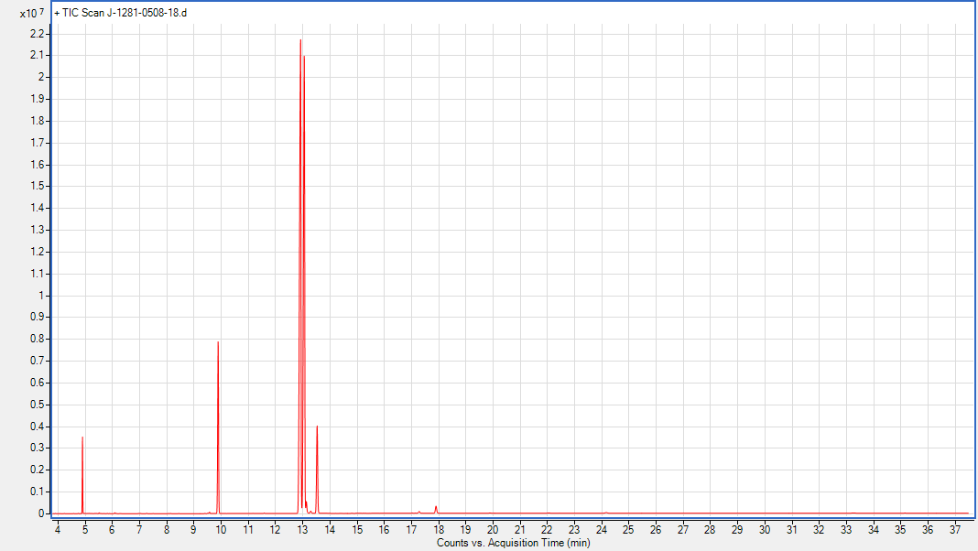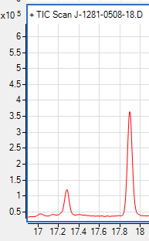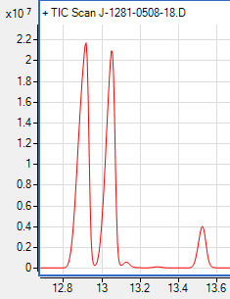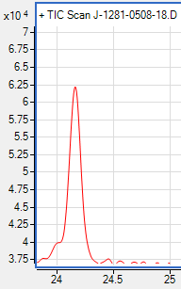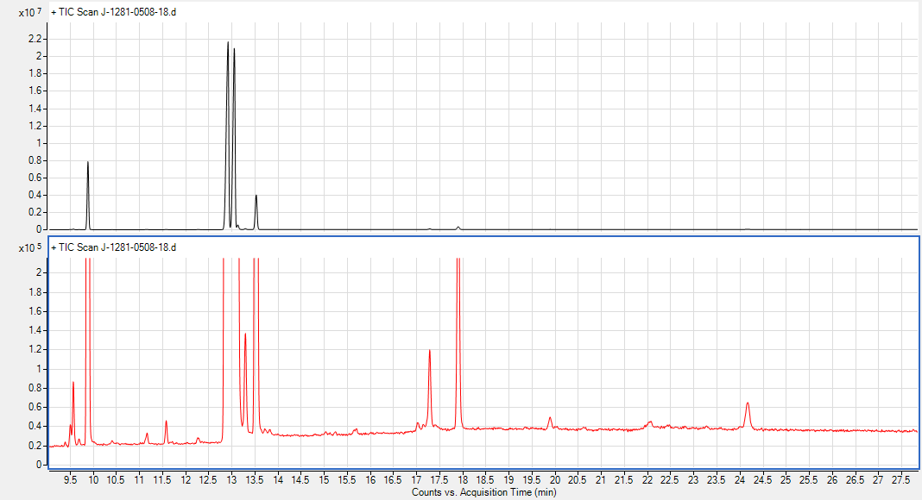

IS

4

5

7

8

2

1

3

6

9

Figure ( S1) GC-MS chromatogram of the fatty acid methyl esters of white sesame seed variety collected from Metema district. "IS" refers to the internal standard (undecanoic acid methyl ester).



**Figure (S2**). GC-MS chromatogramof methyl esters of fatty acids present in Black sesame seed collected from Metema district



**Figure (S3**). GC-MS chromatogram of methyl esters of fatty acids present in white sesame seed collected from West Armachiho district



**Figure (S4)**. GC-MS chromatogram of methyl esters of fatty acids present in Black sesame seed collected from West Armachiho district



.

**Figure (S5).** GC-MS chromatogram of methyl esters of fatty acids present in white sesame seed collected from Amuru district



**Figure (S6)**. GC-MS chromatogram of methyl esters of fatty acids present in black sesame seed collected from Amuru district