Supplementary data

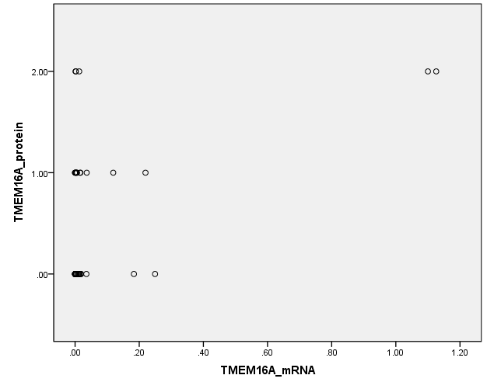

Figure S1 The correlation of TMEM16A mRNA and protein expression (Spearman’s = 0.337, p = 0.019).

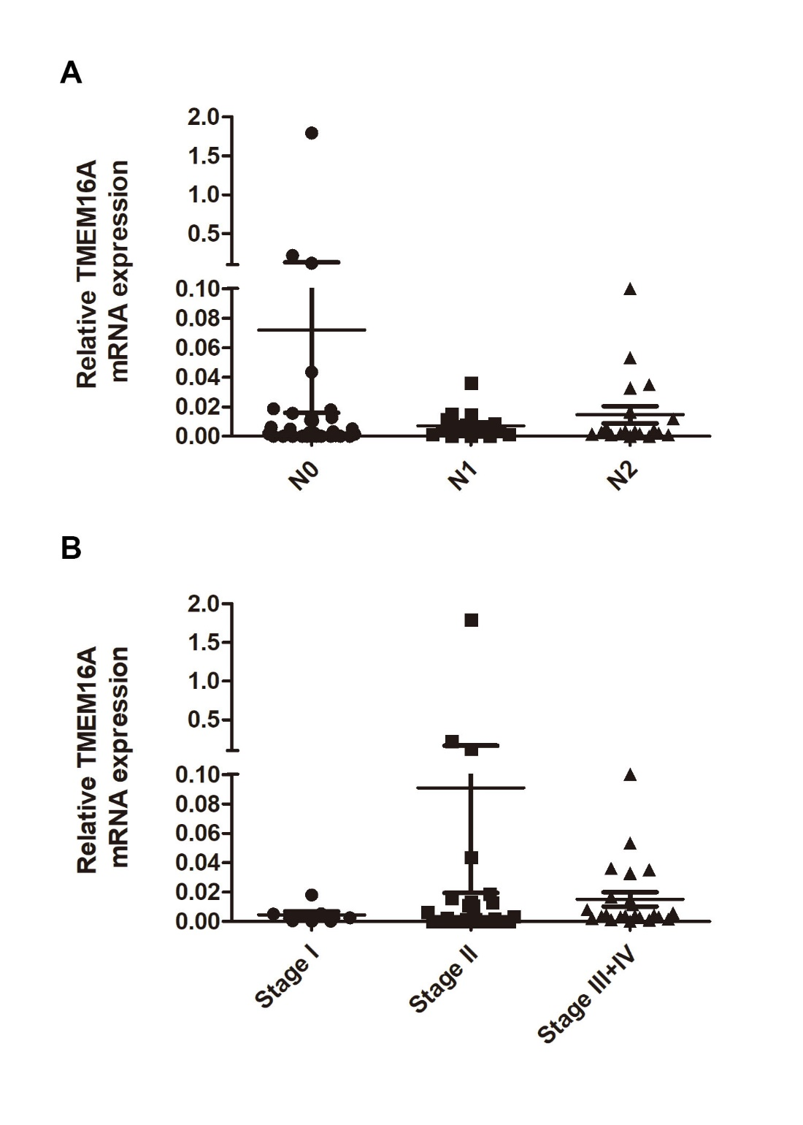

Figure S2 TMEM16A mRNA expression level in different lymph node status and stages. (A) There was no significant correlation between TMEM16A mRNA expression level and lymph node status. (B) There was no significant correlation between TMEM16A mRNA expression level and tumor stage.

A

B

Figure S3 Bioinformatics analysis results of TMEM16A mRNA expression in TCGA database (http://ualcan.path.uab.edu/). COAD: colon adenocarcinoma. (A) There was significant correlation between ANO1/TMEM16A mRNA expression in colon adenocarcinoma (n=286) and normal tissues (n=41). (B) There was no significant correlation between TMEM16A mRNA expression level and overall survival of CRC patients.

