Table of Contents

Results for the linear mixed models (not shown in main text)
Table 1 Factors associated with psychological impact in single children 2
Table 2 Factors associated with psychological impact in sibling 2 2
Random effects of the linear mixed models. Fixed effects are presented in main text and supplementary table 1 and 2 3
Figure 1. Distribution of residuals for the main models for adults and children 5
Results for the robust linear mixed models
Table 3 Factors associated with psychological impact in adults 5
Table 4 Factors associated with psychological impact in men 5
Table 5 Factors associated with psychological impact in women 5
Table 6 Factors associated with psychological impact in HCWs 5
Table 7 Factors associated with psychological impact in children 5
Table 8 Factors associated with psychological impact in sibling 1 6
Table 9 Factors associated with psychological impact in sibling 2 6
Table 10 Factors associated with psychological impact in single children 6
Table 11 Factors associated with psychological impact in HCWs’ children 6
References 7

Results for the linear mixed models.

Table 1.
Factors associated with psychological impact in single children
 | Outcome - Psychological Impact (CRIES-13)
Predictors | Estimates | 95% CI | p
Parental psychological impact (IES-R) | 6·27 | 4·95 – 7·59 | <0·001
Age | -1·39 | -2·72 – -0·07 | 0·039
Have a HCW parent | -2·60 | -5·96 – 0·76 | 0·129

Table 2.
Factors associated with psychological impact in sibling 2
 | Outcome - Psychological Impact (CRIES-13)
Predictors | Estimates | 95% CI | p
Parental psychological impact (IES-R) | 0·20 | 0·08 – 0·33 | 0·001
Age | 0·27 | -0·24 – 0·78 | 0·291
Sibling’s psychological impact (CRIES-13) | 0·48 | 0·35 – 0·61 | <0·001
Have a HCW parent | -0·83 | -4·93 – 3·26 | 0·690

Random effects

Factors associated with psychological impact in adults (see table 3)
Random Effect | Variance (Std. Dev.)
Educational qualification | 0.12 (0.35)
Workplace | 0.001 (0.03)
Age | 0.26 (0.50)
Parent | 0.38 (0.62)
Gender | 18.46 (4.29)

Factors associated with psychological impact in men (see table 3)
Random Effect | Variance (Std. Dev.)
Educational qualification | 0
Workplace | 0
Age | 0.64 (0.80)
Parent | 0

Factors associated with psychological impact in women (see table 3)
Random Effect | Variance (Std. Dev.)
Educational qualification | 0.27 (0.51)
Workplace | 0
Age | 0.07 (0.26)
Parent | 0.22 (0.46)

Factors associated with psychological impact in HCW (see table 4)
Random Effect | Variance (Std. Dev.)
Educational qualification | 2.76 (1.66)
Workplace | 2.59 (1.61)
Age | 1.18 (1.09)
Parent | 0
Gender | 15.3 (3.91)

Factors associated with psychological impact in men HCW (see table 4)
Random Effect | Variance (Std. Dev.)
Educational qualification | 0
Workplace | 0
Age | 0
Parent | 0

Factors associated with psychological impact in women HCW (see table 4)
Random Effect | Variance (Std. Dev.)
Educational qualification | 0
Workplace | 0
Age | 0.65 (0.80)
Parent | 0

Factors associated with psychological impact in children (Table 5)
Random Effect | Variance (Std. Dev.)
Educational qualification | 0.12 (0.35)
Workplace | 0.001 (0.03)
Parents exposure | 0.26 (0.50)
Gender | 2.04 (1.43)

Factors associated with psychological impact in single children (Suppl. table 1)
Random Effect | Variance (Std. Dev.)
Educational qualification | 0·0001 (0.01)
Workplace | 6.84 (2.61)
Parents exposure | 0
Gender | 2.57 (1.60)

Factors associated with psychological impact in sibling -1 (see table 5)
Random Effect | Variance (Std. Dev.)
Educational qualification | 0.48 (0.70)
Workplace | 0
Parents exposure | 0
Gender | 0.28 (0.53)

Factors associated with psychological impact in sibling -2
(Suppl. table 2)
Random Effect | Variance (Std. Dev.)
Educational qualification | 1.79 (1.34)
Workplace | 0·0002 (0.01)
Parents exposure | 0·0001 (0.01)
Gender | 0

Factors associated with psychological impact in children of HCW parents (table 6)
Random Effect | Variance (Std. Dev.)
Educational qualification | 0
Workplace | 0
Parents exposure | 0
Gender | 1.93 (1.39)

Distribution of residuals for adults and offspring main models

Figure 1.
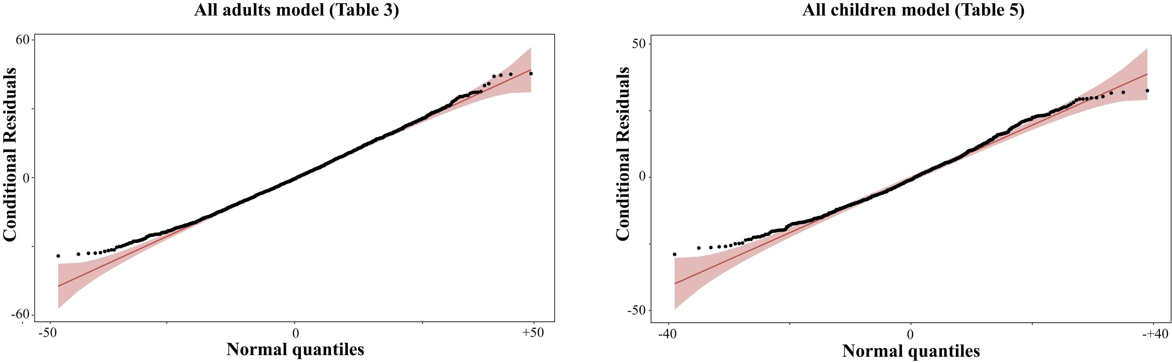

Results of the robust linear mixed model (Koller, 2016)

Table 3.
Factors associated with psychological impact in adults
 | Outcome - Psychological Impact (IES-R)
Predictors | Estimates | 95% CI
Being a HCW | -2·76 | -4·75 -0·77
High exposure to Covid19 | 5·11 | 3·19 – 7·02
Being a HCW * high exposure rate | -0·18 | -3·58 – 3·21

Table 4.
Factors associated with psychological impact in men
 | Outcome - Psychological Impact (IES-R)
Predictors | Estimates | 95% CI
Being a HCW | -2·12 | -6·07 – 1·82
High exposure to Covid19 | -0·99 | -5·20 – 3·22
Being a HCW * high exposure rate | 4·36 | -2·76 – 11·48

Table 5.
Factors associated with psychological impact in women
 | Outcome - Psychological Impact (IES-R)
Predictors | Estimates | 95% CI
Being a HCW | -2·91 | -5·21 – -0·61
High exposure to Covid19 | 6·62 | 4·48 – 8·76
Being a HCW * high exposure rate | -1·21 | -5·06 – 2·65

Table 6.
Factors associated with psychological impact in HCW
 |  | Outcome - Psychological Impact (IES-R)
Predictors | Estimates |  | 95% CI
Both males and females | 5·81 |  | 2·85 – 8·78
Males only | 11·12 |  | 4·26 – 17·97
Females only | 4·88 |  | 1·59 – 8·17

Table 7.
Factors associated with psychological impact in children
 | Outcome - Psychological Impact (CRIES-13)
Predictors | Estimates | 95% CI
Parental psychological impact (IES-R) | 0·46 | 0·40 – 0·52
Age | -0·22 | -0·51 – 0·06
Have a HCW parent | -1·96 | -4·32 – 0·41

Table 8.
Factors associated with psychological impact in sibling 1
 | Outcome - Psychological Impact (CRIES-13)
Predictors | Estimates | 95% CI
Parental psychological impact (IES-R) | 0·29 | 0·19 – 0·39
Age | 0·03 | -0·41– 0·47
Sibling 2 psychological impact (CRIES-13) | 0·41 | 0·31 – 0·51
Have a HCW parent | -0·53 | -4·06 – 3·00

Table 9.
Factors associated with psychological impact in sibling 2
 | Outcome - Psychological Impact (CRIES-13)
Predictors | Estimates | 95% CI
Parental psychological impact (IES-R) | 0·20 | 0·08 – 0·33
Age | 0·35 | -0·17 – 0·87
Sibling 1 psychological impact (CRIES-13) | 0·52 | 0·38 – 0·65
Have a HCW parent | -0·15 | -4·45 – 4·14

Table 10.
Factors associated with psychological impact in single children
 | Outcome - Psychological Impact (CRIES-13)
Predictors | Estimates | 95% CI
Parental psychological impact (IES-R) | 6·45 | 5·02 – 7·88
Age | -1·41 | -2·86 – 0·03
Have a HCW parent | -2·84 | -6·50 – 0·82

Table 11.
Factors associated with psychological impact in offspring of HCW parents
 | Outcome - Psychological Impact (CRIES-13)
Predictors | Estimates | 95% CI
Parental psychological impact (IES-R) | 0·36 | 0·14 – 0·58
Age | -0·12 | -0·83 – 0·59
COVID-19 ward involved parent | 0·17 | -11·31 – 11·65
COVID-19 ward involved parent * Parental psychological impact (IES-R) | 0·09 | -0·22-0:40

References:
Manuel Koller (2016). robustlmm: An R Package for Robust Estimation of Linear Mixed-Effects Models. Journal of Statistical Software, 75(6), 1-24. doi:10.18637/jss.v075.i06

