Supplementary Material

Supplementary Figures and Tables

Supplementary Figures

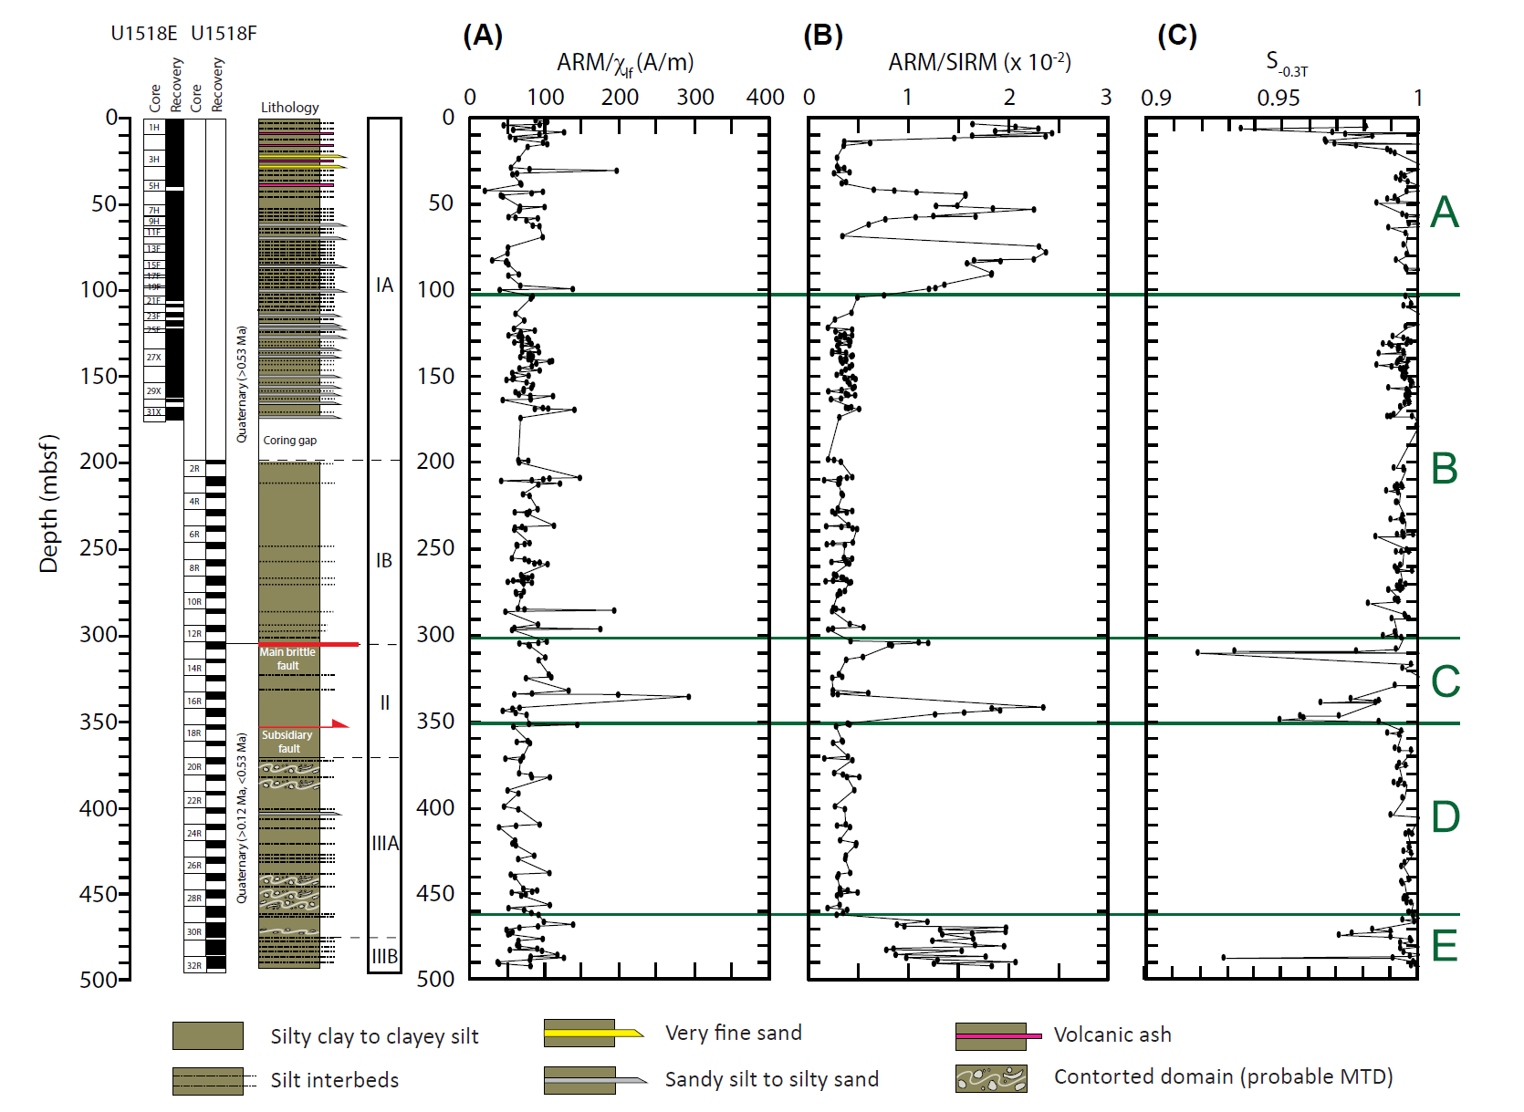
Supplementary Figure 1. Downcore variations of magnetic parameters: (A) ARM/χ_{lf}, (B) ARM/SIRM and (C) S_{-0.3T}. Higher ARM/SIRM correspond to lower coercivity intervals. Zones A to E are indicated (see text for discussion). Core recovery, age and lithologic description are from Wallace et al. (2019).

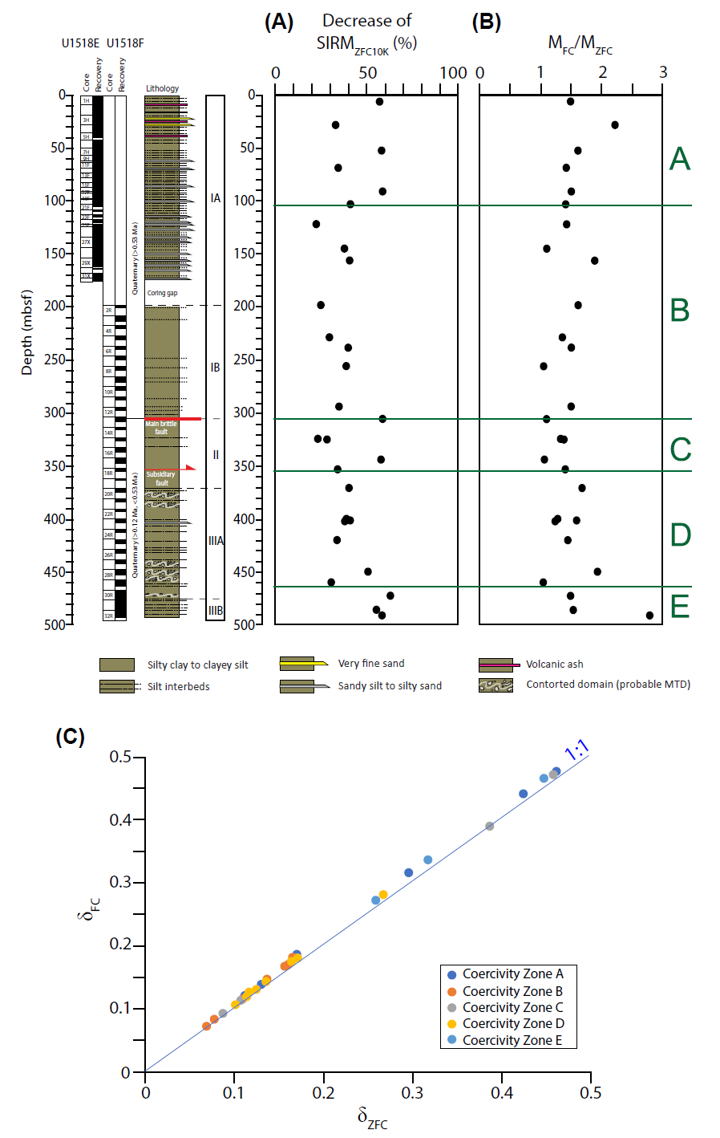
Supplementary Figure 2. Downcore variations of low temperature magnetic parameters: (A) decrease of ZFC remanence between 10 and 30 K, (B) M_{FC}/M_{ZFC} ratio at 10 K, (C) δ_{FC} versus δ_{ZFC} (δ parameter is from Moskowitz et al., 1993). Zones A to E are indicated (see text for discussion). Core recovery, age and lithologic description are from Wallace et al. (2019).

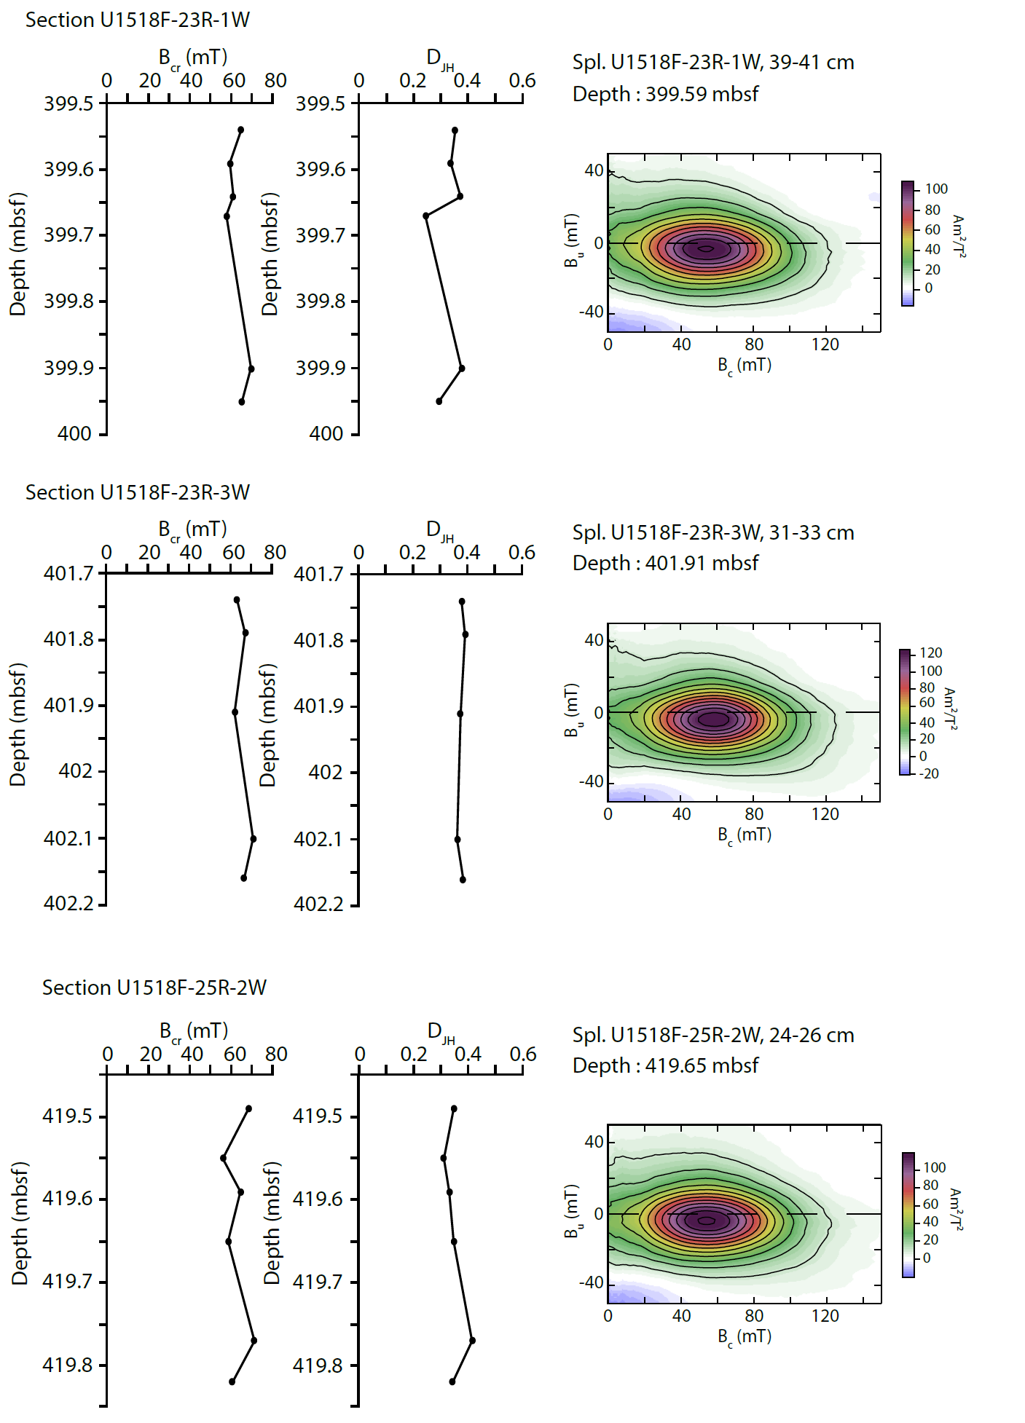
Supplementary Figure 3. Downcore variations of selected rock magnetic parameters, B_{cr} and D_{JH}, for the gas hydrate-bearing sections of Site U1518. On the right, one representative FORC diagram for each section showing typical signature of SD greigite.
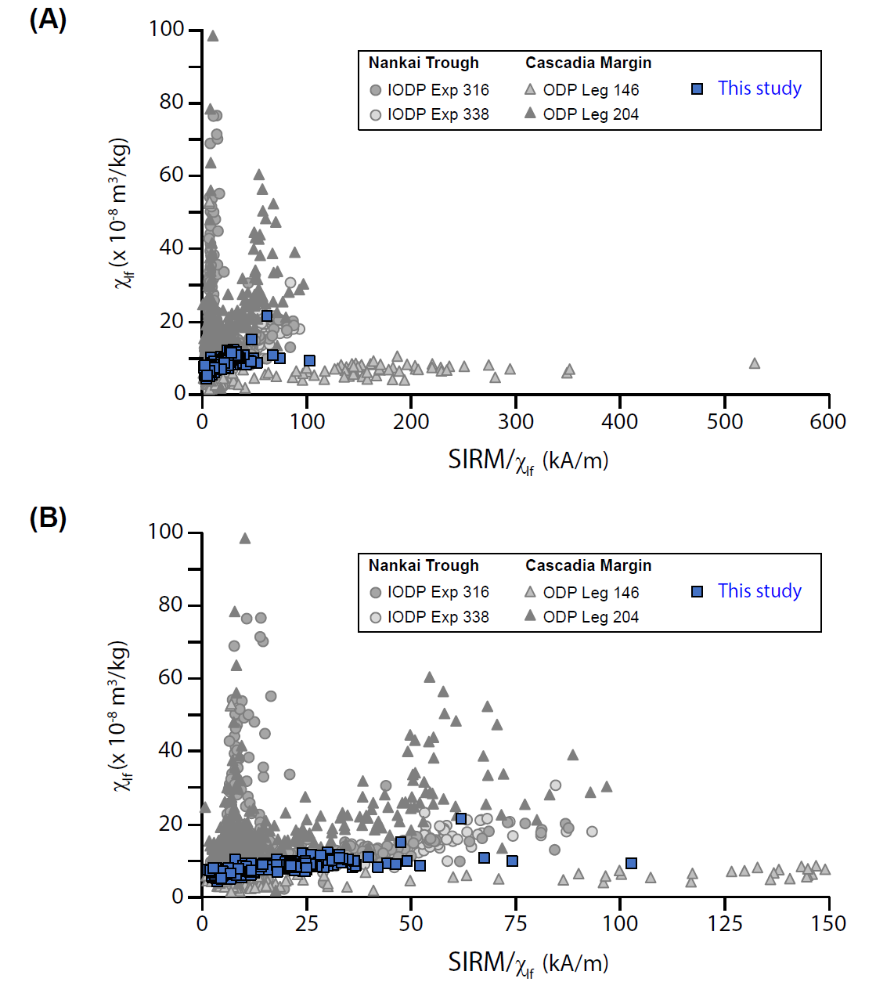
Supplementary Figure 4. Bivariate plot χ_{lf} vs. SIRM/χ_{lf}. (B) is a close-up of (A) for SIRM/χ_{lf} <150 kA/m. IODP Expedition 316 data are from Kars and Kodama (2015a, 2015b), IODP Expedition 338 data are from Kars (unpublished), ODP Leg 146 data are from Housen and Musgrave (1996) and ODP Leg 204 data are from Larrasoaña et al. (2006).

Supplementary Tables
Supplementary Table 1: Average values and standard deviation for concentration-dependent parameters: NRM, ARM, χ_{lf}, SIRM and SIRM/χ_{lf} for all studied samples and for each magnetic zone, respectively, at Site U1518.
 | Depth (mbsf) | Mean NRM (µAm²/kg) | St. dev. NRM (µAm²/kg) | Mean ARM (µAm²/kg) | St. dev. ARM (µAm²/kg) | Mean χ_{lf} (x10⁻⁸ m³/kg) | St. dev. χ_{lf} (x10⁻⁸ m³/kg)
Site U1518 | all | 2.04 | 2.01 | 6.90 | 5.08 | 8.51 | 1.93
Coercivity Zone  A  B  C  D  E | Top – 104  104 – 304  304 – 352  352 -463  466 – 492 | 1.21  2.48  2.40  2.35  0.98 | 1.67  2.48  2.28  1.01  0.53 | 5.42  7.34  10.30  6.77  5.28 | 2.98  4.07  12.99  2.94  1.85 | 7.27  9.10  8.74  9.06  6.94 | 1.85  1.64  3.47  0.96  0.73
 | Mean SIRM (mAm²/kg) | St. dev. SIRM (mAm²/kg) | Mean SIRM/χ_{lf} (kA/m) | St. dev. SIRM/χ_{lf} (kA/m) | Remarks
Site U1518 | 1.71 | 1.46 | 18.84 | 12.87
Coercivity Zone  A  B  C  D  E | 0.81  2.26  1.87  1.96  0.44 | 1.07  1.58  1.84  0.71  0.27 | 10.94  23.60  22.36  21.02  5.97 | 12.58  9.45  24.67  6.26  3.87 | Greigite only  Greigite only

Supplementary Table 2: Selected magnetic parameters for the footwall sections with gas hydrate identified by infra-red camera on the catwalk.
Depth (mbsf) | χ_{lf} (x10⁻⁸ m³/kg) | NRM (µAm²/kg) | ΔNRM/ΔGRM | B_{cr} (mT) | D_{JH}
Section U1518F-23R-1W  399.54  399.59  399.64  399.67  399.90  399.95 | 7.40  11.40  8.07  8.04  8.58  9.65 | 1.19  5.24  1.76  0.87  1.40  1.55 | 0.58  29.17  0.62  0.57  1.65  1.65 | 64.9  59.6  61.1  58.0  69.8  65.3 | 0.35  0.34  0.37  0.24  0.38  0.29
Section U1518F-23R-3W  401.74  401.79  401.91  402.10  402.15 | 8.23  10.67  9.38  7.47  8.84 | 2.87  3.27  3.78  1.64  2.08 | 4.67  0.53  1.13  no GRM  no GRM | 63.2  67.1  62.0  71.1  66.5 | 0.38  0.39  0.37  0.36  0.38
Section U1518F-25R-2W  419.49  419.55  419.59  419.65  419.77  419.82 | 8.23  8.74  9.26  8.77  9.31  7.87 | 1.05  1.31  1.66  1.84  3.27  2.04 | 1.94  0.81  1.17  4.74  5.69  2.38 | 68.6  56.2  64.8  58.8  71.4  60.6 | 0.35  0.31  0.33  0.35  0.42  0.34

