Supplementary Material

Supplementary Figures

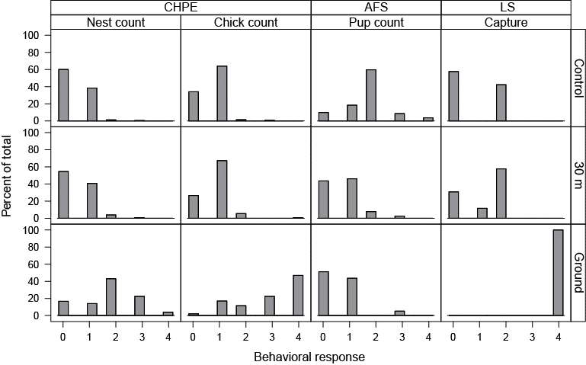
Supplementary Figure 1. Histogram of the raw behavioral response scores of chinstrap penguins (CHPE, n = 404), Antarctic fur seals (AFS, n = 160), and leopard seals (LS, n = 78) during control periods, 30 m UAS overflights, and ground survey methodologies (CHPE = nest and chick census counts, AFS = pup census counts, or LS = leopard seal sedation captures).

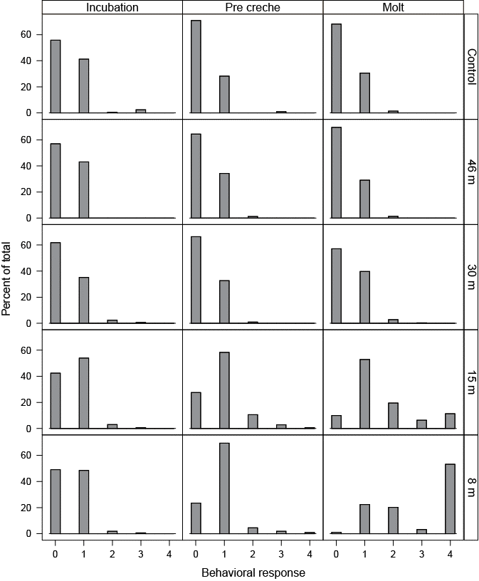
Supplementary Figure 2. Histogram of the raw behavioral response scores of chinstrap penguins (CHPE, n = 1199) to UAS overflights at specific altitudes during early, mid-, and late stages of their summer breeding chronology.

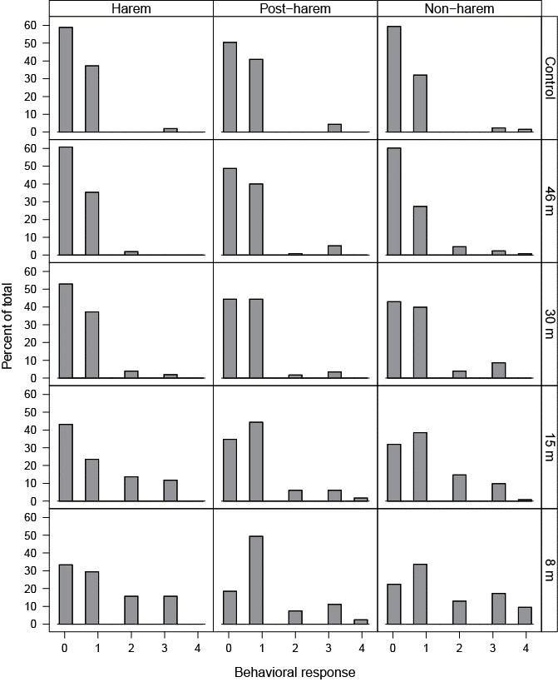
Supplementary Figure 3. Histogram of the raw behavioral response scores of Antarctic fur seals (AFS, n = 1418) to UAS overflights at specific altitudes during early, mid-, and late stages of their summer breeding chronology.

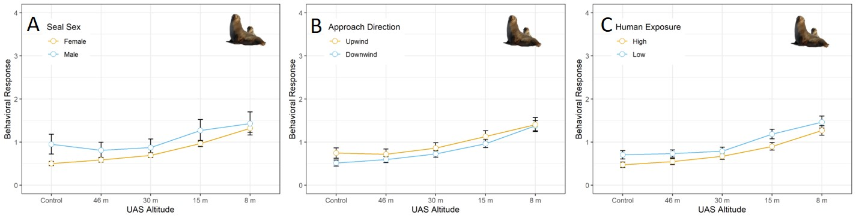
Supplementary Figure 4. Average behavioral responses (n = 4254 scores, plotted with standard deviation error bars) adult Antarctic fur seals (AFS) during UAS overflights at specific altitudes when: (A) compared between male and female animals, (B) the UAS approached target animals from downwind versus upwind, or (C) compared between animals in colonies regularly visited by researchers (High) and colonies rarely visited by researchers (Low).

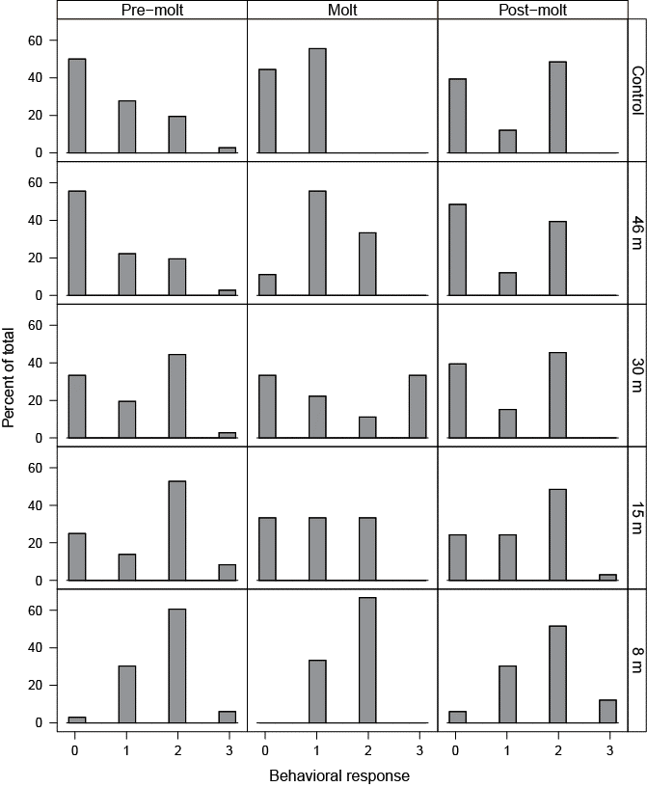
Supplementary Figure 5. Histogram of the raw behavioral response scores of leopard seals (LS, n = 129) to UAS overflights at specific altitudes during early, mid-, and post molt stages. No leopard seals exhibited an “escape” response during any of these overflights.

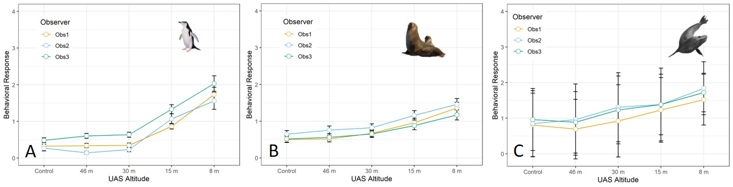
Supplementary Figure 6. Average behavioral responses (plotted with standard deviation error bars) assigned to: (A) chinstrap penguins (CHPE, n = 1199 scores), (B) Antarctic fur seals (AFS, n = 1418 scores), and (C) leopard seals (LS, n = 129) during UAS overflights at specific altitudes by each of three independent observers (Obs 1, Obs 2, and Obs 3)

