**Biosecurity e-alert –** Black scar oyster detected in Far North Queensland

The exotic tropical black scar oyster (*Magallana bilineata)*, also known as *Crassostrea bilineata*, has been recently detected in three Far North Queensland locations - Cairns, Port Douglas and Cooktown. The species has not been previously detected in Australia.

The black scar oyster is found abundantly in the [western Pacific Ocean](https://en.wikipedia.org/wiki/Western_Pacific_Ocean) from the [Philippines](https://en.wikipedia.org/wiki/Philippines) to [Tonga](https://en.wikipedia.org/wiki/Tonga) and [Fiji](https://en.wikipedia.org/wiki/Fiji). While little is known about this pest and the potential impacts in Queensland, we don’t want it spreading further throughout Queensland.

Each pest incursion was reported to Biosecurity Queensland after being detected by:

* a surveillance survey uncovered a population in Cairns which was subsequently confirmed through detection in the Queensland’s Seaports eDNA Surveillance   
  (Q-SEAS) marine pest surveillance program.
* a commercial fisherman noticed them in Port Douglas and collected samples from a boat while it was being cleaning
* Indigenous Rangers discovered a population of the oysters at Cooktown.

Molecular diagnostics including DNA extraction of tissue samples from all three detections performed at Griffith University, and eDNA diagnostics undertaken as part of the Q-SEAS program, confirmed the identification to species level.

Biosecurity Queensland will investigate the extent of the incursions which may inform future control, monitoring or treatment measures.

The black scar oyster shares the traditional features of tropical oysters and are not easily distinguished from their native counterparts until they reach their distinctive size being larger than other species of up to 18cm in length. This makes identification in the early stages of the lifecycle difficult and significantly limits options for selective treatment as a control measure.

The black scar oyster fouls submerged and floating infrastructure including pylons, pontoons and boats, and can occupy disturbed habitats including shallow subtidal sites.

Boat owners are urged to maintain regular maintenance and cleaning of their vessel to prevent spread, including:

* apply antifouling paint
* clean your boat in a dry dock or slipway (out of the water)
* check and clean gear including pots, nets, fishing or diving gear, anchors and ropes, before moving between locations.

A recent increase in marine pest detections in Queensland highlights the ongoing threat of marine pests and the importance of ongoing marine surveillance activities including Biosecurity Queensland’s Q-SEAS program.

If you suspect a suspicious marine organism please report it to Biosecurity Queensland on 13 25 23. More information available at: <https://www.qld.gov.au/environment/coasts-waterways/marine-pests>

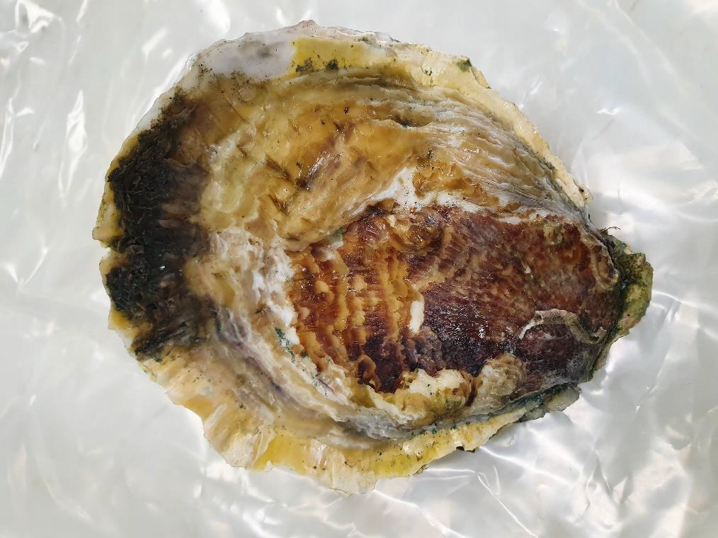

Black scar oyster (Photo: Daniel McInnes, Fishery Monitoring DAF)



Black scar oysters growing on rocks (Photo: Carmel McDougall, Griffith University)