S31 Fig: Chemical structures of molecules optimized with DFT-B3LYP (6-31G, d) level of theory

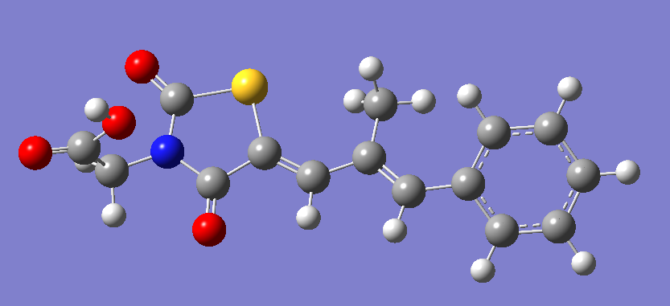  Epalrestat | 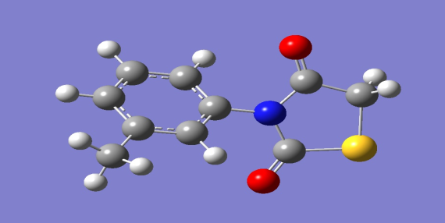  C₁₀H₉NO₂S (4)
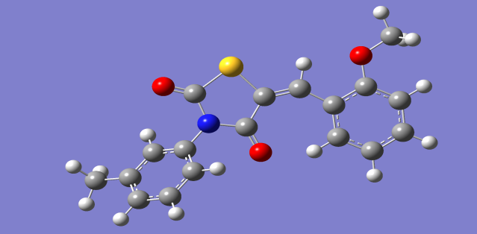  C₁₈H₁₅NO₃S (7a) | 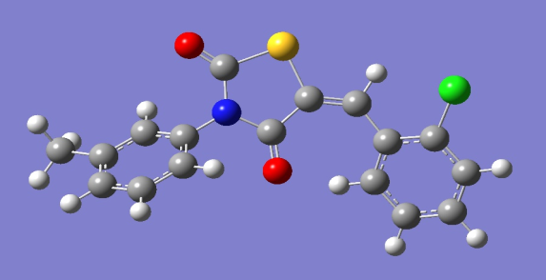  C₁₇H₁₂NO₂SCl (7b)
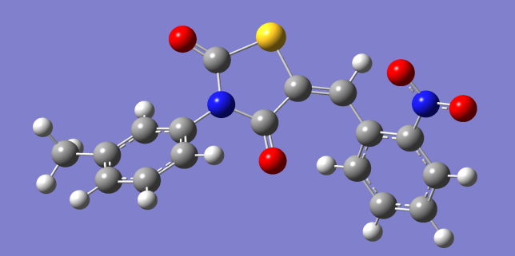  C₁₇H₁₂N₂O₄S (7c) | 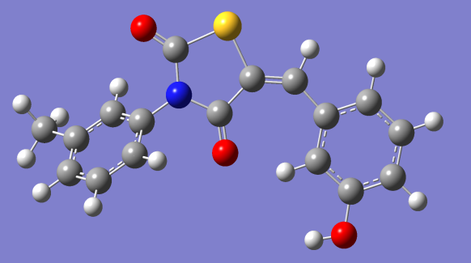  C₁₇H₁₃NO₃S (7d)
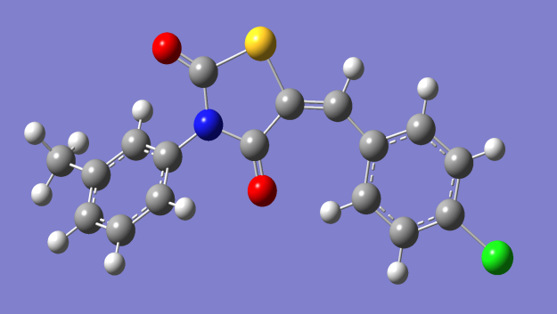
C₁₇H₁₂NO₂SCl (7e)

