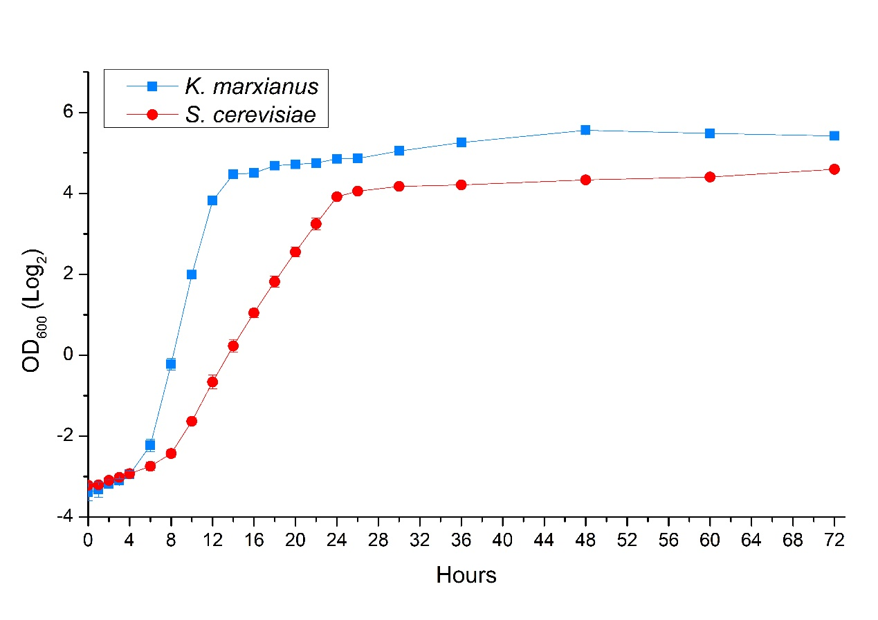
Figure S1. Growth curves of K. marxianus and S. cerevisiae. Cells were grown in 3ml YPD liquid medium overnight. The culture was transferred to a fresh 50 mL YPD medium in a 150-mL flask to start at an OD₆₀₀ of 0.1. OD₆₀₀ was measured at indicated time points after the start of the culture. The logarithm of OD₆₀₀ to the base 2 was calculated. The value was shown as mean±SD (n=4). The blue curve is for K. marxianus and the red curve is for S. cerevisiae.

