Early transplantation-related mortality after allogeneic hematopoietic cell transplantation in patients with acute leukemia

Seom Gim Kong¹, Seri Jeong², Sangjin Lee³, Jee-Yeong Jeong^{4,5}, Da Jung Kim⁶, Ho Sup Lee⁶

¹Department of Pediatrics, Kosin University College of Medicine, Busan, South Korea
²Department of Laboratory Medicine, Kangnam Sacred Heart Hospital, Hallym University College of Medicine, Seoul, South Korea
³Graduate School, Department of Statistics, Pusan National University, Busan, South Korea
⁴Department of Biochemistry, Kosin University College of Medicine, Busan, South Korea;
⁵Institute for Medical Science, Kosin University College of Medicine, Busan, South Korea;
⁶Department of Internal Medicine, Kosin University College of Medicine, Busan, South Korea

Supplemental Fig. 1S. The 5-year overall survival (OS) rates. (A) The 5-year OS rates for children (< 20 years old) were 56.7 ± 2.2% and 61.4 ± 2.6% in the transplantation periods of 2003–2009 and 2010–2015, respectively (p = 0.023). (B) The 5-year OS rates for adults (≥ 20 years old) were 52.1 ± 1.3% and 49.0 ± 1.1% in the transplantation periods of 2003–2009 and 2010–2015, respectively (p = 0.104).

(A)
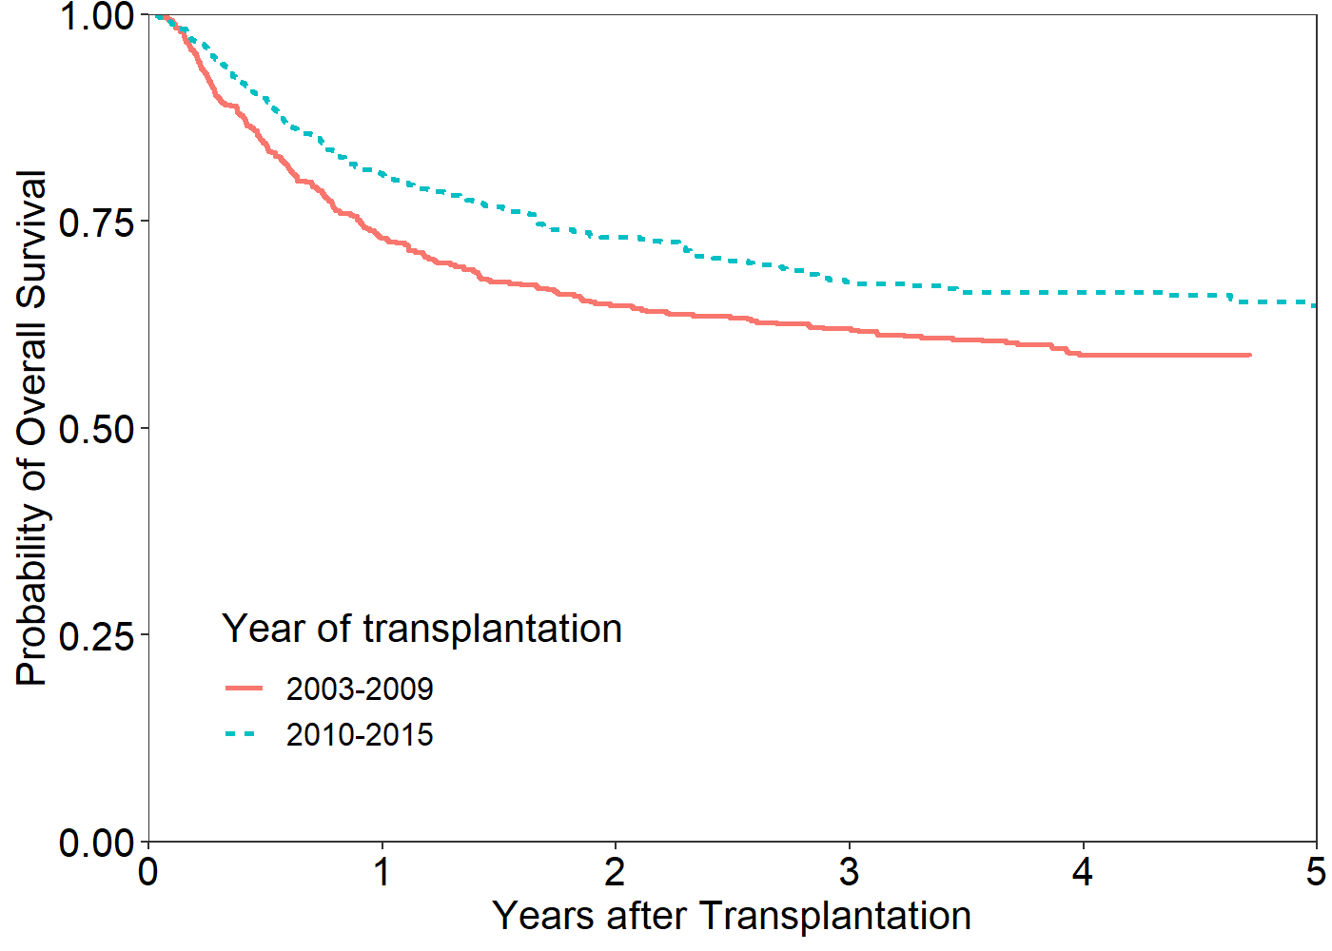
(B)
