Supplementary methods:

Moorings

We use data from oceanographic moorings deployed in 230 m water depth in Kongsfjorden, Svalbard (78°N 11°E) in three years (Table S1). We selected years (out of a possible 14 years of data overall) where a) the fluorometry data were reliable (i.e. minimal biofouling, and b) where in-situ chlorophyll samples had been taken in the area to allow us to determine the magnitude of the curve. 300 kHz RDI Acoustic Doppler Current Profilers (ADCP) were installed at ~100 m, in an upward-looking orientation. In 2013-14, an additional ADCP was deployed in a downwards orientation. The ADCPs recorded acoustic backscatter at 4 m depth resolution every 20 minutes. The top 10 m of data were removed due to noise caused by side-lobe interference at the air-ocean interface. Acoustic backscatter data were converted to Mean Volume Backscattering Strength (S_{v} (dB)) using the method presented in (1)d and normalised to the same mean S_{v} value between years to make data comparable (as per(2)). The depth of the centre of mass of backscatter (CM) was calculated using Equation 1 (3)

$$CM= \frac{\int{zs_{v}\left(z\right) dz}}{s_{v}\left(z\right)dz}$$

Where CM is the resulting centre of mass in metres, z is the depth in metres, and sv(z) is the volume backscattering at depth z. Note that all CM calculations were performed using linear units denoted by s_{v} (in comparison to units presented in figures, S_{v}, where ($S_{v}=10 \log_{10}(s_{v})$)).

A fluorometer was installed as an auxiliary unit on a Seabird 16+ CTD, deployed on the mooring at 24-38 m (Table S1). Data were smoothed using a three-day Butterworth filter, and scaled using in-situ chlorophyll samples collected in the area as per Table 1, since no in situ calibrations were conducted for the fluorometer sensors. We varied the magnitude of the chlorophyll time series by ±50% to investigate sensitivity on the depth of the isolume (Figure S2).

Underwater light calculations

Atmospheric irradiance ($E_{PAR}$) was modelled from a multi-year $E_{PAR}$ time series collected at Kongsfjorden (Ny-Ålesund, Svalbard) (4,5) and solar altitude using Equation 1.
- $E_{PAR}= {10 }^{\frac{\left(y0+a0\right)}{1+e^{-((S-E10)/b0)}}}$

Where y0, a0, E10, and b0 are constants with the values of -5.5882, 7.3168, -4.9378, and 3.2856 respectively. S is the solar elevation in degrees (calculated using the Matlab package SolarAzEl (https://www.mathworks.com/matlabcentral/mlc-downloads/downloads/submissions/23051/versions/2/previews/SolarAzEl.m/index.html).

We estimated the diffuse attenuation coefficient ($K_{d}$) as a function of chlorophyll using the scaled fluorescence time series for 2013-14 and published $K_{d}$values (0.15 m⁻¹ for non-bloom conditions and 0.6 m⁻¹ for spring bloom conditions; (6,7)). These data points formed end-members of a linear relationship between chlorophyll and $K_{d}$ (8), which we used to convert the chlorophyll time series to an annual time series of diffuse attenuation based on data from 2013-14 (Equation 2).

- $K_{d}=0.313 P+0.15$ (Figure S2).

Downwelling underwater light ($E_{ad}$) with depth was then defined as a function of downwelling atmospheric irradiance ($E_{PAR}$), diffuse attenuation ($K_{d}$), and depth (z)

- $E_{a}=E_{d}e^{K_{d}z}$

Periodicity

We calculated Lomb-Scargle periodograms (as per Last et al. (2016) using the Matlab Package Lomb (https://uk.mathworks.com/matlabcentral/fileexchange/22215-lomb-normalized-periodogram?focused=5108122&s_tid=mwa_osa_a&tab=function) to compare periodicity for four points through the year in 2013-14. We extracted 10-day segments of data to represent spring (15-March to 25-March); summer (10-June to 20-June); autumn (30-August to 09-September); winter (16-December to 21-December). These 10-day periods were selected to span the data plotted in Figure 1e-h.

References for supplementary material

1. Deines KL. Backscatter estimation using broadband acoustic Doppler current profilers. In: Proceedings of the IEEE Sixth Working Conference on Current Measurements. 1999. p. 249–53.
2. Wallace MI, Cottier FR, Berge J, Tarling GA, Griffiths C, Brierley AS. Comparison of zooplankton vertical migration in an ice-free and a seasonally ice-covered Arctic fjord: An insight into the influence of sea ice cover on zooplankton behavior. Limnol Oceanogr [Internet]. 2010;55(2):831–45. Available from: http://nora.nerc.ac.uk/14855/
3. Urmy SS, Horne JK, Barbee DH. Measuring the vertical distributional variability of pelagic fauna in Monterey Bay. ICES J Mar Sci. 2012;69(2):184–96.
4. Cohen JH, Berge J, Moline MA, Johnsen GH, Zolich AP. Light in the Polar Night. In: Polar Night Marine Ecology. Springer; 2020. p. 37–67.
5. Zolich A. Systems Integration and Communication in Autonomous Unmanned Vehicles in Marine Environments [Internet]. NTNU; 2018 [cited 2021 Jan 6]. Available from: https://ntnuopen.ntnu.no/ntnu-xmlui/handle/11250/2584513
6. Hanelt D, Tüg H, Bischof K, Groß C, Lippert H, Sawall T, et al. Light regime in an Arctic fjord: a study related to stratospheric ozone depletion as a basis for determination of UV effects on algal growth. Mar Biol [Internet]. 2001 Mar 19;138(3):649–58. Available from: http://link.springer.com/10.1007/s002270000481
7. Pavlov AK, Leu E, Hanelt D, Bartsch I, Karsten U, Hudson SR, et al. The Underwater Light Climate in Kongsfjorden and Its Ecological Implications. In: The Ecosystem of Kongsfjorden, Svalbard. 2019. p. 137–70.
8. Morel A, Maritorena S. Bio-optical properties of oceanic waters’ A reappraisal. J Geophys Res. 2001;106(C4):7163–80.

Supplementary figures:

Figure S1: Conversion from scaled fluorescence (green line) to Kd (red line) using 2013-14 data, and the range of K_{d} (diffuse attenuation coefficient) values expected from Hanelt et al. (2001) shown in red diamonds.

Figure S2: The magnitude of the chlorophyll time series is varied (±50%) to demonstrate the effect on isolume depth. The solid line reflects the chlorophyll magnitude used in the study, and the dotted and dashed lines show the isolume as a consequence of increasing and decreasing the overall magnitude by 50% respectively.
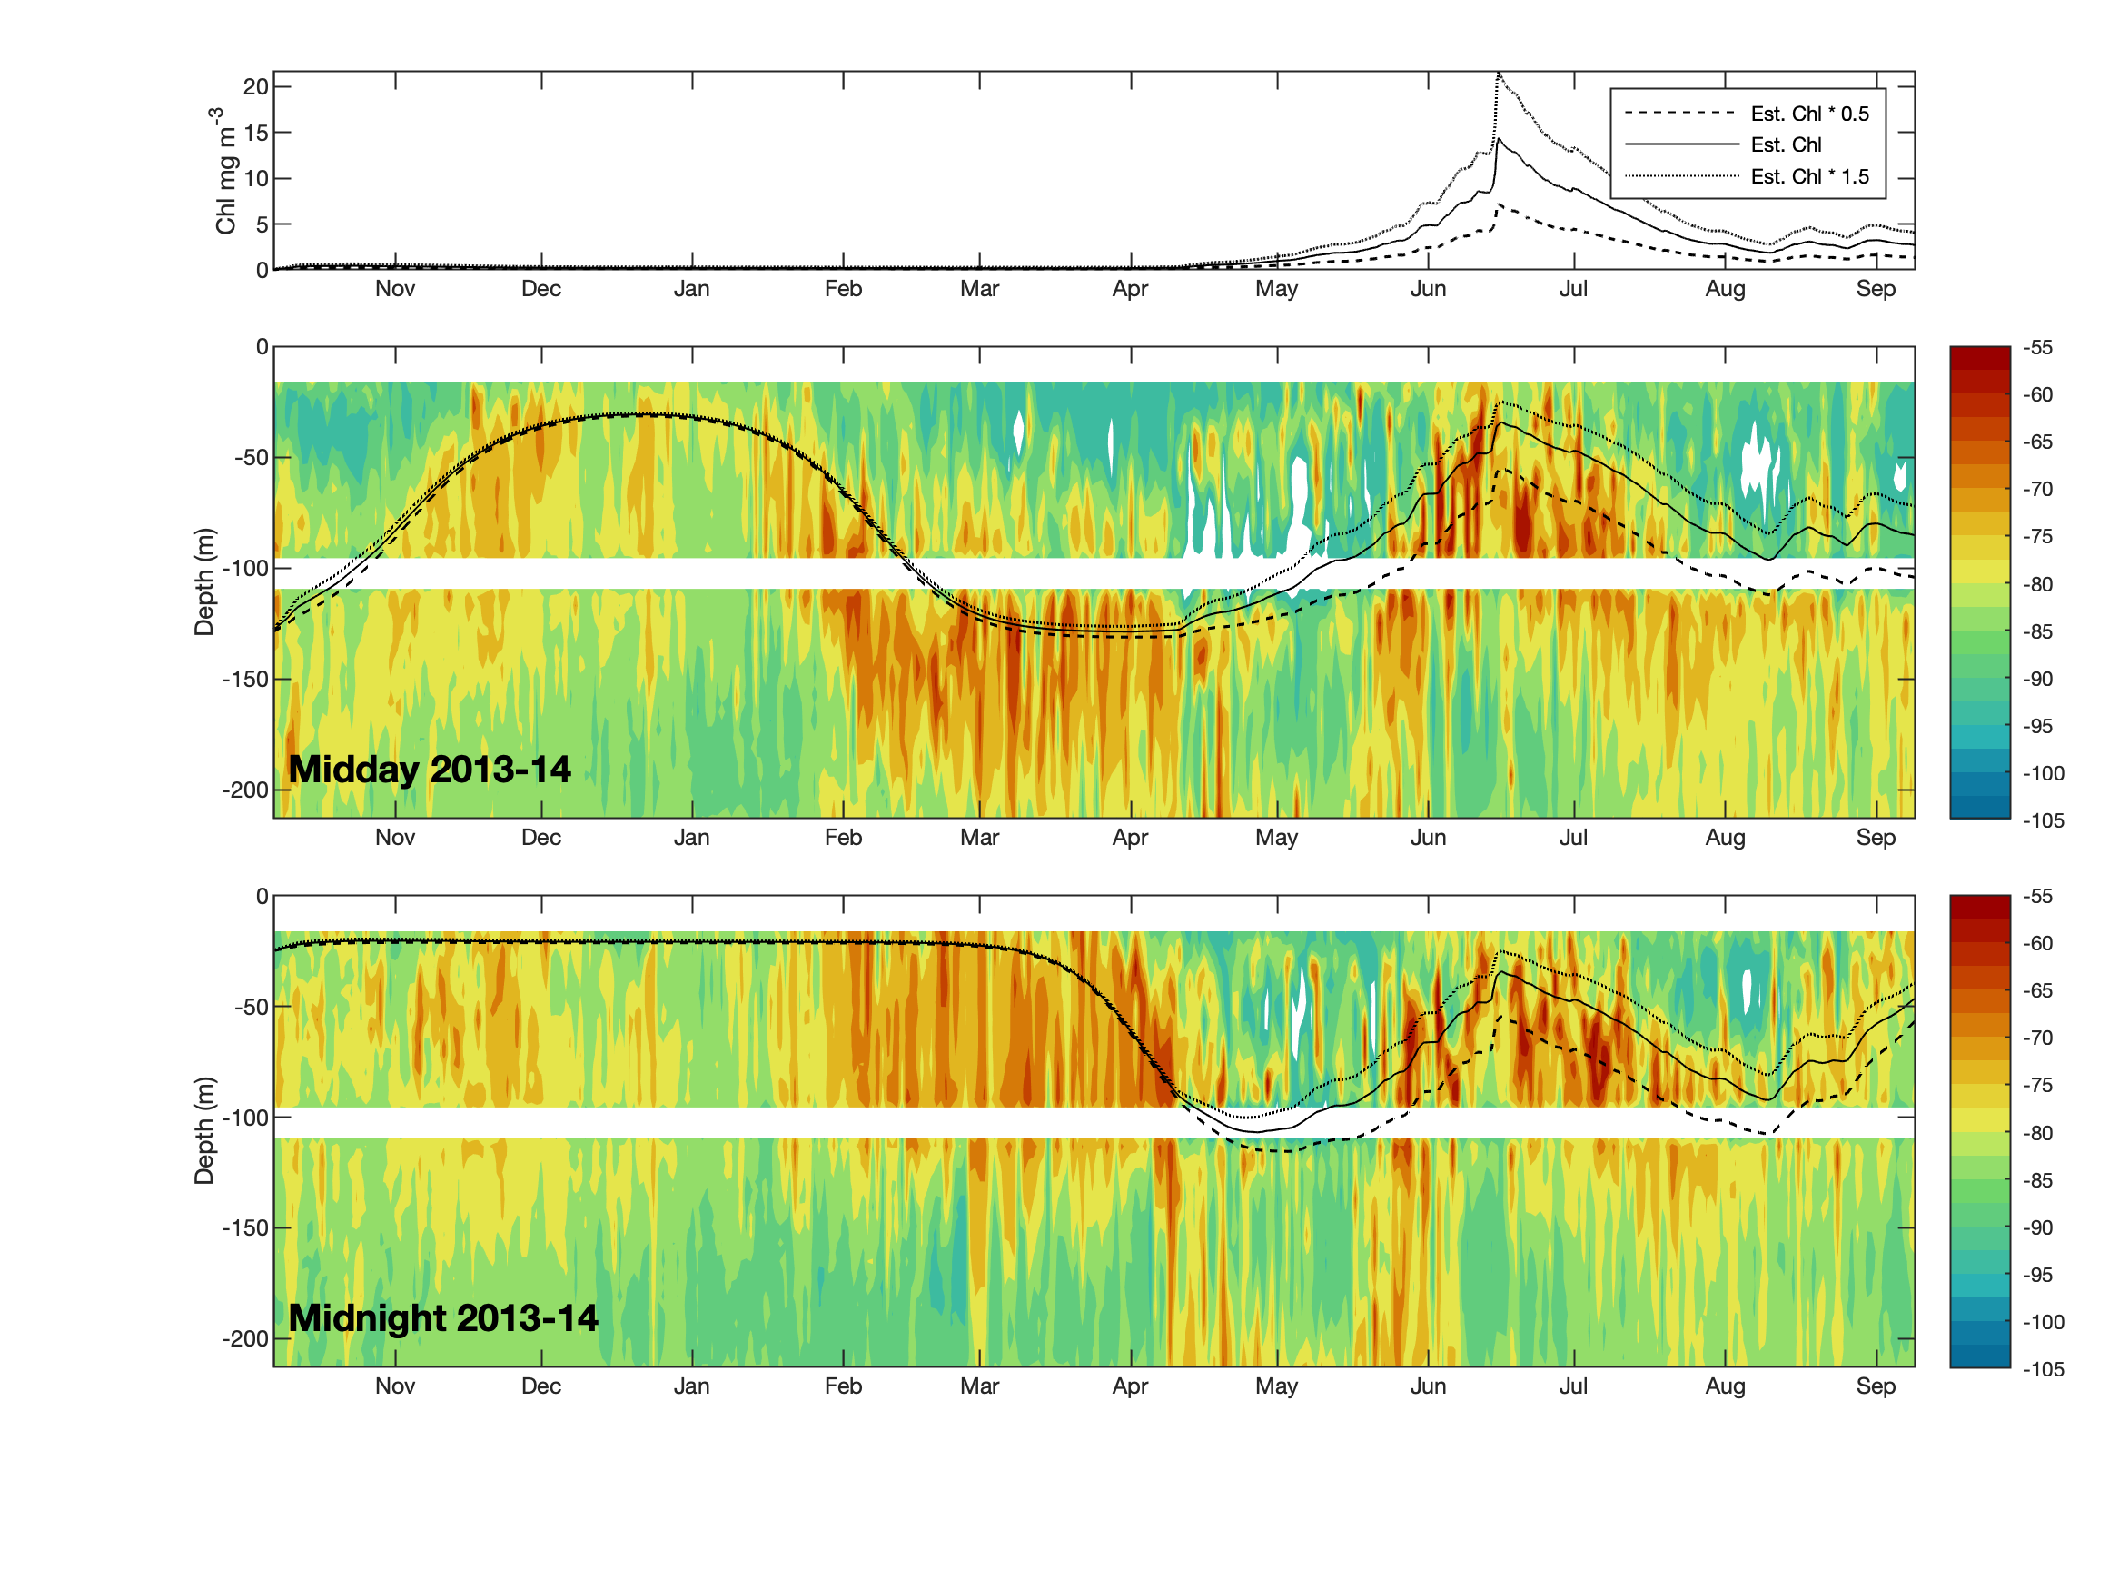

Figure S3: Lomb-scargle periodograms calculated at 30 m for four different time periods (corresponding to Figure 1e-h) across the 2013-14 sampling period. We tested periodicity from 10-day excerpts in the 0-2 day range (f), P shows an indication of periodicity strength. Horizontal dashed line is at the p = 0.05 level of significance. In spring and autumn (albeit to a lesser extent), clear signals of periodicity are seen at the diel scale (Days = 1). In summer and winter, periodicity is much more variable, and no clear peak is seen.

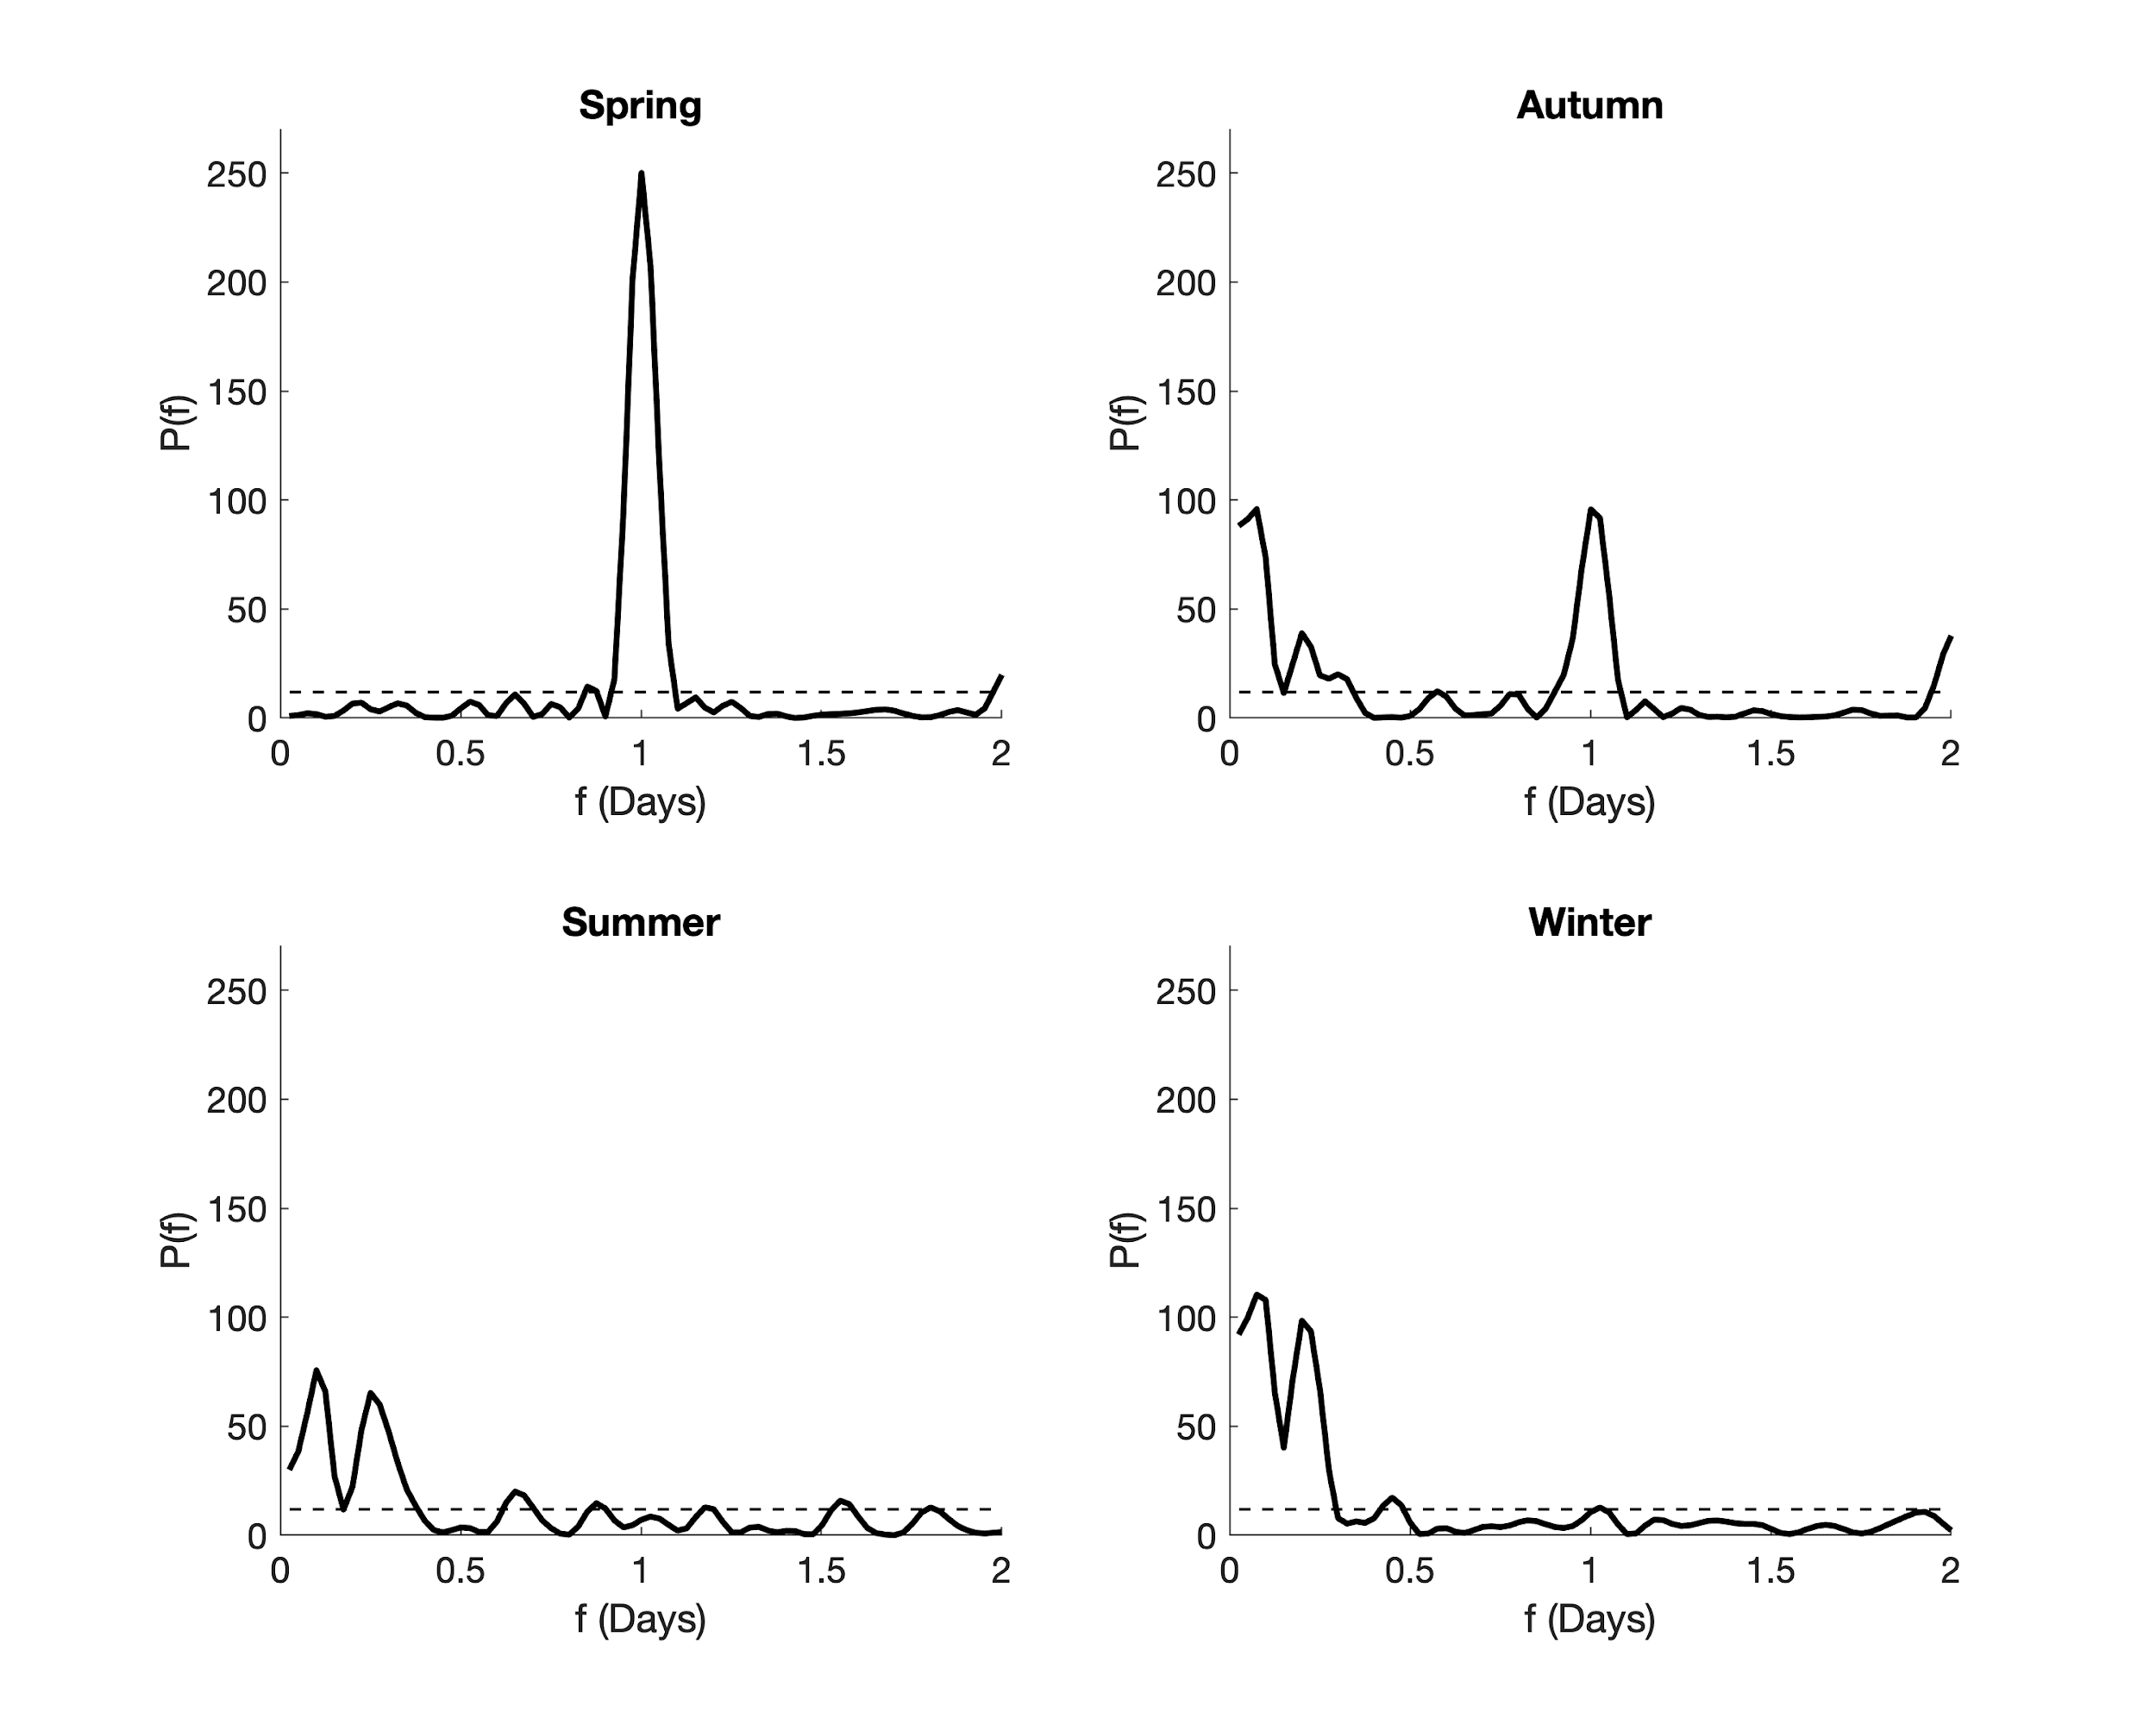

Supplementary table:

Table S1: Details of mooring deployments.

Year | Deployment | Recovery | Depth of fluorometer | Date and value of chlorophyll sample (summarised in (Hegseth et al., 2019) | Depth of upwards looking ADCP (m) | Depth of downwards looking ADCP (m)
2007-08 | 31-Aug-2007 | 17-Aug-2008 | 31.5 | 2.0 μgL⁻¹,  01 May ‘08 | 110 | N/A
2008-09 | 04-Sep-2008 | 22-Aug-2009 | 24 | 2.1 μgL⁻¹,  17-20 Jul ‘09 | 101 | N/A
2013-14 | 06-Oct-2013 | 09-Sep-2014 | 38 | 3.4 μgL⁻¹,  23-25 Jul ‘14 | 102 | 103

