We analyzed all the samples using a stereomicroscope, Olympus C011 trinocular microscope, coupled with a CCD camera. All the samples were measured and photographed by the Infinity Capture software.

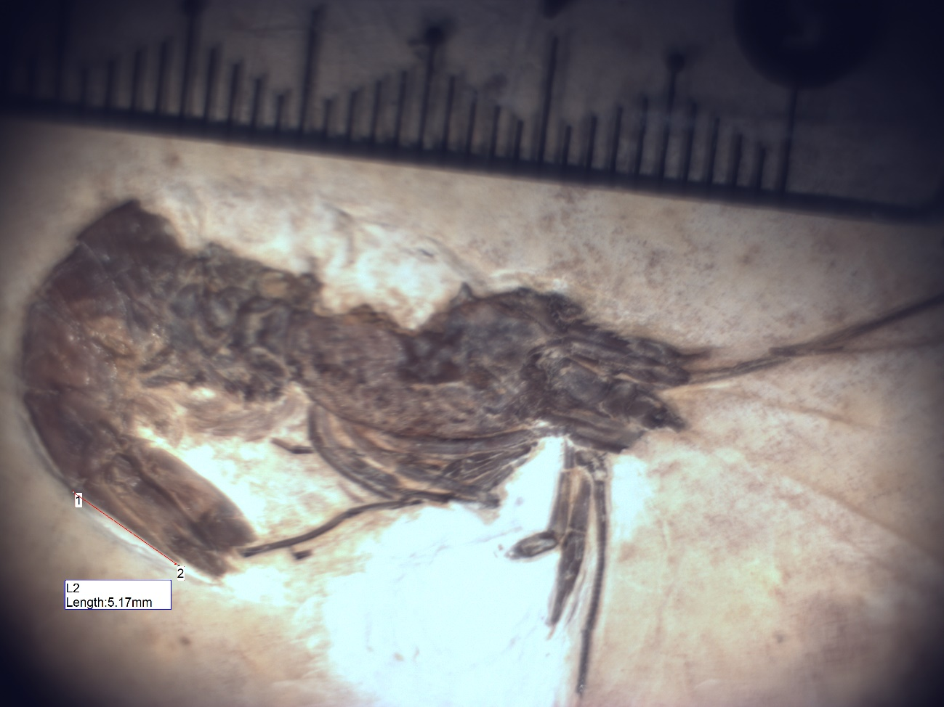

The drawn was improved with a drawing table, Parblo A610 – Graphhic tablet using the program ImageJ (Public Dominic).

The geographical location of the Araripe Basin was produced using the software QGIS Geographic Information System (version 3.12 – QGIS.org – Public Dominic) considering the coordinate system Datum – SIRGAS 200 from Instituto Brasileiro de Geografia e Estatística (IBGE, Brazil) and Companhia de Pesquisa de Recursos Minerais (CPRM, Brazil).
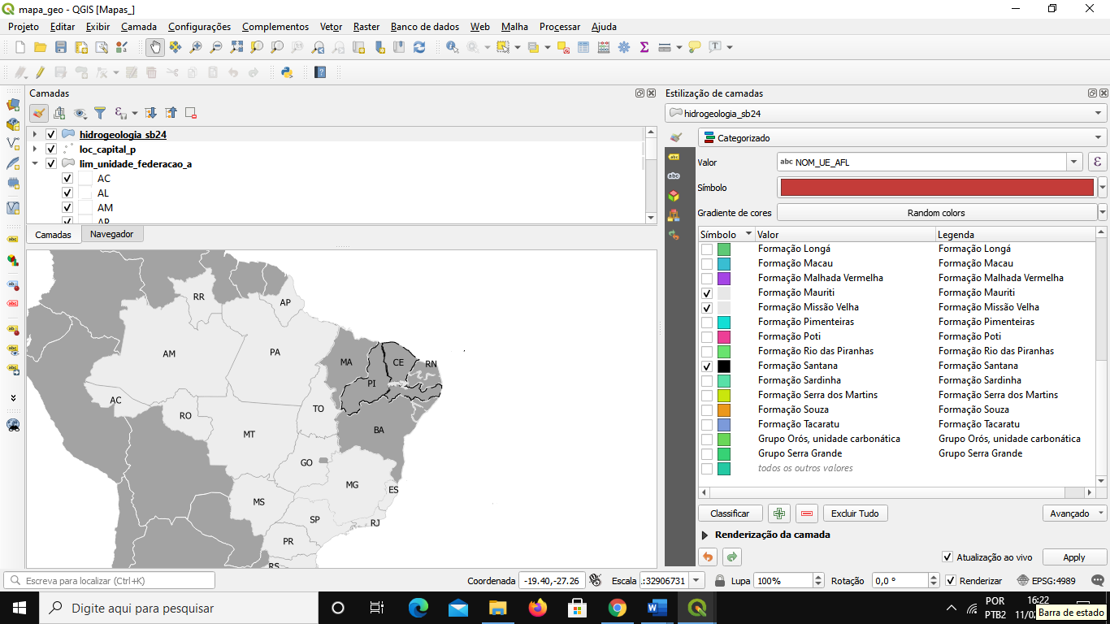

The stratigraphy of the Santana group was drawn with program ImageJ (Public Dominic) to according with stratigraphy on Neumann & Cabreira, 1999 and Valença et al., 2003.

References

VALENÇA, L.M.M., NEUMANN, V.H., & MABESOONE, J.M., 2003. An overview on Callovian-Cenomanian intracratonic basins of Northeast Brazil: Onshore stratrigraphic record of the opening of the southern Atlantic. Geologica Acta, 1(3), 261.

NEUMANN VH, CABRERA L. Uma nueva proposta estratigráfica para la tectonosecuencia post-rifte de la Cuenca de Araripe, Noreste de Brasil. Bol do 5º Simpósio sobre o Cretáceo do Bras. 1999; 279–285.

