Supplementary Material

Supplementary Figure
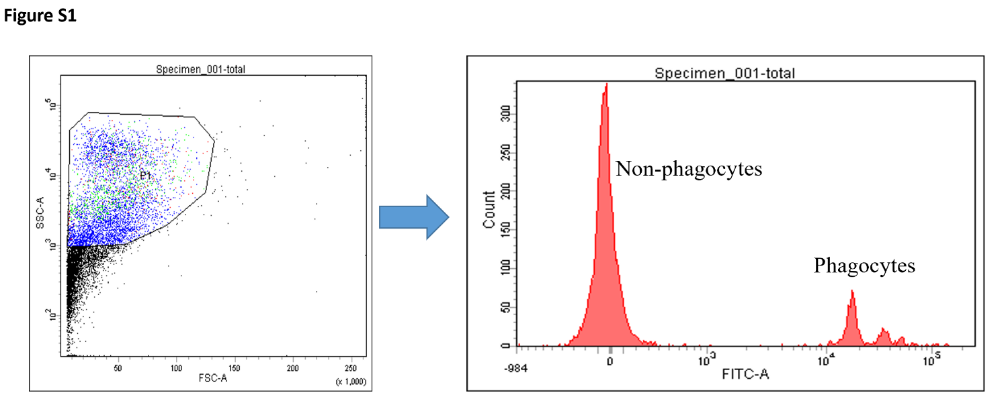

Figure S1. Fluorescence-activated cell sorting (FACS) of phagocytes and non- phagocytes based on their phagocytosis towards FITC-labeled latex beads.

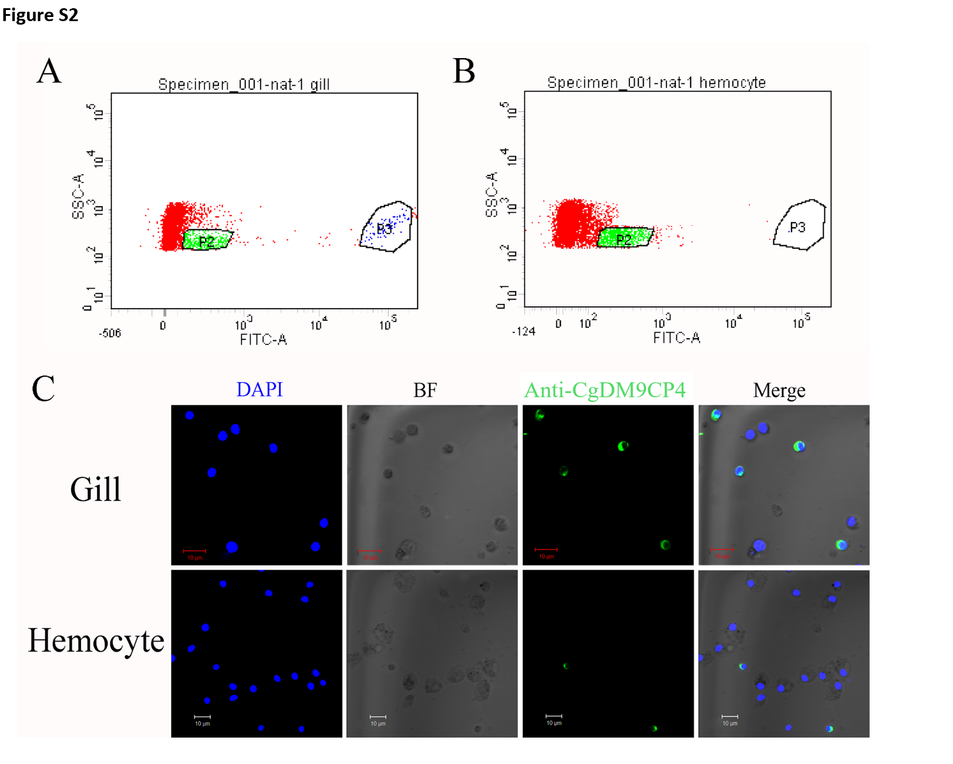
Figure S2. Comparison of CgDM9CP-4-positive hemocytes in gill and hemocytes. Analysis of CgDM9CP-4-positive hemocytes from gill (A) and hemocytes (B). (C) Immunofluorescence of CgDM9CP-4 in the hemocytes from gill and isolated from the heart.
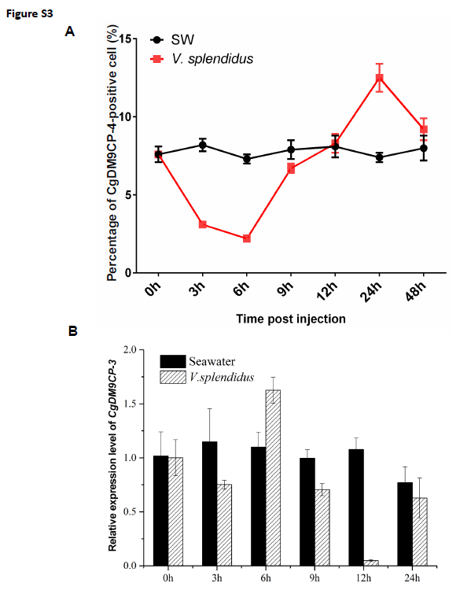
Figure S3. Percentage of CgDM9CP-4-positive hemocytes (A) and CgDM9CP-4 mRNA level in gill (B) after V. splendidus stimulation.

Supplementary Table 1
Primers used in this paper.
Primer | Sequence (5’-3’)
Oligo (dT)-adaptor  Clone primers  P1 (forward)  P2 (reverse)  RT primers  P3  P4  EF primers  P5 (EF-RTF)  P6 (EF-RTR)  Recombination primers  P7 (forward)  P8 (reverse)  Sequencing primers  M13 (forward)  RV (reverse) | GGCCACGCGTCGACTAGTACT₁₇  ATGACACACTGGGTATCTACCTCTG CCACCTTCCTCCRGTTTRTCA  GTCAAAACGGACAACGACAAGT TCCTTCGTGTTGTGTTCTTTCC  GAGCGTGAACGTGGTATCAC  ACAGCACAGTCAGCCTGTGA  GGAATTCCATATGACACACTGGGTATCTAC CCGCTCGAGCTTGATGTTACAGAGGACTTC  AATTAACCCTCACTAAAGGG  TGCGTCGGCTTTGCTCTG

