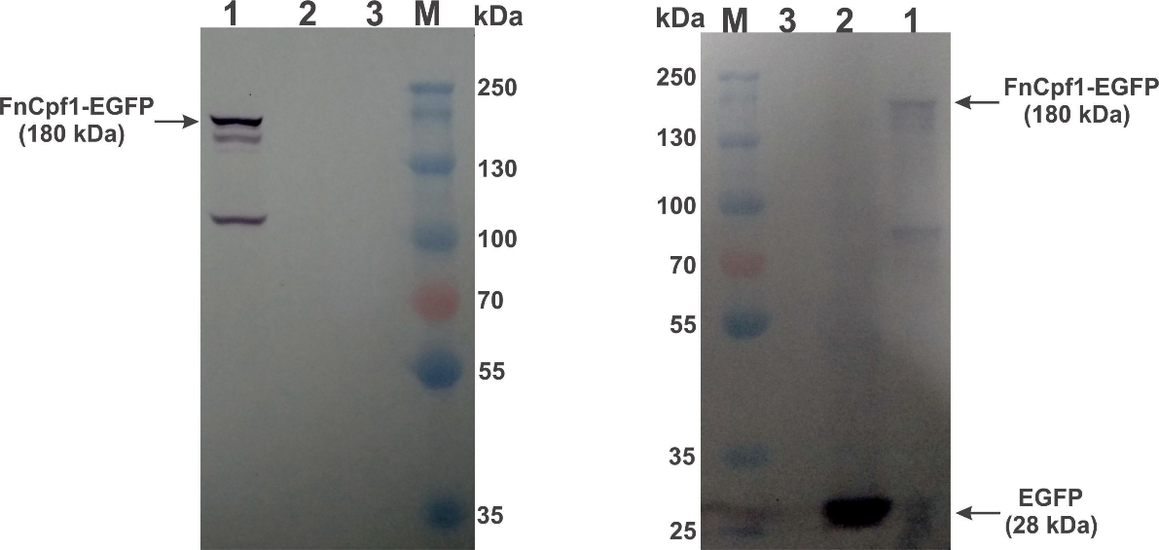

(a) (b)
Fig S2. Western blot detection of heterologous EGFP and Cpf1-EGFP proteins in recombinant A. aculeatus TBRC 277 egfp and Cpf1-egfp, respectively. (a) GenCRISPRᵀᴹ FnCpf1 monoclonal antibody (9H6) was used as the primary detection, 1.0 µg (Genscript, USA). (b) GFP monoclonal antibody (C163) was used for the primary detection, 3 µg (Thermo Fisher, USA). All samples were treated by IgG-AP as the secondary antibody for detection, 2 µg. Lane 1, crude protein of A. aculeatus recombinant (Cpf1-egfp). Lane 2, crude protein of recombinant A. aculeatus (egfp), Lane 3: Crude protein of A. aculeatus TBRC 277 wild-type (control). Each lanes was loaded with 20-µg protein. Anti-GFP (Roche) and FnCpf1 (Genscript, USA) antibody was used as the primary (monoclonal) antibody, anti IgG-conjugated AP was used for secondary antibody. M: PageRuler™ Plus Prestained Protein Ladder (Thermo Fisher, USA). The gels were processed independently.

