Supplementary information

Investigation of sphingosine kinase 1 inhibitory potential cinchonine and colcemid targeting anticancer therapy

Sonam Roy^{1,¥}, Shama Khan^{2, ¥}, Deeba Shamim Jairajpuri³, Afzal Hussain⁴, Mohamed F. Alajmi⁴, Asimul Islam¹, Suaib Luqman^{5,6}, Suhel Parvez⁷ and Md. Imtaiyaz Hassan^{1,*}
¹Centre for Interdisciplinary Research in Basic Sciences, Jamia Millia Islamia, Jamia Nagar, New Delhi-110025, India.
²Department of Clinical Microbiology and Infectious Diseases, School of Pathology, University of the Witwatersrand, Johannesburg2193, South Africa.
³Department of Medical Biochemistry, College of Medicine and Medical Sciences, Arabian Gulf University, P.O. Box 22971, Manama, Bahrain.
⁴Department of Pharmacognosy, College of Pharmacy, King Saud University, Riyadh 11451, Saudi Arabia.
⁵Bioprospection and Product Development Division, CSIR-Central Institute of Medicinal and Aromatic Plants, Lucknow-226015, Uttar Pradesh, India.
⁶Academy of Scientific and Innovative Research (AcSIR), Ghaziabad-201002, Uttar Pradesh, India.
⁷Department of Toxicology, School of Chemical and Life Sciences, Jamia Hamdard, New Delhi – 110062, INDIA

*To whom correspondence should be addressed.
Md. Imtaiyaz Hassan, Ph.D., FRSB., FRSC.
Assistant Professor
Centre for Interdisciplinary Research in Basic Sciences
Jamia Millia Islamia, Jamia Nagar
New Delhi 110025, INDIA
Cell: +91-9990323217
E-mail: mihassan@jmi.ac.in

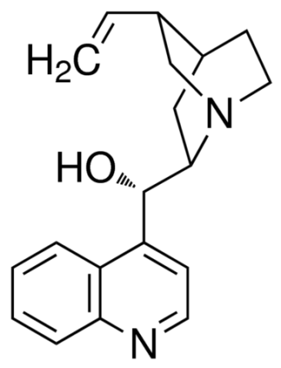
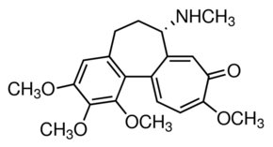
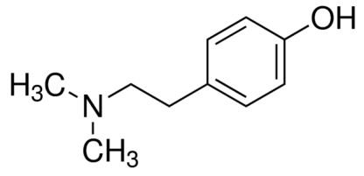
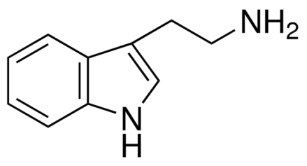
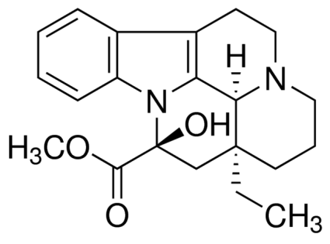
A
B
C
D
E

Figure S1. 2D structure of studied compounds. (A) Cinchonine (B) Colcemid (C) Hordenine (D) Tryptamine and (E) Vincamine.
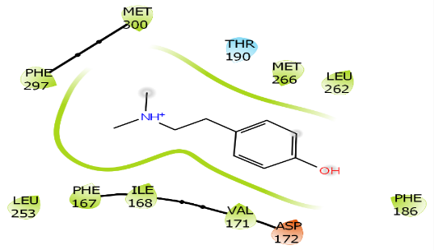
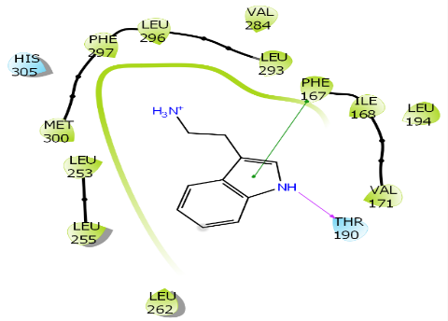
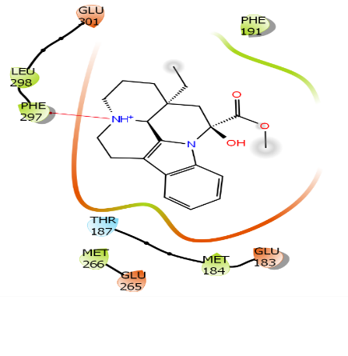
A
B
C

Figure S2. Docked poses of SphK1 with the studied inhibitors. Molecular interaction of (A) Hordenine (B) Tryptamine and (C) Vincamine with the active site of SphK1 enzyme.

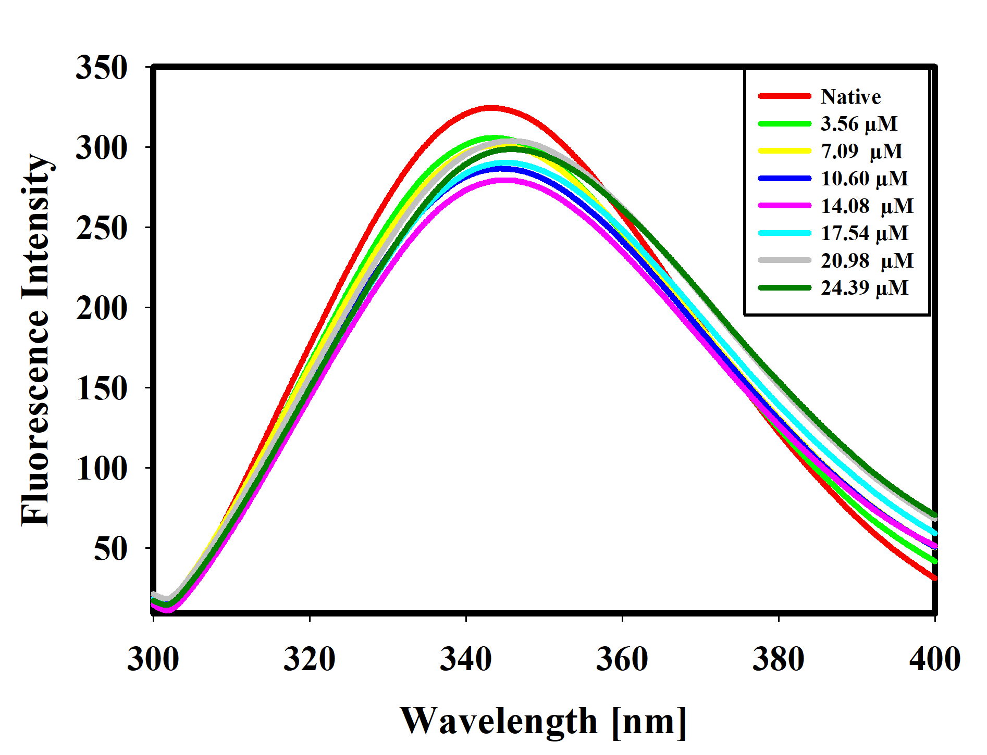
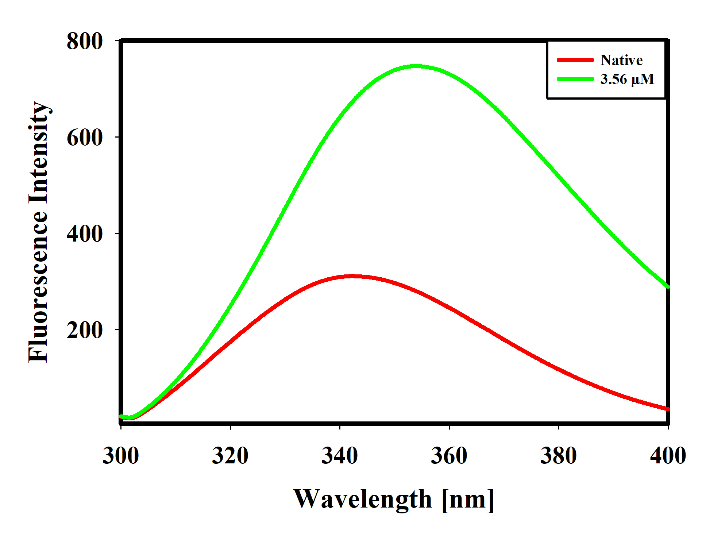
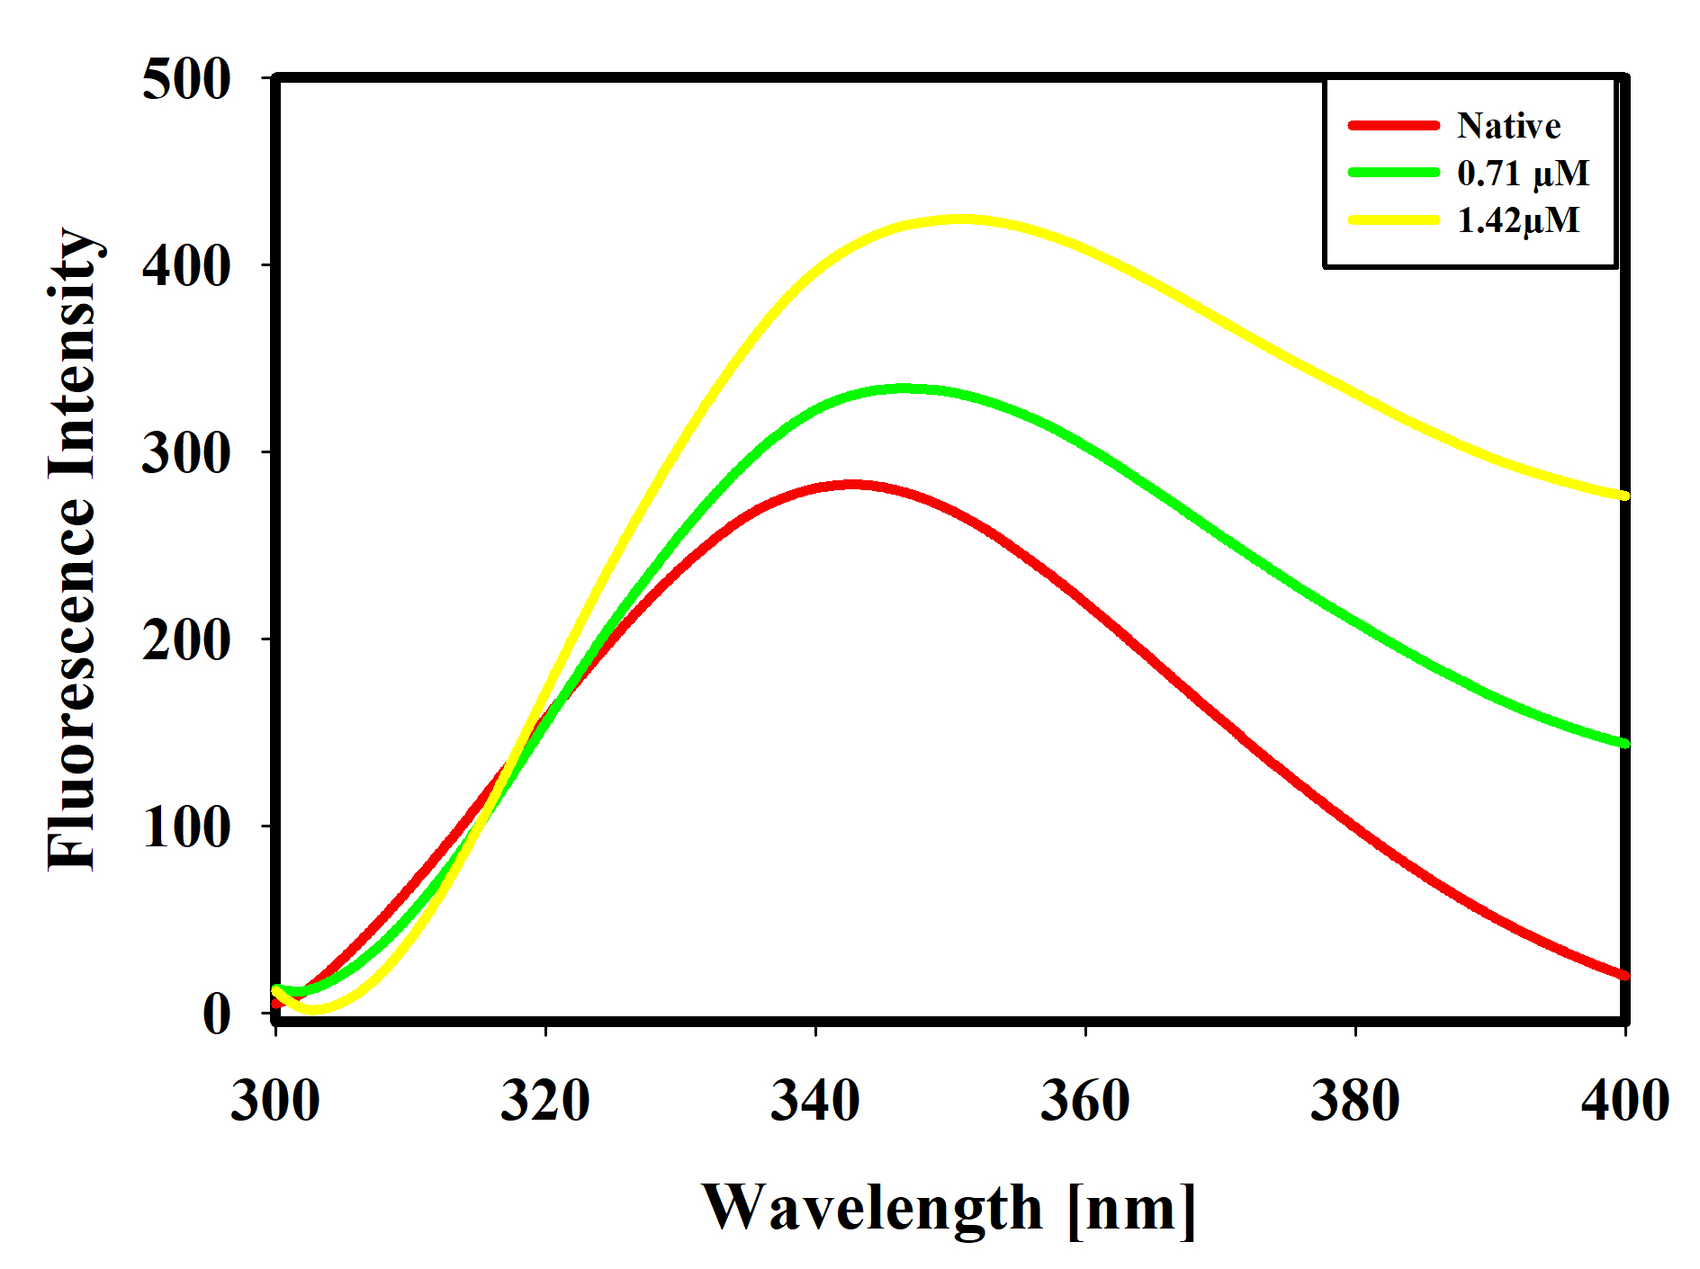
A
B
C
Hordenine
Tryptamine
Vincamine

Figure S3. Fluorescence binding study of SphK1 with selected alkaloids. Fluorescence emission spectra of SphK1(4 µM) with increasing concentrations of selected alkaloids at pH 8.0. A. Hordenine B. Tryptamine C. Vincamine

Table S1. Docking score of selected and screened alkaloids with their binding site residues.
Compounds | Docking score  (kcal/mol) | Interacting Binding Site Residues
Cinchonine | -8.31 | Leu296, Leu257, Leu255, Leu262, Ala268, Ile168, Met300, Phe167, Thr190, Leu194, Leu293, Val284, Leu313, Cys310, Leu253, Phe282
Colcemid | -7.36 | Ser162, Gly336, Asp335, Ala333, Leu255, Ala164, Ile168, Asp172, Met300, Phe297, Leu262, Met266, Val171, Phe186, Gly263, Thr187, Thr190, Glu183, Gly107, Asn108, Asp75, Ala109, Leu257, Leu161
Hordenine | -5.90 | Met300, Phe297, Thr190, Met266, Leu262, Leu253, Phe167, Ile168, Val171, Asp172
Tryptamine | -1.86 | Thr190, Phe167, Val171, Phe167, Ile168, Leu194, Leu293, Leu296, Val284, Phe297, Met300, His305, Leu253, Leu255, Leu262
Vincamine | -2.99 | Phe297, Leu298, Glu301, Thr187, Met184, Glu183, Met266, Glu265. Phe191

