Some common thresholds and corresponding omission rates are as follows. If test data are available, binomial probabilities are calculated exactly if the number of test samples is at most 25, otherwise using a normal approximation to the binomial. These are 1-sided p-values for the null hypothesis that test points are predicted no better than by a random prediction with the same fractional predicted area. The "Balance" threshold minimizes 6 * training omission rate + .04 * cumulative threshold + 1.6 * fractional predicted area.
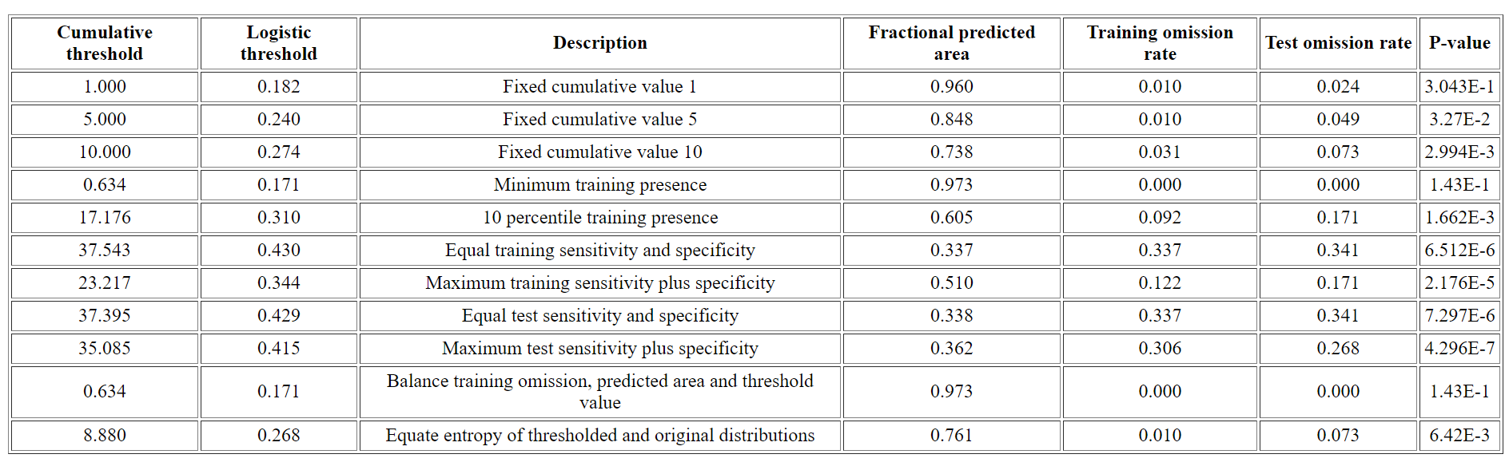
Response curves
These curves show how each environmental variable affects the Maxent prediction. The curves show how the predicted probability of presence changes as each environmental variable is varied, keeping all other environmental variables at their average sample value. Click on a response curve to see a larger version. Note that the curves can be hard to interpret if you have strongly correlated variables, as the model may depend on the correlations in ways that are not evident in the curves. In other words, the curves show the marginal effect of changing exactly one variable, whereas the model may take advantage of sets of variables changing together.
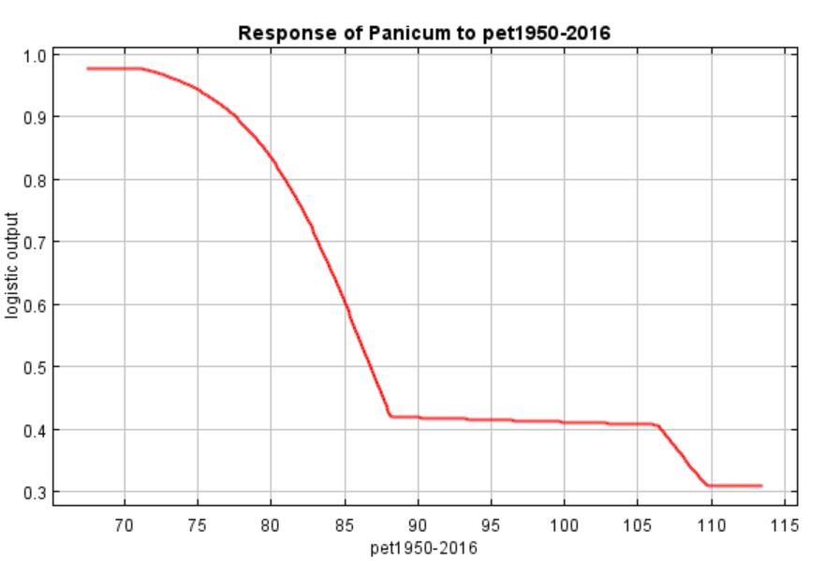
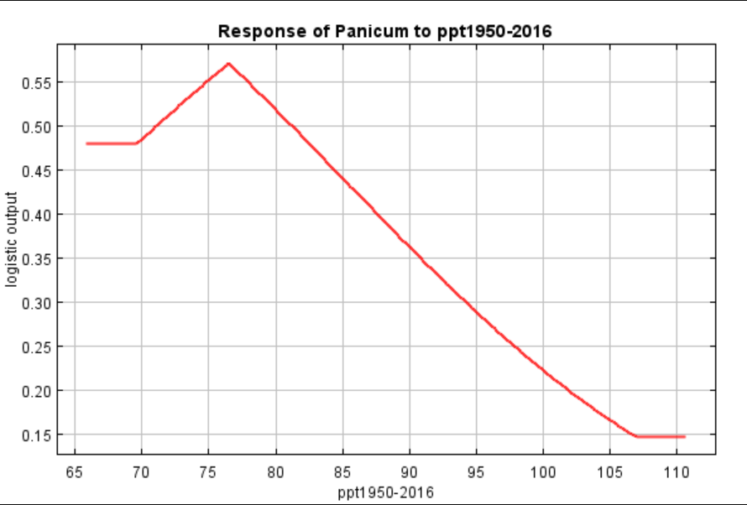
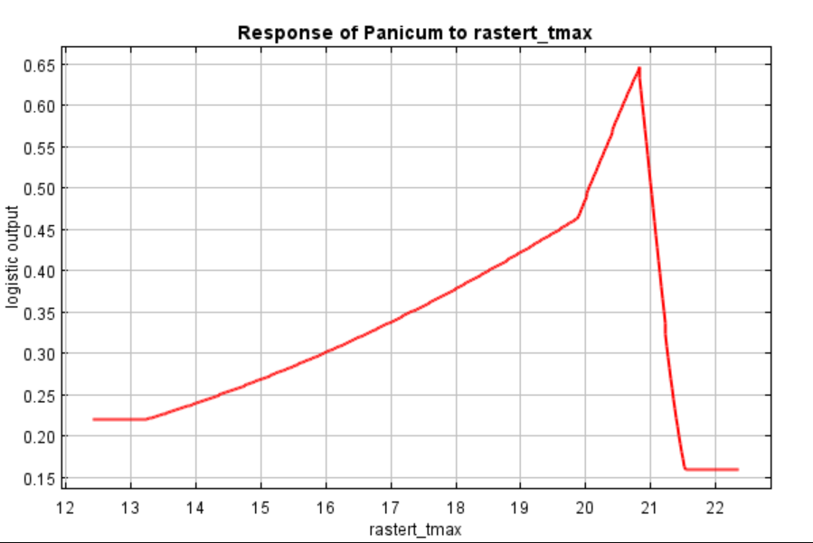
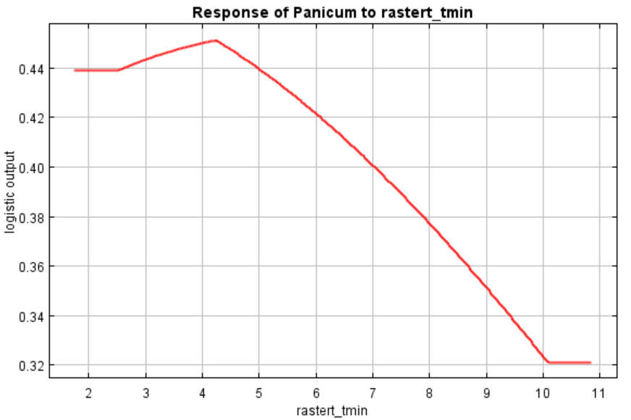
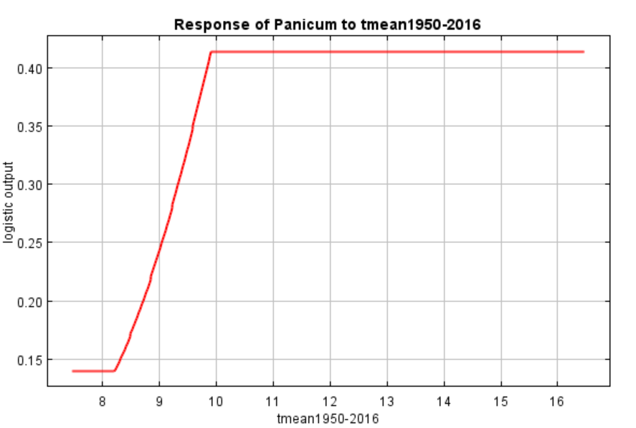
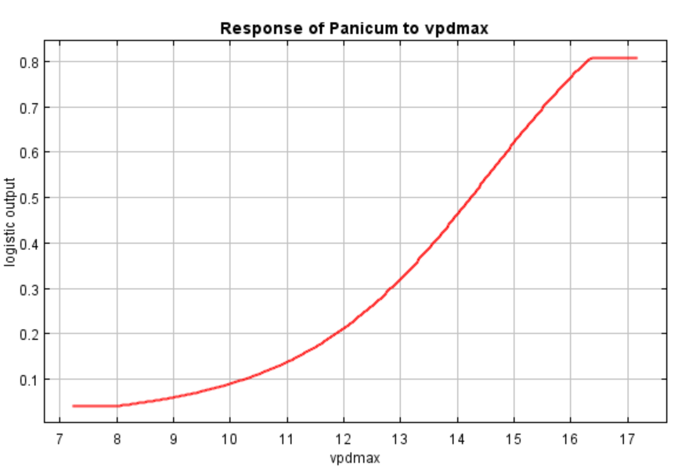
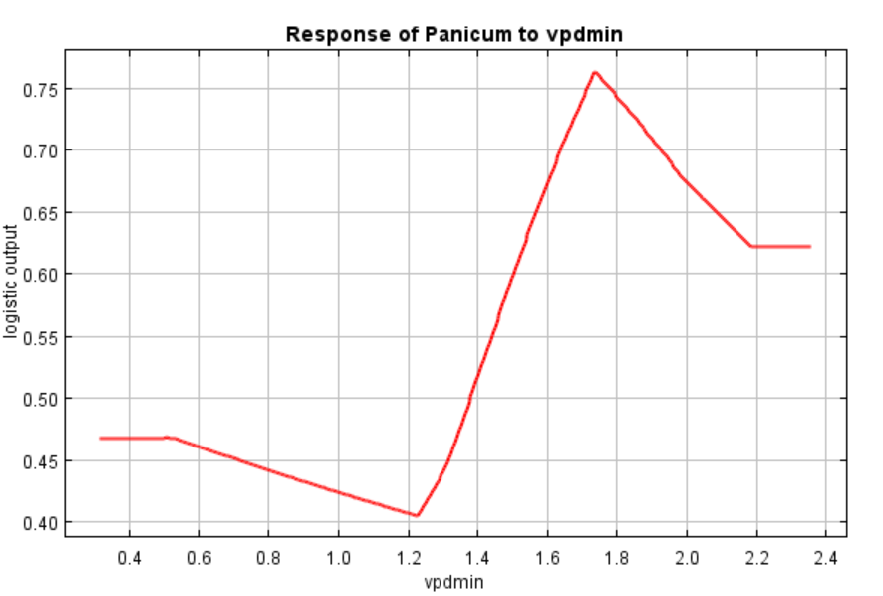
In contrast to the above marginal response curves, each of the following curves represents a different model, namely, a Maxent model created using only the corresponding variable. These plots reflect the dependence of predicted suitability both on the selected variable and on dependencies induced by correlations between the selected variable and other variables. They may be easier to interpret if there are strong correlations between variables.
