Supplementary Material

Triple-isotope calibration of in-house water standards supplemented by determination of ¹⁷O content in USGS49-50 reference materials using cavity-ring-down laser spectrometry
Anna Pierchala, Kazimierz Rozanski, Marek Dulinski, Zbigniew Gorczyca, Robert Czub

Table S1. Description of waters subject to calibration exercise described in the communication.
Water | Isotope ratios* | Description
KWK3 | δ²H=-77.34±0.02 ‰  δ¹⁸O=-11.165±0.003 ‰  δ¹⁷O=-5.884±0.002 ‰ | In-house laboratory standard used for controlling long-term reproducibility of the analyses. Krakow tap water distilled several times and stored in brass container under pressurized argon.
KWK4 | δ²H=-64.32±0.03 ‰  δ¹⁸O=-9.16±0.01 ‰  δ¹⁷O=-4.83±0.01 ‰ | New in-house laboratory standard used for quality control purposes (replacement for KWK3). Krakow tap water distilled several times and stored in stainless steel barrel under pressurized argon.
Tallin7 | δ²H=-357.48±0.97 ‰  δ¹⁸O=-45.56±0.11 ‰  δ¹⁷O=-24.346±0.093 ‰ | Melted water from left-overs of Antarctic ice core, distributed by R. Vaikmae, Technical University, Tallin, Estonia. Upon arrival to Krakow laboratory (20-liter container) the water was distilled several times, split into 1.5-liter aliquots and kept in sealed dark glass bottles at +4ºC.
USGS47 | δ²H=-150.20±0.25 ‰  δ¹⁸O=-19.80±0.01 ‰  δ¹⁷O=-10.47±0.01 ‰ | Secondary reference material prepared and distributed by USGS [1]. Drinking water from Lake Louise (Canada) stored in 5-ml sealed glass ampoules.
USGS48 | δ²H=-2.0±0.2 ‰  δ¹⁸O=-2.224±0.006 ‰  δ¹⁷O=-1.15±0.01 ‰ | Secondary reference material prepared and distributed by USGS [1]. Puerto Rico precipitation water stored in 5-ml sealed glass ampoules.
USGS49 | δ²H=-394.7±0.2 ‰  δ¹⁸O=-50.55±0.02 ‰  δ¹⁷O=-27.17±0.12 ‰ | Secondary reference material prepared and distributed by USGS [1]. Antarctic ice-core water stored in 5-ml sealed glass ampoules.
USGS50 | δ²H=32.8±0.2 ‰  δ¹⁸O=4.95±0.01 ‰  δ¹⁷O=2.54±0.050 ‰ | Secondary reference material prepared and distributed by USGS [1]. Water from Lake Kyoga (Uganda) stored in 5-ml sealed glass ampoules.
* - reported are delta values with their uncertainties

Table S2. Composition of calibration runs of seven water standards calibrated against VSOMW2/SLAP2 primary reference materials with the aid of Picarro L2140-i CRDS analyser.
Date | No. | Sample | δ²H  [‰] | Number  of injections
16.06.2020 | 1 | DI | -62.1 | 10
 | 2 | VSMOW2 | 0 | 15
 | 3 | KWK4 | -64.32 | 15
 | 4 | KWK3 | -77.34 | 10
 | 5 | SLAP2 | -427.5 | 25
 | 6 | USGS49 | -394.7 | 15
 | 7 | TALLIN7 | -357.48 | 15
 | 8 | VSMOW2 | 0 | 25
17.06.2020 | 1 | DI | -62.1 | 10
 | 2 | VSMOW2 | 0 | 15
 | 3 | USGS48 | -2.0 | 15
 | 4 | SLAP2 | -427.5 | 25
 | 5 | USGS47 | -150.2 | 25
 | 6 | VSMOW2 | 0 | 25
18.06.2020 | 1 | DI | -62.1 | 10
 | 2 | VSMOW2 | 0 | 20
 | 3 | USGS50 | 32.8 | 15
 | 4 | SLAP2 | -427.5 | 27
 | 5 | USGS49 | -394.7 | 15
 | 6 | TALLIN7 | -357.48 | 15
 | 7 | VSMOW2 | 0 | 27
19.06.2020 | 1 | DI | -62.1 | 10
 | 2 | SLAP2 | -427.5 | 27
 | 3 | USGS49 | -394.7 | 12
 | 4 | TALLIN7 | -357.48 | 12
 | 5 | VSMOW2 | 0 | 27
 | 6 | USGS50 | 32.8 | 12
 | 7 | SLAP2 | -427.5 | 27
 | 8 | KWK4 | -64.32 | 27
 | 9 | KWK3 | -77.34 | 15
 | 10 | VSMOW2 | 0 | 15
 | 11 | USGS50 | 32.8 | 15
 | 12 | SLAP | -427.5 | 27
 | 13 | USGS47 | -150.2 | 27
 | 14 | VSMOW2 | 0 | 27
 | 15 | KWK3 | -77.34 | 15
 | 16 | USGS49 | -394.7 | 27
 | 17 | SLAP | -427.5 | 27

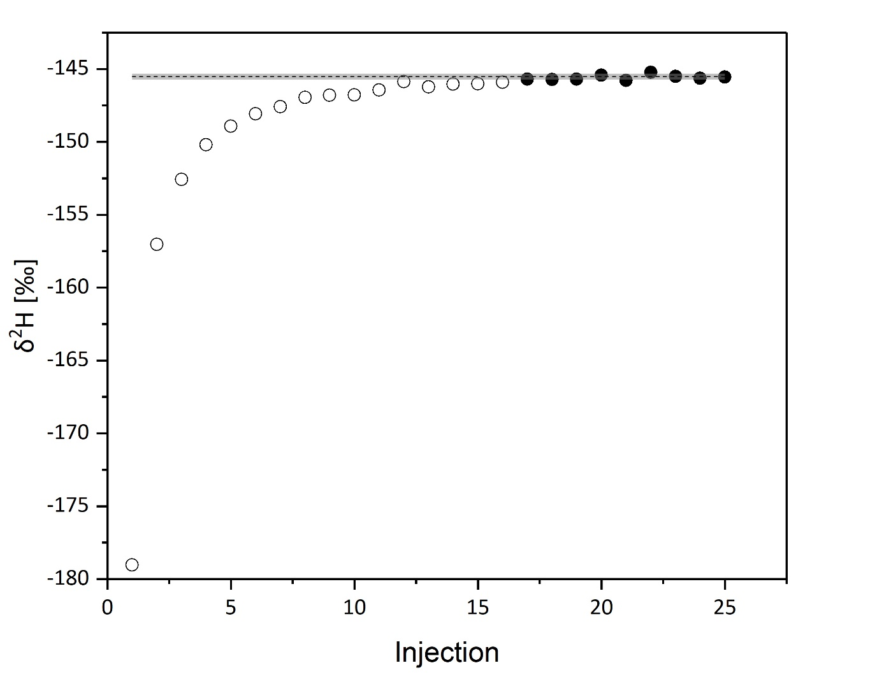
Figure S1. Measurement results of 25 injections of the USGS47 standard analysed on June 17, 2020, preceded by 25 injections of SLAP2 primary reference standard. The results of first 16 injections were rejected (empty circles) due to presence of increasing trend stemming from analysis of the preceding sample (SLAP2). For the last 9 injections (solid circles), the results fluctuate around the average (dashed line; calculated for the last 6 results). The value for the first not rejected injection differs from the mean of the last 6 results by less than one standard deviation (gray area).
Table S3. Values of t-Student distribution for confidence level equal 68% (1σ) [2].
Number of accepted  injections (N) | Number of degree  of freedom $(ν)$ | Value of t-Student  distribution (1σ level)
2 | 1 | 1.84
3 | 2 | 1.32
4 | 3 | 1.20
5 | 4 | 1.14
6 | 5 | 1.11
7 | 6 | 1.09
8 | 7 | 1.08
9 | 8 | 1.07
10 | 9 | 1.06

Table S4. Summary of individual calibrations of seven water standards against VSOMW2/SLAP2 primary reference materials conducted with the aid of Picarro L2140-i CRDS analyser. Uncertainties shown are at the level of one standard uncertainty.
Sample | Date | Number of accepted injections  N | δ²H  [‰] | δ¹⁸O  [‰] | δ¹⁷O  [‰] | d-excess  [‰] | Δ¹⁷O  [per meg]
KWK3 | 16.06.2020 | 6 | -76.90±0.56 | -11.145±0.047 | -5.889±0.049 | 12.26±0.67 | 12±8
 | 19.06.2020 | 10 | -77.21±0.56 | -11.138±0.063 | -5.861±0.061 | 11.89±0.75 | 36±10
 | 19.06.2020 | 9 | -76.64±0.57 | -11.109±0.056 | -5.844±0.048 | 12.23±0.73 | 37±7
KWK4 | 16.06.2020 | 9 | -63.65±0.56 | -9.103±0.047 | -4.797±0.048 | 9.18±0.67 | 20±5
 | 19.06.2020 | 6 | -64.76±0.56 | -9.182±0.064 | -4.830±0.061 | 8.69±0.75 | 28±9
TALLIN7 | 16.06.2020 | 10 | -356.71±0.66 | -45.605±0.057 | -24.388±0.057 | 8.13±0.81 | -45±5
 | 18.06.2020 | 6 | -356.88±0.64 | -45.612±0.057 | -24.383±0.057 | 8.01±0.79 | -36±7
 | 19.06.2020 | 7 | -356.90±0.81 | -45.622±0.080 | -24.383±0.059 | 8.1±1.1 | -30±6
USGS47 | 17.06.2020 | 9 | -150.91±0.57 | -19.744±0.053 | -10.439±0.051 | 7.04±0.71 | 35±9
 | 19.06.2020 | 10 | -151.48±0.56 | -19.903±0.070 | -10.531±0.066 | 7.75±0.79 | 28±5
USGS48 | 17.06.2020 | 10 | -1.89±0.58 | -2.198±0.055 | -1.146±0.050 | 15.69±0.73 | 15±6
USGS49 | 16.06.2020 | 6 | -395.89±0.70 | -50.616±0.063 | -27.061±0.059 | 9.04±0.86 | -8±5
 | 18.06.2020 | 9 | -395.83±0.66 | -50.617±0.061 | -27.028±0.059 | 9.10±0.82 | 26±5
 | 19.06.2020 | 9 | -395.63±0.86 | -50.630±0.091 | -27.060±0.066 | 9.4±1.2 | 1±10
 | 19.06.2020 | 8 | -393.99±0.67 | -50.513±0.061 | -26.992±0.055 | 10.11±0.83 | 5±5
USGS50 | 18.06.2020 | 8 | 32.60±0.53 | 4.959±0.046 | 2.606±0.045 | -7.07±0.65 | -9±7
 | 19.06.2020 | 6 | 33.03±0.62 | 4.992±0.073 | 2.620±0.064 | -6.90±0.85 | -13±13
 | 19.06.2020 | 9 | 32.83±0.59 | 4.947±0.074 | 2.601±0.067 | -6.75±0.84 | -8±6

Quoted references:
[1] Reference Materials and Calibration Services [Internet]. Reston (USA): USGS; 2020 [cited 2020, July 16]. Available from: https://isotopes.usgs.gov/lab/referencematerials.html
[2] Evaluation of Measurement Data. Guide to the expression of uncertainty in measurement. JCGM. 2008;100:8–11, Corrected version. 2010.

