Analysis report about one patient’s pathogenic microorganism detection

Dear Customer:

On November 12, 2019, our company conducted a metagenomic test of pathogenic microorganisms on one cerebrospinal fluid sample, the result was herpes simplex virus type 1. The specific results are as follows, therefore the following viruses can be excluded: Dengue fever virus, Zika virus, West Nile virus, influenza A virus, H1N1 virus and scrub typhus.

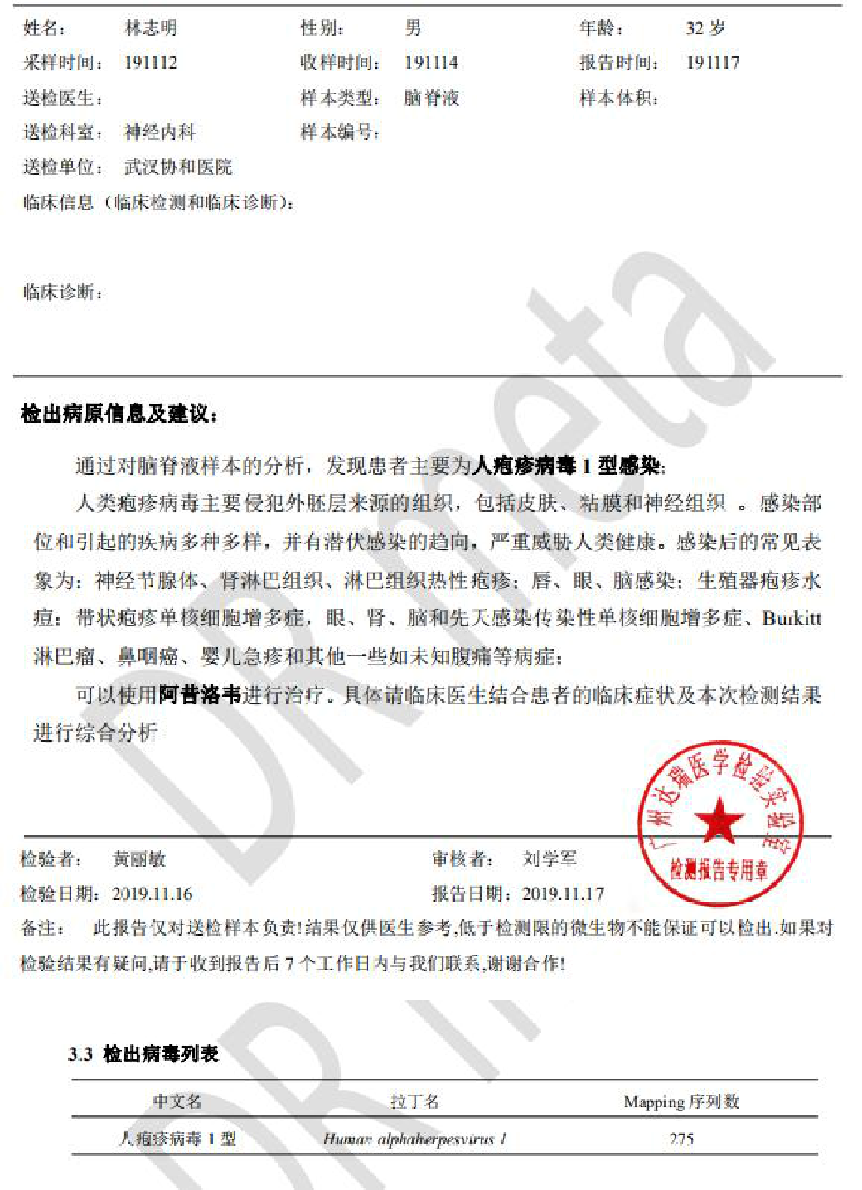
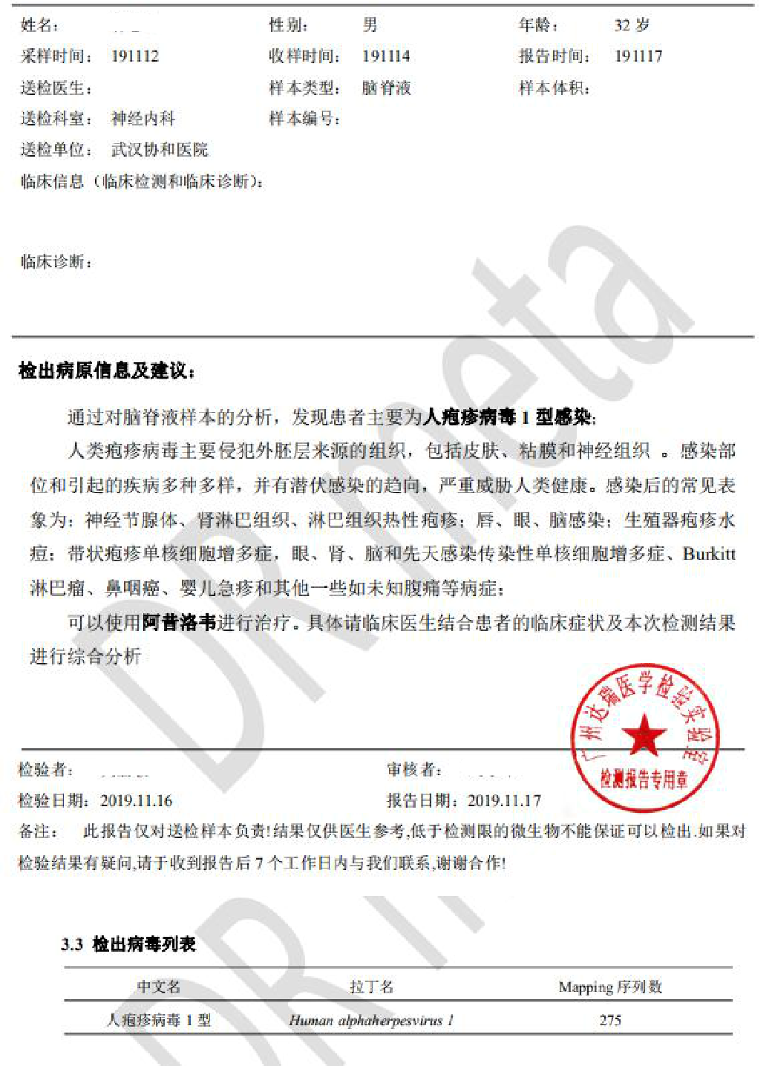

1

