Additional file 11.

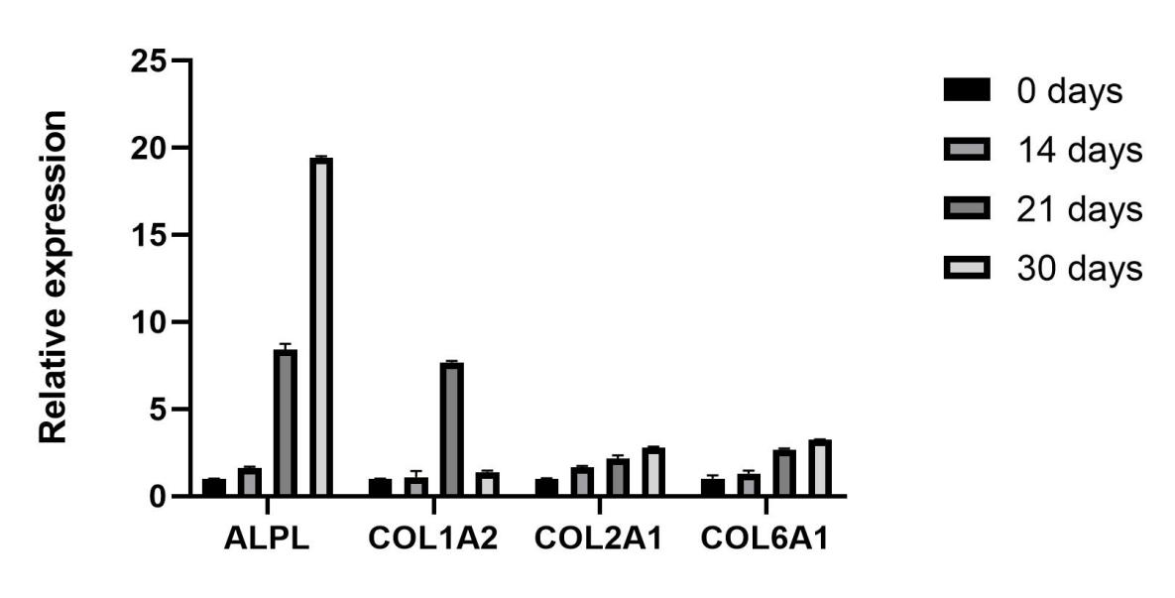
Induction of cartilage-specific gene expression on different days.

