Supplementary Material

# Supplementary Figures



**Supplementary Figure S1.** **Plot of activated fraction versus the dry diameter.** This figure illustrated how the activated fraction is used to determine critical diameter for a population of aerosol. The diameter at the point at which the activated fraction is equal to 0.5, indicating that 50% of the particles were able to activate as CCN is defined as the critical diameter.

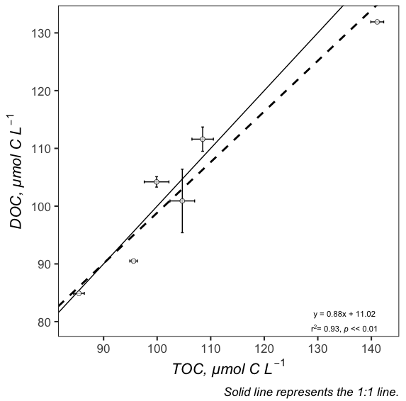

**Supplementary Figure S2.** **Comparison between measured TOC and DOC concentrations in the SML.** This figure shows that the concentrations of TOC and DOC measured in the SML are remarkably similar. At stations where both TOC and DOC concentrations were measured, the mean difference in the concentration was calculated and determined to be 3.94%. For stations where only TOC or DOC was measured the equation: DOC = TOC - (TOC x 0.0394) was used to convert between the two measurements.

# Supplementary Table

The molar concentration of each cation and anion listed in Table S1 was measured using ion chromatography. Using these data and the stoichiometry of the most abundance salts found sea water, the relative concentration of salts was determined by pairing the positive ions with negative ions to predict concentrations of sodium chloride, magnesium chloride, magnesium sulfate, and sodium sulfate. While other compounds found in seawater were not considered, these four compounds comprised at least 95% of the mass of the salts in each SML sample.

**Supplementary Table T1.** **Ion chromatography measurements of SML and DSML samples.**

|  |  |  |  |  |  |  |  |  |  |  |
| --- | --- | --- | --- | --- | --- | --- | --- | --- | --- | --- |
|  |  | Concentration (mg/L) | | | | | | | | |
|  |  | Cl | Br | NO3 | SO4 | Na | NH4 | K | Mg | Ca |
| SML | NAAMES 3  Station 1 | 20,333 | 91 | 21 | 2,998 | 11,652 | - | 412 | 1,450 | 434 |
| NAAMES 3  Station 6* | - | - | - | - | - | - | - | - | - |
| NAAMES 4  Station 2 | 13,742 | 68 | - | 1,749 | 7,720 | - | 459 | 1,190 | 383 |
| NAAMES 4  Station 4 | 14,057 | 72 | - | 1,848 | 8,003 | - | 415 | 1,244 | 406 |
| DSML | NAAMES 3  Station 1 | 6.4 ± 0.8 | 0.02 | 0.01 | 40 ± 3.8 | 8.5 ± 0.3 | 0.03 ± 0.03 | 0.58 ± 0.03 | 10.1 ± 0.5 | 3.5 ± 0.5 |
| NAAMES 3  Station 6 | 3.4 ± 0.2 | 0.01 | 0.02 | 45 ± 4.3 | 5.5 ± 0.4 | 0.03 ± 0.03 | 0.28 ± 0.05 | 10.3 ± 0.8 | 8.1 ± 0.8 |
| NAAMES 4  Station 2 | 2.2 ± 0.2 | <0.01 | <0.01 | 25 ± 0.7 | 6.2 ± 0.1 | 0.03 ± 0.03 | 0.68 ± 0.2 | 5.0 ± 0.3 | 2.2 ± 0.2 |
| NAAMES 4  Station 4 | 2.2 ± 0.2 | <0.01 | 0.01 | 25 ± 2.3 | 6.0 ± 0.3 | 0.03 ± 0.03 | 0.41 ± 0.05 | 5.8 ± 0.3 | 2.2 ± 0.1 |

**\*** No IC data available for NAAMES 3 Station 6 sample so the composition was assumed to be the same as the NAAMES 3 Station 1 sample.